Procedures

CREATE DATABASE EmployeeManagement;

GO

USE EmployeeManagement;

-- departmentsTable

CREATE TABLE Departments (

DepartmentID INT PRIMARY KEY,

DepartmentName VARCHAR(100)

);

-- employeesTable

CREATE TABLE Employees (

EmployeeID INT PRIMARY KEY IDENTITY(1,1),

FirstName VARCHAR(50),

LastName VARCHAR(50),

DepartmentID INT FOREIGN KEY REFERENCES Departments(DepartmentID),

Salary DECIMAL(10,2),

JoinDate DATE

);

-- Insert Departments (unchanged)

INSERT INTO Departments (DepartmentID, DepartmentName) VALUES

(1, 'HR'),

(2, 'Finance'),

(3, 'IT'),

(4, 'Marketing');

-- Insert Employees (Indian Names + More Data)

INSERT INTO Employees (FirstName, LastName, DepartmentID, Salary, JoinDate) VALUES

('John', 'Doe', 1, 5000.00, '2020-01-15'),

('Jane', 'Smith', 2, 6000.00, '2019-03-22'),

('Michael', 'Johnson', 3, 7000.00, '2018-07-30'),

('Emily', 'Davis', 4, 5500.00, '2021-11-05'),

('Rahul', 'Sharma', 1, 5200.00, '2022-01-10'),

('Priya', 'Agarwal', 2, 6100.00, '2022-06-18'),

('Amit', 'Verma', 3, 7300.00, '2022-02-01'),

('Neha', 'Patel', 4, 5400.00, '2021-09-20'),

('Vikram', 'Singh', 3, 7100.00, '2023-01-05'),

('Kavita', 'Rao', 1, 4900.00, '2023-02-14'),

('Anil', 'Mehta', 2, 6300.00, '2020-12-30'),

('Sneha', 'Kumar', 3, 7500.00, '2024-03-12'),

('Rohan', 'Gupta', 4, 5800.00, '2024-04-10');

--creating a procedure Exercise 1

CREATE PROCEDURE sp_InsertEmployee

@FirstName VARCHAR(50),

@LastName VARCHAR(50),

@DepartmentID INT,

@Salary DECIMAL(10,2),

@JoinDate DATE

AS

BEGIN

INSERT INTO Employees (FirstName, LastName, DepartmentID, Salary, JoinDate)

VALUES (@FirstName, @LastName, @DepartmentID, @Salary, @JoinDate);

END;

EXEC sp_InsertEmployee 'Dipanjan', 'Saha', 3, 6200.00, '2022-02-01';

--return value from procedure

CREATE PROCEDURE sp_GetEmployeeCountByDepartment

@DepartmentID INT

AS

BEGIN

SELECT COUNT(*) AS TotalEmployees

FROM Employees

WHERE DepartmentID = @DepartmentID;

END;

EXEC sp_GetEmployeeCountByDepartment @DepartmentID = 3;

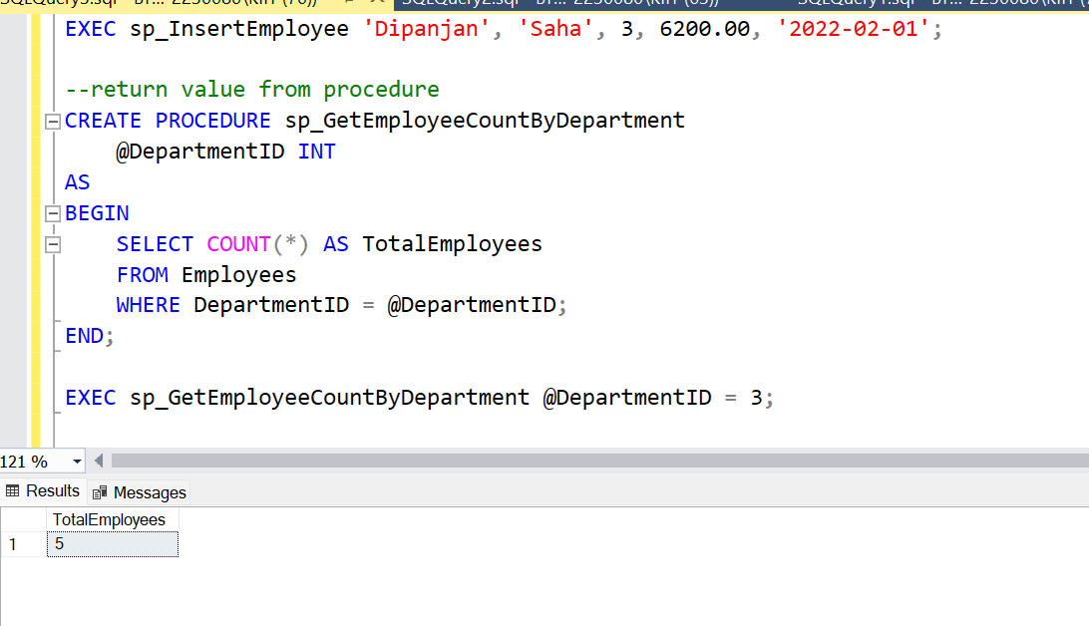

**Exercise-4**

To execute a stored procedure

EXEC sp_GetEmployeeCountByDepartment @DepartmentID = 3; --we run this query to execute a stored procedure