ADVANCED DATA STRUCTURES LABORATORY

**Date : 09/02/2023**

**Exercise : 1**

**Classes, Objects & Constructors**

1. Create a class for Distance having feet and inches as attributes. Try to give

the sum of two distance objects.

1. Create a class named Fibonacci which would generate proper Fibonacci

series when its display function has been invoked.

1. Create a class named Person with attributes name, id, age and salary with

proper member functions accept and display. Create five person objects find out the name of the person getting higher salary.

1. Create a class named Student with name, age and marks. Find out the

students having top 3 marks.

1. Create a class named Book with proper ID, Author Name, Publisher

name, price and year as its data members. Write suitable member

functions to collect the details of various books. Find out the number

of books having the same price.

1. Create a class Account that has a constructor to initialize the bank balance.The balance should be greater than minimum balance.Create a data member for storing balance.Use credit and debit functions to credit and debit money.Use Getbalance function to get the balance.
2. Create a class Employee that has firstname,lastname and salary as its data member.Use constructor to initialize all the data members.Use setter and getter function to set and get the values.Use function hike to increase the employee’s monthly salary by 10%.

**Date : 16/02/2023**

**Exercise : 2**

**String Handling**

Write a C++ program to perform :

1. Reverse String
2. Check palindrome (or) not
3. Count No. Of Words in String
4. Check if the word “Hello” is Present in the given Statement “Welcome to all, Hello Take Your Seat”
5. Take Input as Full Name and Display the abbreviations of the First and Middle name Except the Last Name For Example: Input string: Mahendra Singh Dhoni Output String: M.S.  
   Dhoni.
6. Give a Statement “ I am Okay,Task Completed” and Delect all Conconents from String.
7. Change Every Letter in a given String with the letter following it in the alphabet Input String: d1department Output String: e1efqbsunfou.
8. List all the Substring that can be Formed from the string “ABCD”
9. If Substring function is given as SUBSTRING(string, position, length), find S(5,9) if S=”Welcome to world of C++ Programming”.

Take statement ,count words and find largest word in a statement.

**Date : 23/02/2023**

**Exercise : 3**

**Function Overloading & Templates**

1. Write a program that demonstrates function overloading by defining two functions with the same name but different number of parameters.
2. Write a program that demonstrates function overloading by defining two functions with the same name but different types of parameters.
3. Write a program that demonstrates function overloading by defining two functions with the same name but different const-ness of parameters.
4. Write a program that demonstrates function overloading by defining two functions with the same name but different return types.
5. Write a program that demonstrates function overloading by defining three functions with the same name but different combinations of parameter types and number.
6. Write a program that demonstrates function overloading by defining two functions with the same name and parameter types, but different default argument values.
7. Write a program that demonstrates function overloading by defining two functions with the same name but different templates.
8. Write a program that demonstrates function overloading by defining two functions with the same name and same template, but different template parameters.
9. Write a program that demonstrates function overloading by defining two functions with the same name and same template parameters, but different template parameter lists.
10. Write a program that demonstrates function overloading by defining two functions with the same name and same template parameter list, but different template specializations.

**Date : 02/03/2023**

**Exercise : 4**

**Operator Overloading**

1.Write a C++ program to add , subtract , multiply and divide 2 complex numbers by overloading the arithmetic operators.

2.Write a C++ program to auto increment and auto decrement the time class(Unary operator overloading).

3.Check whether the given 2 strings are equal or not by overloading the

“==”operator.

4.Write a C++ program to create a car class containing model number , name & price . Initialize car details through parameterized constructors during the creation of objects.

**Date : 09/03/2023**

**Exercise : 5**

**Inheritance Heirarchy**

Create a Community member class hierarchy using inheritance for University Community students including their derived classes. The inheritance diagram along with the classes is given below. Use the access specifiers such as Public, Private & Protected in the required classes.

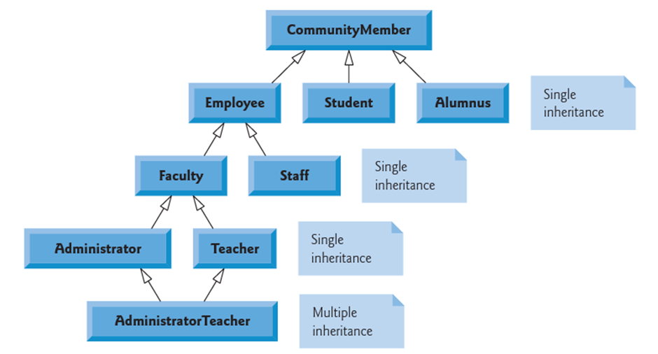

**Date : 16/03/2023**

**Exercise : 6**

**AVL Tree**

Write a C++ program to create an AVL tree and perform the operations such as **Creation, Insertion, Deletion, Search** & **Display** on the AVL tree.