## Difference between Frontend, Backend, and Full-Stack Development

- Frontend (Client-side): The part of the website the user can see and interact with (UI).  
 Example: On Amazon, the product list, buttons, search bar, and design.  
 Technologies: HTML, CSS, JavaScript, React, Angular.  
  
- Backend (Server-side): Handles logic, database, and server operations. Not visible to the user.  
 Example: When you add an item to cart on Amazon, the backend updates your cart in the database.  
 Technologies: Node.js, Django, PHP, Spring Boot.  
  
- Full-Stack: A developer who can build both frontend and backend.  
 Example: In a small startup, a full-stack developer may design the website’s UI and also connect it to the database.

## Client-Server Model Diagram

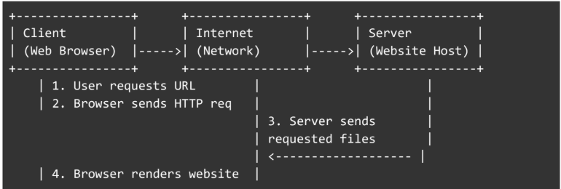

## 3. How a Browser Requests and Displays a Web Page

1. User enters a URL (e.g., www.amazon.com).  
2. Browser sends an HTTP request to the web server.  
3. The server processes the request and responds with HTML, CSS, and JS files.  
4. Browser rendering engine parses HTML, applies CSS, and executes JS.  
5. Final webpage is displayed to the user.

## 4. Tools Required for Web Development Environment

- Code Editor → VS Code, Sublime Text (for writing code)  
- Browser → Chrome, Firefox (for testing and debugging)  
- Version Control → Git & GitHub (for managing project versions)  
- Package Manager → npm or yarn (for installing libraries)  
- Local Server → XAMPP, Node.js (for running apps locally)  
- Terminal/Command Line → For executing commands

## 5. What is a Web Server + Examples

A web server is software (and sometimes hardware) that handles client requests and sends responses.  
Examples: Apache, Nginx, Microsoft IIS, LiteSpeed.

## 6. Roles in a Project

- Frontend Developer → Designs and builds the user interface (HTML, CSS, JS).  
- Backend Developer → Builds server-side logic, authentication, APIs, and integrations.  
- Database Administrator (DBA) → Manages database structure, security, backups, and performance tuning.

## 7. VS Code Installation & Setup

Steps:  
1. Download and install VS Code.  
2. Install extensions: Live Server, Prettier, JavaScript (ES6) snippets.  
3. Create a project folder with index.html, style.css, script.js.  
4. Open with Live Server to run in the browser.

## 8. Difference Between Static and Dynamic Websites

- Static Website: Displays fixed content, no database interaction. Example: Portfolio site.  
- Dynamic Website: Content changes based on user or database. Example: Facebook.

## 9. Five Web Browsers & Rendering Engines

- Google Chrome → Blink engine  
- Mozilla Firefox → Gecko engine  
- Microsoft Edge → Blink engine  
- Apple Safari → WebKit engine  
- Opera → Blink engine  
  
Rendering engines differ in how they interpret HTML, CSS, and JS, so websites may look different across browsers.

## Basic Web Architecture Flow Diagram

