INSIGHTSTREAM: Navigate the NewsLandscape ( React Application)

Team ID : SWTID1741247272158515

TEAM SIZE:4

D.PRAVEEN – TEAM LEADER-( [pp2100448@gmail.com](mailto:pp2100448@gmail.com))

K.RENUKA - TEAM MEMBER-( [renurenukalai@gmail.com](mailto:renurenukalai@gmail.com))

M.SANDHIYA- TEAM MEMBER-([sandhiyam587@gmail.com](mailto:sandhiyam587@gmail.com))

R.REVATHI -TEAM MEMBER- ([revathirevathid2004@gmail.com](mailto:revathirevathid2004@gmail.com))

INTRODUCTION:

PROJECT TITTLE:

INSIGHTSTREAM:Navigate the newslandscape(reactapplication)

In a world of constant change, staying informed is more than a choice—it’s a necessity. InsightSteam is your guide to navigating the evolving landscape of news, trends, and insights. We bridge the gap between information and action, delivering data-driven analysis, expert perspectives, and real-time updates to help you make smarter decisions.

With a commitment to clarity, accuracy, and innovation, InsightSteam transforms complexity into actionable intelligence. Whether you’re tracking industry shifts, market dynamics, or global developments, we empower you to Navigate the Newscape with confidence.

* **Project Overview:**

**PURPOSE:**

**Insight Stream News Navigate is a dynamic news aggregation and navigation system designed to help users access categorized, real-time news updates efficiently. It provides a smooth and interactive experience, allowing users to browse, filter, and personalize their news feeds.**

**The News App is a frontend web application designed to deliver the latest news articles from different categories like technology, business, sports, entertainment, and more. The app fetches real-time data from a news API and presents it in a clean, user-friendly interface.**

**FEATURES:**

**✔ News from API Sources: Access a vast library of global news spanning various categories and interests, ensuring a well-rounded coverage of current affairs.**

**✔ Visual News Exploration: Discover breaking stories and explore different news categories through curated image galleries, enhancing the visual appeal of news discovery.**

**✔ Intuitive Design: Navigate the application seamlessly with a clean, modern interface designed for optimal user experience and clarity in information presentation.**

**✔ Advanced Search Feature: Easily access news articles on specific topics through a powerful search feature, providing users with tailored news content based on their interests.**

* **Architecture:**

**1. Component Structure:**

**The News App is built with a modular approach using React components:**

**App.js: The root component, responsible for routing and managing high-level state.**

**Navbar.js: A navigation bar with category links like Technology, Business, Sports, etc.**

**NewsList.js: Fetches and displays a list of news articles. It maps through the data and renders individual news items.**

**NewsItem.js: A reusable component that shows article details — image, title, description, and a "Read More" link.**

**SearchBar.js: Provides search functionality, filtering articles based on user input.**

**. State Management:**

**We’re using React’s built-in useState and useEffect for state handling:**

**Global state:**

**✔ Selected news category.**

**✔Search query.**

**✔Fetched news articles.**

**Local State:**

**✔Component-level states for input values and UI controls.**

**Routing:**

**Routing is managed with react-router-dom, enabling category-based navigation:**

**/ → Home (top headlines)**

**/category/:name → Category-specific news**

**/search → Search results page.**

**4.Setup Instructions:**

**PRE-REQUISITES:**

**Here are the key prerequisites for developing a frontend application using React.js:**

**✔ Node.js and npm:**

**Node.js is a powerful JavaScript runtime environment that allows you to run JavaScript code on the local environment. It provides a scalable and efficient platform for building network applications. Install Node.js and npm on your development machine, as they are required to run JavaScript on the server-side.**

**● Download:** [**https://nodejs.org/en/download/**](https://nodejs.org/en/download/)

**● Installation instructions:** [**https://nodejs.org/en/download/package-manager/**](https://nodejs.org/en/download/package-manager/)

**✔ React.js: React.js is a popular JavaScript library for building user interfaces. It enables developers to create interactive and reusable UI components, making it easier to build dynamic and responsive web applications.**

**Install React.js, a JavaScript library for building user interfaces.**

**● Create a new React app:**

**npx create-react-app my-react-app**

**Replace my-react-app with your preferred project name. ● Navigate to the project directory: cd my-react-app**

**● Running the React App: With the React app created, you can now start the development server and see your React application in action.**

**● Start the development server:**

**npm start**

**This command launches the development server, and you can access your React app at** [**http://localhost:3000**](http://localhost:3000/) **in your web browser.**

**✔ HTML, CSS, and JavaScript: Basic knowledge of HTML for creating the structure of your app, CSS for styling, and JavaScript for client-side interactivity is essential.**

**✔ Version Control: Use Git for version control, enabling collaboration and tracking changes throughout the development process. Platforms like GitHub or Bitbucket can host your repository.**

**• Git: Download and installation instructions can be found at:** [**https://git-scm.com/downloads**](https://git-scm.com/downloads)**.**

**✔ Development Environment: Choose a code editor or Integrated Development Environment (IDE) that suits your preferences, such as Visual Studio Code, Sublime Text, or WebStorm.**

**• Visual Studio Code: Download from** [**https://code.visualstudio.com/download**](https://code.visualstudio.com/download)

**• Sublime Text: Download from** [**https://www.sublimetext.com/download**](https://www.sublimetext.com/download)

**• WebStorm: Download from** [**https://www.jetbrains.com/webstorm/download**](https://www.jetbrains.com/webstorm/download)

**Installation:**

**To install and run the Application project from google drive:**

**Follow below steps:**

**✔ Get the code: • Download the code from the drive link given below:** [**https://drive.google.com/file/d/11vQB4r8TSDN8w9TbYkIW8AjfBn1AixHF/view?usp=drive_link**](https://drive.google.com/file/d/11vQB4r8TSDN8w9TbYkIW8AjfBn1AixHF/view?usp=drive_link)

[**https://drive.google.com/file/d/1aWNbe43Gkt6XeS5492Xmj7dk-LZA1dNp/view?usp=drive_link**](https://drive.google.com/file/d/1aWNbe43Gkt6XeS5492Xmj7dk-LZA1dNp/view?usp=drive_link)

[**https://drive.google.com/file/d/1DlnIQFB6S2jLtHenXvp4OkdDj9S_ROvv/view?usp=drive_link**](https://drive.google.com/file/d/1DlnIQFB6S2jLtHenXvp4OkdDj9S_ROvv/view?usp=drive_link)

**• Navigate into the cloned repository directory and install libraries:**

**cd news-app-react**

**npm install**

**✔ Start the Development Server:**

**• To start the development server, execute the following command: npm start Access the App:**

**• Open your web browser and navigate to** [**http://localhost:3000**](http://localhost:3000/)**.**

**• You should see the applications homepage, indicating that the installation and setup were successful.**

**You have successfully installed and set up the application on your local machine.**

**You can now proceed with further customization, development, and testing as needed.**

**5.Folder Structure:**

**Client:**

**In this project, we’ve split the files into 4 major folders, Components, Context, Pages and Styles. In the pages folder, we store the files that acts as pages at different URLs in the application. The components folder stores all the files, that returns the small components in the application. The context Api will be coded in the context folder. All the styling css files will be stored in the styles folder.**

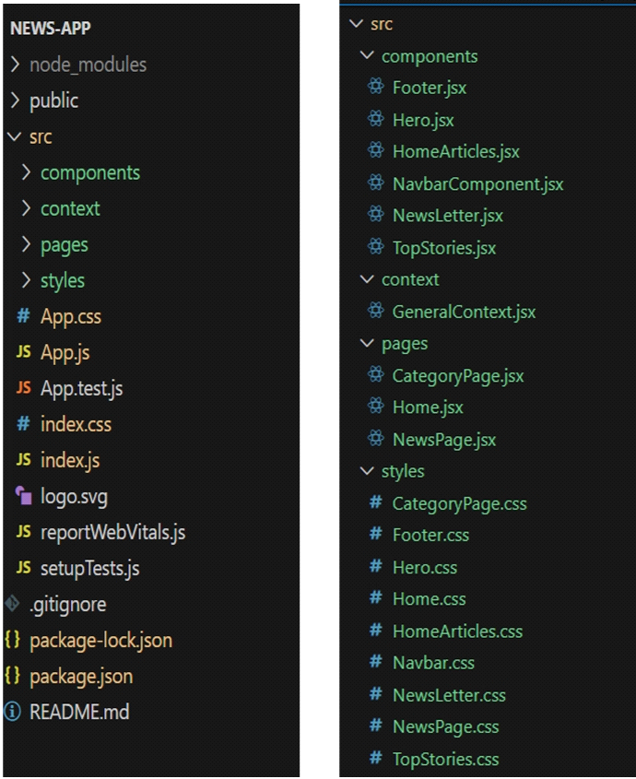

**6.Running the Application:**

**Installation of required tools:**

**To build InsightStream, we'll need a developer's toolkit. We'll use React.js for the interactive interface, React Router Dom for seamless navigation, and Axios to fetch news data.**

**For visual design, we'll choose either Bootstrap or Tailwind CSS for pre-built styles and icons.**

**Open the project folder to install necessary tools. In this project, we use:**

**o React Js**

**o React Router Dom**

**o React Icons**

**o Bootstrap/tailwind css**

**o Axios**

7.**Component documentation**

**1. Key Components:**

**App.js**

**Purpose: Root component that manages routing and global state.**

**Props: None.**

**State:**

**category → Stores the selected news category.**

**searchQuery → Stores the user’s search input.**

**Navbar.js**

**Purpose: Navigation bar for selecting news categories and accessing search.**

**Props:**

**onCategoryChange(category) → Function to set the current category.**

**State: None.**

**NewsList.js**

**Purpose: Fetches and displays a list of news articles.**

**Props:**

**articles → Array of news articles to display.**

**State:**

**loading → Boolean to show a loading indicator while fetching data.**

**NewsItem.js**

**Purpose: Reusable component that displays individual news articles.**

**Props:**

**title → Article headline.**

**description → Short summary of the article.**

**imageUrl → URL of the article’s thumbnail image.**

**newsUrl → Link to the full article.**

**State: None.**

**SearchBar.js**

**Purpose: Allows users to search for news articles by keyword.**

**Props:**

**onSearch(query) → Function to handle search input.**

**State:**

**searchInput → Stores the current value of the search field.**

**2. Reusable Components:**

**Button.js (optional)**

**Purpose: A customizable button used across the app.**

**Props:**

**label → Button text.**

**onClick() → Click event handler.**

**style → Custom inline styles.**

**Loader.js (optional)**

**Purpose: Displays a spinner while content is loading.**

**Props: None.**

**State: None.**

8**.State management**

**We’re using React’s built-in useState and useEffect for state handling:**

**Global state:**

**✔ Selected news category.**

**✔Search query.**

**✔Fetched news articles.**

**Local State:**

**✔Component-level states for input values and UI controls.**

**Routing:**

**Routing is managed with react-router-dom, enabling category-based navigation:**

**/ → Home (top headlines)**

**/category/:name → Category-specific news**

**/search → Search results page**

**9.User Interface**

**Hero components**

**In the hero component, the trending news articles are displayed. It is to highlight**

**them. Apart from that, the search bar is also available to search for various**

**articles and categories.**

**Popular categories**

**In the hero component, the trending news articles are displayed. It is to**

**highlight them. Apart from that, the search bar is also available to search for**

**various articles and categories.**

**Newsletter**

**Staying informed is key! This section would act as a magnet for users who want**

**to stay up-to-date on the latest news. A brief signup form with an email field**

**would be presented, along with a clear call to action button like "Subscribe Now"**

**or "Get Daily News Updates." With a simple click, users can join the**

**InsightStream community and receive curated news delivered straight to their**

**inbox.**

**Category/Search result page**

**Finding the news you crave is effortless with InsightStream. This page displays a**

**neatly organized list of articles matching your chosen category or specific search**

**query. Each entry would provide a clear headline, a concise summary, and if**

**available, an image to give you a quick glimpse into the story. To further refine**

**your exploration, filters or sorting options might be available.**

**Redirected Article page**

**This is where you dive deep! The article page proudly displays the complete**

**news story, retrieved directly from the original source. To keep you engaged and**

**exploring related topics, the page might also suggest additional articles based on**

**the current story. These suggestions can open doors to a world of interconnected**

**information, allowing you to become a well-rounded news connoisseur.**

**10.styling**

**1. CSS Frameworks/Libraries**

**Your current project uses CSS for styling without a framework. However, if you plan to enhance it, you can use CSS frameworks like Tailwind CSS or Bootstrap for better styling and responsiveness.**

**✅ Current CSS Approach**

**Uses plain CSS (style.css) for layout, colors, fonts, and responsiveness.**

**Includes custom styles for homepage, category pages, and recipe details pages.**

**✅ Future Enhancements (Optional)**

**Tailwind CSS – A utility-first CSS framework for faster styling.**

**npm install -D tailwindcss**

**Bootstrap – Provides pre-designed UI components for buttons, cards, and grids.**

**npm install bootstrap**

**2. Theming**

**Currently, the project does not have a dark/light theme switch or a custom design system. However, you can implement:**

**✅ Custom Theming with CSS Variables (Example)**

**:root {**

**--primary-color: #30ac72;**

**--background-color: #f5f5f5;**

**--text-color: #333;**

**}**

**body {**

**background: var(--background-color);**

**color: var(--text-color);**

**}**

**This approach allows easy theme customization without modifying individual styles.**

**11.Testing:**

**Testing Approach:**

**We’ll use a combination of unit testing, integration testing, and end-to-end (E2E) testing to ensure the News App works reliably and meets user expectations.**

**Unit Testing:**

**Test individual components like NewsItem.js, SearchBar.js, and Navbar.js.**

**Ensure props are passed and rendered correctly.**

**Validate state changes and function calls.**

**Tools: Jest, React Testing Library**

**Integration Testing:**

**Test interaction between components (e.g., how SearchBar.js passes data to NewsList.js).**

**Ensure state management and API calls work seamlessly.**

**Check whether the app fetches and displays data properly.**

**12.Screenshorts and Demos:**

**Demo link:**

[**https://drive.google.com/file/d/1R9O7pNTLgm4bxA6f5A8EdVe8bUYdBNvW/view?usp=drivesdk**](https://drive.google.com/file/d/1R9O7pNTLgm4bxA6f5A8EdVe8bUYdBNvW/view?usp=drivesdk)

**Screenshorts:**

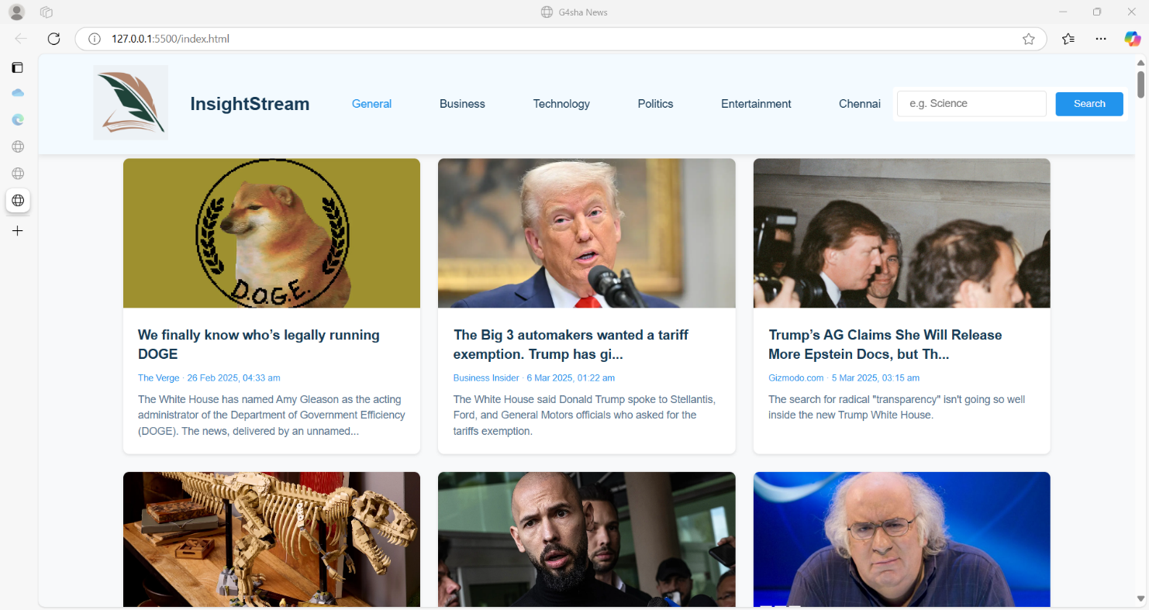

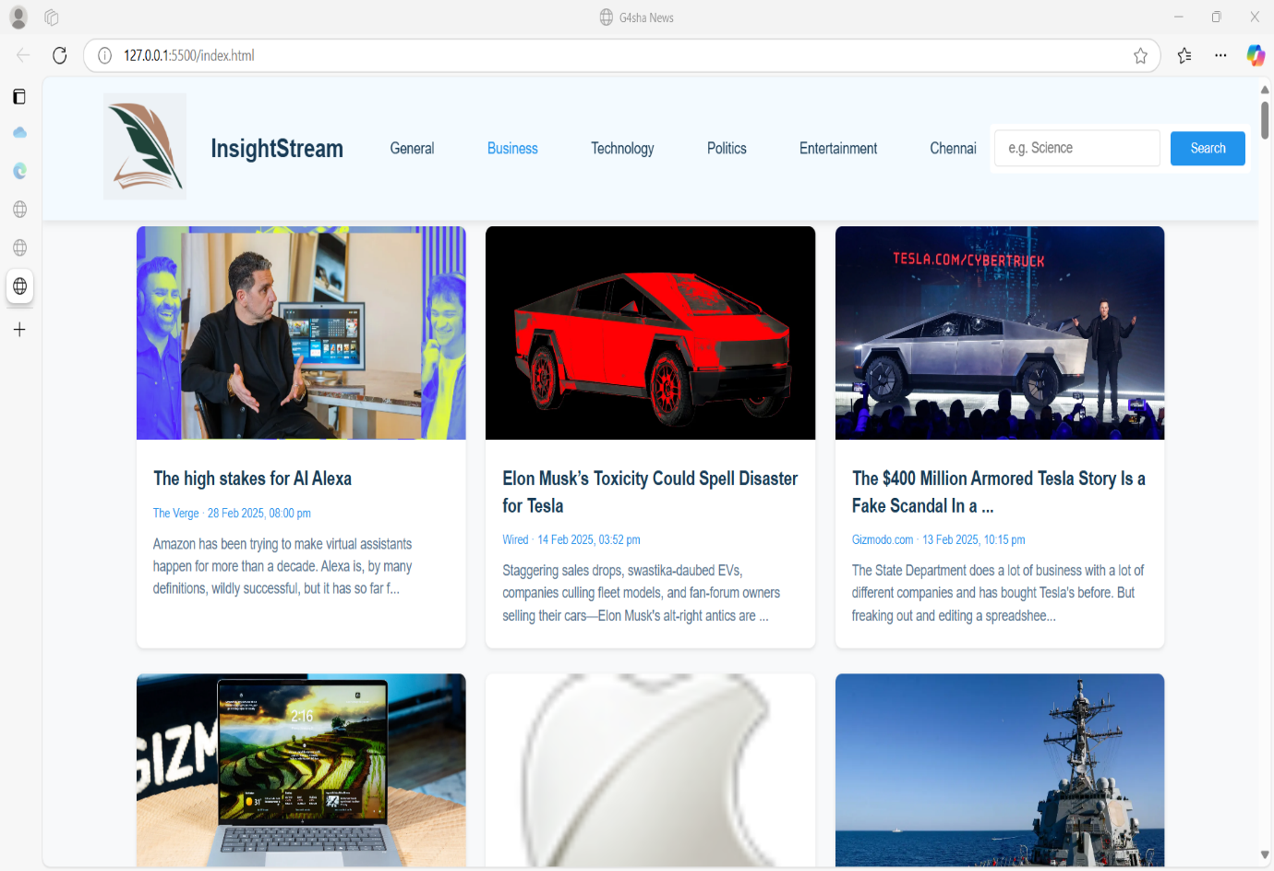

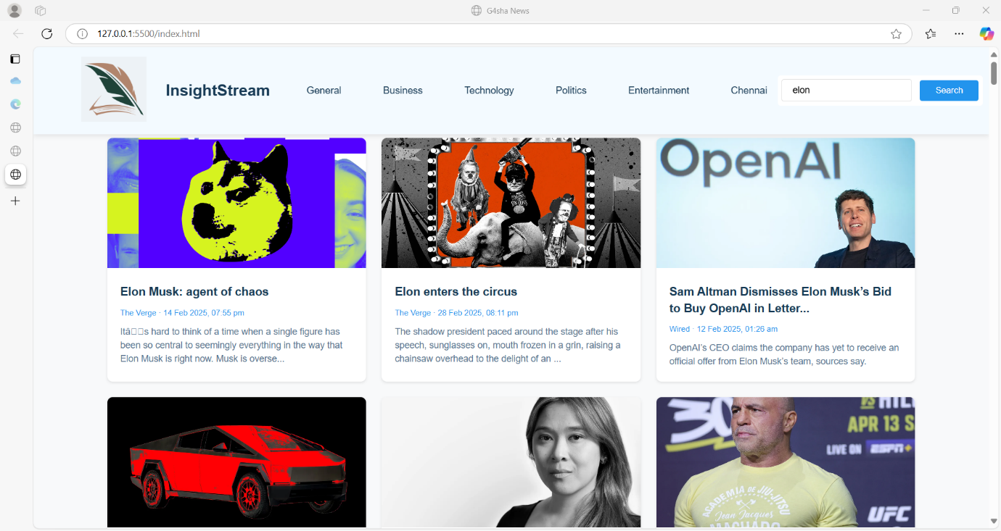

**13.Known issues:**

**1. API Rate Limiting:**

**The news API may have a request limit, which could lead to errors if too many requests are made in a short time.**

**Workaround: Cache data where possible and handle errors gracefully with user-friendly messages.**

**2. Search Sensitivity:**

**The search function may not return results for partial or misspelled words.**

**Workaround: Implement a debounce function and suggest similar keywords.**

**3. Image Load Failures:**

**Some articles may not have images, leading to broken links in the UI.**

**Workaround: Use a placeholder image when an article’s image URL is missing.**

**4. Responsiveness Glitches:**

**On very small screens, the news cards may not align perfectly.**

**Workaround: Fine-tune CSS media queries for better mobile support.**

**5. Slow Loading on Low Bandwidth:**

**API calls may take time on slow internet connections, leaving the UI looking empty.**

**Workaround: Add a loading spinner and skeleton screens to improve perceived performance.**

**6. Cross-Browser Compatibility:**

**Some CSS styles or JavaScript features might behave differently on older browsers.**

**Workaround: Test on multiple browsers and use polyfills for older versions.**

**7. Error Handling:**

**Generic error messages when API requests fail.**

**Workaround: Provide specific error feedback (like "No results found" or "Server unavailable").**

**14.Future Enhancement:**

**Future enhancement of Insight Stream News Navigate application refers to planned improvements that will enhance its**

**functionality, usability, and overall user experience.These enhancements may include personalized news recommendations**

**using AI, multi-language support to provide news in regional languages, and advanced search and filtering options for better content discovery. Security features like social logins, two-factor authentication, and role-based access can also be added to ensure secure user authentication. Additionally, developing a mobile application using React Native or Flutter will expand accessibility,**

**while features like push notifications and offline reading mode will enhance user engagement. To support long-term sustainability, monetization options such as advertisements, subscriptions, or**

**partnerships with news agencies can be integrated. These future enhancements will help the application evolve, stay relevant, and provide a seamless news-reading experience for users.**

**THANK YOU!!!**