**Logins**

**East Bastian:-** open putty

Use port forwarding in putty for connecting to historian related websites , using foxy poxy

|  |  |
| --- | --- |
| Historian migration url’s | Website names |
| http://10.228.145.117:8161/admin/queues.jsp | active mq |
| Ipaddress_of_EMR:8088/cluster | hadoop cluster |
| http://ip-10-228-156-50.ec2.internal:8088/cluster | final parquets |

**Putty Configuration :-**

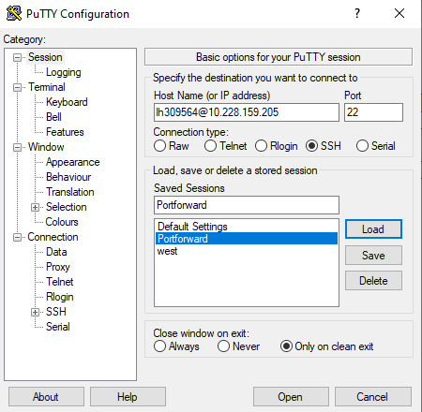

**Step 1:-**

Here we wont use SSO id for login we need unix ID for login

Should get the login id from One IDM **Unix Logon and Group Membership** group and we will get the login id for loging into east bastian

In putty we must configure few things and save it

**Step2:-**

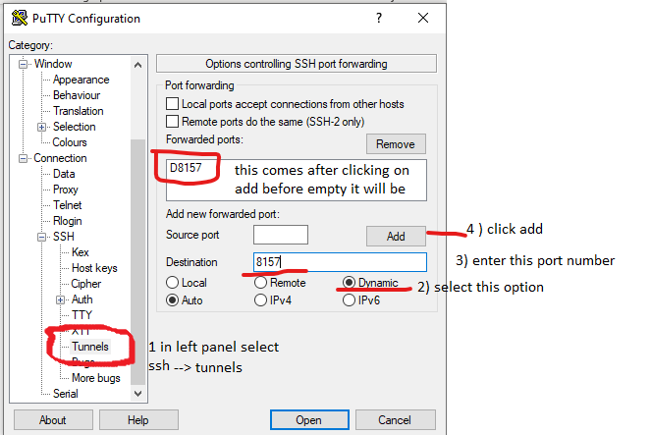

**Step 3:-**

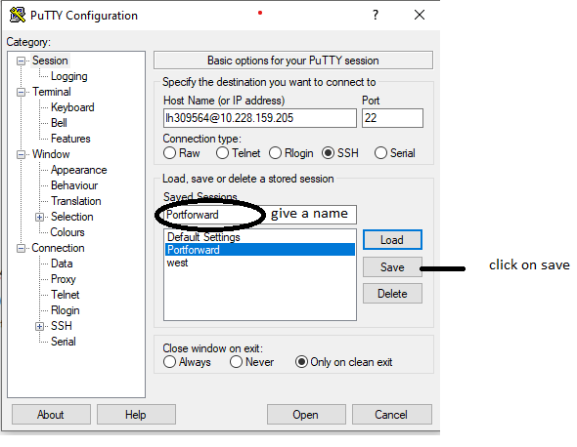

**Foxy proxy settings:-**

In chrome install foxy proxy plugin from extensions menu

1. Open foxy proxy 🡪 add new proxy 🡪 give it a name 🡪 click on Proxy details
2. Give below details and select below options

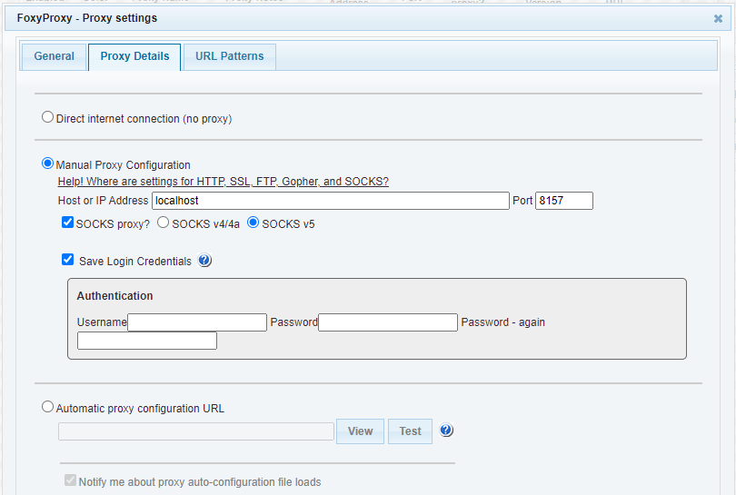

1. Click on beside tab url patterns
2. Click on “**Add new pattern**” enter the details by selecting **Add new pattern** many times

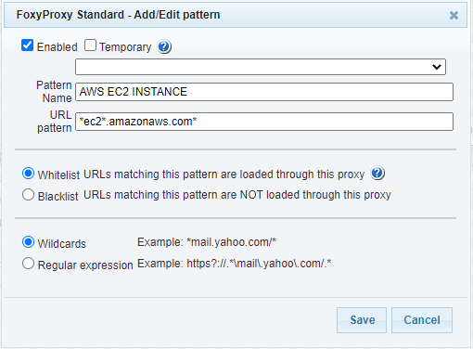

1. Add these all patterns in same way as above given example

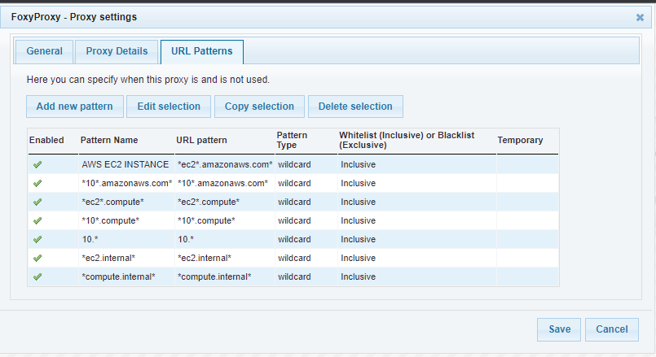

Now east bastian is configured

Now to login into any west side historian related EC2 instances we need to create a SSH public key from west Bastian and copy to a S3 bucket

ssh username@IP_EMR should login next

**West Bastian :-**

This is used to access west side aws ec2 instances , EMR’s , Airflow , Genie,

We need **VPN & jumphost** access which should be raised from service now and addendum

**Steps:-** the below doc has the steps to raise jumphost access



**VPN:-**  vpn we use Sophos application we need to raise addendum from below link for getting it installed

* <https://supportcentral.ge.com/login>
* first we need to login into Sophos using the password which we get from access team

login into west bastian 10.8.0.237 or 10.8.0.205 using same port forward settings like east bastian as given above

and we can connect to Airflow ,genie , emr’s , ec2 instances

* to login into ec2 instances from west we need to add the ssh pub keys generated from west bastian into authentication file which is in s3 bucket path given below

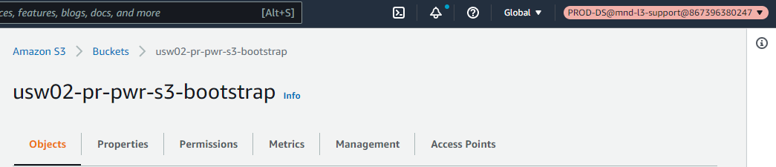

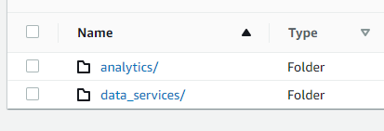

In These two folders we must update the ssh pub key into “**authorized_keys**” in **user_access** folder

* login to west Bastian 🡪 ssh ec2-user@DNS name of instance
* for EMR’s user name is **Hadoop** .

**Airflow:-**  we have multiple ENV’s Airflow is been utilized ,

Airflow consist of Dag’s which where data analysis tasks details are shown

<https://airflow-analytic-services.predixdatafabric.com/admin/>

This link :- [Common URLs - Power Digital Engineering - Developer Cloud (ge.com)](https://devcloud.swcoe.ge.com/devspace/pages/viewpage.action?spaceKey=XGRDH&title=Common+URLs) has all the list of the airflow ENV’s

* we have airflow flower web app to get the ec2 instances names which are deployed for airflow .
* depending upon the ENV we have to select the link , make sure foxy proxy is enabled in chrome and click on that link
* you will get a page like this which has details

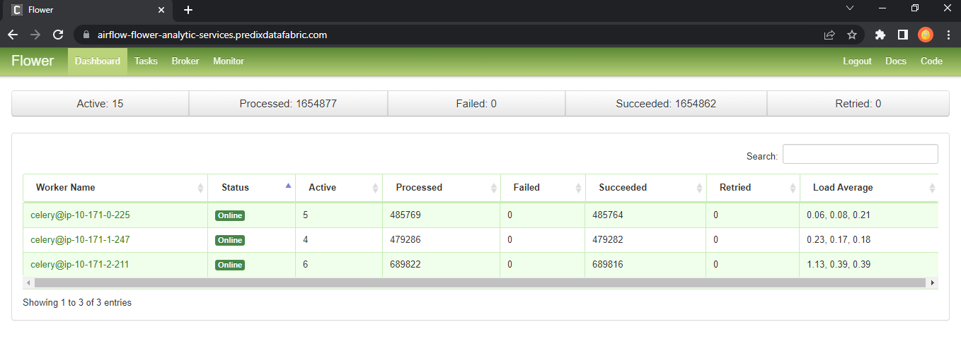

* Select the worker name which shows online 🡪 copy the dns name from their **EX:- ip-10-171-0-225**
* As same ENV selected same ENV we have to go in AWS , **EX:-** if we select **Prod-ds** env airflow we have open **Prod-ds** aws account ec2 services
* Paste the copied dns name in search for instance , we will get a ec2 instance ,

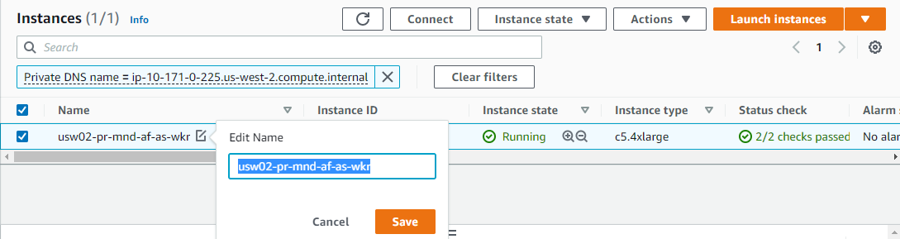

* now we have get all the worker noded and scheduler node we have to copy the whole instance name and in search bar paste and remove **-wkr** the last part of it
* and we will get the list of instances related to it

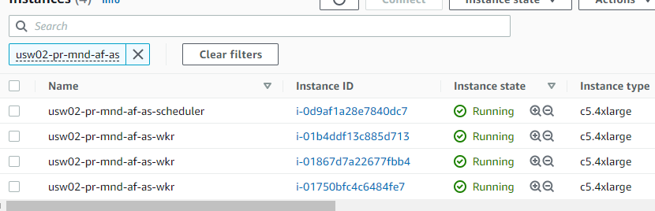

* from here we can login into nodes related to airflow and troubleshoot the airflow engines

**EMR**

* Data services and analysis , two accounts we have
* In both emr related s3 buckets same path as above we have to add pub keys to login into them
* 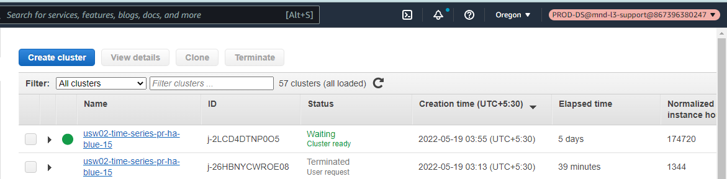
* Ec2 emr lies in Oregon region go to emr services 🡪 filter active clusters 🡪 copy dns name of any emr
* Login into west bastian “ ssh hadoop@emr_dns_name “