AWS S3 script for getting the retrieval of S3 Bucket list , volume of the bucket and Life Cycle policy of the bucket

List bucket :-

*# Module used in python for boto3*

import boto3

*#creating a session of aws login using profile from aws_crediantials ENV*

session = boto3.Session(profile_name='011821064023_mnd-l3-support-role')

*#testing the login by getting region name of the above profile*

print(session.region_name)

*#defined proxy for the flow of data between clients*

proxy_definitions = {

    'http': 'http_proxy=http://PITC-Zscaler-Americas-Alpharetta3PR.proxy.corporate.ge.com:80',

    'https': 'https_proxy=http://PITC-Zscaler-Americas-Alpharetta3PR.proxy.corporate.ge.com:80',

    'no_proxy': '.ge.com'

}

*#defining the services we want using sessions here ver defined s3 session*

s3 = session.client('s3', verify=False)

*#defined the variable responce and using the session service s3 we created to get the bucket names list*

response = s3.list_buckets()['Buckets']

*#using for loop to print the list of all buckets*

for bucket in response:

    print(format(bucket['Name']))

#executing the above script gives this output here we have excuted the python script and taken the output to a file called as s3_bucket_dev.csv

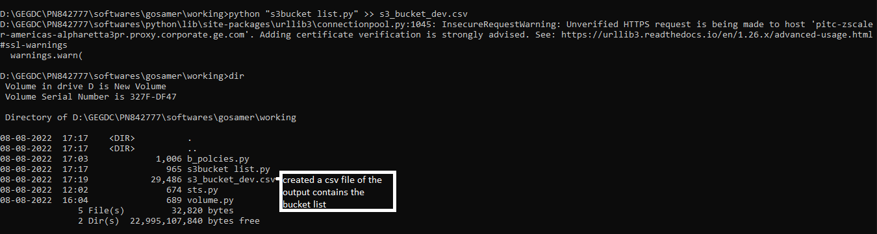

#volume of the bucket

import boto3

session = boto3.Session(profile_name='011821064023_mnd-l3-support-role')*#, region_name='us-west-2')*

print(session.region_name)

proxy_definitions = {

    'http': 'http_proxy=http://PITC-Zscaler-Americas-Alpharetta3PR.proxy.corporate.ge.com:80',

    'https': 'https_proxy=http://PITC-Zscaler-Americas-Alpharetta3PR.proxy.corporate.ge.com:80',

    'no_proxy': '.ge.com'

}

*#s3 = session.resource('s3', verify=False)*

*#ge-power-arf-shim-stage-us-west-2-replication*

s3 = session.resource('s3', verify = False)

*#defined the variable bytes and using the session service s3 we created to get the bucket volume*

bytes = sum([object.size for object in s3.Bucket('ge-power-arf-shim-stage-us-west-2').objects.all()])

print(f'total bucket size: {bytes//1000/1024/1024} GB')

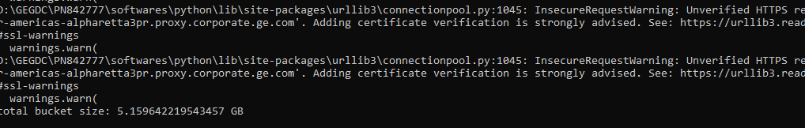

#bucket lifecycle policy

*# Module used in python for boto3*

import boto3

import json

*#creating a session of aws login using profile from aws_crediantials ENV*

session = boto3.Session(profile_name='011821064023_mnd-l3-support-role')

*#testing the login by getting region name of the above profile*

print(session.region_name)

*#defined proxy for the flow of data between clients*

proxy_definitions = {

    'http': 'http_proxy=http://PITC-Zscaler-Americas-Alpharetta3PR.proxy.corporate.ge.com:80',

    'https': 'https_proxy=http://PITC-Zscaler-Americas-Alpharetta3PR.proxy.corporate.ge.com:80',

    'no_proxy': '.ge.com'

}

*#defining the services we want using sessions here ver defined s3 session*

s3 = session.client('s3', verify=False)

*#defined the variable result and using the session service s3 we created to get the bucket lifecycle policy*

result = s3.get_bucket_lifecycle (Bucket='ge-power-arf-shim-stage-us-west-2-replication')

*#print(result)*

json_formatted_str = json.dumps(result)

print(json_formatted_str)

