**Kerberos :**

* Kerberos is a centralized authentication protocol designed to securely authenticate users and services within a network.
* It operates using a trusted third-party server called the Key Distribution Center (KDC), which is responsible for managing authentication and issuing cryptographic keys.
* The KDC consists of an authentication server and a database that stores credentials to verify clients' identities.
* In Kerberos, every user and service within the network is referred to as a principal, and the protocol ensures mutual authentication between users and servers, enhancing security.

**The main components of Kerberos are:**

1. **Authentication Server (AS):**The Authentication Server performs the initial authentication and ticket for Ticket Granting Service.
2. **Database:**The Authentication Server verifies the access rights of users in the database.
3. **Ticket Granting Server (TGS):**The Ticket Granting Server issues the ticket for the Server**.**

**Kerberos Overview:**

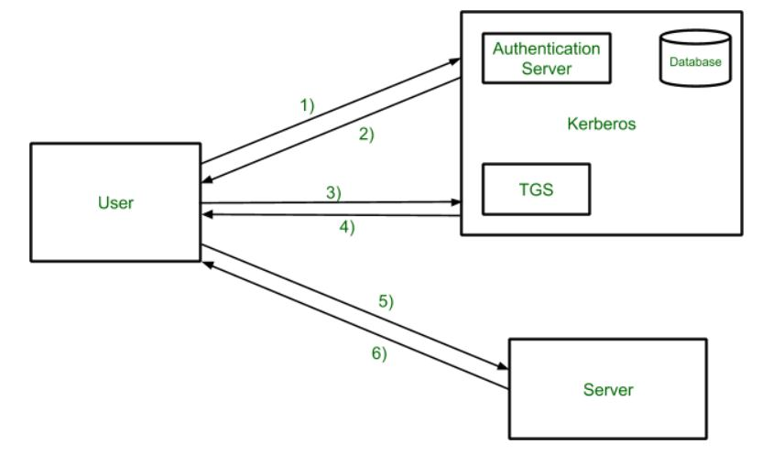

Working :

* **Step-1:**The user logs into the system and requests access to a specific service hosted on a server. As part of the request, the user asks for a Ticket-Granting Service (TGS) from the Authentication Server (AS).
* **Step-2:**The Authentication Server (AS) verifies the user's identity by checking their credentials (e.g., username and password) against a database.

The AS generates a Ticket-Granting Ticket (TGT) and a session key for secure communication. Both the TGT and session key are encrypted using the user’s password. The encrypted information is sent back to the user.

* **Step-3:**The user decrypts the message from the AS using their password then send the ticket along with an authenticator to the Ticket Granting Server . The ticket contains authenticator like user’s name, network address, and a timestamp to verify the request.
* **Step-4:**The Ticket Granting Server (TGS) decrypts the TGT and verifies the user’s request using the authenticator. If the request is valid then the TGS generates a service ticket that allows the user to access the service from the server.
* **Step-5:**The user forwards the service ticket and another authenticator to the target server where the requested service is hosted.
* **Step-6:**The server verifies the ticket and authenticator will confirm the user’s details if valid, then the server grants the user access to the requested service.

**Is Kerberos Infallible?**

Kerberos is not entirely impregnable, as hackers have developed methods to exploit it over time, including forging tickets, brute force attacks, and using malware to weaken encryption.  Kerberos remains the best access security protocol available today. The protocol is flexible enough to employ stronger encryption algorithms to combat new threats .

**Kerberos Limitations :**

* It doesn’t work well in a timeshare environment
* Secured Kerberos Server
* Requires an always-on Kerberos server
* Stores all passwords are encrypted with a single key
* May result in cascading loss of trust.

**Advantages of Kerberos**

1. **Strong Security :** Kerberos ensures that both users and servers verify each other, making it hard for attackers to impersonate them.
2. **Efficiency :** Once you log in, you don't need to re-enter your password for accessing multiple services.
3. **Less Password Exposure :** Your password isn't sent over the network often, so it's safer from being stolen.
4. **Integration with Active Directory :** Works well with Microsoft's systems, making it easy to manage user credentials in large organizations.
5. **Widely Used :** Many systems support Kerberos, making it a reliable choice for secure logins.

**Applications :**

* **User Authentication:** Users only have to input their username and password once with Kerberos to gain access to the network.
* **Single Sign-On (SSO** : A user can access any network resource they have been authorized to use after being authenticated by the Kerberos server .
* **Network File Systems:** Kerberos secures access to network file systems like NFS (Network File System).
* **Email Protocols:** Used as an alternative authentication method for email protocols such as POP (Post Office Protocol) and SMTP (Simple Mail Transfer Protocol).