**What is Meta Data in Data Warehousing?**

* Metadata is data that describes other data.
* It provides details about the content, format, structure, and characteristics of data, helping improve organization and accessibility.
* Metadata can be stored in formats like text, XML, or RDF.
* Standards like Dublin Core, schema.org, and METS guide metadata creation and management.
* Metadata schemas provide a consistent structure for organizing and describing data.

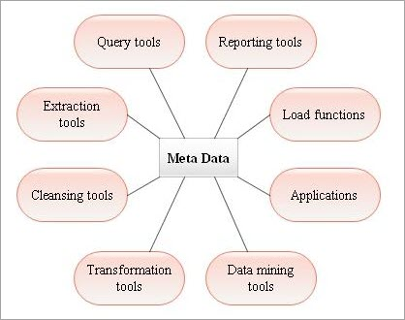**Diagram:**

**Types of Metadata:**

* **Descriptive metadata:** Describes data content with details like title, author, and keywords to improve discoverability.
* **Administrative metadata:** Provides technical and management details like file format, size, and creation date for data maintenance.
* **Structural metadata:** Organizes data with elements like links and tables of contents to support navigation and connections.
* **Provenance metadata:** Details the history and origin of data, including creator, creation date, and sources for context and credibility.
* **Rights metadata:** Covers ownership, licensing, and access controls to manage intellectual property and compliance.
* **Educational metadata:** Highlights educational value, learning objectives, and outcomes to support resource discovery and learning design.

**Metadata Repository:**

* A metadata repository is a storage system for managing, organizing, and maintaining metadata consistently, improving data discovery and access.
* It can store metadata about various data types (e.g., documents, images, videos) and is often structured using standards and schemas.
* Metadata repositories range from simple systems like spreadsheets to complex databases, chosen based on organizational needs and data complexity.

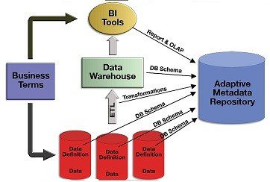**Diagram:**

**Benefits of Metadata Repository:**

* **Improved data quality:** Ensures consistent and accurate metadata for better data quality.
* **Increased data accessibility:** Makes data easier to find and understand by providing context.
* **Enhanced data integration:** Streamlines combining data from multiple sources using centralized metadata.
* **Improved data governance:** Enforces standards and policies for proper data usage and management.
* **Enhanced data security:** Protects metadata with access controls for sensitive information.

**Challenges for Metadata Management:**

* **Lack of standardization:** Different conventions make managing metadata across sources challenging.
* **Data quality:** Poorly structured or incorrect metadata affects usability and understanding of data.
* **Data integration:** Ensuring consistent metadata across multiple sources can be difficult.
* **Data governance:** Enforcing metadata standards and policies is complex in large organizations.
* **Data security:** Protecting sensitive metadata and ensuring privacy is a key challenge.