Name: K. Praveen kumar

Day-2 ASSIGNMENT

Creating a Table:

create table employee_details(id int,name varchar(20),age varchar(30),city varchar(20), salary varchar(20));

Inserting data into Table:

insert into employee_details(id,name,age,city,salary) VALUES('101','john','26','chennai','25000');

insert into employee_details(id,name,age,city,salary) VALUES('102','ram','26','chennai','30000');

insert into employee_details(id,name,age,city,salary) VALUES('103','sri','26','chennai','50000');

insert into employee_details(id,name,age,city,salary) VALUES('104','snow','26','chennai','30000');

insert into employee_details(id,name,age,city,salary) VALUES('105','sam','26','chennai','25000');

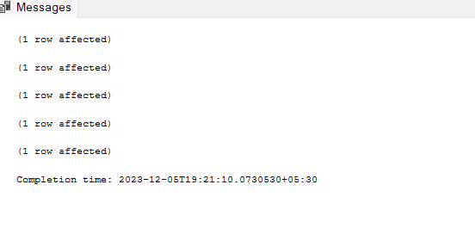

To show Tabels:

select * from sys.tables;

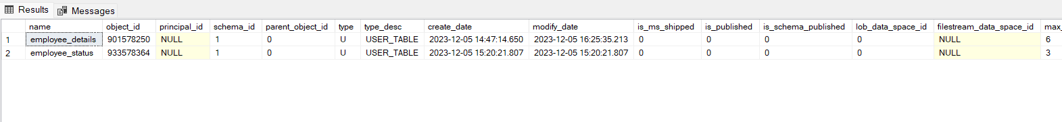

To display rows and columns of a Table:

select * from employee_details;

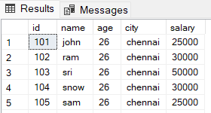

To update a Table:

alter table employee_details

add branch varchar;

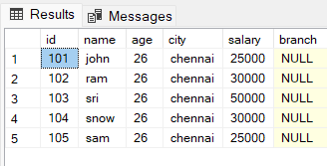

To drop a column:

alter table employee_details

drop column branch;

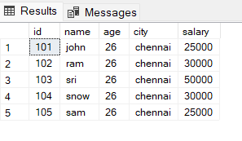

To delete all Rows:

truncate table employee_details;

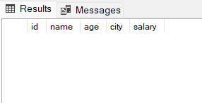

To update a record :

update employee_details set age='25' where id='105';

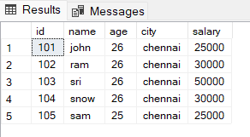

To delete a record:

delete from employee_details where id ='104'

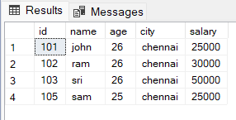

Creation of another Table:

create table employee_status(id int,working_status varchar(10),experience varchar(20));

Inserting a data:

insert into employee_status(id,working_status,experience)values('101','working','5yrs');

insert into employee_status(id,working_status,experience)values('102','notworking','4yrs');

insert into employee_status(id,working_status,experience)values('103','working','3yrs');

insert into employee_status(id,working_status,experience)values('104','notworking','7yrs');

insert into employee_status(id,working_status,experience)values('105','working','4yrs');

insert into employee_status(id,working_status,experience)values('106','notworking','2yrs');

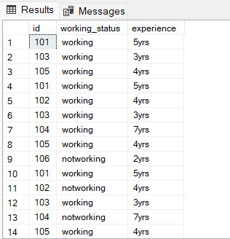

**Distinct :** There are duplicate ID’s in the above table. So the distinct keyword is used to show the different id’s.

select distinct id,experience from employee_status;

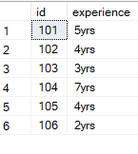

**Updating a record using where clause**:

update employee_status set working_status = 'working' where experience > '2yrs';

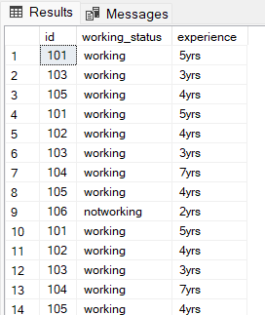

**Where clause:**

select * from employee_details where salary>'30000';

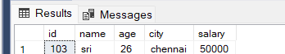

**Order by**:

select id from employee_status order by experience asc;

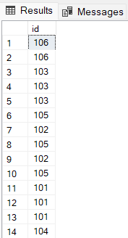

**Group by and count:**

select count(salary) as total_count from employee_details

group by salary;

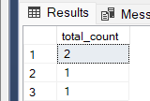

Join:

select * from employee_details join employee_status on employee_details.id=employee_status.id;

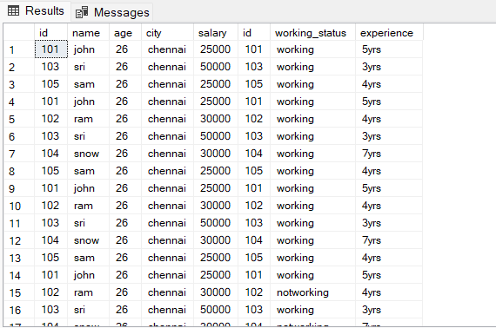

Inner join:

select employee_details.id,employee_details.name,employee_details.age,employee_status.working_status,employee_status.experience

from employee_details inner join employee_status on employee_details.id = employee_status.id;

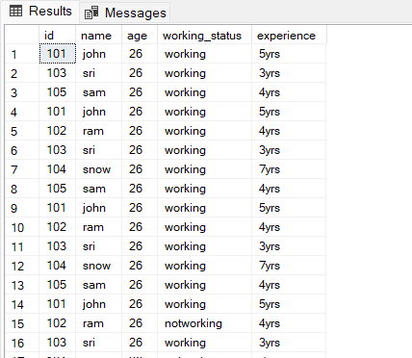

Right join:

select employee_details.id,employee_details.name,employee_details.age,employee_details.salary,employee_status.working_status,employee_status.experience

from employee_details right join employee_status on employee_details.id = employee_status.id;

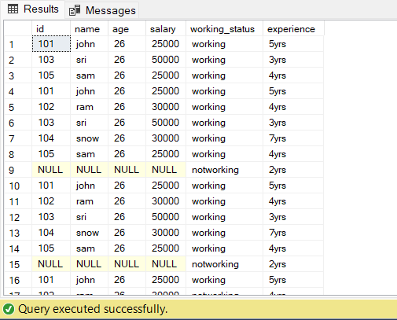

Left join:

select employee_details.id,employee_details.name,employee_details.salary,employee_status.working_status,employee_status.experience

from employee_details left join employee_status on employee_details.id = employee_status.id;

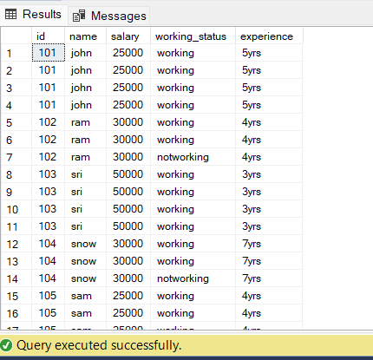

Outer join:

select employee_details.id,employee_details.name,employee_details.salary,employee_status.working_status,employee_status.experience

from employee_details right join employee_status on employee_details.id = employee_status.id

union

select employee_details.id,employee_details.name,employee_details.salary,employee_status.working_status,employee_status.experience

from employee_details left join employee_status on employee_details.id = employee_status.id

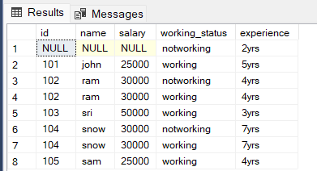

AND:

select * from employee_details where city='chennai' and age='25';

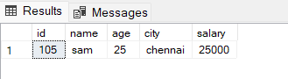

IN:

SELECT * FROM employee_details WHERE id IN ('101', '105');

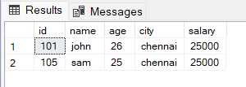

NOT:

SELECT * FROM employee_details WHERE name NOT LIKE 's%';

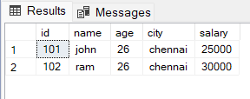

OR:

select * from employee_details where salary>'30000' or age='25';

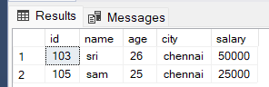

Between:

select * from employee_status where experience between '4yrs' and '7yrs';

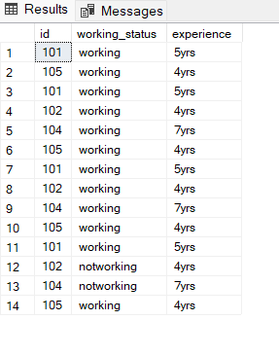

Here are the few results which I have taken in online compiler: