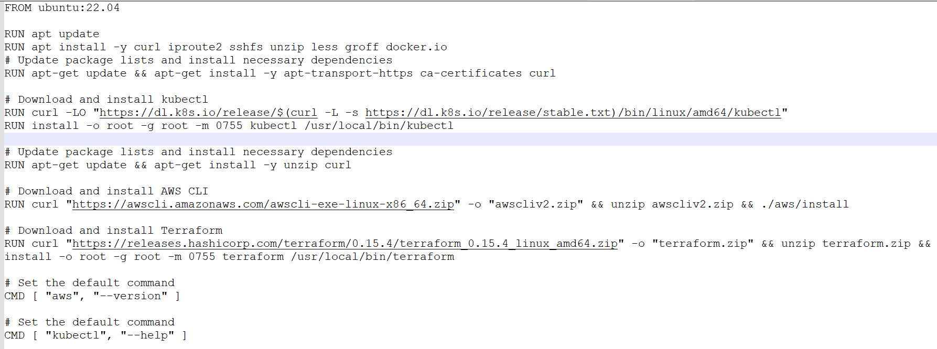

Based on Docker file, Created image

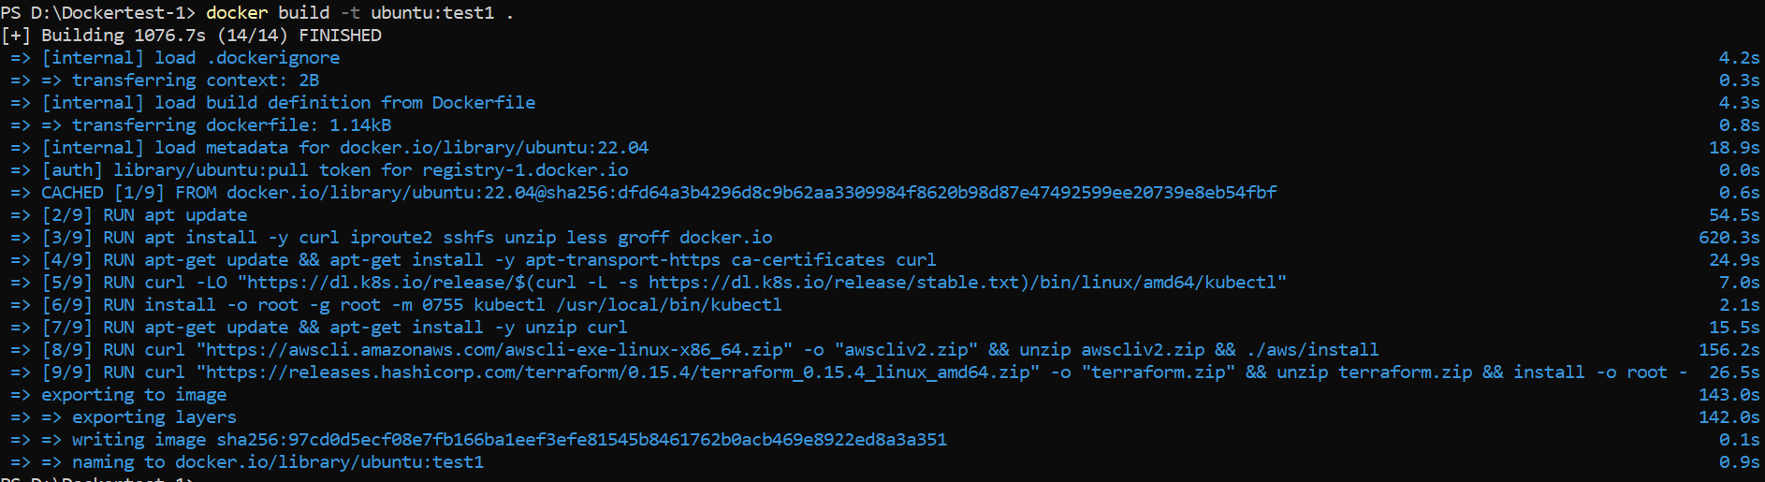

List of all Images



Created Container Named “testcontainer” based on the Image



List the Docker Containers



**Executing the container**

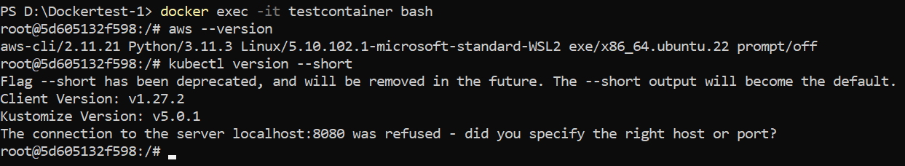

In Docker Desktop UI

