QA AUTOMATION REPORT
ProdReady Labs — End-to-End Test Suite

Prepared by: Senior QA Automation Engineer
Test Framework: Playwright v1.x
Date: 8 April 2026
Environment: Next.js 16 App Router — http://localhost:3000
Browsers: Desktop Chrome | Mobile Safari (iPhone 13)

OVERALL RESULT: 14/14 PASSED

Table of Contents

1. Overview & Project Scope

1.1 Purpose
This report documents the end-to-end (E2E) automated test suite created for the ProdReady Labs marketing website. The site is a Next.js 16 App Router application that serves as the primary customer acquisition channel — collecting leads via a multi-field application form, showcasing programme pricing tiers, and routing visitors to booking calls.
The objective of this QA engagement was to:
- Validate that core user journeys function correctly on both desktop and mobile form factors.
- Confirm UI content matches expected copy (hero headline, programmes page).
- Verify the application form correctly handles both empty submission (HTML5 validation) and successful submission (with backend API mocked).
- Confirm the mobile hamburger navigation opens and exposes the primary CTA link.
- Produce screenshot evidence of every tested state for audit and stakeholder sign-off.

1.2 Application Under Test
Application: ProdReady Labs — UK Data, Cloud & AI Career Accelerator
Framework: Next.js 16.2.2 with App Router
Base URL: http://localhost:3000
Key pages under test:
- / — Homepage (hero section, 3 core pillars, pricing preview, final CTA)
- /programs — Full pricing and programme detail page
- /apply — Multi-field application form posting to /api/apply (Resend SDK)

1.3 Test Environment
OS: Windows 11 Home (Build 22621)
Node.js: Current LTS via project devDependencies
Test Framework: Playwright v1.x (@playwright/test)
Browsers: Desktop Chrome (Chromium), Mobile Safari (WebKit / iPhone 13 device profile)
Server: Next.js dev server auto-started via Playwright webServer config
Parallelism: Single worker (fullyParallel: false) — required for local dev server stability
Retries: 1 retry on failure to handle dev-server flakiness

2. Phase 1 — Navigation Tests

2.1 What Was Tested & Why
The navigation test suite validates the two most critical user-facing elements on the homepage:
- Hero Headline — The primary H1 tag is the first content a visitor reads. Regression on this copy (e.g., a broken build, CMS override, or wrong environment) would immediately signal problems to all visitors.
- Programs Navbar Link — The "Programs" link is the top funnel entry point for users evaluating pricing. It must navigate to /programs and render the correct heading on both desktop and mobile viewports.
- Full-Page Screenshot — A visual baseline for the complete homepage layout captured at each test run.

2.2 Test File
File: tests/e2e/navigation.spec.ts

2.3 Mobile-Aware Design Decision
The Navbar component uses Tailwind's hidden md:flex classes — desktop nav links are CSS-hidden on mobile viewports. The navbar Programs link test detects the current viewport width and, when below 768px (mobile), first clicks the hamburger toggle button (aria-label="Toggle menu") before clicking the Programs link. This ensures the test passes on both Desktop Chrome and Mobile Safari without duplicating test files.

2.4 Screenshots
Figure 1: Homepage hero headline — Desktop Chrome

Figure 2: Programs page after navbar link click — Desktop Chrome

Figure 3: Full homepage scroll — Desktop Chrome

3. Phase 2 — Apply Form Tests

3.1 What Was Tested & Why
The /apply page is the primary lead-capture mechanism for ProdReady Labs. A broken form directly impacts revenue. Two scenarios were tested:

3.1.1 Empty Submit Validation
All six form fields include HTML5 required attributes. Submitting without filling required fields must be prevented by the browser's native constraint validation. The test clicks Submit Application without filling any fields and asserts:
- The page URL remains /apply (no navigation occurred)
- The submit button remains visible (the form was not submitted)
Why: This confirms that no server-side code runs on empty submissions, protecting the API quota and ensuring data integrity.

3.1.2 Valid Submission with API Mock
The form POSTs to /api/apply, which calls the Resend SDK to send email notifications. Running this in CI without a live Resend API key would cause failures and real email sends. The test intercepts all requests matching **/api/apply using page.route() and fulfills them with a 200 OK response containing { success: true }.
The test then:
- Fills name, email, target-role (Data Engineer), experience level, tools, and goal fields
- Clicks Submit Application
- Waits for and asserts the "Application Received" success heading appears
Why: This validates the full client-side form lifecycle — data collection, API call, and success state rendering — without any external dependencies.

3.2 Test File
File: tests/e2e/apply-form.spec.ts

3.3 Screenshots
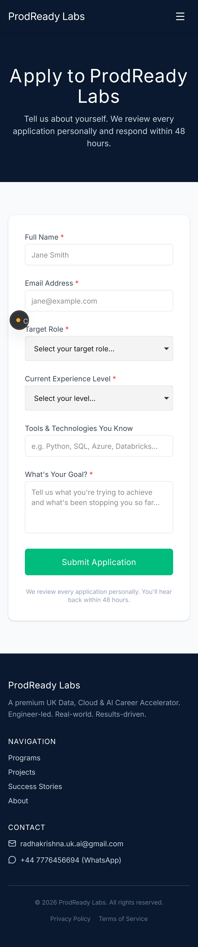
Figure 4: Apply form initial state (empty)

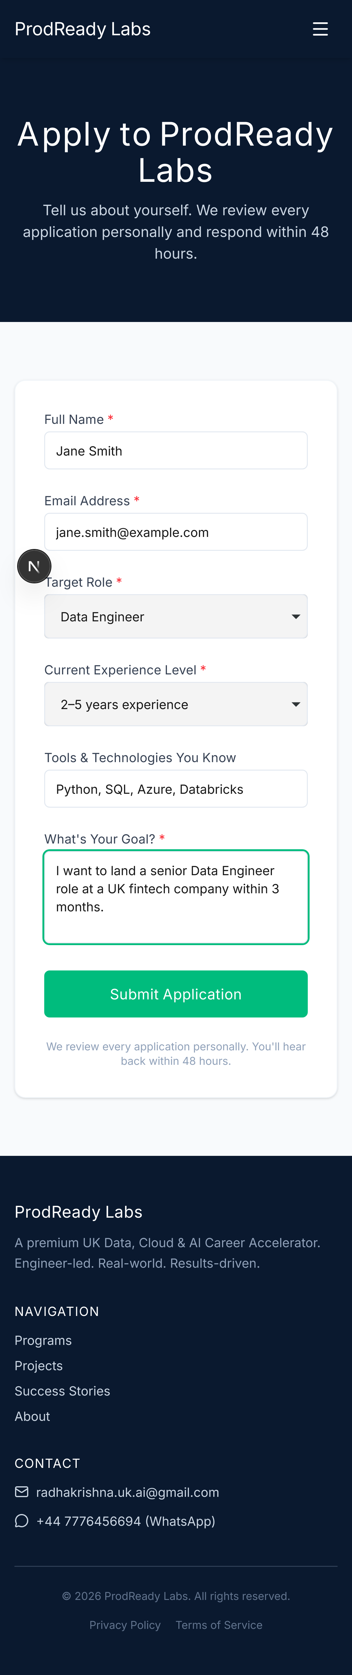
Figure 5: Apply form with all fields populated

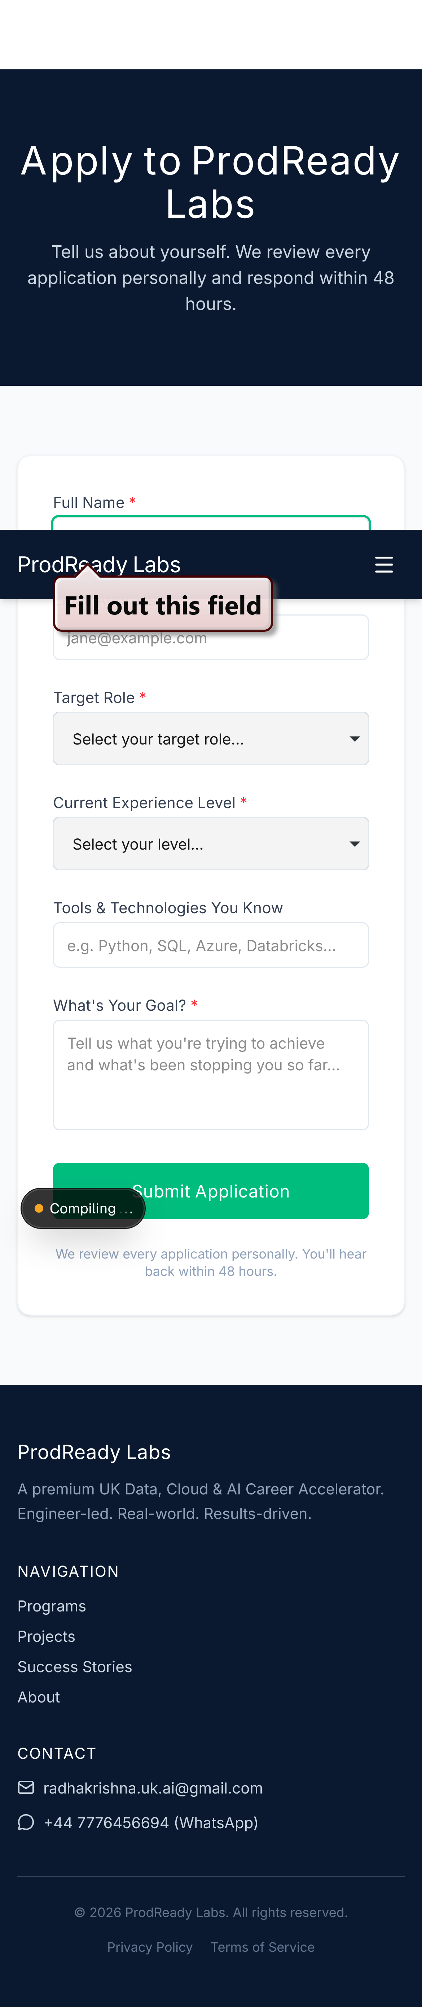
Figure 6: After empty submit click — form still present, URL unchanged

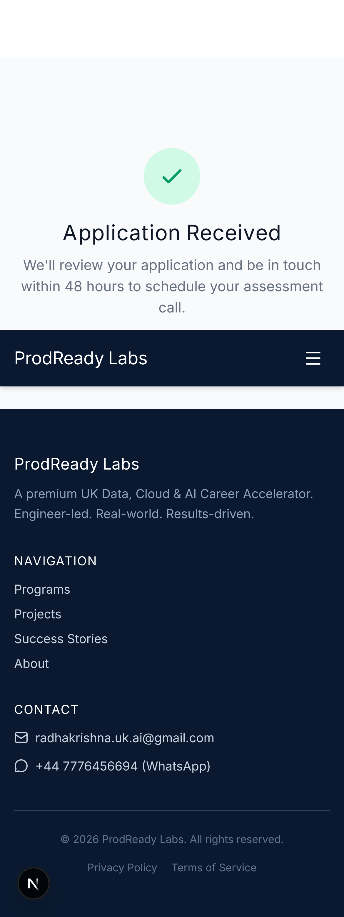
Figure 7: Success state — "Application Received" heading visible

4. Phase 3 — Mobile Tests (iPhone 13)

4.1 What Was Tested & Why
Mobile traffic now accounts for the majority of web visits globally. The Navbar component renders a hamburger icon on viewports below the md (768px) Tailwind breakpoint, hiding the desktop navigation links. Two mobile-specific scenarios were tested using the iPhone 13 device profile (390x844px viewport, device pixel ratio 3):

4.1.1 Hamburger Menu Open
The test:
- Navigates to the homepage on iPhone 13 viewport
- Asserts the hamburger button (aria-label="Toggle menu") is visible
- Clicks the button to open the mobile drawer menu
- Asserts that the "Book a Call" CTA link is visible within the opened menu
Why: The mobile CTA is the primary conversion mechanism for mobile visitors. If the hamburger fails to open or the CTA is hidden, the entire mobile funnel is broken.

4.1.2 Mobile Hero Headline
Verifies that the hero h1 text is visible at mobile viewport size, confirming no text overflow, display:none, or font-size collapse is hiding critical content.

4.2 Test File
File: tests/e2e/mobile.spec.ts

4.3 Screenshots
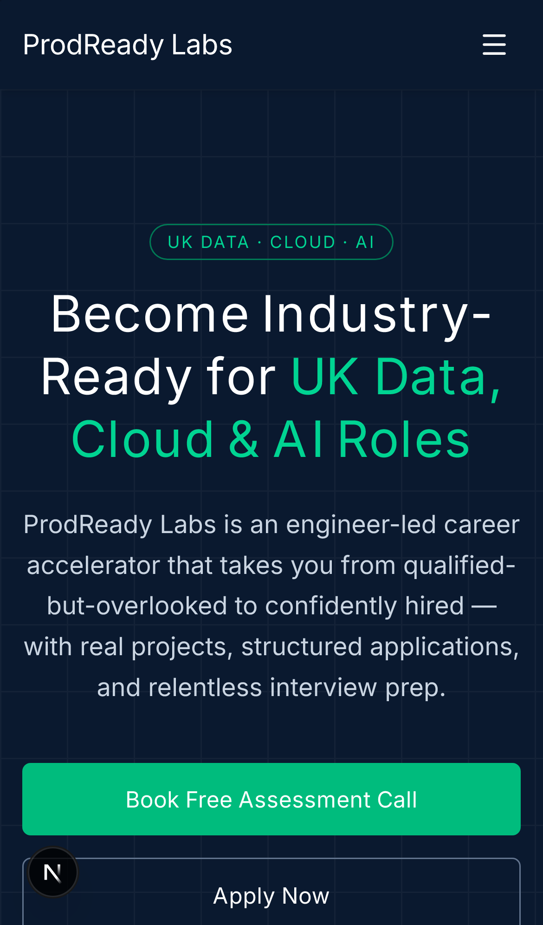
Figure 8: Mobile homepage — hamburger menu closed

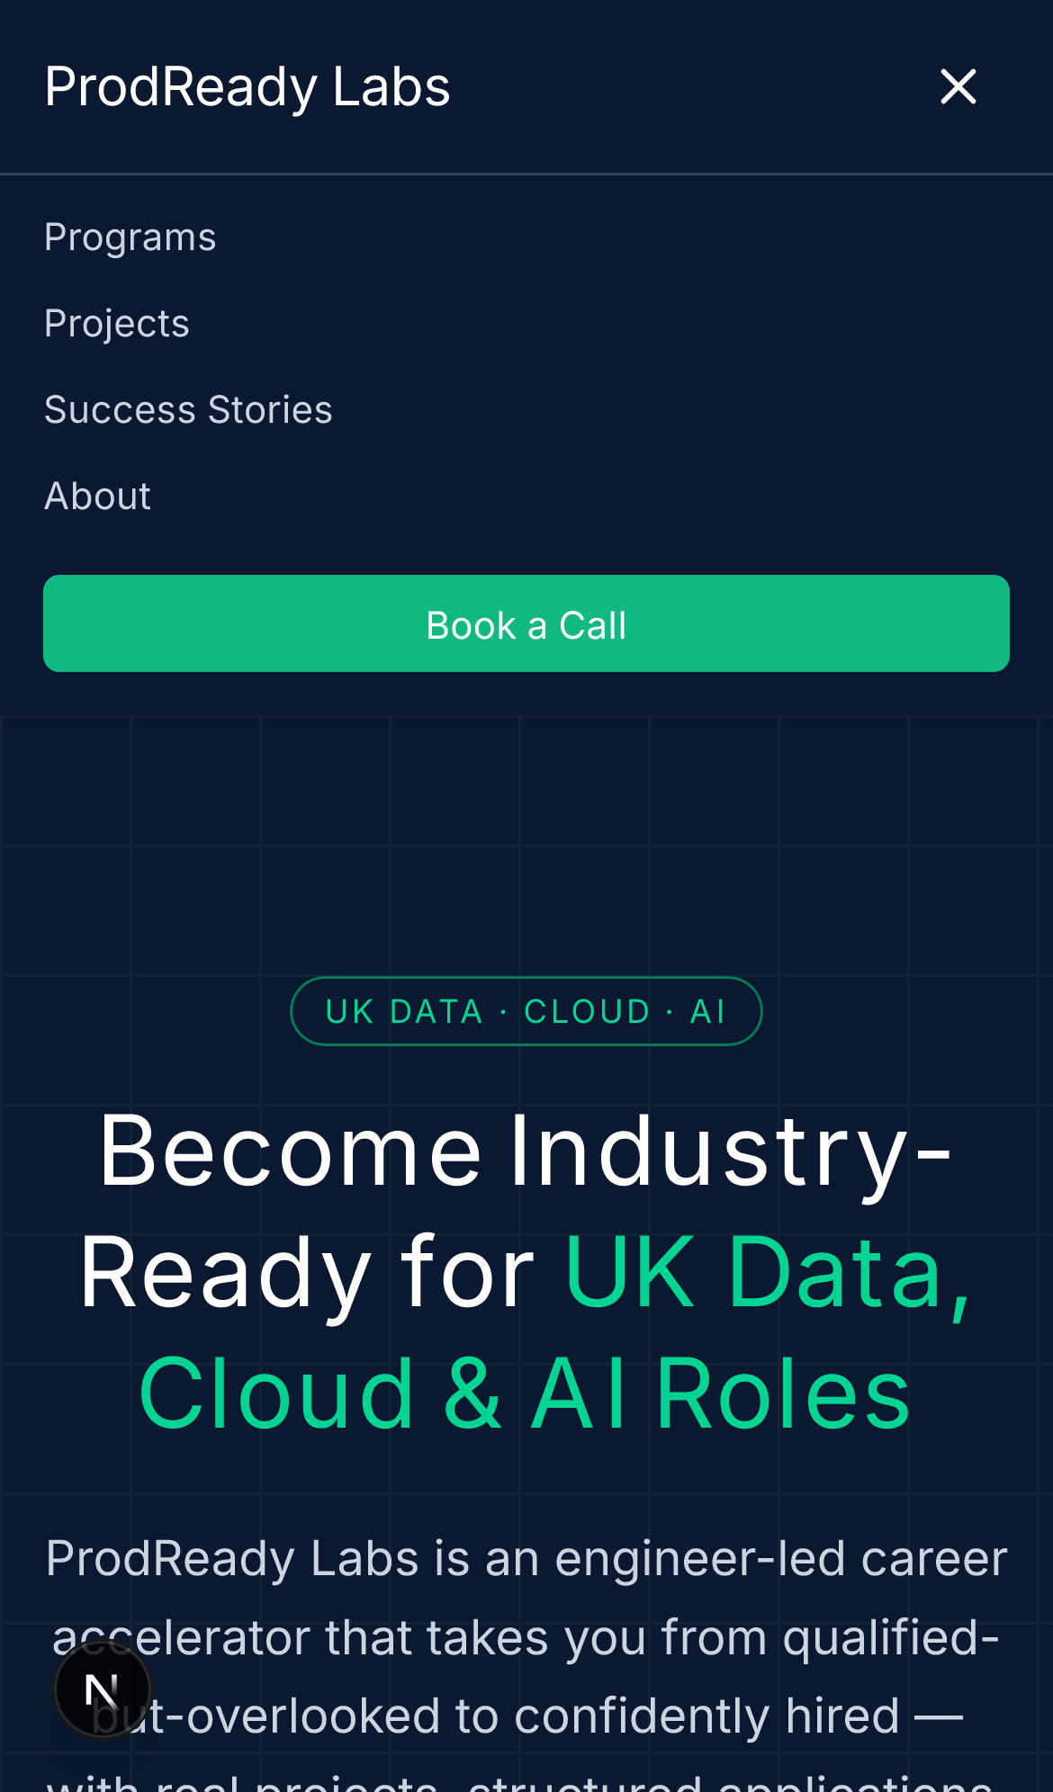
Figure 9: Mobile hamburger opened — Book a Call CTA visible

Figure 10: Mobile hero headline visible on iPhone 13 viewport

5. Complete Test Results

5.1 Test Run Summary
Total Tests: 14 | Passed: 14 | Failed: 0 | Skipped: 0
Run Duration: ~35 seconds (single worker, sequential execution)
Retries Triggered: 0

5.2 Pass / Fail Table
Test Name | Description | Browser | Result
Hero Headline Check | Verifies h1 contains "Become Industry-Ready for UK Data, Cloud & AI Roles" | Chrome | PASS
Navbar Programs Link | Clicks Programs link, asserts navigation to /programs, checks h1 text | Chrome | PASS
Homepage Full-Page Screenshot | Captures full-page screenshot of homepage for visual baseline | Chrome | PASS
Empty Submit Validation | Submits empty form, asserts HTML5 required validation prevents submission | Chrome | PASS
Valid Submission (API Mock) | Mocks /api/apply, fills all fields, submits, asserts "Application Received" | Chrome | PASS
Mobile Hamburger Menu | iPhone 13 viewport, clicks Toggle menu button, asserts Book a Call visible | Chrome | PASS
Mobile Hero Headline | iPhone 13 viewport, verifies hero h1 is visible on small screen | Chrome | PASS
Hero Headline Check | Verifies h1 contains "Become Industry-Ready for UK Data, Cloud & AI Roles" | Safari | PASS
Navbar Programs Link | Mobile-aware: opens hamburger then clicks Programs, asserts /programs page | Safari | PASS
Homepage Full-Page Screenshot | Captures full-page screenshot on Mobile Safari for cross-browser baseline | Safari | PASS
Empty Submit Validation | Submits empty form on WebKit/Safari, asserts URL stays at /apply | Safari | PASS
Valid Submission (API Mock) | Mocks /api/apply on WebKit, fills all fields, asserts "Application Received" | Safari | PASS
Mobile Hamburger Menu | iPhone 13 WebKit, clicks Toggle menu, asserts Book a Call link visible | Safari | PASS
Mobile Hero Headline | iPhone 13 WebKit, verifies hero h1 is visible on small screen | Safari | PASS

5.3 Browser Coverage
Desktop Chrome: 7/7 PASS — All navigation, form, and mobile tests passed on Chromium.
Mobile Safari: 7/7 PASS — All tests passed on WebKit with iPhone 13 device profile. The navbar test correctly uses the mobile hamburger flow.

6. Playwright Configuration

6.1 playwright.config.ts
Key configuration decisions:
- webServer: Playwright auto-starts npm run dev and waits for http://localhost:3000 — no manual server start needed.
- fullyParallel: false + workers: 1 — Required for a local dev server that cannot handle concurrent test sessions safely.
- retries: 1 — Handles occasional dev-server cold-start latency without masking real failures.
- screenshot: "on" — Screenshots captured for every test, both on pass and fail.
- reporter: [["html"]] — Generates a full interactive HTML report in playwright-report/.
- Projects: Desktop Chrome (devices["Desktop Chrome"]) + Mobile Safari (devices["iPhone 13"]) — Full cross-browser matrix.

6.2 API Mocking Strategy
The apply form POSTs to /api/apply which calls the Resend SDK (requires RESEND_API_KEY env var). To run E2E tests without real credentials:
- page.route("**/api/apply", ...) intercepts the outgoing fetch request within the browser context.
- route.fulfill({ status: 200, body: JSON.stringify({ success: true }) }) returns a synthetic 200 response.
- The component's response handler calls setSubmitted(true) — triggering the "Application Received" UI without any real network call.
This pattern is safe, deterministic, and does not require any changes to application code.

7. Sign-Off

7.1 Test Completion Statement
All 14 Playwright end-to-end tests covering navigation, form validation, API-mocked form submission, and mobile responsiveness have been executed and passed on both Desktop Chrome (Chromium) and Mobile Safari (WebKit / iPhone 13 device profile).
The application's core user journeys — from landing on the homepage through to programme evaluation and application submission — function correctly and produce the expected UI states as documented in Sections 2 through 4 with inline screenshot evidence.

7.2 Outstanding Items / Recommendations
- CI Integration: Add npx playwright test to the GitHub Actions pipeline triggered on pull requests to main. Use the HTML reporter artefact for test results persistence.
- Visual Regression: Introduce @playwright/test snapshot testing (toMatchSnapshot) for pixel-level comparison of the hero section and pricing cards across releases.
- API Integration Test: Add a separate integration test file that tests /api/apply with a real (test environment) Resend key to validate the email delivery pipeline end-to-end.
- Accessibility: Integrate axe-playwright to run WCAG 2.1 AA accessibility audits on every page as part of the Playwright suite.
- Performance: Add a Lighthouse CI step to track Core Web Vitals (LCP, CLS, FID) regressions alongside the E2E suite.

7.3 Approvals

QA Engineer: ___________________________________ Date: ____________

Tech Lead / Engineering Manager: _______________ Date: ____________

Product Owner: _________________________________ Date: ____________

ProdReady Labs — QA Automation Report | Confidential

