**Spring Boot User Validation Assignment 1**

**UsersController.java**

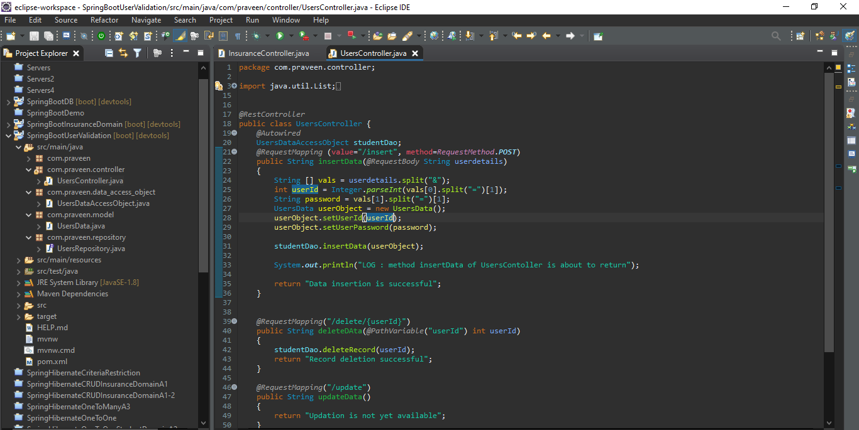

**UsersDataAccessObject.java**

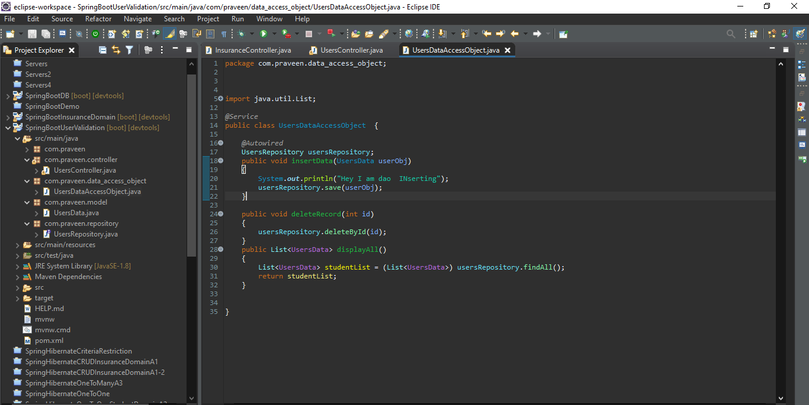

**UsersData.java**

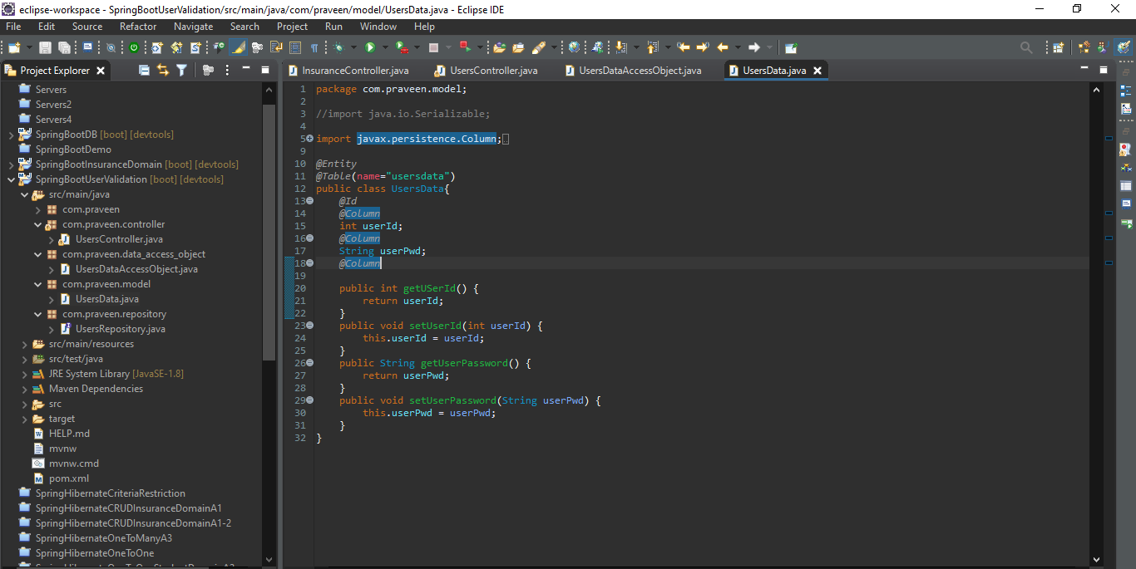

**UsersRepository.java**

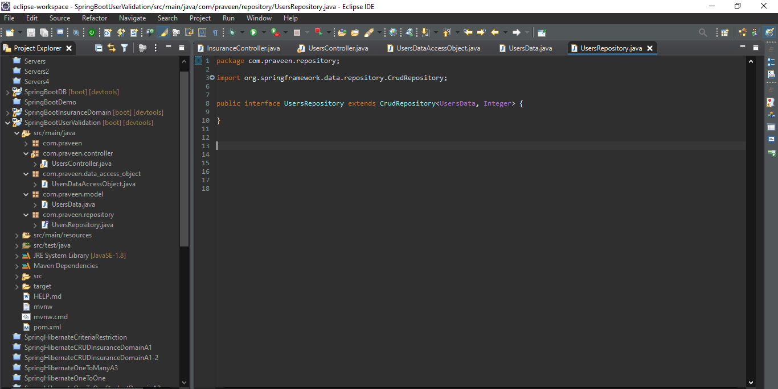

**PostMan Outputs**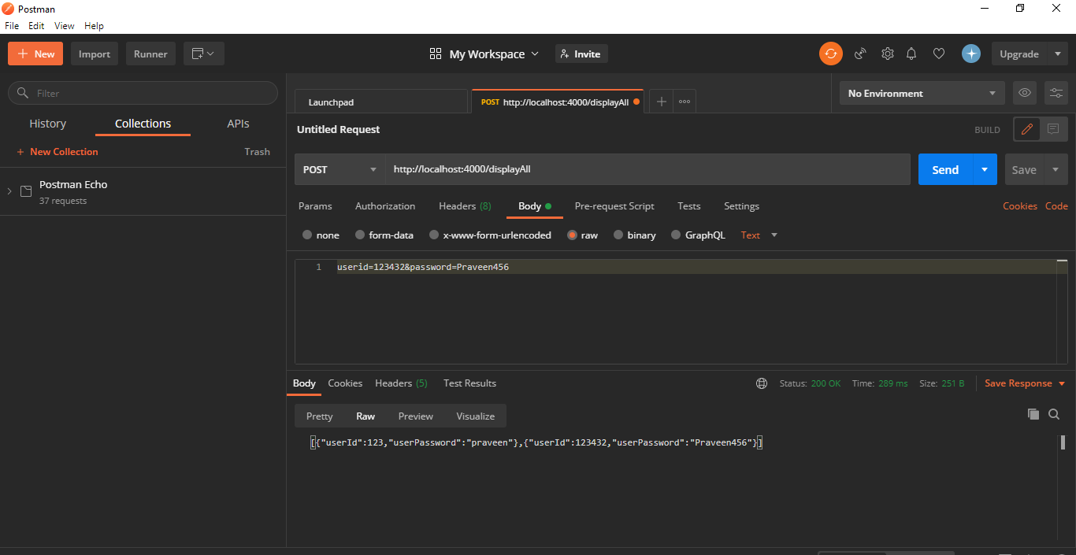

**Heidi Sql Database**

