YuvaIntern – Virtual Data Science with Python Trainee
TASK 3 REPORT
Unsupervised Learning and Clustering Analysis
Student Name | Praveenkumar Mokashi
Internship | Virtual Data Science with Python Trainee
Task | Week 3 – Unsupervised Learning and Clustering Analysis
Dataset | Iris Dataset
Algorithm | K-Means Clustering
Selected k | 2

1. Abstract
This report applies unsupervised learning to the public Iris dataset using K-Means clustering. The four numerical flower measurements are standardized and clustered without using the original species labels. Candidate values of k from 2 to 6 are compared using inertia and silhouette score. The selected K-Means model is then visualized with PCA, and each cluster is profiled using its mean feature values. The analysis demonstrates how unsupervised learning can discover meaningful segments without a target variable.

2. Objective
The objective is to select a public dataset appropriate for clustering, preprocess it, apply K-Means, justify the number of clusters, visualize the resulting groups, and interpret their characteristics and potential applications.

3. Dataset
The Iris dataset contains 150 observations and four numerical features: sepal length, sepal width, petal length, and petal width. It is suitable for clustering because the measurements can be used directly as feature vectors. The original species labels are excluded from model training and are used only for an optional external validation metric.
Feature | Unit | Use
sepal length (cm) | cm | Clustering feature
sepal width (cm) | cm | Clustering feature
petal length (cm) | cm | Clustering feature
petal width (cm) | cm | Clustering feature

4. Methodology
- Load the Iris dataset.
- Standardize all four numerical features.
- Test k = 2, 3, 4, 5, and 6.
- Compare inertia and silhouette score.
- Select the highest-silhouette solution.
- Train final K-Means with random_state=42 and n_init=10.
- Use PCA to visualize the four-dimensional clustering in two dimensions.
- Profile cluster sizes and mean feature values.

5. Preprocessing
Standardization is performed because K-Means is distance-based. StandardScaler converts each feature to approximately zero mean and unit variance, preventing a feature with greater spread from dominating Euclidean distance.
scaler = StandardScaler()\nX_scaled = scaler.fit_transform(X)

6. Selecting k
k | Inertia | Silhouette
2 | 222.36 | 0.582
3 | 139.82 | 0.460
4 | 114.09 | 0.387
5 | 90.93 | 0.346
6 | 81.54 | 0.317

7. Elbow Method
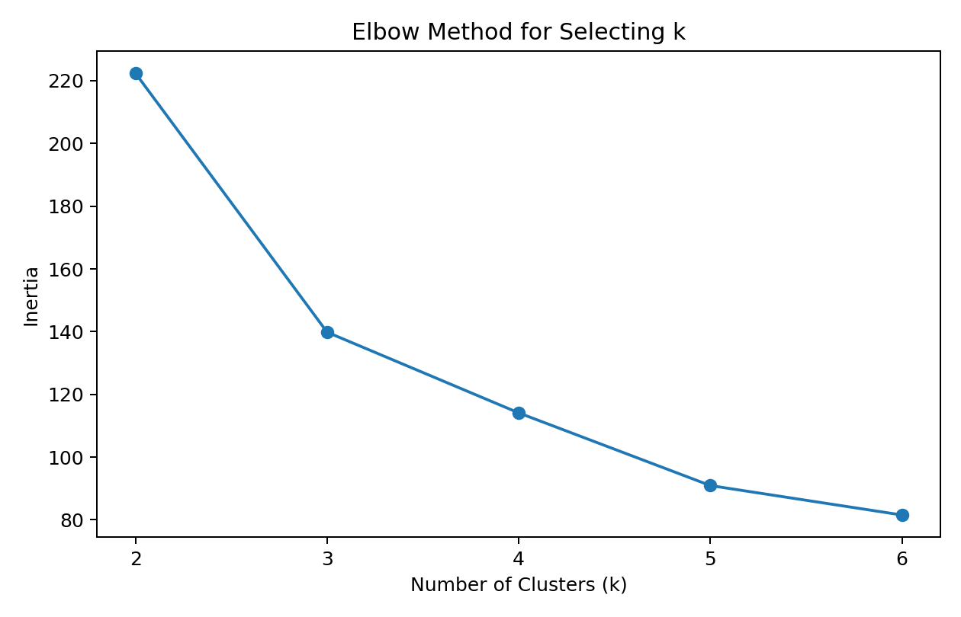
Inertia decreases as more clusters are added. The elbow method helps identify a point where additional clusters provide smaller improvements.

8. Silhouette Analysis
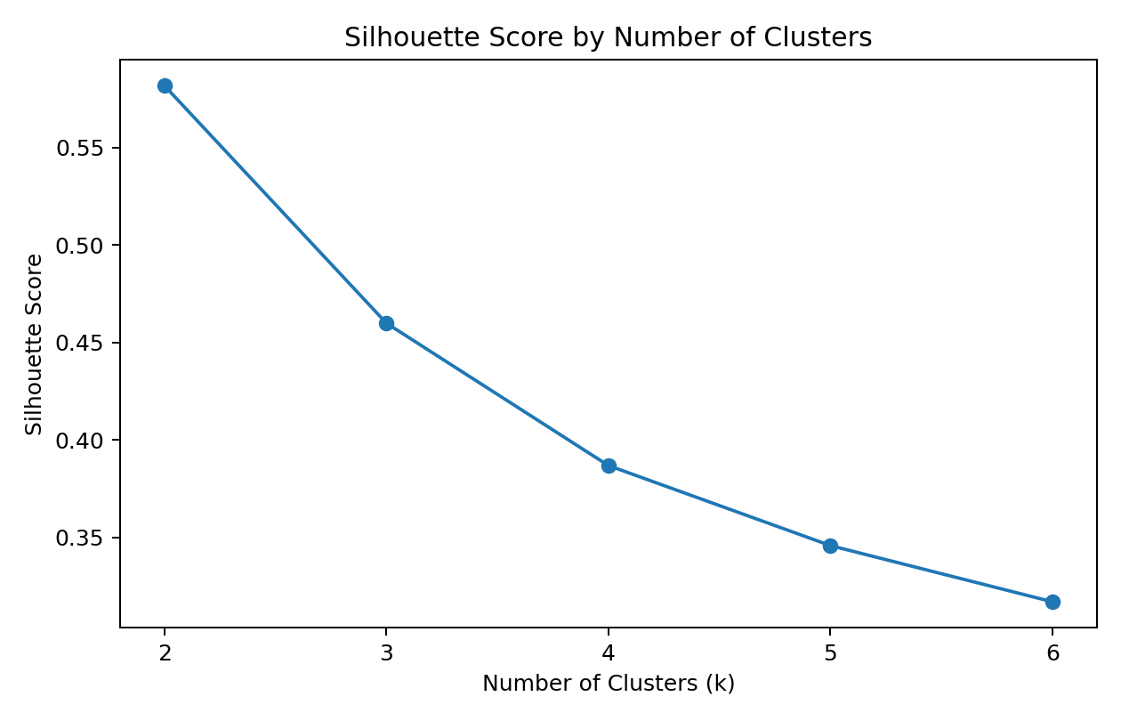
The highest tested silhouette score is 0.582 at k=2. Therefore k=2 is selected for the final model. Silhouette score measures how well observations fit their own cluster compared with neighbouring clusters.

9. Final K-Means Model
kmeans = KMeans(n_clusters=2, random_state=42, n_init=10)\nclusters = kmeans.fit_predict(X_scaled)
The fixed random seed improves reproducibility, while multiple initializations reduce dependence on one random starting configuration.

10. PCA Cluster Visualization
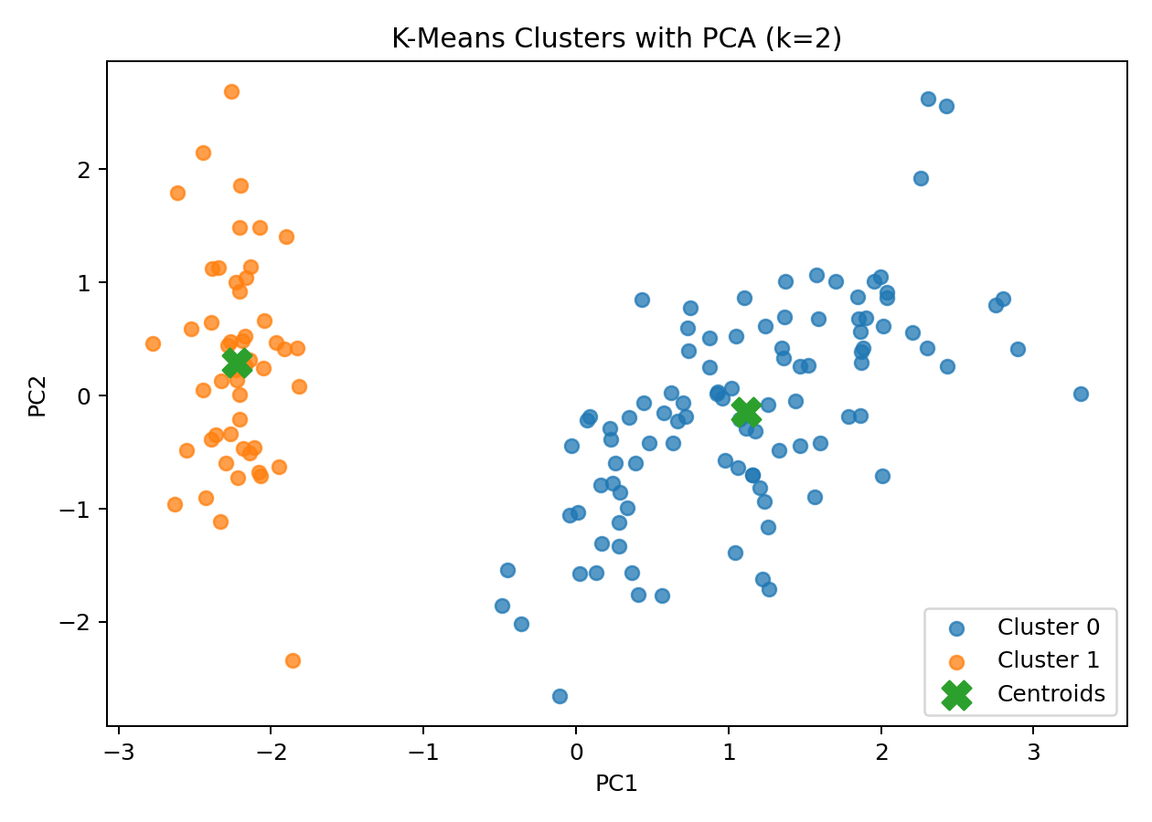
PCA reduces the standardized four-feature space to two principal components for visualization. PC1 explains 73.0% of variance and PC2 explains 22.9%, for 95.8% combined. The plot shows distinct regions with some overlap.

11. Cluster Sizes
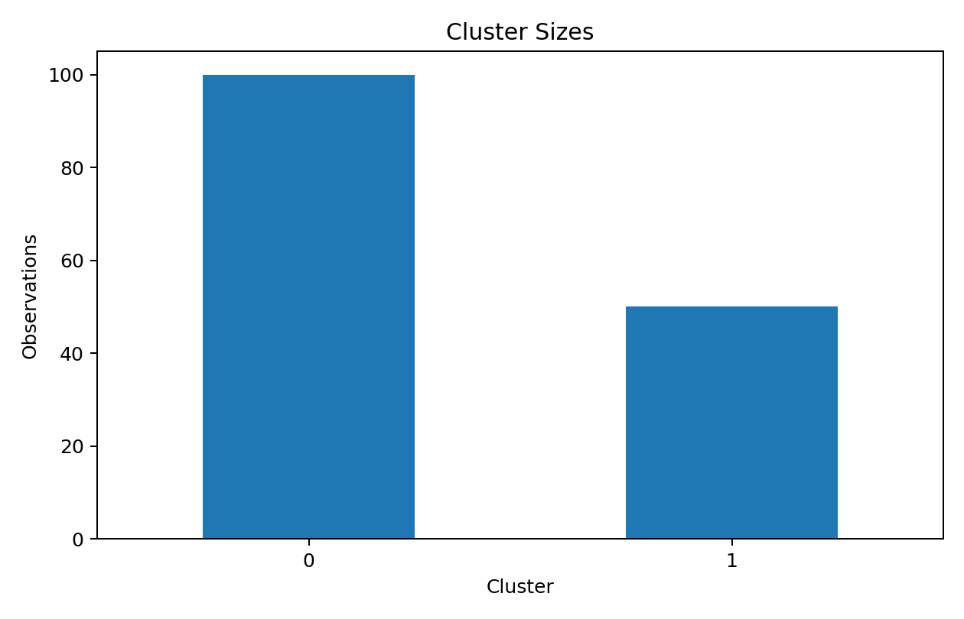
Cluster | Observations
0 | 100
1 | 50

12. Cluster Profiles
Cluster | Sepal length | Sepal width | Petal length | Petal width
0 | 6.26 | 2.87 | 4.91 | 1.68
1 | 5.01 | 3.43 | 1.46 | 0.25
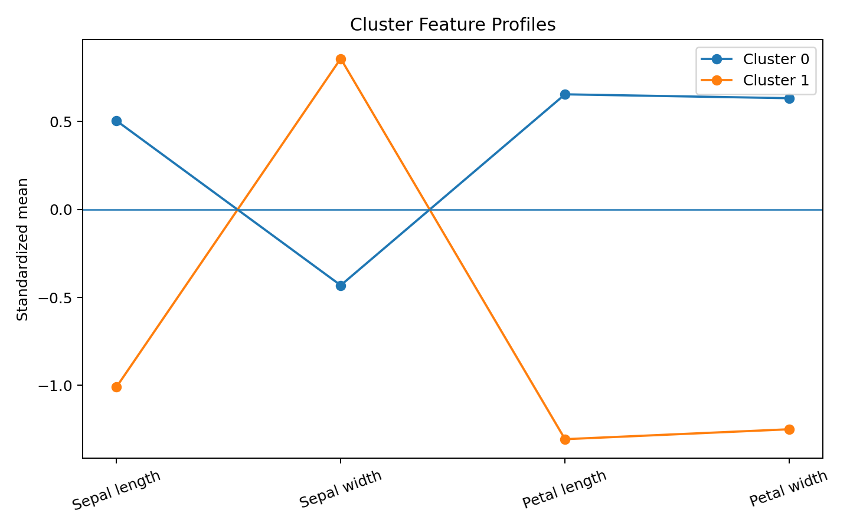
The cluster profiles reveal that the main separation is driven by petal measurements. One group has notably smaller petals, another has larger petals, and the remaining group is intermediate. This demonstrates how K-Means can create useful segments from feature similarity alone.

13. Interpretation of Clusters
Cluster 0 contains 100 observations. Mean sepal length = 6.26 cm, mean sepal width = 2.87 cm, mean petal length = 4.91 cm, and mean petal width = 1.68 cm. Its profile should be interpreted as a feature-based segment rather than a species label.
Cluster 1 contains 50 observations. Mean sepal length = 5.01 cm, mean sepal width = 3.43 cm, mean petal length = 1.46 cm, and mean petal width = 0.25 cm. Its profile should be interpreted as a feature-based segment rather than a species label.

14. Optional External Validation
The original species labels were not used during training. For diagnostic comparison only, the Adjusted Rand Index is 0.568. This is not model accuracy; it measures agreement between discovered clusters and the known labels after clustering.

15. Business / Research Implications
The same workflow can be transferred to customer segmentation, product grouping, network-event segmentation, or biological sample classification. A practical deployment would profile each cluster, determine whether the segment is actionable, and then monitor whether the cluster structure remains stable over time.

16. Limitations
- K-Means is distance-based and can be sensitive to scaling and initialization.
- The Iris dataset is small and relatively clean compared with production datasets.
- PCA is only used for visualization; clustering uses all four standardized features.
- Cluster numbers are arbitrary identifiers.
- The known species labels were deliberately excluded from training.

17. Conclusion
This task demonstrates an end-to-end unsupervised learning workflow. Standardization prepares the features, multiple k values are compared, and k=2 is selected based on the strongest tested silhouette score. PCA visualization and cluster profiles make the discovered segments interpretable. The project demonstrates the central idea of clustering: discovering structure without supplying a target label.

18. References
- Scikit-learn KMeans documentation: https://scikit-learn.org/stable/modules/generated/sklearn.cluster.KMeans.html
- Scikit-learn silhouette_score documentation: https://scikit-learn.org/stable/modules/generated/sklearn.metrics.silhouette_score.html
- Scikit-learn Iris dataset documentation: https://scikit-learn.org/stable/modules/generated/sklearn.datasets.load_iris.html
- Scikit-learn StandardScaler documentation: https://scikit-learn.org/stable/modules/generated/sklearn.preprocessing.StandardScaler.html
- Scikit-learn PCA documentation: https://scikit-learn.org/stable/modules/generated/sklearn.decomposition.PCA.html

Appendix A – Complete Python Code
from sklearn.datasets import load_iris
from sklearn.preprocessing import StandardScaler
from sklearn.cluster import KMeans
from sklearn.metrics import silhouette_score, adjusted_rand_score
from sklearn.decomposition import PCA
import pandas as pd
import matplotlib.pyplot as plt
iris = load_iris()
X = pd.DataFrame(iris.data, columns=iris.feature_names)
y = iris.target
scaler = StandardScaler()
X_scaled = scaler.fit_transform(X)
results = []
for k in range(2, 7):
model = KMeans(n_clusters=k, random_state=42, n_init=10)
labels = model.fit_predict(X_scaled)
results.append([k, model.inertia_, silhouette_score(X_scaled, labels)])
metrics = pd.DataFrame(results, columns=["k","inertia","silhouette_score"])
best_k = int(metrics.loc[metrics["silhouette_score"].idxmax(),"k"])
kmeans = KMeans(n_clusters=best_k, random_state=42, n_init=10)
clusters = kmeans.fit_predict(X_scaled)
df = X.copy()
df["cluster"] = clusters
print("Dataset shape:", X.shape)
print("\nK selection:")
print(metrics)
print("\nCluster sizes:")
print(df["cluster"].value_counts().sort_index())
print("\nCluster profiles:")
print(df.groupby("cluster")[iris.feature_names].mean().round(2))
pca = PCA(n_components=2)
X_pca = pca.fit_transform(X_scaled)
plt.figure(figsize=(8,5))
for c in sorted(df["cluster"].unique()):
mask=df["cluster"]==c
plt.scatter(X_pca[mask,0],X_pca[mask,1],label=f"Cluster {c}")
centers=pca.transform(kmeans.cluster_centers_)
plt.scatter(centers[:,0],centers[:,1],marker="X",s=180,label="Centroids")
plt.title(f"K-Means Clusters with PCA (k={best_k})")
plt.xlabel("Principal Component 1")
plt.ylabel("Principal Component 2")
plt.legend(); plt.tight_layout(); plt.show()
print("\nOptional external comparison (labels not used for training):")
print("Adjusted Rand Index:", round(adjusted_rand_score(y,clusters),3))
df.to_csv("task3_iris_clustered.csv",index=False)
metrics.to_csv("task3_k_selection_metrics.csv",index=False)
df.groupby("cluster")[iris.feature_names].mean().round(2).to_csv("task3_cluster_profiles.csv")

