YuvaIntern Task 5 – Deep Learning Application in Data Science
Handwritten Digit Recognition using a Neural Network

1. Abstract
This project demonstrates a practical neural-network approach to handwritten digit classification. A public handwritten-digits dataset available through scikit-learn was used. Each image is represented as an 8×8 grayscale image with 64 pixel features, and the target is one of ten digits from 0 to 9. The data was normalized and divided into training and testing sets. A multilayer perceptron neural network with two hidden layers was trained using the Adam optimizer and ReLU activation. Early stopping was enabled to reduce unnecessary training and help control overfitting. Performance was assessed with accuracy, precision, recall, F1-score, and a confusion matrix.

2. Problem Statement
The problem is to automatically recognize a handwritten digit from its pixel values. This is a multiclass classification problem with ten possible outputs (0–9). The project demonstrates how a neural network can learn patterns in image pixels and use them to make predictions on previously unseen images.

3. Dataset
The public scikit-learn Digits dataset contains 1,797 labeled grayscale images of handwritten digits. Each image is 8×8 pixels, resulting in 64 numerical input features. Pixel values range from 0 to 16 and were divided by 16 so the model receives values in the 0–1 range.

4. Data Preparation
The images were represented as flattened 64-value vectors. Pixel normalization was applied to place all inputs on a compact and consistent scale. The data was split into 80% training and 20% testing data using a stratified split, preserving the distribution of the ten digit classes.

5. Neural Network Architecture
The selected architecture is a compact feed-forward neural network: an input layer with 64 pixel values, a first dense hidden layer with 128 neurons, a second dense hidden layer with 64 neurons, and a 10-class output layer. ReLU activation was used in hidden layers. The model used Adam optimization with a learning rate of 0.001 and batch size 32. Early stopping was enabled with a validation fraction of 15%.
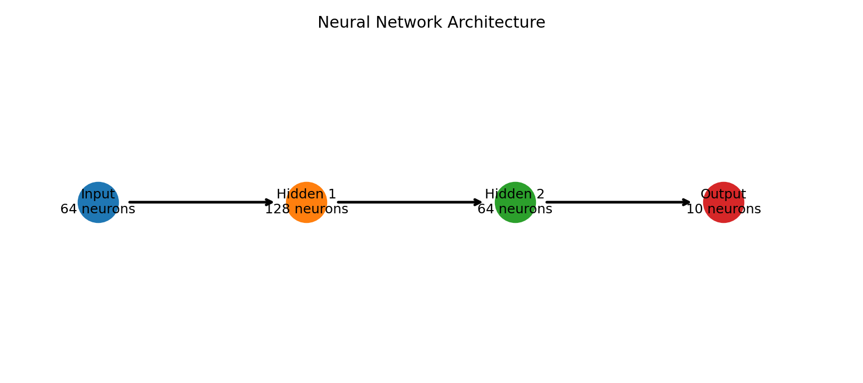

6. Training Process
The model learned the relationship between pixel patterns and digit labels from the training set. During training, the optimizer updated the network weights to reduce classification loss. A validation subset was monitored automatically, and early stopping stopped training when validation performance stopped improving.
Core model configuration:
MLPClassifier(hidden_layer_sizes=(128, 64), activation='relu', solver='adam', batch_size=32, learning_rate_init=0.001, early_stopping=True)

7. Evaluation Metrics
The model achieved 0.975 test accuracy, with weighted precision of 0.975, weighted recall of 0.975, and weighted F1-score of 0.975. Training stopped after 23 iterations.
Metric | Value
Accuracy | 0.975
Weighted Precision | 0.975
Weighted Recall | 0.975
Weighted F1-Score | 0.975
Training Iterations | 23.000

8. Confusion Matrix
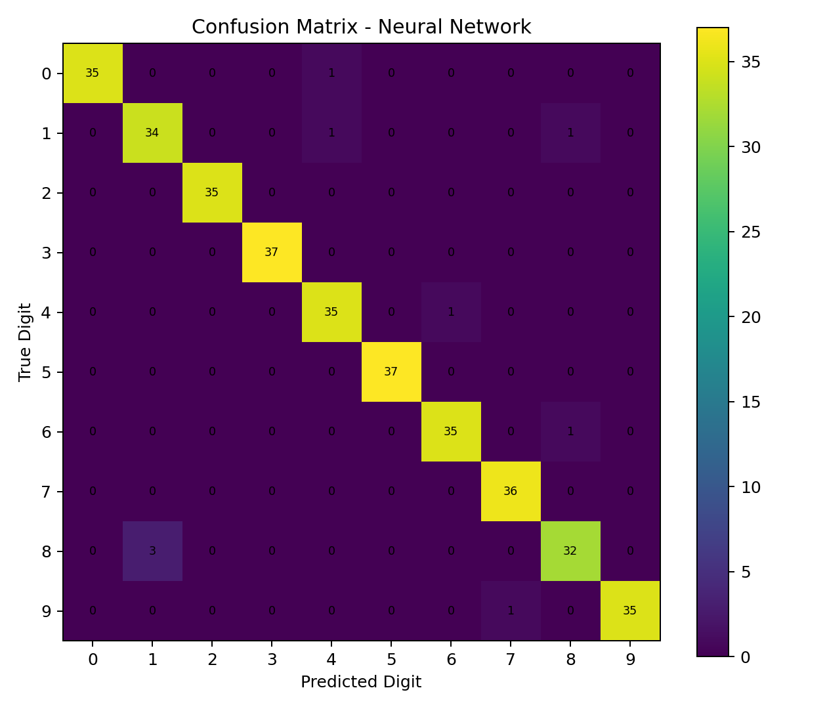
The confusion matrix shows which digits were correctly recognized and which pairs were confused. Most correct predictions appear along the diagonal, while off-diagonal entries highlight visually similar handwritten patterns that are harder for the network to distinguish.

9. Training and Validation Behavior
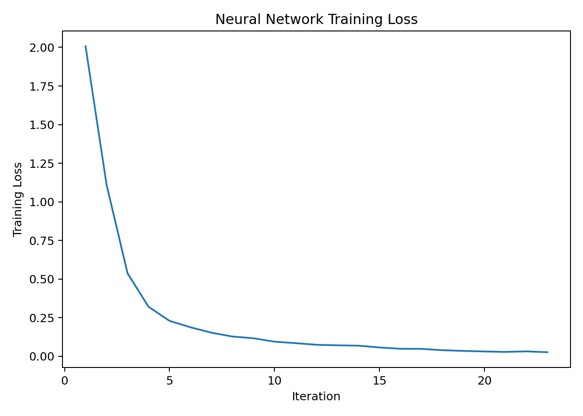
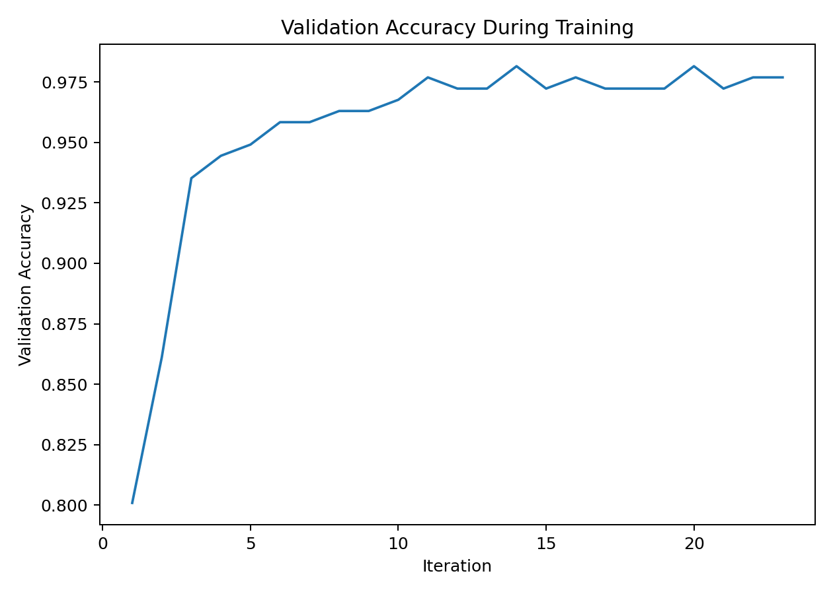
The training curves provide a view of how learning progressed. Early stopping was used as a practical control against overfitting and unnecessary computation.

10. Sample Images
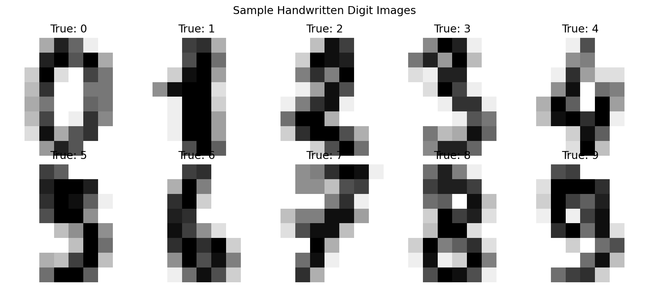

11. Class Distribution
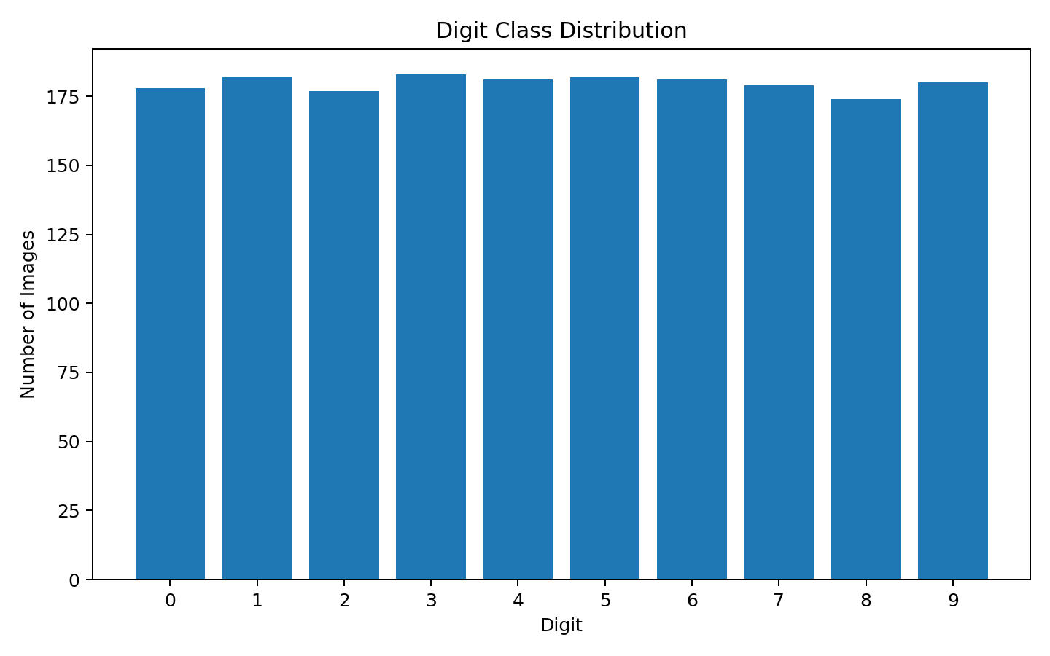
The classes are reasonably represented, which supports balanced evaluation of the ten-class classification task.

12. Challenges and Solutions
- Overfitting risk: early stopping and a validation subset were used to stop training when validation performance stopped improving.
- Different pixel scales: pixel values were normalized from 0–16 to 0–1 before training.
- Resource constraints: the network was kept compact (128 and 64 hidden neurons) so it can train quickly on a normal computer.
- Class confusion: the confusion matrix was used to identify digit pairs that are more difficult to distinguish.

13. Strengths
- Uses a genuine neural-network model for image classification.
- Simple architecture that is easy to understand and reproduce.
- Normalization improves numerical stability during training.
- Early stopping helps control overfitting and training time.
- Multiple evaluation metrics provide a broader view than accuracy alone.

14. Limitations
- The images are only 8×8 pixels, so this is much simpler than real-world image recognition.
- A feed-forward network does not explicitly exploit spatial structure the way a CNN does.
- The dataset is relatively small compared with modern deep-learning datasets.
- Results on this clean benchmark may not transfer directly to noisy handwritten images.

15. Possible Improvements
- Use a Convolutional Neural Network (CNN) to learn spatial image features.
- Apply hyperparameter tuning to hidden-layer sizes, learning rate, and regularization.
- Use data augmentation for more varied handwriting examples.
- Test the final architecture on a larger dataset such as MNIST.

16. Conclusion
The project demonstrates the main stages of a deep-learning workflow: selecting a public dataset, preparing image data, designing a neural network, training it, evaluating predictions, and analyzing challenges. The compact neural network achieved strong performance on the handwritten-digit benchmark while remaining lightweight enough for beginner experimentation. The project also shows why validation, normalization, and careful evaluation are important when developing neural-network models.

17. References
Scikit-learn documentation – Digits dataset and MLPClassifier.
Public handwritten digit recognition benchmark documentation.

18. Complete Python Code
"""
YuvaIntern Task 5 - Deep Learning Application in Data Science

Project: Handwritten Digit Recognition
Framework-style approach: Neural Network / MLP using scikit-learn.
Dataset: Public sklearn Digits dataset (8x8 grayscale handwritten digits).
"""

import pandas as pd
from sklearn.datasets import load_digits
from sklearn.model_selection import train_test_split
from sklearn.neural_network import MLPClassifier
from sklearn.metrics import (
accuracy_score, precision_score, recall_score, f1_score,
classification_report, confusion_matrix
)

# 1. Load public handwritten-digit dataset
digits = load_digits()
X = digits.data / 16.0 # normalize pixel values from 0-16 to 0-1
y = digits.target

# 2. Split into training and testing sets
X_train, X_test, y_train, y_test = train_test_split(
X, y, test_size=0.20, random_state=42, stratify=y
)

# 3. Build neural network
model = MLPClassifier(
hidden_layer_sizes=(128, 64),
activation="relu",
solver="adam",
alpha=1e-4,
batch_size=32,
learning_rate_init=0.001,
max_iter=100,
early_stopping=True,
validation_fraction=0.15,
n_iter_no_change=8,
random_state=42
)

# 4. Train
model.fit(X_train, y_train)

# 5. Predict
y_pred = model.predict(X_test)

# 6. Evaluate
print("Accuracy:", accuracy_score(y_test, y_pred))
print("Weighted Precision:", precision_score(y_test, y_pred, average="weighted"))
print("Weighted Recall:", recall_score(y_test, y_pred, average="weighted"))
print("Weighted F1:", f1_score(y_test, y_pred, average="weighted"))

print("\nClassification Report:")
print(classification_report(y_test, y_pred))

print("\nConfusion Matrix:")
print(confusion_matrix(y_test, y_pred))

print("\nTraining iterations:", model.n_iter_)

