YuvaIntern – Virtual Data Science with Python Trainee
TASK 2 REPORT
Exploratory Data Analysis and Visualization
Student Name | Praveenkumar Mokashi
Internship | Virtual Data Science with Python Trainee
Task | Week 2 – Exploratory Data Analysis and Visualization
Dataset | Palmer Penguins
Dataset Size | 344 rows × 8 columns
Libraries | Pandas, Matplotlib, Seaborn

1. Abstract
This report presents an exploratory data analysis of the Palmer Penguins dataset. The analysis examines the dataset structure, missing values, species distribution, numerical summaries, relationships among physical measurements, correlations, group-level differences, and potential anomalies. Pandas is used for data loading and transformation, while Matplotlib and Seaborn are used for visualization. The dataset contains 344 penguins across three species and three islands, with eight variables. The analysis combines univariate, bivariate, correlation, and aggregation-based approaches so that the findings can be interpreted rather than simply displayed.

2. Objective
The objective of this task is to perform EDA on a suitable public dataset, summarize important characteristics, create multiple properly annotated visualizations, identify patterns and anomalies, and explain the transformations or aggregations used during the analysis.

3. Dataset Selection and Source
The Palmer Penguins dataset was selected because it contains a mixture of categorical and continuous variables and is specifically intended as an introductory dataset for data exploration and visualization. The official project documentation describes 344 penguins, three species, three islands, and eight variables. The dataset includes bill dimensions, flipper length, body mass, sex, and study year. citeturn0search0turn0search12
Official source: Allison Horst, Alison Hill, and Kristen Gorman, palmerpenguins. The public repository provides the simplified penguins.csv file and states that the data are available under a CC0 license. citeturn0search3

4. Dataset Structure
Variable | Type | Description
species | Categorical | Adelie, Chinstrap, Gentoo
island | Categorical | Biscoe, Dream, Torgersen
bill_length_mm | Numerical | Bill length in millimetres
bill_depth_mm | Numerical | Bill depth in millimetres
flipper_length_mm | Numerical | Flipper length in millimetres
body_mass_g | Numerical | Body mass in grams
sex | Categorical | Female, male, or missing
year | Numerical | Study year: 2007–2009

5. Initial Analysis and Basic Statistics
The dataset contains 344 records. Species counts are Adelie = 152, Chinstrap = 68, and Gentoo = 124. The official project documentation provides these counts and the corresponding species-level means. citeturn4search2
Species | Records | Mean flipper (mm) | Mean body mass (g)
Adelie | 152 | 190 | 3701
Chinstrap | 68 | 196 | 3733
Gentoo | 124 | 217 | 5076
Across all observations, the numerical variables have the following published descriptive statistics: bill length mean 43.92 mm, bill depth mean 17.15 mm, flipper length mean 200.92 mm, and body mass mean 4201.75 g. The standard deviations are 5.46 mm, 1.97 mm, 14.06 mm, and 801.95 g respectively. citeturn4search13

6. Missing-Value Analysis
The curated dataset contains 333 complete cases and 19 missing values in total. Missing values occur mainly in the measurement fields and sex. The published data summary reports 2 missing values for each of the four main measurement variables and 11 missing sex values. citeturn0search0turn4search13
Variable | Missing values
bill_length_mm | 2
bill_depth_mm | 2
flipper_length_mm | 2
body_mass_g | 2
sex | 11
For EDA, categorical missing sex values are labelled 'Unknown'. For plots that require a complete body-mass value, the median is used in the analysis copy. This is documented explicitly so that the original dataset remains unchanged.

7. Visualization 1 – Species Distribution
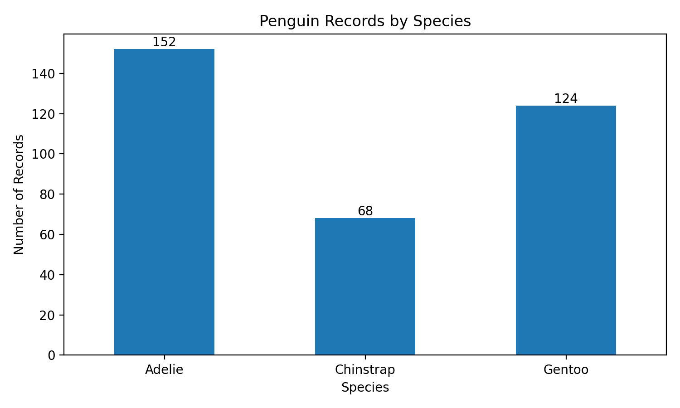
Interpretation: Adelie is the largest group with 152 records, Gentoo has 124, and Chinstrap has 68. These are the sample counts in this dataset and should not be interpreted as population abundance in Antarctica.

8. Visualization 2 – Mean Body Mass by Species
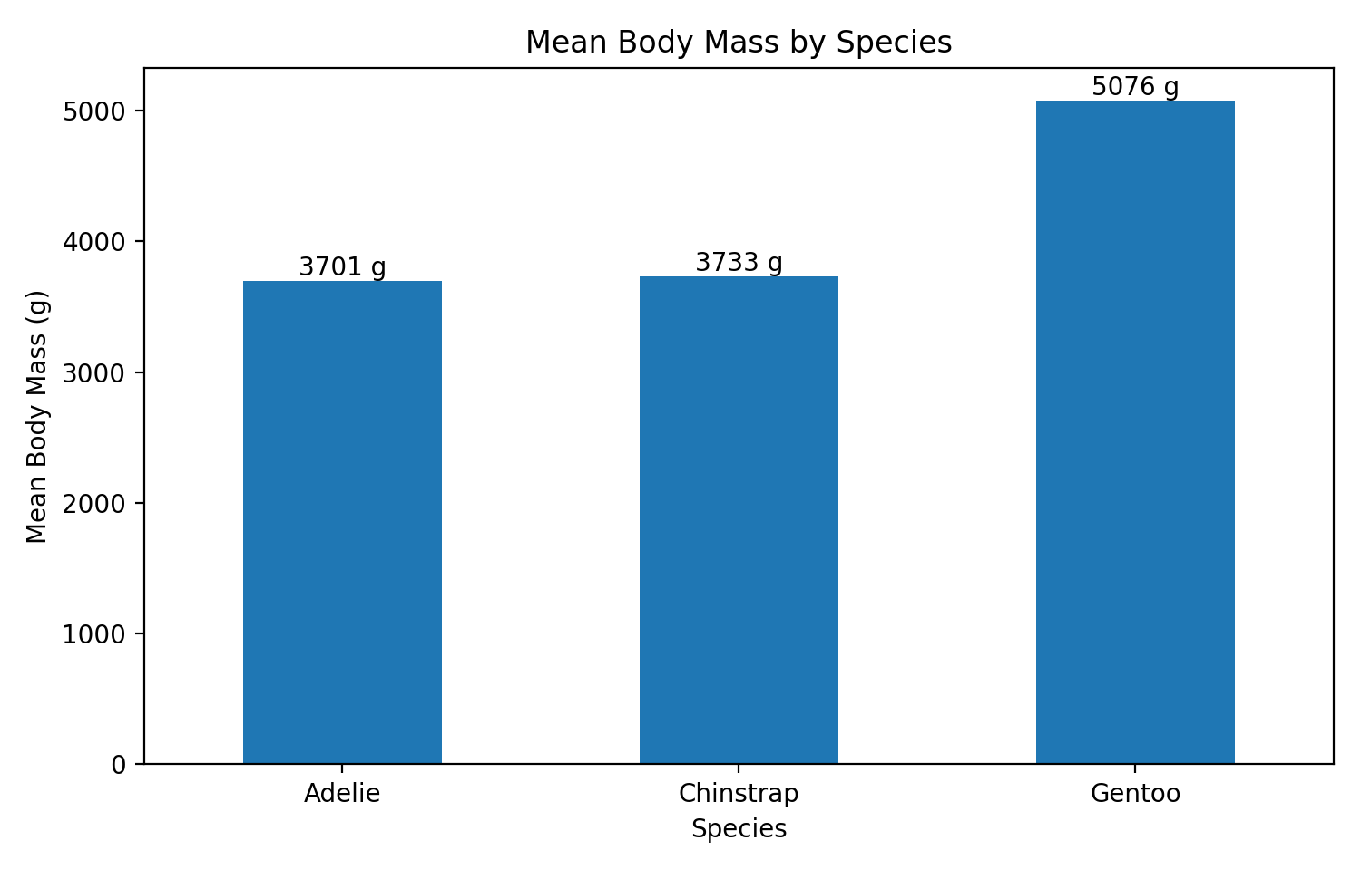
Interpretation: Gentoo has a substantially higher mean body mass (about 5076 g) than Adelie (about 3701 g) and Chinstrap (about 3733 g). This is one of the clearest group-level differences in the dataset. The large difference suggests that body mass is a useful feature for distinguishing species in subsequent modelling tasks. citeturn4search2

9. Visualization 3 – Mean Flipper Length by Species
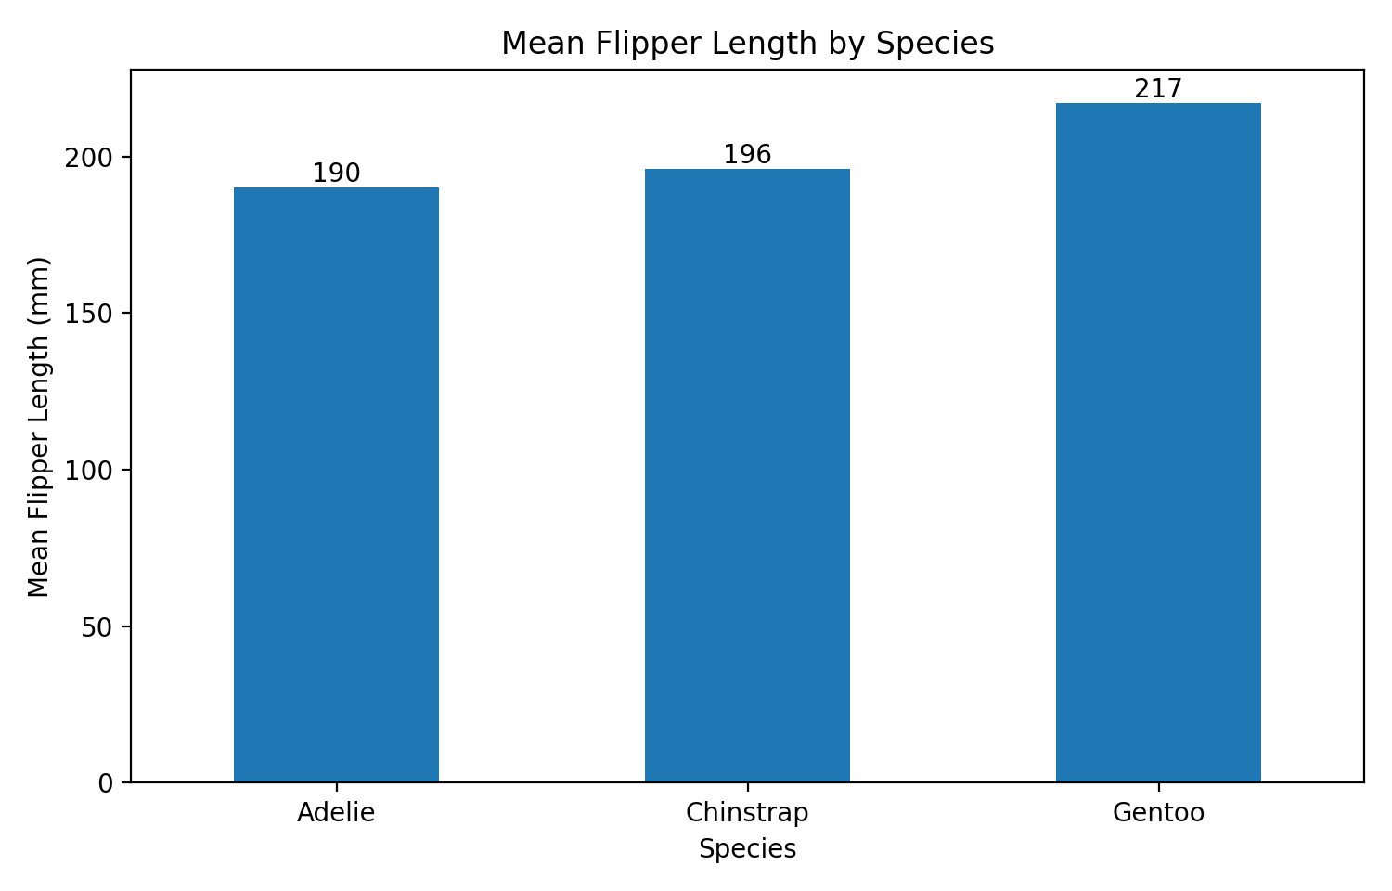
Interpretation: Gentoo has the longest average flipper length at approximately 217 mm, compared with 196 mm for Chinstrap and 190 mm for Adelie. The pattern is consistent with the difference in body size between Gentoo and the other species. citeturn4search2

10. Visualization 4 – Correlation Matrix
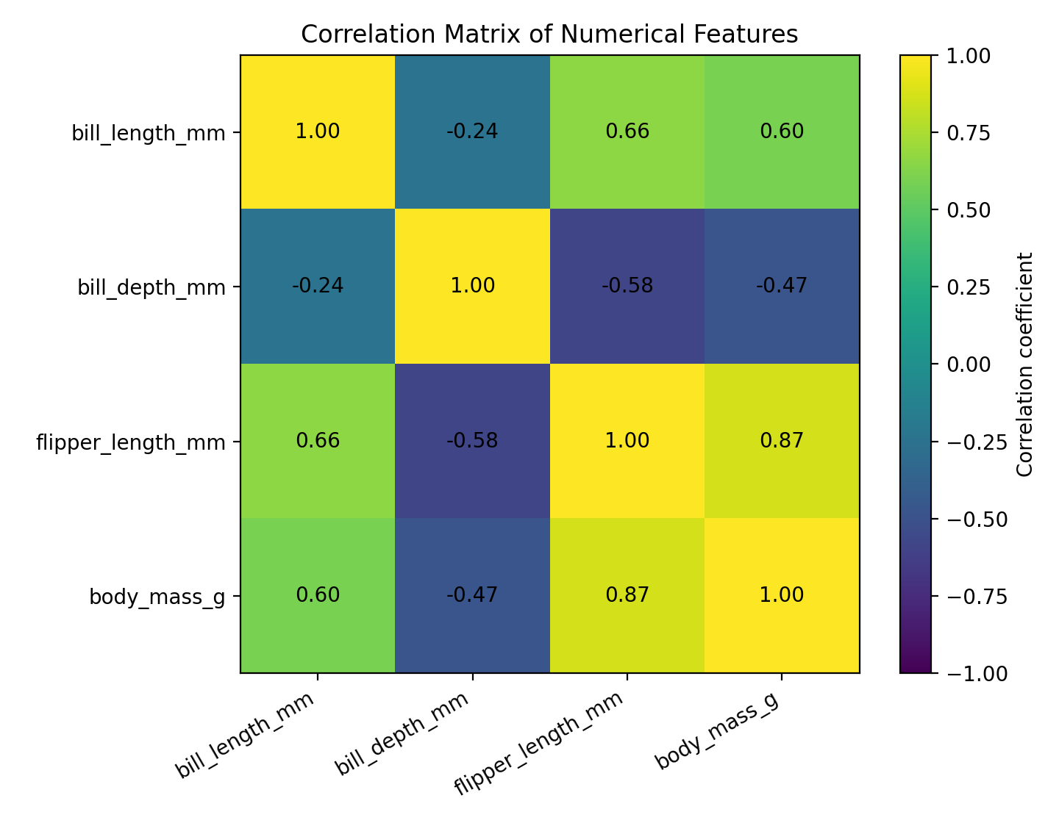
Interpretation: flipper length and body mass have the strongest positive correlation, approximately 0.87. Bill length is positively related to flipper length (about 0.66) and body mass (about 0.60). Bill depth has negative correlations with flipper length (about -0.58) and body mass (about -0.47). These are pooled correlations and partly reflect species differences. Correlation indicates association, not causation. citeturn4search11turn4search12

11. Visualization 5 – Missing Values
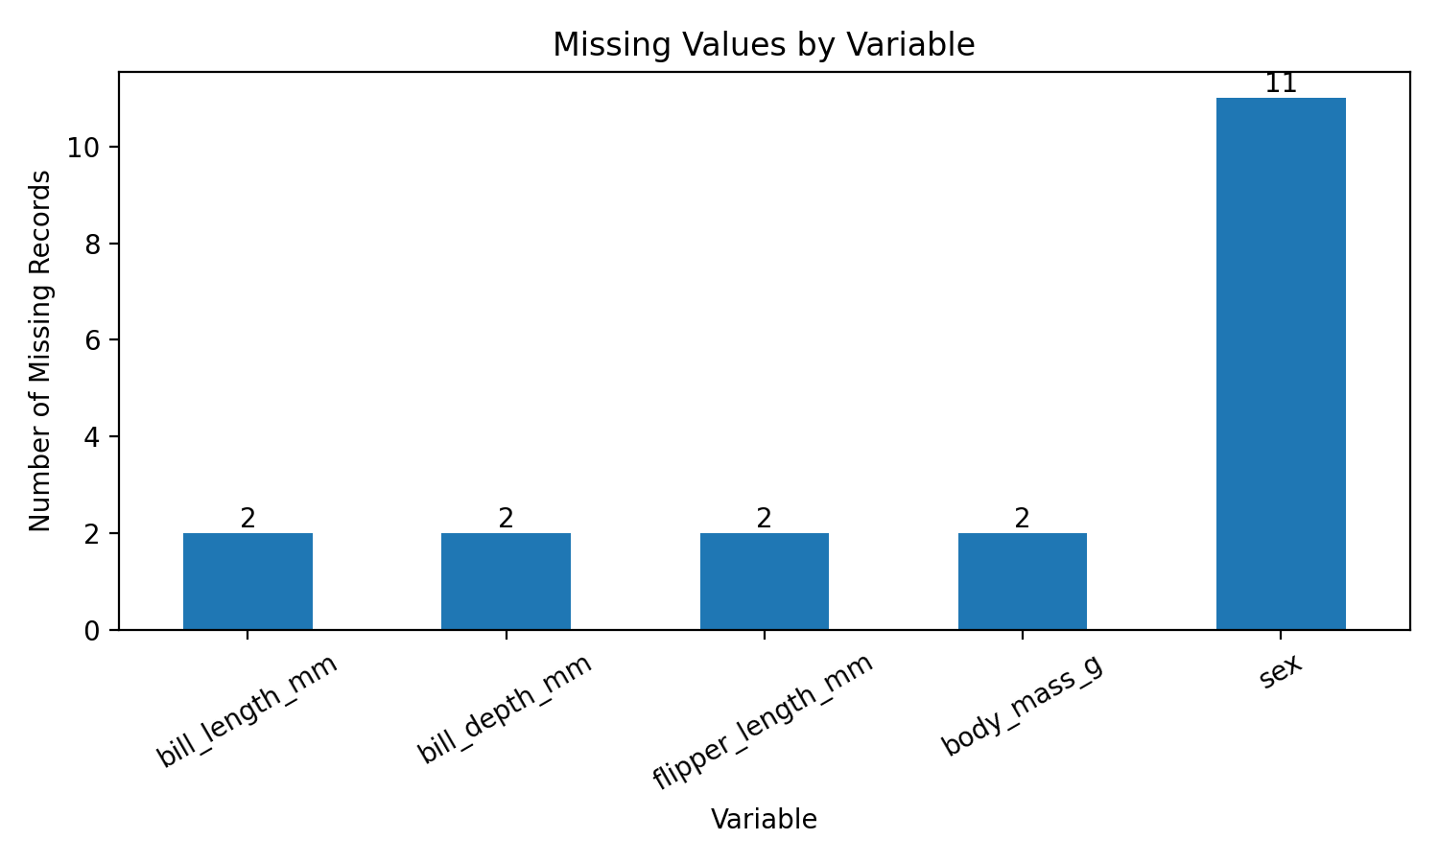
Interpretation: sex contains the largest number of missing observations (11), while each of the four main measurement variables has two missing values. Because missingness is limited, the dataset retains most of its observations, but the missing rows must still be considered during analysis.

12. Data Transformations and Aggregations
Several transformations were performed. First, the raw dataset was copied into an EDA working DataFrame so that the source data were not overwritten. Second, missing sex values were assigned the explicit category 'Unknown'. Third, body mass was median-imputed only in the EDA copy when a complete numerical series was required. Finally, numerical variables were grouped by species and their means calculated. A species-by-island cross-tabulation was also created to summarize categorical distribution.
eda = df.copy()
eda["sex"] = eda["sex"].fillna("Unknown")
eda["body_mass_g"] = eda["body_mass_g"].fillna(
eda["body_mass_g"].median()
)
species_summary = (
eda.groupby("species")[numeric_cols]
.mean()
.round(2)
)
island_species = pd.crosstab(
eda["island"], eda["species"]
)

13. Correlation Table
Feature | Bill length | Bill depth | Flipper | Body mass
bill_length_mm | 1.00 | -0.24 | 0.66 | 0.60
bill_depth_mm | -0.24 | 1.00 | -0.58 | -0.47
flipper_length_mm | 0.66 | -0.58 | 1.00 | 0.87
body_mass_g | 0.60 | -0.47 | 0.87 | 1.00

14. Outlier and Anomaly Analysis
The Python script performs an IQR-based review for each numerical variable. The IQR method flags observations below Q1 − 1.5×IQR or above Q3 + 1.5×IQR. These observations are treated as candidates for investigation rather than automatically deleted. In a biological dataset, an extreme measurement may be a genuine animal rather than a data-entry error.
q1 = eda[col].quantile(0.25)
q3 = eda[col].quantile(0.75)
iqr = q3 - q1
lower = q1 - 1.5 * iqr
upper = q3 + 1.5 * iqr
count = ((eda[col] < lower) | (eda[col] > upper)).sum()

15. Key Findings
- The dataset contains 344 penguins from three species and three islands.
- Adelie has the largest sample (152), followed by Gentoo (124) and Chinstrap (68).
- Gentoo has the highest mean body mass (5076 g) and mean flipper length (217 mm).
- Chinstrap has the highest mean bill length (48.8 mm), while Gentoo has the shallowest mean bill depth (15.0 mm).
- Flipper length and body mass have a strong positive correlation of approximately 0.87.
- The dataset contains 19 missing values across the curated variables, with sex accounting for 11 of them.
- The relationships between measurements show that species-level structure is important when interpreting pooled correlations.

16. Critical Discussion and Limitations
EDA is descriptive rather than causal. The strong association between flipper length and body mass does not prove that one causes the other. Species differences can create or strengthen pooled correlations. The sample sizes are unequal across species, so raw counts and group averages should be interpreted with care. Missing values are limited but should be handled consistently. For future machine-learning work, imputation should be fitted only on training data to avoid data leakage.

17. Conclusion
The analysis demonstrates a complete EDA workflow using Pandas, Matplotlib, and Seaborn. The visualizations reveal clear differences in body mass and flipper length between species, while the correlation matrix identifies flipper length and body mass as the strongest positively associated pair of numerical variables. Missing-value analysis and outlier review add an important data-quality perspective. Overall, the Palmer Penguins dataset provides a strong foundation for understanding how descriptive statistics, visualization, aggregation, and critical interpretation work together in practical data science.

18. References
- Allison Horst, Alison Hill & Kristen Gorman. palmerpenguins – official project. https://allisonhorst.github.io/palmerpenguins/
- Official GitHub repository and penguins.csv: https://github.com/allisonhorst/palmerpenguins
- UCI Machine Learning Repository – Palmer Penguins: https://archive.ics.uci.edu/dataset/690/palmer%2Bpenguins-3
- Pandas documentation: https://pandas.pydata.org/docs/
- Matplotlib documentation: https://matplotlib.org/stable/
- Seaborn documentation: https://seaborn.pydata.org/

Appendix A – Complete Python Code
"""
YuvaIntern – Virtual Data Science with Python Trainee
Task 2: Exploratory Data Analysis and Visualization
Dataset: Palmer Penguins
Official public source:
https://github.com/allisonhorst/palmerpenguins
"""
import pandas as pd
import matplotlib.pyplot as plt
import seaborn as sns
# Load the complete public dataset
url = "https://raw.githubusercontent.com/allisonhorst/palmerpenguins/main/inst/extdata/penguins.csv"
df = pd.read_csv(url)
print("Dataset shape:", df.shape)
print("\nFirst 5 rows:")
print(df.head())
print("\nData types:")
print(df.dtypes)
print("\nMissing values:")
print(df.isna().sum())
print("\nDescriptive statistics:")
print(df.describe(include="all"))
# EDA working copy
eda = df.copy()
# Keep categorical missing values visible
eda["sex"] = eda["sex"].fillna("Unknown")
# For numerical plotting that requires complete body mass,
# use median imputation only in the EDA working copy.
eda["body_mass_g"] = eda["body_mass_g"].fillna(
eda["body_mass_g"].median()
)
# -------------------------------------------------
# 1. Species distribution
# -------------------------------------------------
plt.figure(figsize=(8, 5))
sns.countplot(data=eda, x="species")
plt.title("Penguin Records by Species")
plt.xlabel("Species")
plt.ylabel("Number of Records")
plt.tight_layout()
plt.savefig("species_distribution.png", dpi=200)
plt.show()
# -------------------------------------------------
# 2. Body-mass distribution
# -------------------------------------------------
plt.figure(figsize=(8, 5))
sns.histplot(
data=eda,
x="body_mass_g",
hue="species",
kde=True,
element="step"
)
plt.title("Body Mass Distribution by Species")
plt.xlabel("Body Mass (g)")
plt.ylabel("Frequency")
plt.tight_layout()
plt.savefig("body_mass_distribution.png", dpi=200)
plt.show()
# -------------------------------------------------
# 3. Flipper length vs body mass
# -------------------------------------------------
plt.figure(figsize=(8, 5))
sns.scatterplot(
data=eda,
x="flipper_length_mm",
y="body_mass_g",
hue="species",
style="sex"
)
plt.title("Flipper Length vs Body Mass")
plt.xlabel("Flipper Length (mm)")
plt.ylabel("Body Mass (g)")
plt.legend(title="Species / Sex")
plt.tight_layout()
plt.savefig("flipper_vs_body_mass.png", dpi=200)
plt.show()
# -------------------------------------------------
# 4. Bill length vs bill depth
# -------------------------------------------------
plt.figure(figsize=(8, 5))
sns.scatterplot(
data=eda,
x="bill_length_mm",
y="bill_depth_mm",
hue="species"
)
plt.title("Bill Length vs Bill Depth")
plt.xlabel("Bill Length (mm)")
plt.ylabel("Bill Depth (mm)")
plt.legend(title="Species")
plt.tight_layout()
plt.savefig("bill_length_vs_depth.png", dpi=200)
plt.show()
# -------------------------------------------------
# 5. Correlation matrix
# -------------------------------------------------
numeric_cols = [
"bill_length_mm",
"bill_depth_mm",
"flipper_length_mm",
"body_mass_g"
]
corr = eda[numeric_cols].corr()
plt.figure(figsize=(8, 6))
sns.heatmap(
corr,
annot=True,
cmap="viridis",
vmin=-1,
vmax=1
)
plt.title("Correlation Matrix of Numerical Features")
plt.tight_layout()
plt.savefig("correlation_heatmap.png", dpi=200)
plt.show()
# -------------------------------------------------
# 6. Species-level aggregation
# -------------------------------------------------
species_summary = (
eda.groupby("species")[numeric_cols]
.mean()
.round(2)
)
print("\nMean measurements by species:")
print(species_summary)
# -------------------------------------------------
# 7. Island/species aggregation
# -------------------------------------------------
island_species = pd.crosstab(
eda["island"],
eda["species"]
)
print("\nSpecies counts by island:")
print(island_species)
# -------------------------------------------------
# 8. IQR outlier review
# -------------------------------------------------
print("\nPotential IQR outliers:")
for col in numeric_cols:
q1 = eda[col].quantile(0.25)
q3 = eda[col].quantile(0.75)
iqr = q3 - q1
lower = q1 - 1.5 * iqr
upper = q3 + 1.5 * iqr
count = (
(eda[col] < lower) |
(eda[col] > upper)
).sum()
print(
f"{col}: {int(count)} "
f"(bounds: {lower:.2f} to {upper:.2f})"
)
# Save outputs
eda.to_csv("penguins_eda_task2_cleaned.csv", index=False)
species_summary.to_csv("penguins_species_summary_task2.csv")
corr.to_csv("penguins_correlation_matrix_task2.csv")
print("\nEDA complete. Output files saved.")

