YuvaIntern Week 6 – Integrative Capstone Project
Student Performance Prediction and Segmentation

1. Abstract
This capstone builds an end-to-end Data Science pipeline using the public Student Performance dataset for the Portuguese language course. The workflow covers data loading, cleaning checks, exploratory analysis, feature engineering, supervised classification, unsupervised clustering, evaluation, and recommendations. A Random Forest classifier predicts whether a student passes based on available student and academic characteristics, while K-Means identifies groups of students using non-grade characteristics. The Random Forest achieved 0.885 test accuracy and 0.903 mean five-fold cross-validation accuracy. K-Means selected k=2 using the highest silhouette score among k=2–5. The clustering score was 0.112, so the clusters are treated as exploratory segments rather than definitive student types.

2. Problem Statement
Educational datasets contain information that can help identify patterns associated with student outcomes. The goal of this project is to use Python-based Data Science methods to predict student pass/fail status and explore whether students can be grouped into meaningful segments based on demographic, family, study, support, and lifestyle characteristics.

3. Dataset and Data Collection
The supplied UCI Student Performance dataset contains separate files for Mathematics and Portuguese courses. This project uses the Portuguese course file, student-por.csv, containing 649 student records and 33 columns including G1, G2 and G3. The accompanying attribute documentation defines variables such as studytime, failures, absences, family support, Internet access, and final grade. The dataset contains no missing values in the loaded file.

4. Data Cleaning and Preparation
The CSV was read using semicolon separation. Data types and missing-value counts were checked. No missing values required imputation. Categorical variables were one-hot encoded and numerical variables were standardized inside a preprocessing pipeline. The final grade G3 was converted into a binary performance target: Pass for G3 >= 10 and Fail otherwise.

5. Feature Engineering
The main engineered target is performance. For the supervised model, G3 itself was removed from the input features to prevent direct target leakage. G1 and G2 were retained because they are earlier-period grades and can be legitimate predictive variables for the final outcome. For clustering, G1, G2 and G3 were all excluded so that the segments would describe student characteristics rather than simply reproduce academic performance.

6. Exploratory Data Analysis
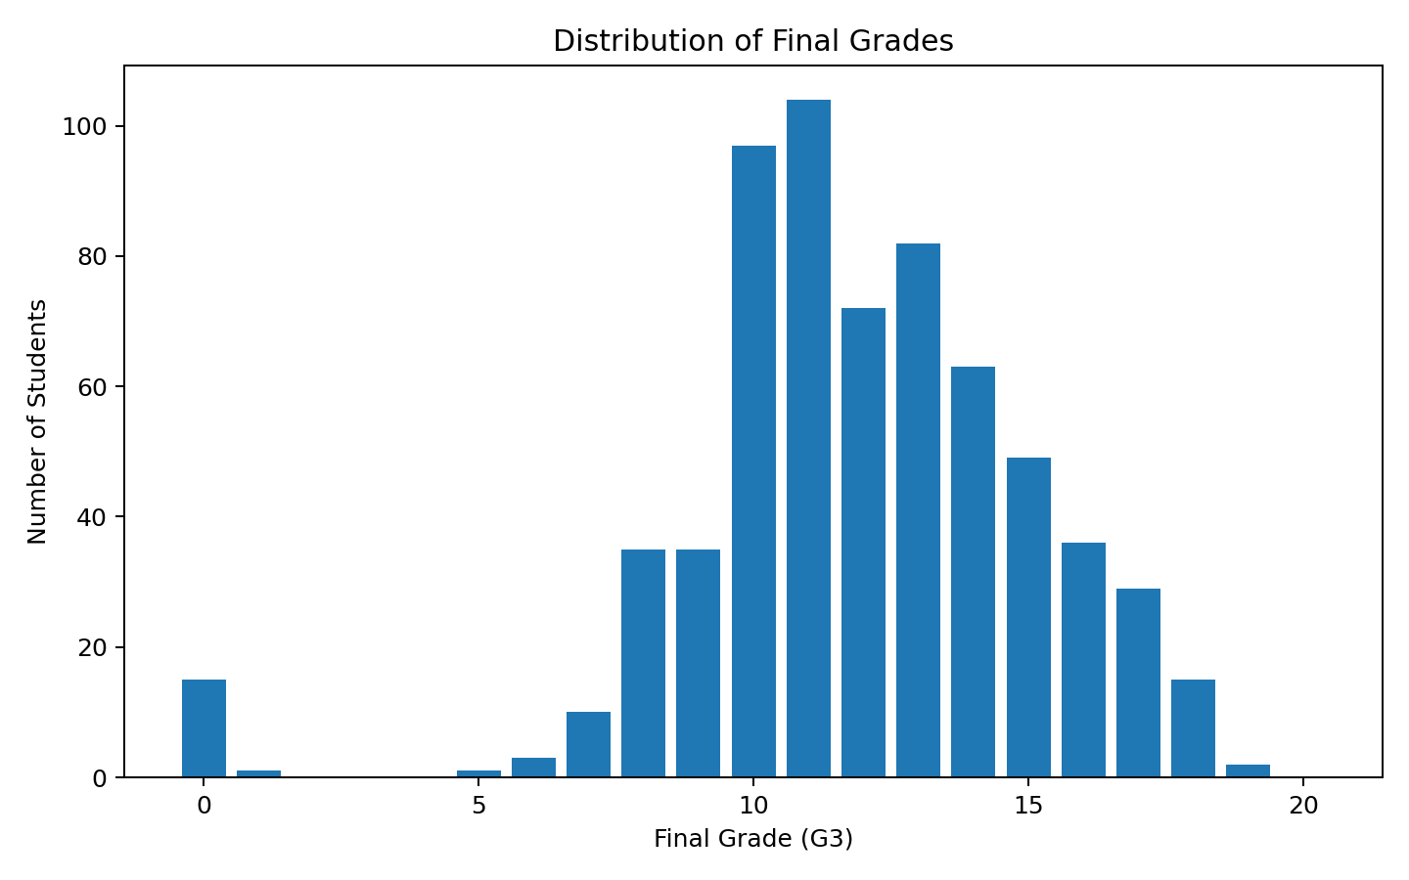
The final-grade distribution has a mean of 11.91 and median of 12. There are 549 students classified as Pass and 100 as Fail.
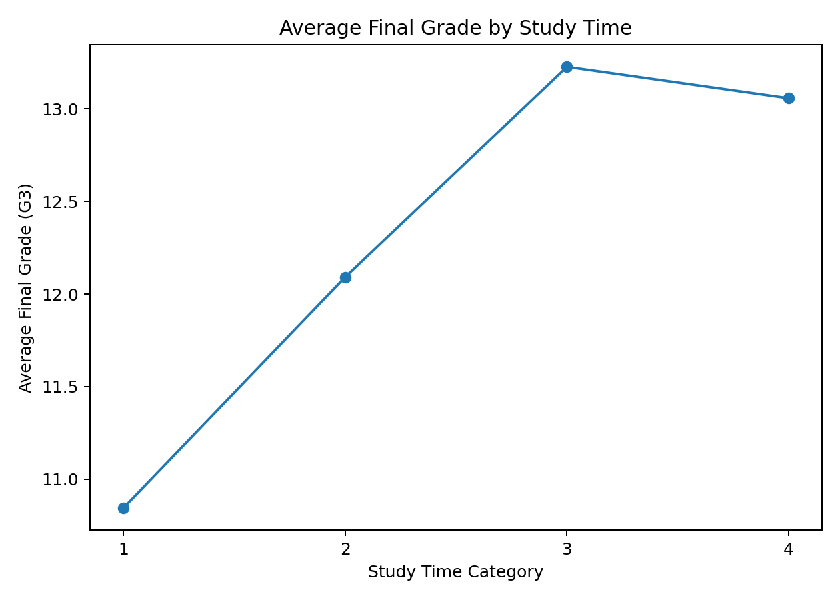
Average final grade was compared across the four study-time categories. This is an observational pattern and should not be interpreted as proof that study time alone causes higher grades.
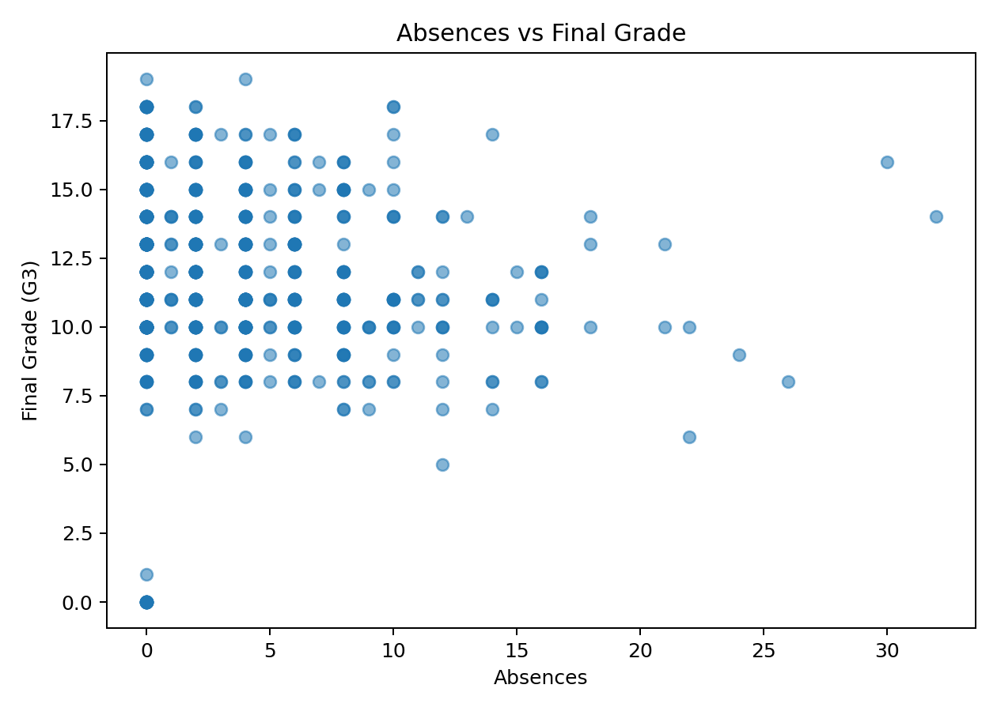
Absence counts were compared with final grades to identify possible patterns and outliers. The scatter plot shows substantial variation, indicating that absences alone do not explain every student's result.

7. Supervised Learning – Random Forest
A Random Forest Classifier with 300 trees was selected because it works well with mixed, tabular features after encoding, can model non-linear relationships, and provides feature-importance information. The dataset was split into 80% training and 20% testing data using stratification.
Test accuracy was 0.885. For the Pass class, precision was 0.913, recall was 0.955, and F1-score was 0.933.
Metric | Score
Test Accuracy | 0.885
Pass Precision | 0.913
Pass Recall | 0.955
Pass F1-Score | 0.933
Mean 5-Fold CV Accuracy | 0.903
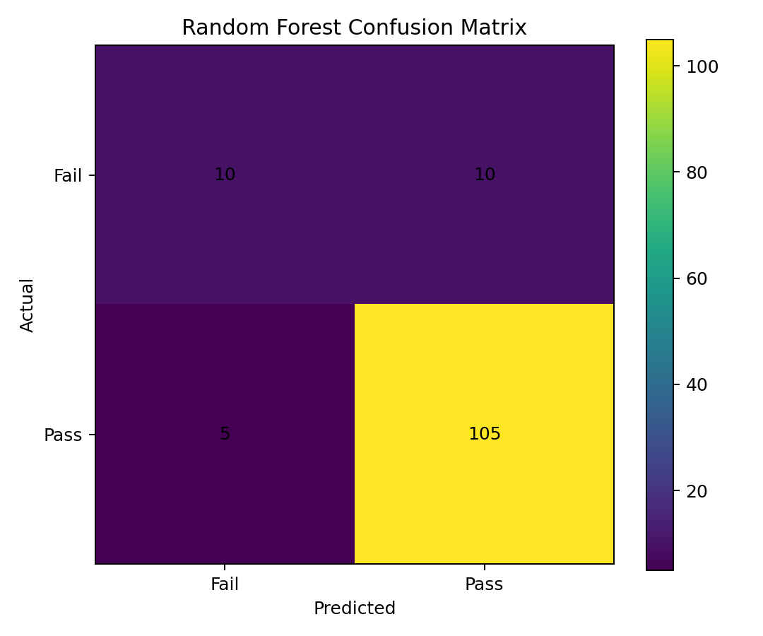
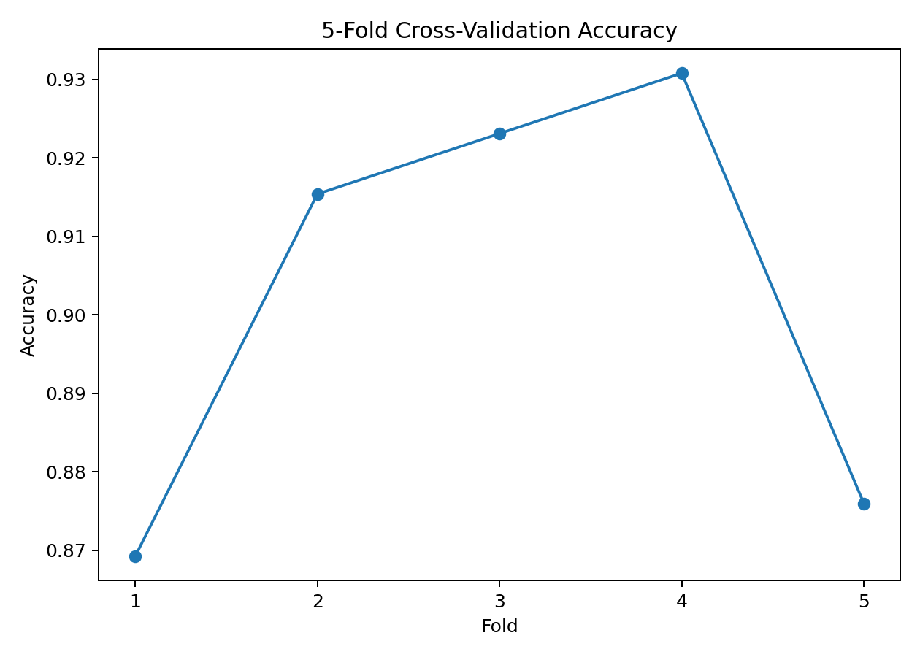
Five-fold cross-validation produced a mean accuracy of 0.903. The similarity between test and cross-validation performance suggests reasonable stability on this dataset.
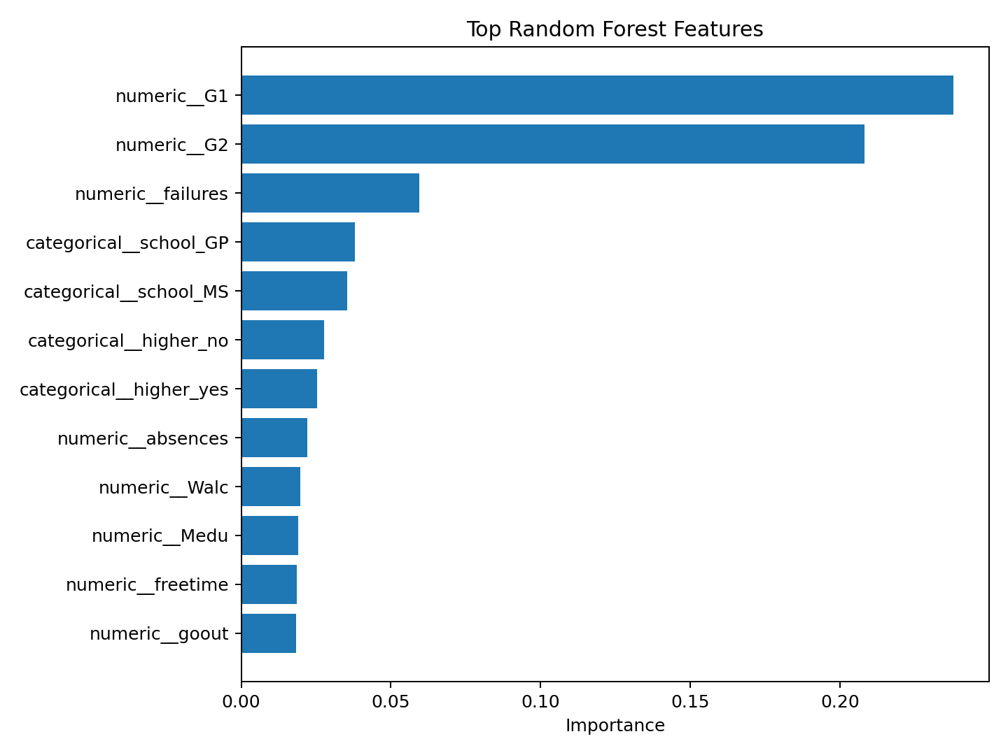
Feature importance highlights which encoded inputs contributed most to the Random Forest's decisions. Importance is model-specific and should not be interpreted as causal influence.

8. Unsupervised Learning – K-Means
K-Means was applied to demographic, family, study, support and lifestyle variables after encoding and scaling. Candidate values k=2, 3, 4 and 5 were compared using silhouette score. The best value was k=2 with a silhouette score of 0.112.
k | Silhouette Score
2 | 0.112
3 | 0.068
4 | 0.069
5 | 0.067
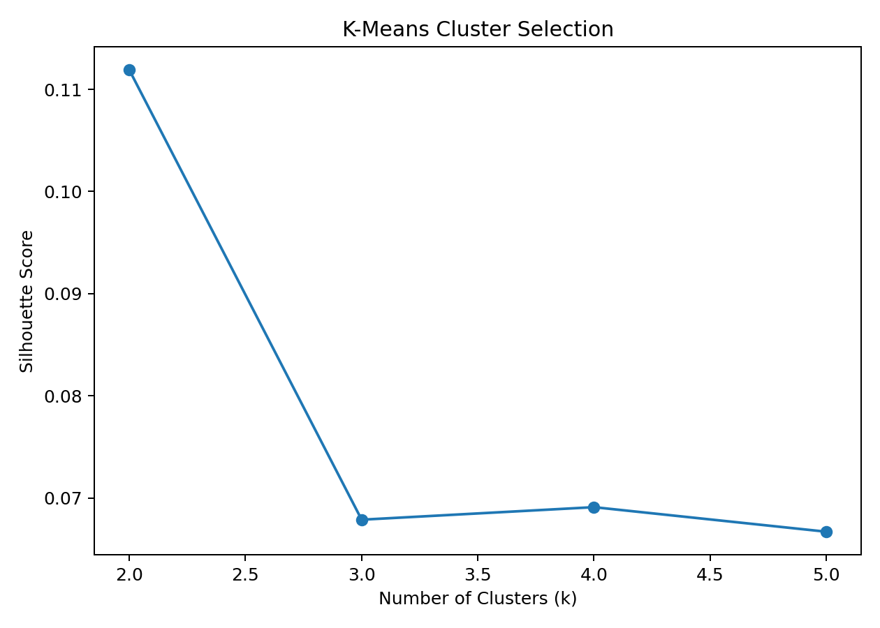
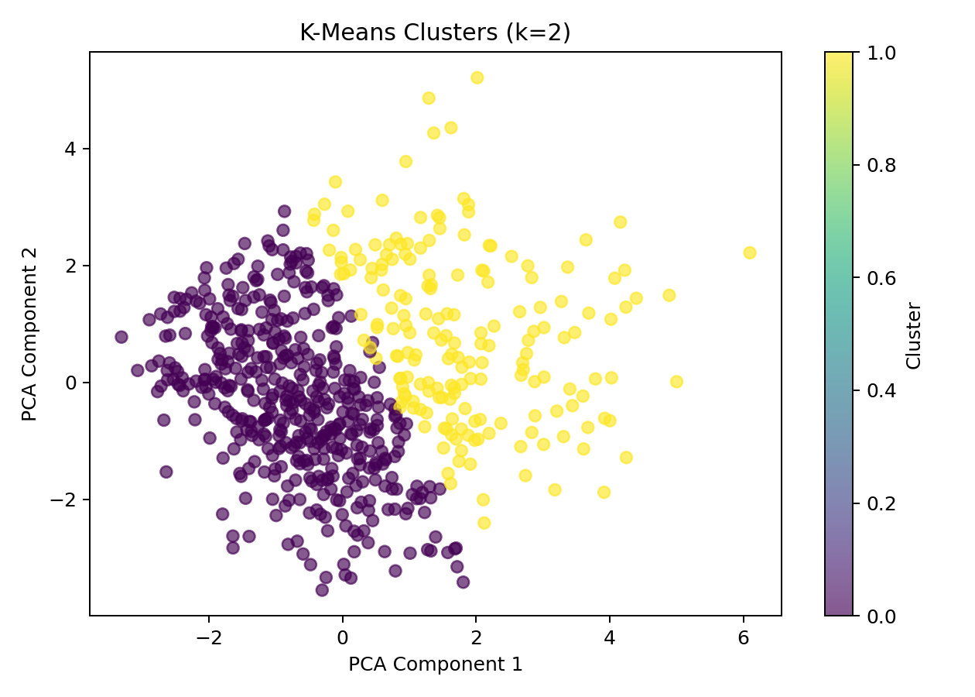
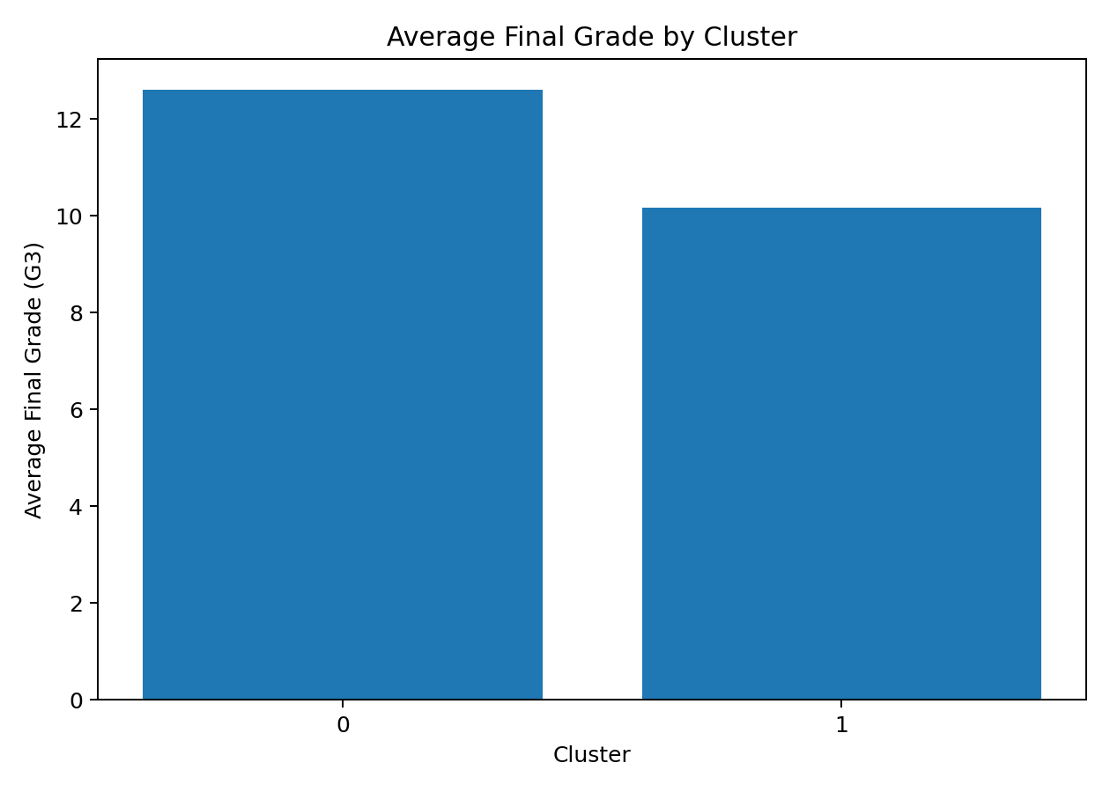
The PCA chart provides a two-dimensional visual summary of the clusters. Because the silhouette score is relatively low, the segments should be considered exploratory and overlapping rather than sharply separated.
Cluster profiles were generated using average grades, study time, failures and absences. These summaries help describe how the discovered groups differ without using grade variables to create the clusters.

9. Key Insights
- The dataset contains 649 Portuguese-course student records and no missing values in the loaded file.
- 549 students are classified as Pass and 100 as Fail using the G3 >= 10 rule.
- The Random Forest achieved 88.5% test accuracy and 90.3% mean five-fold CV accuracy.
- Earlier-period grades G1 and G2 are important predictive signals, which is expected because they directly reflect academic progress before the final grade.
- K-Means selected 2 clusters, but the silhouette score of 0.112 indicates that the segments are not strongly separated.
- Study time, failures, absences, family/support variables and other characteristics provide useful context, but observational patterns should not be treated as causal relationships.

10. Recommendations
- Use the supervised model as an analytical support tool rather than an automatic decision-maker.
- Students predicted as at-risk can be reviewed for additional academic support, while human staff consider context not captured by the dataset.
- Collect newer institutional data and test the pipeline before applying it to a real educational setting.
- Compare additional models such as Logistic Regression, Gradient Boosting and neural networks.
- For stronger segmentation, experiment with alternative distance measures, dimensionality reduction, or clustering methods and validate segments with domain experts.

11. Challenges and Solutions
- Mixed categorical and numerical data: handled with one-hot encoding and scaling in reproducible preprocessing pipelines.
- Target leakage risk: G3 was excluded from supervised inputs and all grade variables were excluded from clustering.
- Class imbalance: class_weight='balanced' was used in the Random Forest and stratified splitting preserved class proportions.
- Choosing cluster count: silhouette scores were compared across multiple k values instead of selecting an arbitrary number.
- Interpretation of clustering: the relatively low silhouette score was reported honestly and the clusters were treated as exploratory.

12. Limitations
- The dataset represents specific schools and courses and may not generalize to all students.
- The pass/fail threshold is an analytical choice based on the grade scale and does not capture the full range of performance.
- Random Forest feature importance does not establish causation.
- K-Means assumes a distance-based structure and produced only modest cluster separation in this feature space.
- The project is based on a static dataset, so it does not evaluate performance on future cohorts.

13. Future Work
Future work could include hyperparameter tuning, model comparison, explainability methods such as permutation importance or SHAP, longitudinal student data, and more advanced clustering. A deep-learning model could also be tested if a sufficiently large dataset is available.

14. Conclusion
This capstone demonstrates a complete Python Data Science workflow from raw public data to actionable analysis. Exploratory analysis identified patterns in grades, study time and absences. The Random Forest provided strong predictive performance, while K-Means offered exploratory segmentation with clear limitations. The project shows that good Data Science requires not only building models, but also careful preprocessing, validation, interpretation and honest discussion of uncertainty.

15. Source Documentation
The supplied dataset documentation describes the variables for student-mat.csv and student-por.csv, including student demographics, study habits, support, absences and grades G1, G2 and G3. The documentation also notes that some students appear in both course datasets.
Complete Python implementation is included at the end of this report.

16. Complete Python Code
"""
YuvaIntern Week 6 Capstone
Student Performance Prediction and Segmentation

Dataset: UCI Student Performance (Portuguese course), supplied as student-por.csv.
Pipeline: acquisition -> cleaning -> EDA -> feature engineering ->
Random Forest classification -> cross-validation -> K-Means clustering -> evaluation.
"""

import pandas as pd
import numpy as np
from sklearn.model_selection import train_test_split, cross_val_score
from sklearn.compose import ColumnTransformer
from sklearn.preprocessing import OneHotEncoder, StandardScaler
from sklearn.pipeline import Pipeline
from sklearn.ensemble import RandomForestClassifier
from sklearn.metrics import accuracy_score, precision_score, recall_score, f1_score
from sklearn.cluster import KMeans
from sklearn.metrics import silhouette_score

df = pd.read_csv("student-por.csv", sep=";")

# Target engineering: Pass if final grade G3 >= 10, otherwise Fail.
df["performance"] = np.where(df["G3"] >= 10, "Pass", "Fail")

# Supervised learning: exclude G3 to avoid target leakage.
X = df.drop(columns=["G3", "performance"])
y = df["performance"]

categorical = X.select_dtypes(include="object").columns
numeric = X.select_dtypes(exclude="object").columns

preprocessor = ColumnTransformer([
("categorical", OneHotEncoder(handle_unknown="ignore"), categorical),
("numeric", StandardScaler(), numeric)
])

model = RandomForestClassifier(
n_estimators=300, random_state=42, class_weight="balanced"
)
pipeline = Pipeline([
("preprocessor", preprocessor),
("model", model)
])

X_train, X_test, y_train, y_test = train_test_split(
X, y, test_size=0.20, random_state=42, stratify=y
)
pipeline.fit(X_train, y_train)
pred = pipeline.predict(X_test)

print("Accuracy:", accuracy_score(y_test, pred))
print("Precision:", precision_score(y_test, pred, pos_label="Pass"))
print("Recall:", recall_score(y_test, pred, pos_label="Pass"))
print("F1:", f1_score(y_test, pred, pos_label="Pass"))

cv = cross_val_score(pipeline, X, y, cv=5, scoring="accuracy")
print("5-fold CV:", cv)
print("Mean CV accuracy:", cv.mean())

# Unsupervised learning: exclude grade columns so clusters describe student characteristics.
cluster_cols = [c for c in df.columns if c not in ["G1", "G2", "G3", "performance"]]
Xc = df[cluster_cols]
catc = Xc.select_dtypes(include="object").columns
numc = Xc.select_dtypes(exclude="object").columns

cluster_preprocessor = ColumnTransformer([
("categorical", OneHotEncoder(handle_unknown="ignore"), catc),
("numeric", StandardScaler(), numc)
])
Z = cluster_preprocessor.fit_transform(Xc)

scores = {}
for k in range(2, 6):
km = KMeans(n_clusters=k, random_state=42, n_init=20)
labels = km.fit_predict(Z)
scores[k] = silhouette_score(Z, labels)

best_k = max(scores, key=scores.get)
final_kmeans = KMeans(n_clusters=best_k, random_state=42, n_init=20)
df["cluster"] = final_kmeans.fit_predict(Z)

print("Best k:", best_k)
print("Best silhouette:", scores[best_k])
print(df.groupby("cluster")[["G3", "G1", "G2", "studytime", "failures", "absences"]].mean())

