YuvaIntern Task 4 – Supervised Learning Model Implementation
Virtual Data Science with Python Trainee

1. Abstract
This report presents a supervised machine learning classification project using the public Iris dataset. The goal is to predict the species of an Iris flower from four measurements: sepal length, sepal width, petal length, and petal width. A Random Forest Classifier was selected because it can capture non-linear relationships, is relatively easy to interpret through feature importance, and performs well on small tabular datasets. The workflow covers data preparation, stratified train/test splitting, model training, prediction, evaluation, five-fold cross-validation, and feature-importance analysis.

2. Objective
The objective is to build a complete supervised learning pipeline that predicts Iris flower species, evaluate its performance using appropriate classification metrics, validate the model with cross-validation, and discuss its strengths, limitations, and possible improvements.

3. Problem Definition
This is a multiclass classification problem. The input consists of four numerical flower measurements, and the target is one of three species: setosa, versicolor, or virginica.

4. Dataset
The Iris dataset contains 150 observations, four numerical input features, and three target classes. The dataset is publicly available through scikit-learn and is commonly used for demonstrating machine learning workflows.
Feature | Description
sepal length (cm) | Length of the sepal in centimeters
sepal width (cm) | Width of the sepal in centimeters
petal length (cm) | Length of the petal in centimeters
petal width (cm) | Width of the petal in centimeters

5. Data Preparation and Feature Engineering
The dataset was loaded directly using scikit-learn's built-in dataset loader. The four measurement columns were used as predictors and the species label was used as the target. The data was split into 80% training and 20% testing data using a stratified split so that the class proportions were maintained. No missing-value imputation was required for this dataset. The numerical measurements were already in compatible units, so additional scaling was not required for the Random Forest model.

6. Model Selection and Rationale
Random Forest Classifier was chosen because it combines multiple decision trees and can model complex relationships without requiring feature scaling. It is also less sensitive to individual noisy observations than a single decision tree. The model was configured with 200 trees and a fixed random state of 42 to make the experiment reproducible.

7. Model Training
The classifier was fitted using only the training portion of the dataset. Predictions were then generated for the unseen test set. This separation helps provide a more realistic estimate of how the model performs on new observations.
Core training code:
model = RandomForestClassifier(n_estimators=200, random_state=42)
model.fit(X_train, y_train)
y_pred = model.predict(X_test)

8. Evaluation Results
On the 20% held-out test set, the model achieved an accuracy of 0.900, weighted precision of 0.902, weighted recall of 0.900, and weighted F1-score of 0.900.
Metric | Score
Test Accuracy | 0.900
Weighted Precision | 0.902
Weighted Recall | 0.900
Weighted F1-Score | 0.900
Mean 5-Fold CV Accuracy | 0.960

9. Confusion Matrix and Classification Analysis
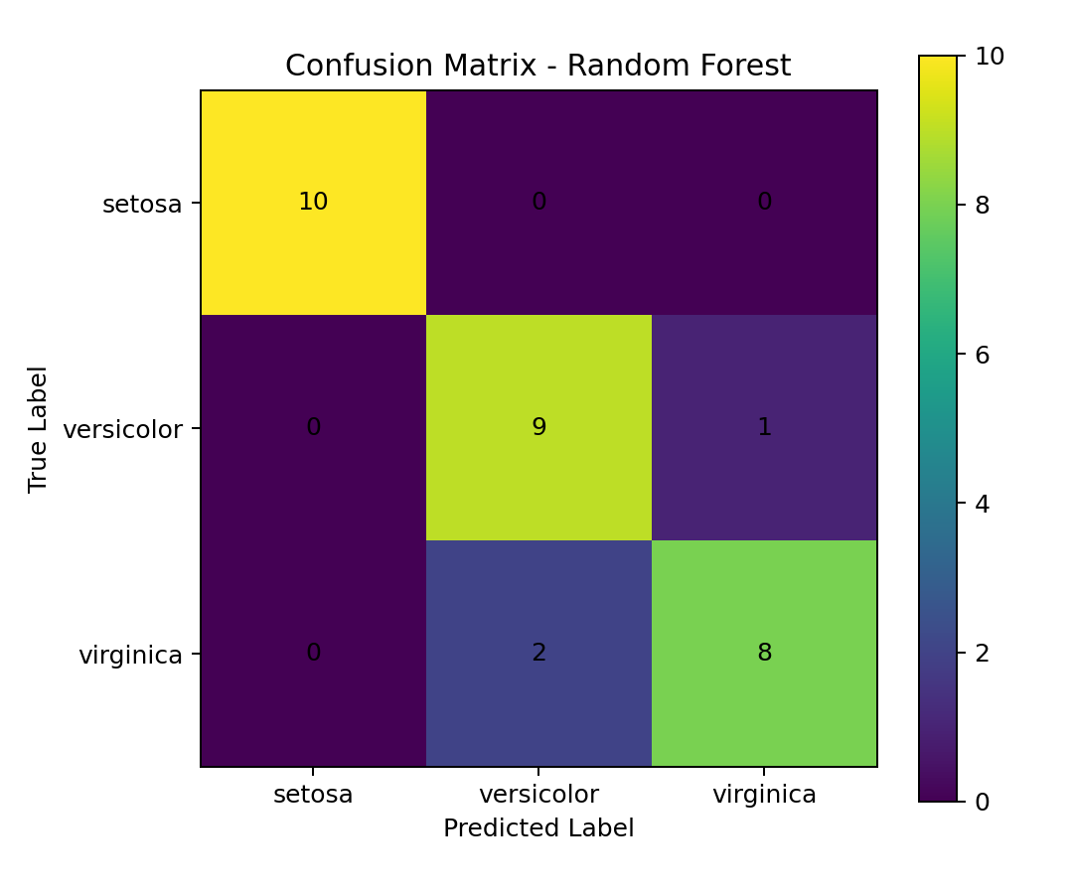
The confusion matrix compares actual and predicted species. Correct predictions appear on the diagonal. A strong diagonal indicates that the classifier is distinguishing the three species effectively.

10. Cross-Validation
Five-fold stratified cross-validation was used to check whether the model's performance was consistent across different subsets of the data. The mean cross-validation accuracy was 0.960.
Fold | Accuracy
1 | 1.000
2 | 0.967
3 | 0.933
4 | 1.000
5 | 0.900
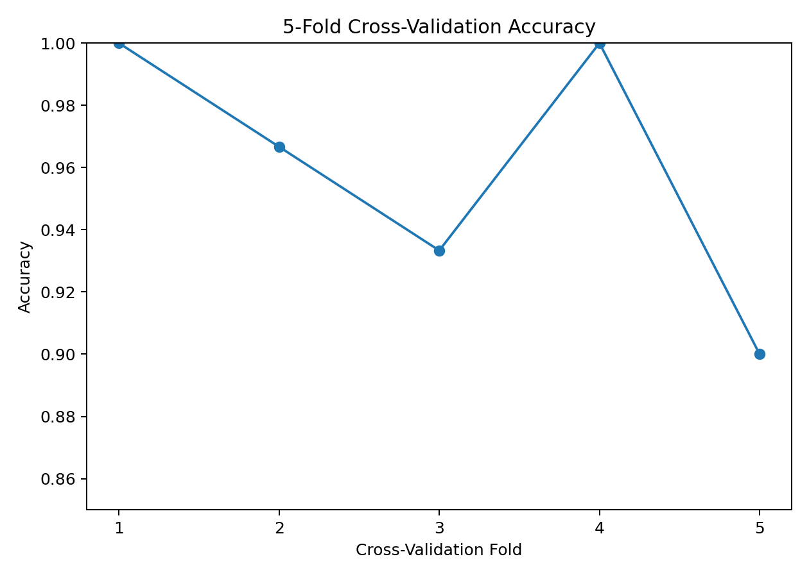

11. Feature Importance
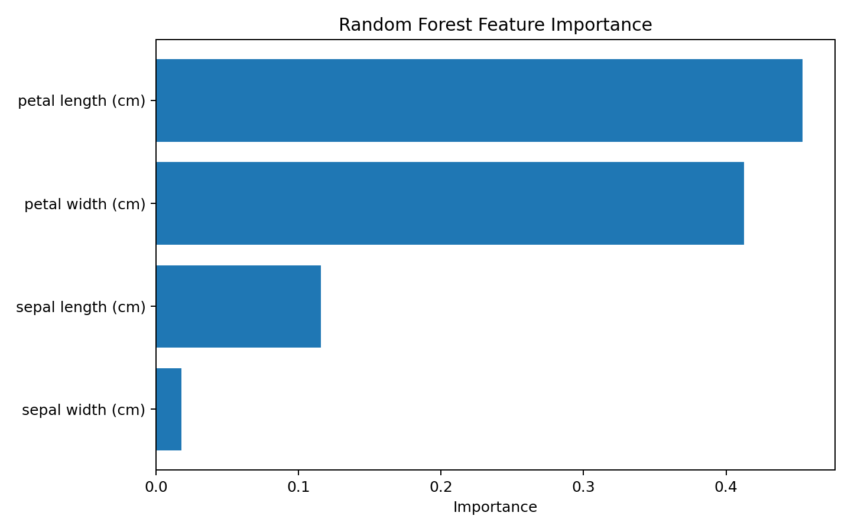
The feature-importance analysis shows which measurements contributed most to the Random Forest's decisions. In this experiment, petal length (cm) had the highest relative importance. Feature importance indicates contribution to model decisions; it should not be interpreted as proof of causation.

12. Class Distribution
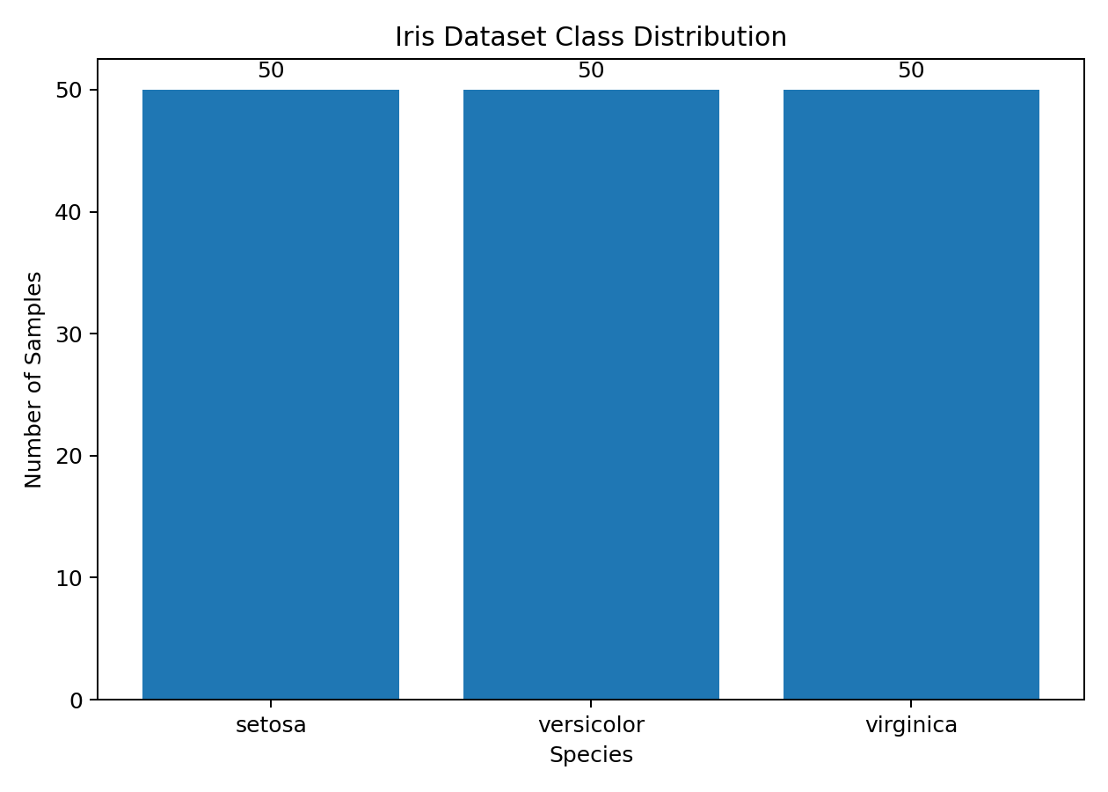
The three Iris classes are evenly represented in the dataset, which makes the dataset suitable for a balanced multiclass classification demonstration.

13. Strengths
- Works well with small tabular datasets and non-linear relationships.
- Does not require feature scaling for this dataset.
- Provides feature-importance information for interpretation.
- Cross-validation was used to check performance stability.
- The complete workflow is reproducible using a fixed random state.

14. Limitations
- The Iris dataset is small and relatively clean, so results may not represent real-world noisy data.
- A Random Forest can be harder to interpret than a single decision tree.
- Feature importance is model-specific and does not establish causal relationships.
- A single dataset cannot demonstrate how the model behaves across different domains.

15. Possible Improvements
- Compare Random Forest with Logistic Regression, K-Nearest Neighbors, and Support Vector Machine.
- Tune hyperparameters using GridSearchCV or RandomizedSearchCV.
- Use additional evaluation such as ROC-AUC for multiclass classification.
- Test the pipeline on a larger, noisier real-world dataset.

16. Conclusion
The project successfully demonstrates a complete supervised learning workflow for multiclass classification. The Random Forest model produced strong performance on the Iris dataset, and five-fold cross-validation provided additional evidence that the performance was consistent. The task also demonstrated how evaluation metrics, confusion matrices, cross-validation, and feature importance can be combined to understand a predictive model rather than relying only on a single accuracy value.

17. References
Scikit-learn documentation – Iris dataset and RandomForestClassifier.
Fisher, R. A. (1936). The use of multiple measurements in taxonomic problems.

18. Complete Python Code
"""
YuvaIntern Task 4 - Supervised Learning Model Implementation
Problem: Iris flower species classification using Random Forest.
"""

import pandas as pd
from sklearn.datasets import load_iris
from sklearn.model_selection import train_test_split, StratifiedKFold, cross_val_score
from sklearn.ensemble import RandomForestClassifier
from sklearn.metrics import (
accuracy_score, precision_score, recall_score, f1_score,
classification_report, confusion_matrix
)

# 1. Load public dataset
iris = load_iris(as_frame=True)
df = iris.frame.copy()
df["species"] = df["target"].map(dict(enumerate(iris.target_names)))
df = df.drop(columns=["target"])

# 2. Define features and target
X = df[iris.feature_names]
y = df["species"]

# 3. Split the data
X_train, X_test, y_train, y_test = train_test_split(
X, y, test_size=0.20, random_state=42, stratify=y
)

# 4. Train Random Forest classifier
model = RandomForestClassifier(n_estimators=200, random_state=42)
model.fit(X_train, y_train)

# 5. Predict
y_pred = model.predict(X_test)

# 6. Evaluate
print("Accuracy:", accuracy_score(y_test, y_pred))
print("Weighted Precision:", precision_score(y_test, y_pred, average="weighted"))
print("Weighted Recall:", recall_score(y_test, y_pred, average="weighted"))
print("Weighted F1:", f1_score(y_test, y_pred, average="weighted"))

print("\nClassification Report:")
print(classification_report(y_test, y_pred))

print("\nConfusion Matrix:")
print(confusion_matrix(y_test, y_pred))

# 7. 5-fold cross-validation
cv = StratifiedKFold(n_splits=5, shuffle=True, random_state=42)
cv_scores = cross_val_score(model, X, y, cv=cv, scoring="accuracy")
print("\n5-Fold CV Scores:", cv_scores)
print("Mean CV Accuracy:", cv_scores.mean())

# 8. Feature importance
feature_importance = pd.DataFrame({
"Feature": iris.feature_names,
"Importance": model.feature_importances_
}).sort_values("Importance", ascending=False)
print("\nFeature Importance:")
print(feature_importance)

