**Q_01:**

Code:

package Q_01;  
  
public class Q_01 {  
 public static void main(String[] args) {  
   
 // This is a part a   
 int A = 5;  
 int B = 10;  
 int C = 15;  
  
 double answer_a = Math.*sqrt*( Math.*pow*(B,2) + (4 * A * C) );  
 System.*out*.println(answer_a);  
   
 // This is a part b  
 int X =200;  
 int Y =5;  
  
 double answer_b = Math.*sqrt*( X+(4*(Math.*pow*(Y,3))));  
 System.*out*.println(answer_b);  
   
 // This is a part c  
 double answer_c = Math.*cbrt*(X*Y);  
 System.*out*.println(answer_c);  
   
 // This is a part d  
 int Radius = 21;  
 double answer_d = Math.*PI*\*Math.*pow*(Radius, 2);  
 System.*out*.println(answer_d);  
  
 }  
}

Output:

**Q_02:**

**Code:**

package Q_02;  
  
import java.util.Scanner;  
  
import java.util.Scanner;  
  
public class Q_02 {  
 public static void main(String[] args) {  
 Scanner sc = new Scanner(System.*in*);  
  
 System.*out*.print("Enter the Length in Centimeters: ");  
 double cm = sc.nextDouble();  
  
 // Convert feet to inches  
 int feet = (int) (cm / 30.48);  
 double remainder = cm % 30.48;  
 double inch = remainder / 2.54;  
  
  
 System.*out*.printf("Entered length in feet and inches: %d ft and %.2f inch%n", feet, inch);  
  
  
 }  
}

Output

Q_03:

Code:

package Q_03;  
  
import java.util.Scanner;  
  
public class Q_03 {  
 public static void main(String[] args) {  
  
 Scanner input= new Scanner(System.*in*);  
 System.*out*.print("Enter the temperature in degrees of Celsius: ");  
  
 double cel = input.nextDouble();  
 double fah = (1.8 * cel) + 32;  
  
 System.*out*.printf("Temperature in degrees of Fahrenheit: %.2f" ,fah );  
 } **}**

**Output**

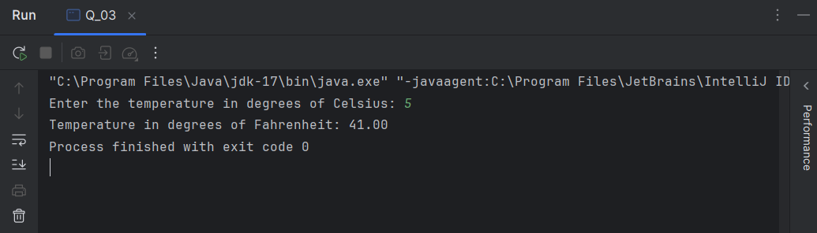

Q_04

**Code:**

package Q_04;  
  
import java.util.Scanner;  
public class Q_04 {  
 public static void main(String[] args) {  
 Scanner sc = new Scanner(System.*in*);  
 System.*out*.print("Enter your body weight: ");  
 double bodyWeight = sc.nextDouble();  
 double calories = bodyWeight * 19;  
 System.*out*.println("You need approximately " + calories + " calories per day");  
 }  
}

**Output:**

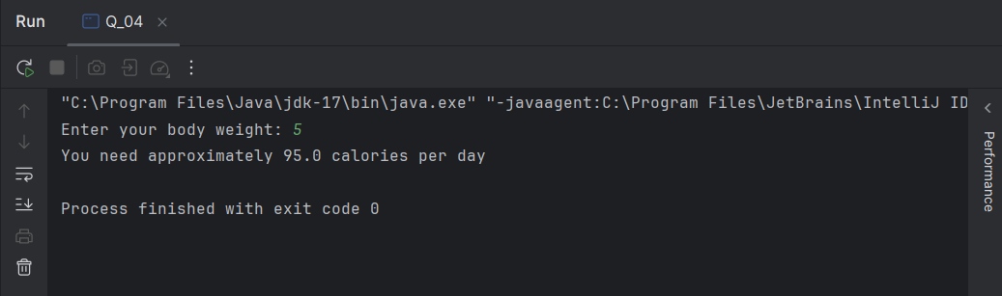

Q_05

**Code:**

package Q_05;  
  
import java.util.Scanner;  
  
public class Q_05 {  
 public static void main(String[] args) {  
  
 Scanner input= new Scanner(System.*in*);  
 System.*out*.print("Enter the temperature in degrees of Fahrenheit: ");  
  
 double fah = input.nextDouble();  
 double cel = (5.0 / 9.0) * ( fah - 32) ;  
  
 System.*out*.printf("Temperature in degrees of Celsius: %.2f" ,cel );  
 }  
}

**Output:**

Q_06:

**Code:**

package Q_06;  
  
import java.util.GregorianCalendar;  
import java.util.Scanner;  
  
public class Q_06 {  
 public static void main(String[] args) {  
  
 Scanner input = new Scanner(System.*in*);  
 System.*out*.print("Enter your birth year: ");  
 int birthyear = input.nextInt();  
  
 GregorianCalendar cal = new GregorianCalendar();  
 int current_year = cal.get(GregorianCalendar.*YEAR*);  
 //System.out.print(current_year);  
 int age = current_year - birthyear;  
  
 System.*out*.printf("You were born in %d and will be %d years old this year", birthyear, age);  
 }  
}

**Output:**

Q_07:

**Code:**

package Q_07;  
  
import java.util.Scanner;  
  
public class Q_07 {  
 public static void main(String[] args) {  
  
 Scanner input = new Scanner(System.*in*);  
 System.*out*.print("Enter Your Height(cm): ");  
 int height = input.nextInt();  
  
 System.*out*.print("Enter Your Weight(Kg): ");  
 int weight = input.nextInt();  
  
 double BMI = weight / (Math.*pow*( (height / 100.0), 2));  
 System.*out*.printf("Your BMI value is: %.3f%n" ,BMI);  
  
 if (BMI >= 20 && BMI <= 25) {  
 System.*out*.println("Your BMI value is normal");  
  
 } else  
 System.*out*.println("Your BMI value is not in the healthy range");  
  
 }  
}

**Output:**

Q_08:

**Code:**

package Q_08;  
  
import java.util.Scanner;  
  
public class Q_08 {  
 public static void main(String[] args) {  
  
 Scanner input = new Scanner(System.*in*);  
 System.*out*.print("Enter the radius of the sphere: ");  
 double r = input.nextDouble();  
  
 double PI = 3.14;  
 double v = (4.0 / 3.0) * (PI * Math.*pow*(r, 3));  
 System.*out*.printf("Volume of the sphere is: %.3f%n" ,v);  
 }  
}

**Output:**

Q_09:

**Code:**

package Q_09;  
  
import java.util.Scanner;  
  
public class Q_09 {  
 public static void main(String[] args) {  
  
 Scanner input = new Scanner(System.*in*);  
 System.*out*.print("Enter the amount of investment: ");  
 double P = input.nextDouble();  
  
 System.*out*.print("Enter the annual interest rate(%): ");  
 double R = input.nextDouble();  
  
 System.*out*.print("Enter the number of years for the investment: ");  
 double N = input.nextDouble();  
  
 double grow = P * (Math.*pow* ( (1 + (R / 100)), N));  
  
 System.*out*.printf("The amount of money you will earn after %.0f years is: $ %.2f" , N, grow);  
 }  
}

**Output:**

Q_10:

**Code:**

package Q_10;  
  
import java.util.Scanner;  
  
public class Q_10 {  
 public static void main(String[] args) {  
  
 Scanner input = new Scanner(System.*in*);  
 System.*out*.print("Enter the loan amount: ");  
 double l_amount = input.nextDouble();  
  
 System.*out*.print("Enter the annual interest rate(%): ");  
 double a_i_rate = input.nextDouble();  
  
 System.*out*.print("Enter the loan period(in years): ");  
 double l_period = input.nextDouble();  
 double months = 12.0;  
   
 double m_i_rate = (a_i_rate / 100.0 / months) ;  
 System.*out*.printf("The monthly interest rate for the loan: %.6f%%%n", m_i_rate);  
  
 double no_payments = (l_period * months);  
 System.*out*.printf("Number of payments: %.0f%n", no_payments);  
  
 double m_payment = (l_amount * m_i_rate) / (1 - Math.*pow*( (1 / (1 + m_i_rate)), no_payments));  
 System.*out*.printf("The monthly payment amount: $ %.2f%n", m_payment);  
  
 double t_payment = m_payment * no_payments;  
 System.*out*.printf("The total payment amount: $ %.2f%n", t_payment);  
  
 }  
}

**Output:**

