ANALYSIS COVID 19 VACCINES

TEAM MEMBER

**732521104037: PRAVEEN N**

PHASE 5:SUBMISSION DOCUMENT

**PROJECT :COVID 19 VACCINES ANALYSIS**

**INTRODUCTION:**

***The COVID 19 pandemic caused due to the Corona virus devastated the world by causing several fatalities around the world.***

***This virus originated in Wuhan, China in 2019 and was later spread throughout the world due to human contact in one way or the other.***

***symptoms like breathing problems caused by damage to the lungs.***

***PROBLEM STATEMENT:***

***A correlation study to assess the knowledge and self-expressed stigma regarding COVID-19 Outbreak among adults at selected society of Pune city. 0***



***Design Thinking:***

***Data Collection: Collect Covid-19 vaccine data from reputable sources like health organizations, government databases, and research publications.***

***Data Preprocessing: Clean and preprocess the data, handle missing values, and convert categorical features into numerical representations.***

***Exploratory Data Analysis: Explore the data to understand its characteristics, identify trends, and outliers.***

***Statistical Analysis: Perform statistical tests to analyze vaccine efficiency,adverse effects, and distribution across different populations.***

***Visualization: Create visualizations (e.g., bar plots, line charts, heat maps) to present key findings and insights.***

***Insights and Recommendations: Provide actionable insights and recommendations based on the analysis to assist policymakers and health organizations.***

**STEPS OF DATA*:***

**Data Importing :**

***In power BI desktop with the help of the get data option import the CSV data which is named as country vaccinations and clicked load option.***

**Data Cleaning :**

***After loading the data and after analyzing the data | understood that there are 86512 rows and 15 columns.***

***And in that some of the columns contained null values I have replaced the null values by 0 with the use of replace functions and started working on the data.***

**Visualizations :**

**In visualization part with the help of power BI desktop software I have used different kinds of charts, graphs, cards and table to display the data in the format which will be easy to understand*.***

**Analysis :**

**In the analysis part first | have analyzed the top 10 fully vaccinated countries by using area chart and have used the filter option to find the top countries and the result obtained as below,** 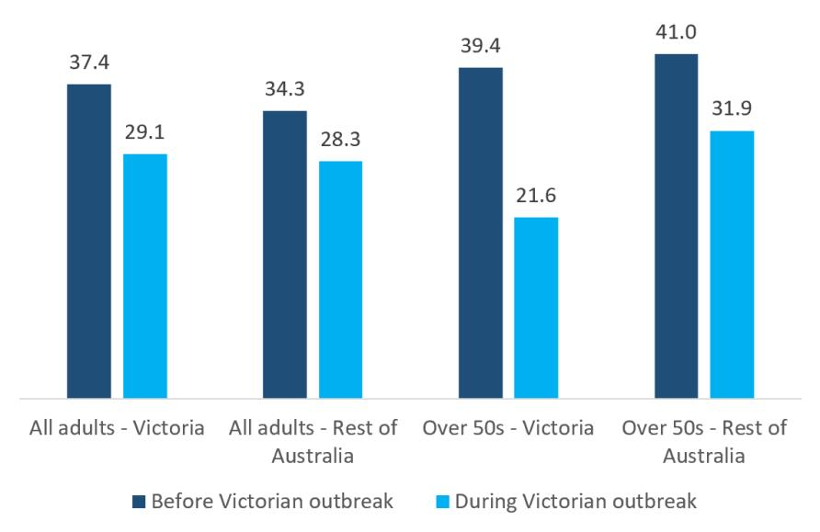

**From the below image we can able to come to know that India is the top country in terms full vaccination with 116 billon , followed by united states of America and china with 67 billion a35 billion respectively.**

**IMPORTING LIBRARIES:**

**import pandas as pd # data processing, CSV file**

**import numpy as np # linear algebra**

**I/O (e.g. pd.read_csv)**

**import matplotlib.pyplot as plt**

**import seaborn as sns**

**import plotly.express as px**

**from plotly.offline import**

**download_plotlyjs,init_notebook_mode,plot,iplot**

**import plotly.graph_objects as go**

**import plotly.figure_factory as ff**

**from plotly.colors import n_colors**

**from wordcloud import**

**WordCloud,ImageColorGenerator**

**init_notebook_mode(connected=True)**

**from plotly.subplots import make_subplots**

**from pywaffle import Waffle**

**import warnings**

**warnings.filterwarnings(&quot;ignore&quot;)nd**

**DATA ANALYSIS :**

**Here’s a simplified step-by- step guide on how you might approach this:**

**1.Data collection:**

**obtain a reliable dataset with covid19 vaccine information such as vaccination rates ,vaccine types and demographic data.**

**2.data cleaning:**

**remove duplicates and missing values Convert data types as needed Handle outliers and anomalies.**

**3.descriptive statistics:**

**Calculate basic statistics like mans ,median ,standard deviation Create summary tables and visualization to get a sense of the data.**

**4.visualization:**

**Plot histogram for vaccine distributed**

**Create bar charts to compare vaccine types or Manufactures.**

**5.correlation analysis:**

**Use correlation coefficients and scayyer plots to visualize these relationship.**

**6.Time series analysis:**

**If you have data over time analyze trends and**

**seasonality in vaccination rates.**

**7.hypothesis testing:**

**Test hypothesis related to vaccine efficacy.**

**8.geospatial analysis:**

**If you have geographic data perform spatial analysis.**

**9.machine learning:**

**If you have enough data perform predictive models to forecast future vaccination rates.**

**10.interpretation:**

**Provide meaningful insights and conclusion from your Analysis.**

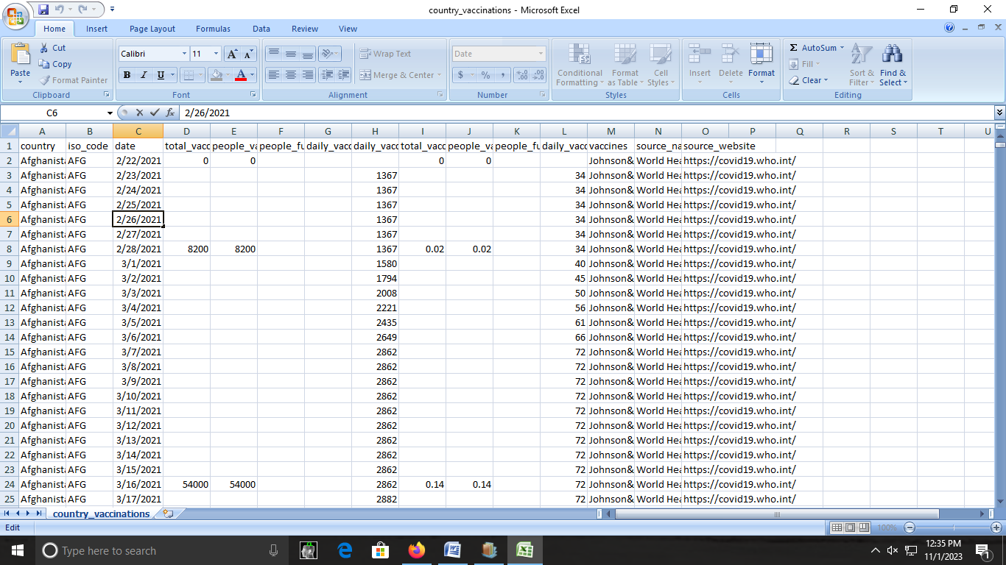

**Dataset Link:**

[**https://www.kaggle.com/datasets/gpreda/covid-world-vaccination-progress**](https://www.kaggle.com/datasets/gpreda/covid-world-vaccination-progress)

**Conclusion:**

**This is possible through a PHC approach that**

**provides universal access to good-quality health**

**services through empowered communities and**

**multi-sectoral policy and action for health**

**development.**