AtomLens Relay
Submission Credentials and Architecture
Prepared for AtomQuest Hackathon 1.0 judging upload
Project access summary
Application URL: http://localhost:3000
This project uses role-based access instead of a traditional username/password login page.
From the landing page, use Judge access pack to generate the latest Agent access URL, Customer access URL, and role tokens.
Judge credentials
Agent role: Call Agent
Customer role: Customer
Admin dashboard URL: http://localhost:3000/?admin=1
Admin dashboard key: demo-admin-key
Judge flow: open the home page, click Generate Judge Credentials, then open the generated Agent access URL and Customer access URL in separate browser tabs.
Architecture notes
Frontend: single-page browser UI for agent, customer, and admin operations.
Backend: Node.js HTTP server with a custom WebSocket relay for session, chat, and media transport.
Persistence: local storage under the data directory for session history, files, and recording metadata.
Recording: the agent can start and stop recording; the server packages separate media streams plus a manifest into a downloadable archive.
Observability: operational metrics are exposed at /metrics.
Architecture diagram
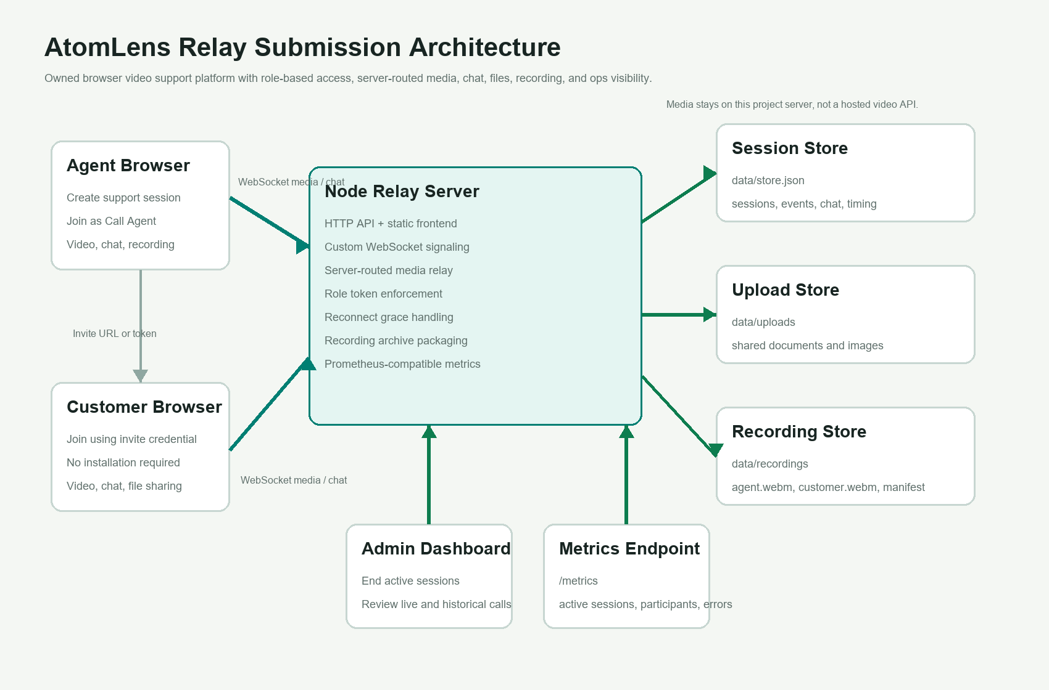
Figure 1. AtomLens Relay architecture for judging review.

