**AI BASED STOCK PRICE PREDICTION USING BERT MODEL**

**PROBLEM STATEMENT:**

The stock market has been a popular topic of interest in the recent past. The growth in the inflation rate has compelled people to invest in the stock and commodity markets and other areas rather than saving. Further, the ability of Deep Learning models to make predictions on the time series data has been proven time and again. Technical analysis on the stock market with the help of technical indicators has been the most common practice among traders and investors.

This project proposed an ensemble of state-of-the-art methods for predicting stock prices. Firstly sentiment analysis of the news and the headlines for the company Apple Inc, and is performed using a version of BERT, which is a pre-trained transformer model by Google for Natural Language Processing (NLP).

**PROCESS FLOW DIAGRAM:**

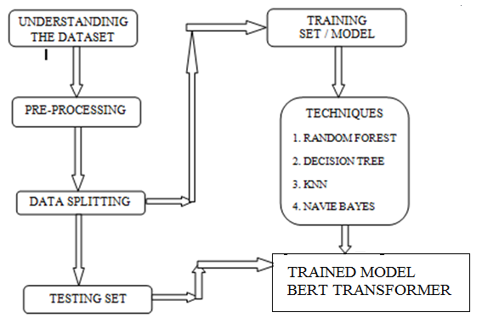

Figure: Process Flow Diagram For Ai Based Stock Price Prediction Using Bert

DATASET:

Download dataset from following link and put files in Data folder. This implementation train model to predict up/down trend.

DataSets DOI in figshare: 10.6084/m9.figshare.11977908 DataSets link in figshare