**AI BASED STOCK PRICE PREDICTION USING BERT MODEL**

**Program Code for Loading and Preprocessing Dataset:**

**(By BERT Transformer Model)**

import numpy as np

import pandas as pd

import tensorflow as tf

import matplotlib.pyplot as plt

from sklearn.model_selection import train_test_split

path = 'embedding_files/'

max_embedding = pd.read_json(path+'max_embedding.json')

min_embedding = pd.read_json(path+'min_embedding.json')

mean_embedding = pd.read_json(path+'mean_embedding.json')

sum_embedding = pd.read_json(path+'sum_embedding.json')

djia = pd.read_csv('data/DJIA_table.csv')

djia = djia.loc[:, ['Date', 'Open', 'Adj Close']].sort_values('Date').set_index('Date')



open_price = djia[['Open']]

adj_close_price = djia[['Adj Close']]

djia.head()

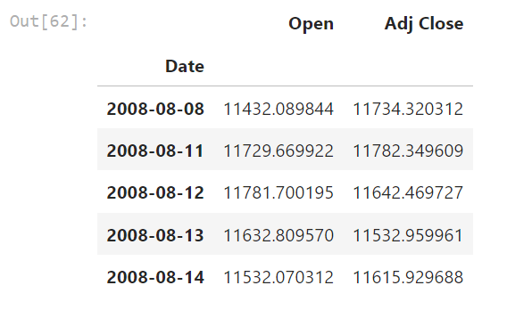

max_embedding.head(1)

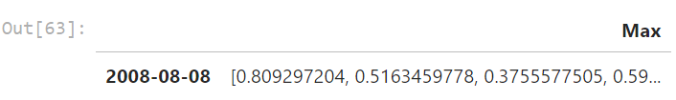

**Program Code for Feature-Extraction and Classification:**

def transform_data(tbl):

tbl = pd.DataFrame(tbl.iloc[:, 0].tolist())

tbl = tbl.set_index(djia.index)

return tbl

max_embedding = transform_data(max_embedding)

min_embedding = transform_data(min_embedding)

sum_embedding = transform_data(sum_embedding)

mean_embedding = transform_data(mean_embedding)

max_embedding.head(1)

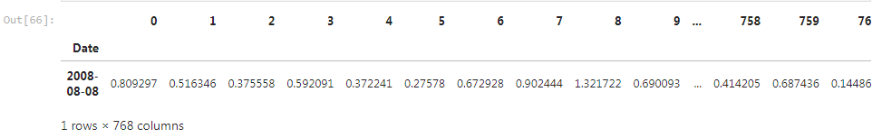

max_embedding.shape, open_price.shape, adj_close_price.shape



def split_test(embedding, test_size):

embedding_test = embedding.iloc[-test_size:, :]

embedding = embedding.iloc[:-test_size, :]

return embedding_test, embedding

test_size = 300

max_embedding_test, max_embedding = split_test(max_embedding, test_size)

min_embedding_test, min_embedding = split_test(min_embedding, test_size)

sum_embedding_test, sum_embedding = split_test(sum_embedding, test_size)

mean_embedding_test, mean_embedding = split_test(mean_embedding, test_size)

combined_embedding = pd.concat((mean_embedding, max_embedding, min_embedding, sum_embedding), axis=1)

combined_embedding_test = pd.concat((mean_embedding_test, max_embedding_test, min_embedding_test, sum_embedding_test), axis=1)

open_test, open_price = split_test(open_price, test_size)

adj_close_test, adj_close_price = split_test(adj_close_price, test_size)

max_embedding.shape, combined_embedding.shape, open_price.shape, adj_close_price.shape



def data_loader(data, batch_size, num_iter=100):

# x : Embedding Values

# y : Open Price

# z : Close Price

x = data[0]

y = data[1]

z = data[2]

# num_iter iterations per epoch

# mini batch

for _ in range(num_iter):

idx = np.random.choice(np.arange(x.shape[0]), size=batch_size, replace=False)

batch_x = x.iloc[idx, :]

batch_y = y.iloc[idx]

batch_z = z.iloc[idx]

yield batch_x, batch_y, batch_z

class get_model():

def __init__(self, learning_rate=1e-3, dropout_rate=.5):

self.learning_rate = learning_rate

self.dropout_rate = dropout_rate

# BERT Embedding

self.x = tf.placeholder(tf.float32, shape=(None, 768))

# Open Price

self.y = tf.placeholder(tf.float32, shape=(None, 1))

# Adj Close Price

self.z = tf.placeholder(tf.float32, shape=(None, 1))

self.pred = self.run_model()

self.loss = tf.sqrt(tf.losses.mean_squared_error(self.z, self.pred), name='loss')

self.optimizer = tf.train.AdamOptimizer(learning_rate=learning_rate, name='optimizer').minimize(self.loss)

self.saver = tf.train.Saver()

def run_model(self):

# Dense model

layer1 = tf.contrib.layers.fully_connected(self.x, 1000)

layer1 = tf.nn.dropout(layer1, rate=self.dropout_rate)

layer1 = tf.layers.batch_normalization(layer1)

layer2 = tf.contrib.layers.fully_connected(layer1, 500)

layer2 = tf.nn.dropout(layer2, rate=self.dropout_rate)

layer2 = tf.layers.batch_normalization(layer2)

# This would be the value of coefficient indicating how much it impacts on a day's open price

layer3 = tf.contrib.layers.fully_connected(layer2, 1)

layer4 = layer3 * self.y

layer5 = tf.contrib.layers.fully_connected(layer4, 100)

layer5 = tf.nn.dropout(layer5, rate=self.dropout_rate)

layer5 = tf.layers.batch_normalization(layer5)

output = tf.contrib.layers.fully_connected(layer5, 1)

return output

def get_data(embedding):

X = pd.concat((embedding, open_price), axis=1)

X_train, X_valid, y_train, y_valid = train_test_split(X, adj_close_price, test_size=.2)

return [X_train.iloc[:, :-1], X_train.iloc[:, -1:], y_train], [X_valid.iloc[:, :-1], X_valid.iloc[:, -1:], y_valid]

mean_data_train, mean_data_valid = get_data(mean_embedding)

max_data_train, max_data_valid = get_data(max_embedding)

min_data_train, min_data_valid = get_data(min_embedding)

sum_data_train, sum_data_valid = get_data(sum_embedding)

combined_data_train, combined_data_valid = get_data(combined_embedding)

# Train

data_name = {'mean_embedding':[mean_data_train, mean_data_valid],

'max_embedding':[max_data_train, max_data_valid],

'min_embedding':[min_data_train, min_data_valid],

'sum_embedding':[sum_data_train, sum_data_valid]}

def train_model(embedding_name, learning_rate=1e-5, epochs=300, batch_size=16, dropout_rate=.5, load_params=True,

verbose=True, save_model=True):

data_train, data_valid = data_name[embedding_name]

tf.reset_default_graph()

model = get_model(learning_rate=learning_rate, dropout_rate=dropout_rate)

# For plots

train_losses = []

valid_losses = []

with tf.Session() as sess:

sess.run(tf.global_variables_initializer())

if load_params:

# Load Model

try:

print(f'------------- Attempting to Load {embedding_name} Model -------------')

model.saver.restore(sess, f'./model/{embedding_name}_model.ckpt')

print(f'------------- {embedding_name} Model Loaded -------------')

except:

print('Training New Model')

else:

print('Training New Model')

# Train Model

print('\n------------- Training Model -------------\n')

for epoch in range(epochs):

for x, y, z in data_loader(data_train, batch_size=batch_size):

train_loss, _ = sess.run([model.loss, model.optimizer], feed_dict={model.x:x,

model.y:y,

model.z:z})

# x : embedding, y : open price, z : close price

valid_loss = sess.run(model.loss, feed_dict={model.x:data_valid[0],

model.y:data_valid[1],

model.z:data_valid[2]})

# print losses

if verbose:

print(f'Epoch {epoch+1}/{epochs}, Train RMSE Loss {train_loss}, Valid RMSE Loss {valid_loss}')

# Save Model at every 20 epochs

if save_model:

if (epoch+1) % 20 == 0 and epoch > 0:

if not os.path.exists('./model'):

os.mkdir('./model/')

model.saver.save(sess, f"./model/{embedding_name}_model.ckpt")

print('\n------------- Model Saved -------------\n')

train_losses.append(train_loss)

valid_losses.append(valid_loss)

return model, train_losses, valid_losses

# Possible Names : mean_embedding, max_embedding, min_embedding, sum_embedding

epochs = 300

learning_rate = 1e-4

#New Model for Combined Dataset

class combined_model():

def __init__(self, learning_rate=1e-3, dropout_rate=.5):

self.learning_rate = learning_rate

self.dropout_rate = dropout_rate

# BERT Embedding

self.x = tf.placeholder(tf.float32, shape=(None, 3072))

# Open Price

self.y = tf.placeholder(tf.float32, shape=(None, 1))

# Adj Close Price

self.z = tf.placeholder(tf.float32, shape=(None, 1))

self.pred = self.run_model()

self.loss = tf.sqrt(tf.losses.mean_squared_error(self.z, self.pred), name='loss')

self.optimizer = tf.train.AdamOptimizer(learning_rate=learning_rate, name='optimizer').minimize(self.loss)

self.saver = tf.train.Saver()

def run_model(self):

# Dense layers

layer1 = tf.contrib.layers.fully_connected(self.x, 1000)

layer1 = tf.nn.dropout(layer1, rate=self.dropout_rate)

layer1 = tf.layers.batch_normalization(layer1)

layer2 = tf.contrib.layers.fully_connected(layer1, 500)

layer2 = tf.nn.dropout(layer2, rate=self.dropout_rate)

layer2 = tf.layers.batch_normalization(layer2)

# Coefficient of impact values

layer3 = tf.contrib.layers.fully_connected(layer2, 1)

layer4 = layer3 * self.y

layer5 = tf.contrib.layers.fully_connected(layer4, 100)

layer5 = tf.nn.dropout(layer5, rate=self.dropout_rate)

layer5 = tf.layers.batch_normalization(layer5)

output = tf.contrib.layers.fully_connected(layer5, 1)

return output

tf.reset_default_graph()

model = combined_model(learning_rate=1e-4, dropout_rate=.5)

epochs = 300

combined_train_losses = []

combined_valid_losses = []

with tf.Session() as sess:

sess.run(tf.global_variables_initializer())

try:

print(f'------------- Attempting to Load Combined Model -------------')

model.saver.restore(sess, f'./model/combined_model.ckpt')

print(f'------------- Combined Model Loaded -------------')

except:

print('Training New Model')

# Train Model

print('\n------------- Training Model -------------\n')

for epoch in range(epochs):

for x, y, z in data_loader(combined_data_train, batch_size=16):

train_loss, _ = sess.run([model.loss, model.optimizer], feed_dict={model.x:x,

model.y:y,

model.z:z})

valid_loss = sess.run(model.loss, feed_dict={model.x:combined_data_valid[0],

model.y:combined_data_valid[1],

model.z:combined_data_valid[2]})

if epoch % 20 == 0:

print(f'Epoch {epoch+1}/{epochs}, Combined Train RMSE Loss {train_loss}, Combined Valid RMSE Loss {valid_loss}')

if not os.path.exists('./model'):

os.mkdir('./model/')

model.saver.save(sess, f"./model/combined_model.ckpt")

print('\n------------- Model Saved -------------\n')

combined_train_losses.append(train_loss)

combined_valid_losses.append(valid_loss)

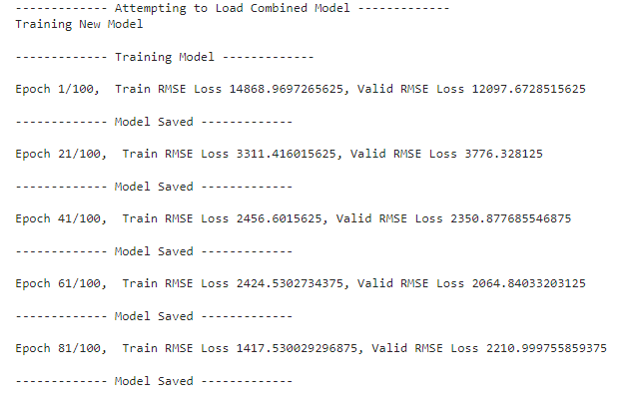

# Losses of each model

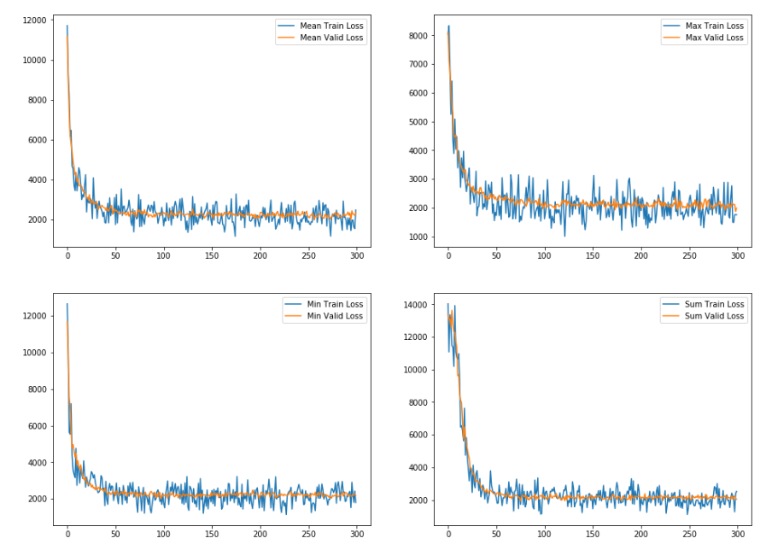

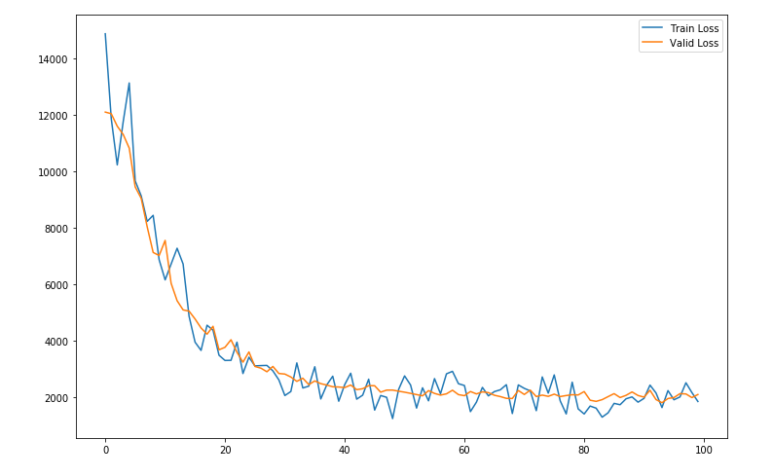

embedding_data = {'mean_embedding':mean_embedding_test,

'max_embedding':max_embedding_test,

'min_embedding':min_embedding_test,

'sum_embedding':sum_embedding_test}

def predict_model(embedding_name):

tf.reset_default_graph()

data = embedding_data[embedding_name]

model = get_model(learning_rate=1e-5)

with tf.Session() as sess:

sess.run(tf.global_variables_initializer())

# Load Model

try:

print(f'------------- Attempting to Load {embedding_name} Model -------------')

model.saver.restore(sess, f'./model/{embedding_name}_model.ckpt')

print('------------- Model Loaded -------------')

except:

pass

pred = sess.run(model.pred, feed_dict={model.x:data,

model.y:open_test})

return model, pred

mean_model, mean_pred = predict_model('mean_embedding')

max_model, max_pred = predict_model('max_embedding')

sum_model, sum_pred = predict_model('sum_embedding')

min_model, min_pred = predict_model('min_embedding')

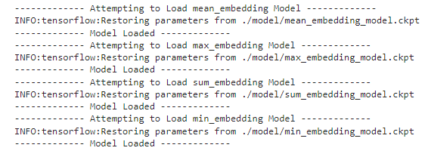

tf.reset_default_graph()

model = combined_model(learning_rate=1e-5)

with tf.Session() as sess:

sess.run(tf.global_variables_initializer())

# Load Model

try:

print(f'------------- Attempting to Load Combined Model -------------')

model.saver.restore(sess, f'./model/combined_model.ckpt')

print('------------- Model Loaded -------------')

except:

pass

combined_pred = sess.run(model.pred, feed_dict={model.x:combined_embedding_test,

model.y:open_test})

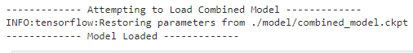

mean_pred = mean_pred.flatten()

max_pred = max_pred.flatten()

min_pred = min_pred.flatten()

sum_pred = sum_pred.flatten()

combined_pred = combined_pred.flatten()

