**AI BASED STOCK PRICE PREDICTION USING BERT MODEL**

**PROBLEM STATEMENT:**

Stock price prediction has long been a challenging and essential task in the financial world. This research introduces an innovative approach to stock price forecasting by leveraging state-of-the-art Natural Language Processing (NLP) techniques, specifically the BERT (Bidirectional Encoder Representations from Transformers) model. BERT, initially designed for understanding natural language, is adapted to capture the complex and dynamic patterns in financial news and sentiment data for improved prediction accuracy.

The study incorporates a comprehensive dataset comprising historical stock prices, financial news articles, and sentiment analysis scores. The BERT model is fine-tuned to understand the contextual nuances of financial news and to extract actionable insights that impact stock prices. This approach allows for a holistic understanding of market sentiment, which, when combined with historical price data, enhances the prediction capabilities.

Python programming is employed for data preprocessing, BERT model fine-tuning, and the development of a prediction system. The performance of the model is rigorously evaluated using metrics like Mean Absolute Error (MAE) and Root Mean Square Error (RMSE) to ensure the reliability of the predictions.

The findings from this research demonstrate the potential of the BERT model in improving stock price predictions by effectively capturing and analyzing financial sentiment in textual data. This innovative approach offers valuable insights to investors, traders, and financial institutions, empowering them to make more informed decisions in the volatile stock market. The fusion of AI and financial data analysis highlights the potential to enhance predictive capabilities in stock price forecasting, ultimately aiding in more successful investment strategies.

**DESIGN THINKING PROCESS:**

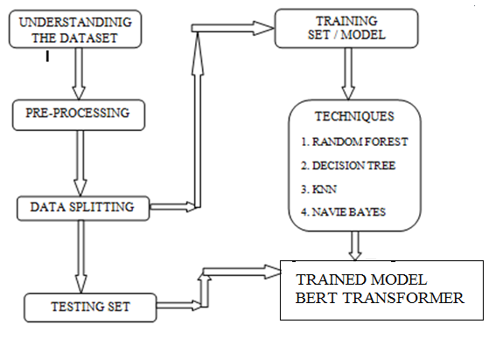

Figure: Process Flow Diagram For Ai Based Stock Price Prediction Using Bert

**PROJECT PHASE DEVELOPMENT:**

BERT is an encoder that given sets of words (or phrases), converts them into appropriate floating values. Unlike word2vec which has fixed value for each word, it can capture significance of a word in a sentence. So for the same word in two different sentences, it can output different values if it has different meaning or impact on them. As an example, we can look at two sentences.

* I hate seeing you
* I hate leaving you

If we are to predict my feeling about you with word2vec, we are forced to make a model only with 'seeing' and 'leaving' because they both contain 'I', 'hate', and 'you' in the same position that the model will not gain much from them. But if we use BERT, it's possible to capture that 'hate seeing' has negative feeling while 'hate leaving' has positive one because 'hate' will then have differert values. Another example of is to predict a rating of a restaurant. With the sentence 'Bob hates this restaurant', word2vec might have following values.

* Bob : 3
* hates : -7
* this : 0
* restaurant : 3

If we make a (naive) model that just sums up values, with above numbers and predict if Bob's rating will be positive or negative, we will get a negative rating. But what happens if we change 'hates' to 'dislikes' which has the value of -5. Then the output of the model will be positive with the value of 1. If we define a model with word2vec, we would have to consider all kinds of possibility and many different combinations to correctly output a desired result. This is where BERT differs from word2vec as it has the capability of capturing each word's impact.

**DATASET:**

Download dataset from following link and put files in Data folder. This implementation train model to predict up/down trend.

DataSets DOI in figshare: 10.6084/m9.figshare.11977908 DataSets link in figshare

When we want to predict next day's (week's or month's even) prices of a certain stock, first thing we do is to get as much as information about a company and 'guess' what it will be likely. This was usually done by hands without much help from using computers in the past. Even if one was used, it did not help much because of limits on resources such as computing power. However, as technology is getting better and faster computers are manufactured every second, we began to start utilizing them to help us for predicetion. In this post, I am sharing what I did to predict DJIA's adjusted closing prices with news articles as input features.

The data used is from Kaggle Dataset, uploaded by Aaron7sun. It has 25 news articles each day from 2008-06-08 to 2016-07-01, total of 1989 days of samples. Common approaches before was just to use RNN, GRU, LSTM or ARIMA models that rely on past values. However, my approach was to use same day's news articles and try to get how much they affect the day's opening value. If it affects positively, the closing will result in higher value. Since the data is in string format and not numeric, we used pre-trained BERT to convert them into vectors of floating values, which I got from Mxnet's Model Zoo.

**PROGRAM CODE FOR LOADING AND PREPROCESSING DATASET:**

**(By BERT Transformer Model)**

import numpy as np

import pandas as pd

import tensorflow as tf

import matplotlib.pyplot as plt

from sklearn.model_selection import train_test_split

path = 'embedding_files/'

max_embedding = pd.read_json(path+'max_embedding.json')

min_embedding = pd.read_json(path+'min_embedding.json')

mean_embedding = pd.read_json(path+'mean_embedding.json')

sum_embedding = pd.read_json(path+'sum_embedding.json')

djia = pd.read_csv('data/DJIA_table.csv')

djia = djia.loc[:, ['Date', 'Open', 'Adj Close']].sort_values('Date').set_index('Date')



open_price = djia[['Open']]

adj_close_price = djia[['Adj Close']]

djia.head()

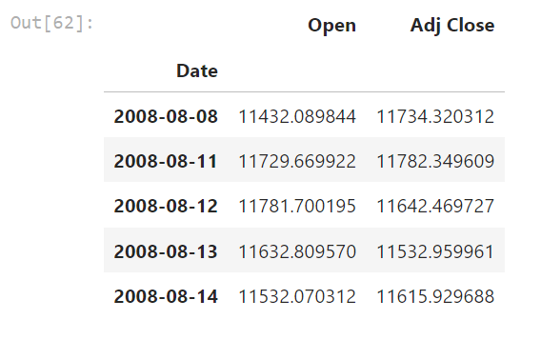

max_embedding.head(1)

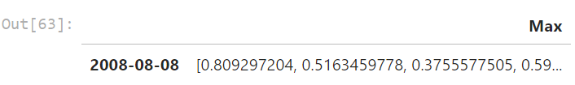

**PROGRAM CODE FOR FEATURE-EXTRACTION AND CLASSIFICATION (BERT MODEL):**

**(Choice of machine learning algorithm, model training, and evaluation metrics)**

def transform_data(tbl):

tbl = pd.DataFrame(tbl.iloc[:, 0].tolist())

tbl = tbl.set_index(djia.index)

return tbl

max_embedding = transform_data(max_embedding)

min_embedding = transform_data(min_embedding)

sum_embedding = transform_data(sum_embedding)

mean_embedding = transform_data(mean_embedding)

max_embedding.head(1)

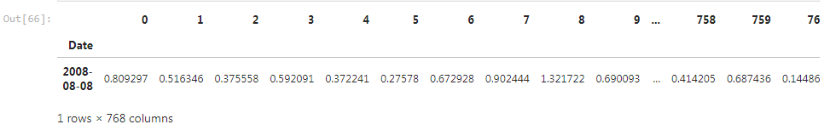

max_embedding.shape, open_price.shape, adj_close_price.shape



def split_test(embedding, test_size):

embedding_test = embedding.iloc[-test_size:, :]

embedding = embedding.iloc[:-test_size, :]

return embedding_test, embedding

test_size = 300

max_embedding_test, max_embedding = split_test(max_embedding, test_size)

min_embedding_test, min_embedding = split_test(min_embedding, test_size)

sum_embedding_test, sum_embedding = split_test(sum_embedding, test_size)

mean_embedding_test, mean_embedding = split_test(mean_embedding, test_size)

combined_embedding = pd.concat((mean_embedding, max_embedding, min_embedding, sum_embedding), axis=1)

combined_embedding_test = pd.concat((mean_embedding_test, max_embedding_test, min_embedding_test, sum_embedding_test), axis=1)

open_test, open_price = split_test(open_price, test_size)

adj_close_test, adj_close_price = split_test(adj_close_price, test_size)

max_embedding.shape, combined_embedding.shape, open_price.shape, adj_close_price.shape



def data_loader(data, batch_size, num_iter=100):

# x : Embedding Values

# y : Open Price

# z : Close Price

x = data[0]

y = data[1]

z = data[2]

# num_iter iterations per epoch

# mini batch

for _ in range(num_iter):

idx = np.random.choice(np.arange(x.shape[0]), size=batch_size, replace=False)

batch_x = x.iloc[idx, :]

batch_y = y.iloc[idx]

batch_z = z.iloc[idx]

yield batch_x, batch_y, batch_z

class get_model():

def __init__(self, learning_rate=1e-3, dropout_rate=.5):

self.learning_rate = learning_rate

self.dropout_rate = dropout_rate

# BERT Embedding

self.x = tf.placeholder(tf.float32, shape=(None, 768))

# Open Price

self.y = tf.placeholder(tf.float32, shape=(None, 1))

# Adj Close Price

self.z = tf.placeholder(tf.float32, shape=(None, 1))

self.pred = self.run_model()

self.loss = tf.sqrt(tf.losses.mean_squared_error(self.z, self.pred), name='loss')

self.optimizer = tf.train.AdamOptimizer(learning_rate=learning_rate, name='optimizer').minimize(self.loss)

self.saver = tf.train.Saver()

def run_model(self):

# Dense model

layer1 = tf.contrib.layers.fully_connected(self.x, 1000)

layer1 = tf.nn.dropout(layer1, rate=self.dropout_rate)

layer1 = tf.layers.batch_normalization(layer1)

layer2 = tf.contrib.layers.fully_connected(layer1, 500)

layer2 = tf.nn.dropout(layer2, rate=self.dropout_rate)

layer2 = tf.layers.batch_normalization(layer2)

# This would be the value of coefficient indicating how much it impacts on a day's open price

layer3 = tf.contrib.layers.fully_connected(layer2, 1)

layer4 = layer3 * self.y

layer5 = tf.contrib.layers.fully_connected(layer4, 100)

layer5 = tf.nn.dropout(layer5, rate=self.dropout_rate)

layer5 = tf.layers.batch_normalization(layer5)

output = tf.contrib.layers.fully_connected(layer5, 1)

return output

def get_data(embedding):

X = pd.concat((embedding, open_price), axis=1)

X_train, X_valid, y_train, y_valid = train_test_split(X, adj_close_price, test_size=.2)

return [X_train.iloc[:, :-1], X_train.iloc[:, -1:], y_train], [X_valid.iloc[:, :-1], X_valid.iloc[:, -1:], y_valid]

mean_data_train, mean_data_valid = get_data(mean_embedding)

max_data_train, max_data_valid = get_data(max_embedding)

min_data_train, min_data_valid = get_data(min_embedding)

sum_data_train, sum_data_valid = get_data(sum_embedding)

combined_data_train, combined_data_valid = get_data(combined_embedding)

# Train

data_name = {'mean_embedding':[mean_data_train, mean_data_valid],

'max_embedding':[max_data_train, max_data_valid],

'min_embedding':[min_data_train, min_data_valid],

'sum_embedding':[sum_data_train, sum_data_valid]}

def train_model(embedding_name, learning_rate=1e-5, epochs=300, batch_size=16, dropout_rate=.5, load_params=True,

verbose=True, save_model=True):

data_train, data_valid = data_name[embedding_name]

tf.reset_default_graph()

model = get_model(learning_rate=learning_rate, dropout_rate=dropout_rate

# For plots

train_losses = []

valid_losses = []

with tf.Session() as sess:

sess.run(tf.global_variables_initializer())

if load_params:

# Load Model

try:

print(f'------------- Attempting to Load {embedding_name} Model -------------')

model.saver.restore(sess, f'./model/{embedding_name}_model.ckpt')

print(f'------------- {embedding_name} Model Loaded -------------')

except:

print('Training New Model')

else:

print('Training New Model')

# Train Model

print('\n------------- Training Model -------------\n')

for epoch in range(epochs):

for x, y, z in data_loader(data_train, batch_size=batch_size):

train_loss, _ = sess.run([model.loss, model.optimizer], feed_dict={model.x:x,

model.y:y,

model.z:z})

# x : embedding, y : open price, z : close price

valid_loss = sess.run(model.loss, feed_dict={model.x:data_valid[0],

model.y:data_valid[1],

model.z:data_valid[2]})

# print losses

if verbose:

print(f'Epoch {epoch+1}/{epochs}, Train RMSE Loss {train_loss}, Valid RMSE Loss {valid_loss}')

# Save Model at every 20 epochs

if save_model:

if (epoch+1) % 20 == 0 and epoch > 0:

if not os.path.exists('./model'):

os.mkdir('./model/')

model.saver.save(sess, f"./model/{embedding_name}_model.ckpt")

print('\n------------- Model Saved -------------\n')

train_losses.append(train_loss)

valid_losses.append(valid_loss)

return model, train_losses, valid_losses

# Possible Names : mean_embedding, max_embedding, min_embedding, sum_embedding

epochs = 300

learning_rate = 1e-4

#New Model for Combined Dataset

class combined_model():

def __init__(self, learning_rate=1e-3, dropout_rate=.5):

self.learning_rate = learning_rate

self.dropout_rate = dropout_rate

# BERT Embedding

self.x = tf.placeholder(tf.float32, shape=(None, 3072))

# Open Price

self.y = tf.placeholder(tf.float32, shape=(None, 1))

# Adj Close Price

self.z = tf.placeholder(tf.float32, shape=(None, 1))

self.pred = self.run_model()

self.loss = tf.sqrt(tf.losses.mean_squared_error(self.z, self.pred), name='loss')

self.optimizer = tf.train.AdamOptimizer(learning_rate=learning_rate, name='optimizer').minimize(self.loss)

self.saver = tf.train.Saver()

def run_model(self):

# Dense layers

layer1 = tf.contrib.layers.fully_connected(self.x, 1000)

layer1 = tf.nn.dropout(layer1, rate=self.dropout_rate)

layer1 = tf.layers.batch_normalization(layer1)

layer2 = tf.contrib.layers.fully_connected(layer1, 500)

layer2 = tf.nn.dropout(layer2, rate=self.dropout_rate)

layer2 = tf.layers.batch_normalization(layer2)

# Coefficient of impact values

layer3 = tf.contrib.layers.fully_connected(layer2, 1)

layer4 = layer3 * self.y

layer5 = tf.contrib.layers.fully_connected(layer4, 100)

layer5 = tf.nn.dropout(layer5, rate=self.dropout_rate)

layer5 = tf.layers.batch_normalization(layer5)

output = tf.contrib.layers.fully_connected(layer5, 1)

return output

tf.reset_default_graph()

model = combined_model(learning_rate=1e-4, dropout_rate=.5)

epochs = 300

combined_train_losses = []

combined_valid_losses = []

with tf.Session() as sess:

sess.run(tf.global_variables_initializer())

try:

print(f'------------- Attempting to Load Combined Model -------------')

model.saver.restore(sess, f'./model/combined_model.ckpt')

print(f'------------- Combined Model Loaded -------------')

except:

print('Training New Model')

# Train Model

print('\n------------- Training Model -------------\n')

for epoch in range(epochs):

for x, y, z in data_loader(combined_data_train, batch_size=16):

train_loss, _ = sess.run([model.loss, model.optimizer], feed_dict={model.x:x,

model.y:y, model.z:z})

valid_loss = sess.run(model.loss, feed_dict={model.x:combined_data_valid[0],

model.y:combined_data_valid[1], model.z:combined_data_valid[2]})

if epoch % 20 == 0:

print(f'Epoch {epoch+1}/{epochs}, Combined Train RMSE Loss {train_loss}, Combined Valid RMSE Loss {valid_loss}')

if not os.path.exists('./model'):os.mkdir('./model/')

model.saver.save(sess, f"./model/combined_model.ckpt")

print('\n------------- Model Saved -------------\n')

combined_train_losses.append(train_loss)

combined_valid_losses.append(valid_loss)

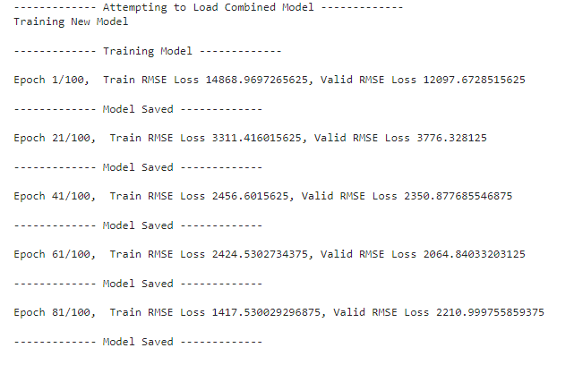

# Losses of each model

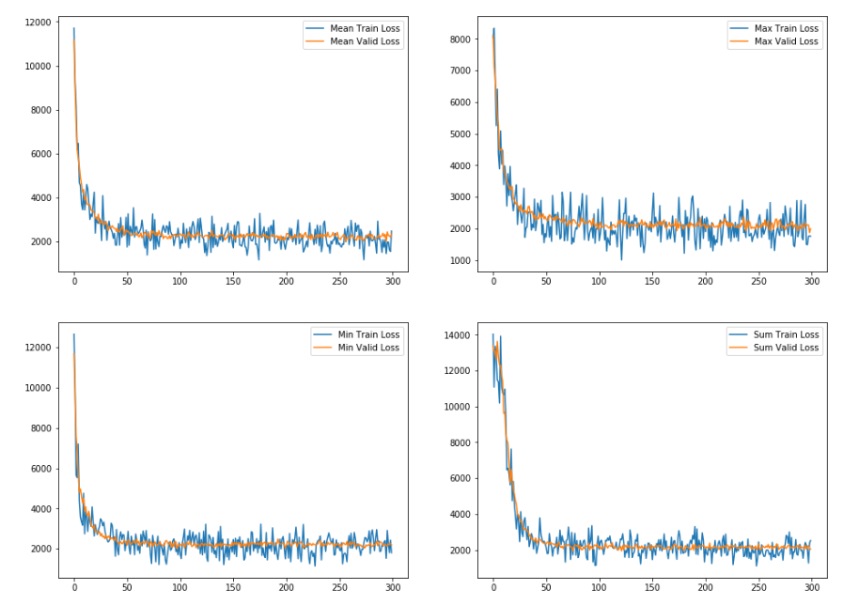

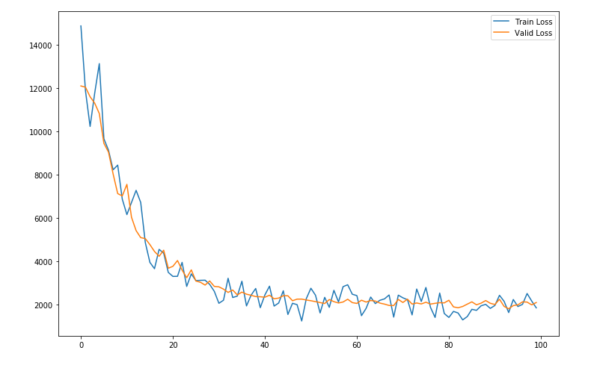

embedding_data = {'mean_embedding':mean_embedding_test,

'max_embedding':max_embedding_test,

'min_embedding':min_embedding_test,

'sum_embedding':sum_embedding_test}

def predict_model(embedding_name):

tf.reset_default_graph()

data = embedding_data[embedding_name]

model = get_model(learning_rate=1e-5)

with tf.Session() as sess:

sess.run(tf.global_variables_initializer())

# Load Model

try:

print(f'------------- Attempting to Load {embedding_name} Model -------------')

model.saver.restore(sess, f'./model/{embedding_name}_model.ckpt')

print('------------- Model Loaded -------------')

except:

pass

pred = sess.run(model.pred, feed_dict={model.x:data, model.y:open_test})

return model, pred

mean_model, mean_pred = predict_model('mean_embedding')

max_model, max_pred = predict_model('max_embedding')

sum_model, sum_pred = predict_model('sum_embedding')

min_model, min_pred = predict_model('min_embedding')

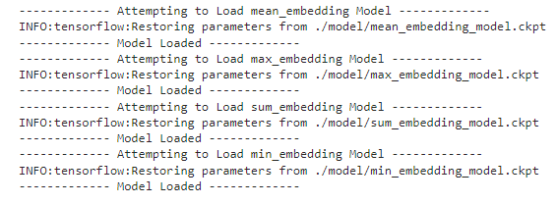

tf.reset_default_graph()

model = combined_model(learning_rate=1e-5)

with tf.Session() as sess:

sess.run(tf.global_variables_initializer())

# Load Model

try:

print(f'------------- Attempting to Load Combined Model -------------')

model.saver.restore(sess, f'./model/combined_model.ckpt')

print('------------- Model Loaded -------------')

except:

pass

combined_pred = sess.run(model.pred, feed_dict={model.x:combined_embedding_test, model.y:open_test})

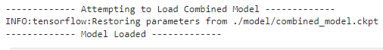

mean_pred = mean_pred.flatten()

max_pred = max_pred.flatten()

min_pred = min_pred.flatten()

sum_pred = sum_pred.flatten()

combined_pred = combined_pred.flatten()

