**AI BASED STOCK PRICE PREDICTION USING BERT MODEL**

**Program Code for Loading and Preprocessing Dataset:**

**(By BERT Transformer Model)**

import numpy as np

import pandas as pd

import tensorflow as tf

import matplotlib.pyplot as plt

from sklearn.model_selection import train_test_split

path = 'embedding_files/'

max_embedding = pd.read_json(path+'max_embedding.json')

min_embedding = pd.read_json(path+'min_embedding.json')

mean_embedding = pd.read_json(path+'mean_embedding.json')

sum_embedding = pd.read_json(path+'sum_embedding.json')

djia = pd.read_csv('data/DJIA_table.csv')

djia = djia.loc[:, ['Date', 'Open', 'Adj Close']].sort_values('Date').set_index('Date')



open_price = djia[['Open']]

adj_close_price = djia[['Adj Close']]

djia.head()

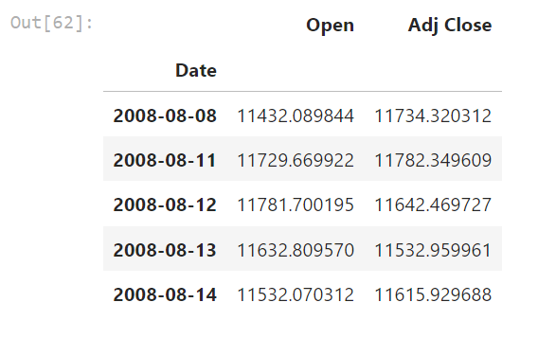

max_embedding.head(1)

