Filehandling:

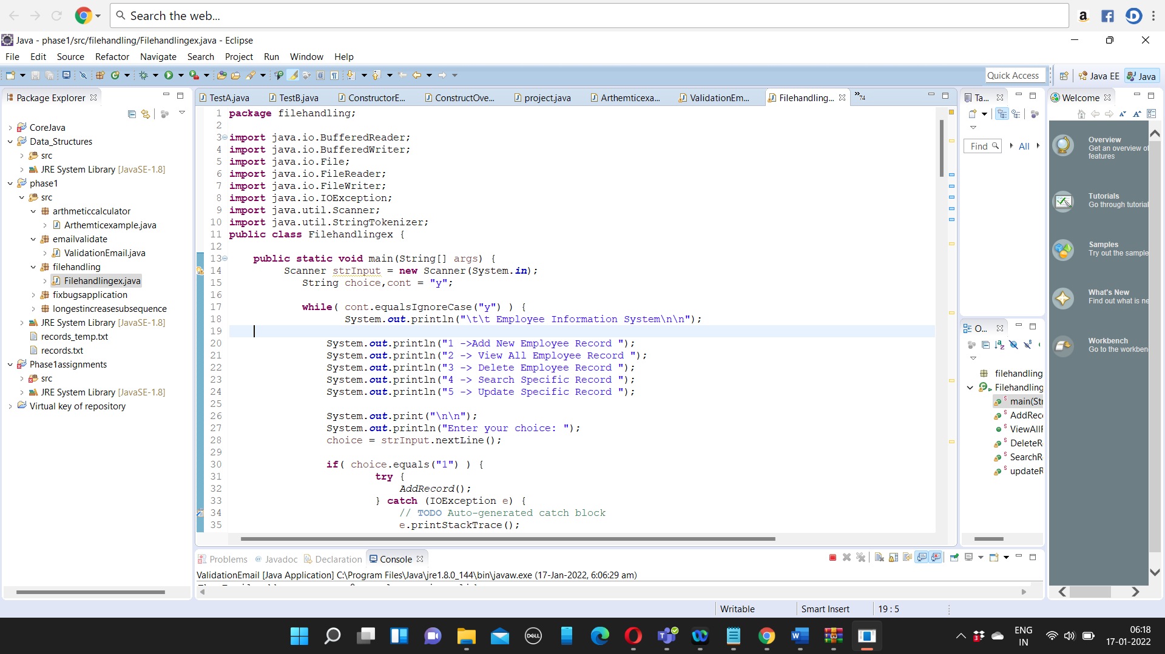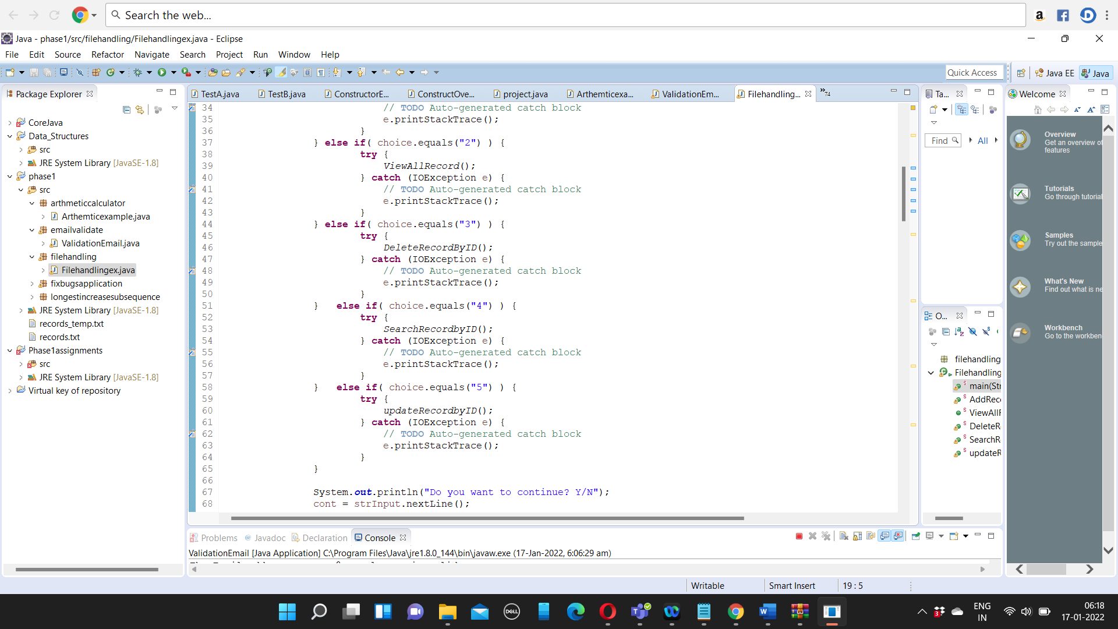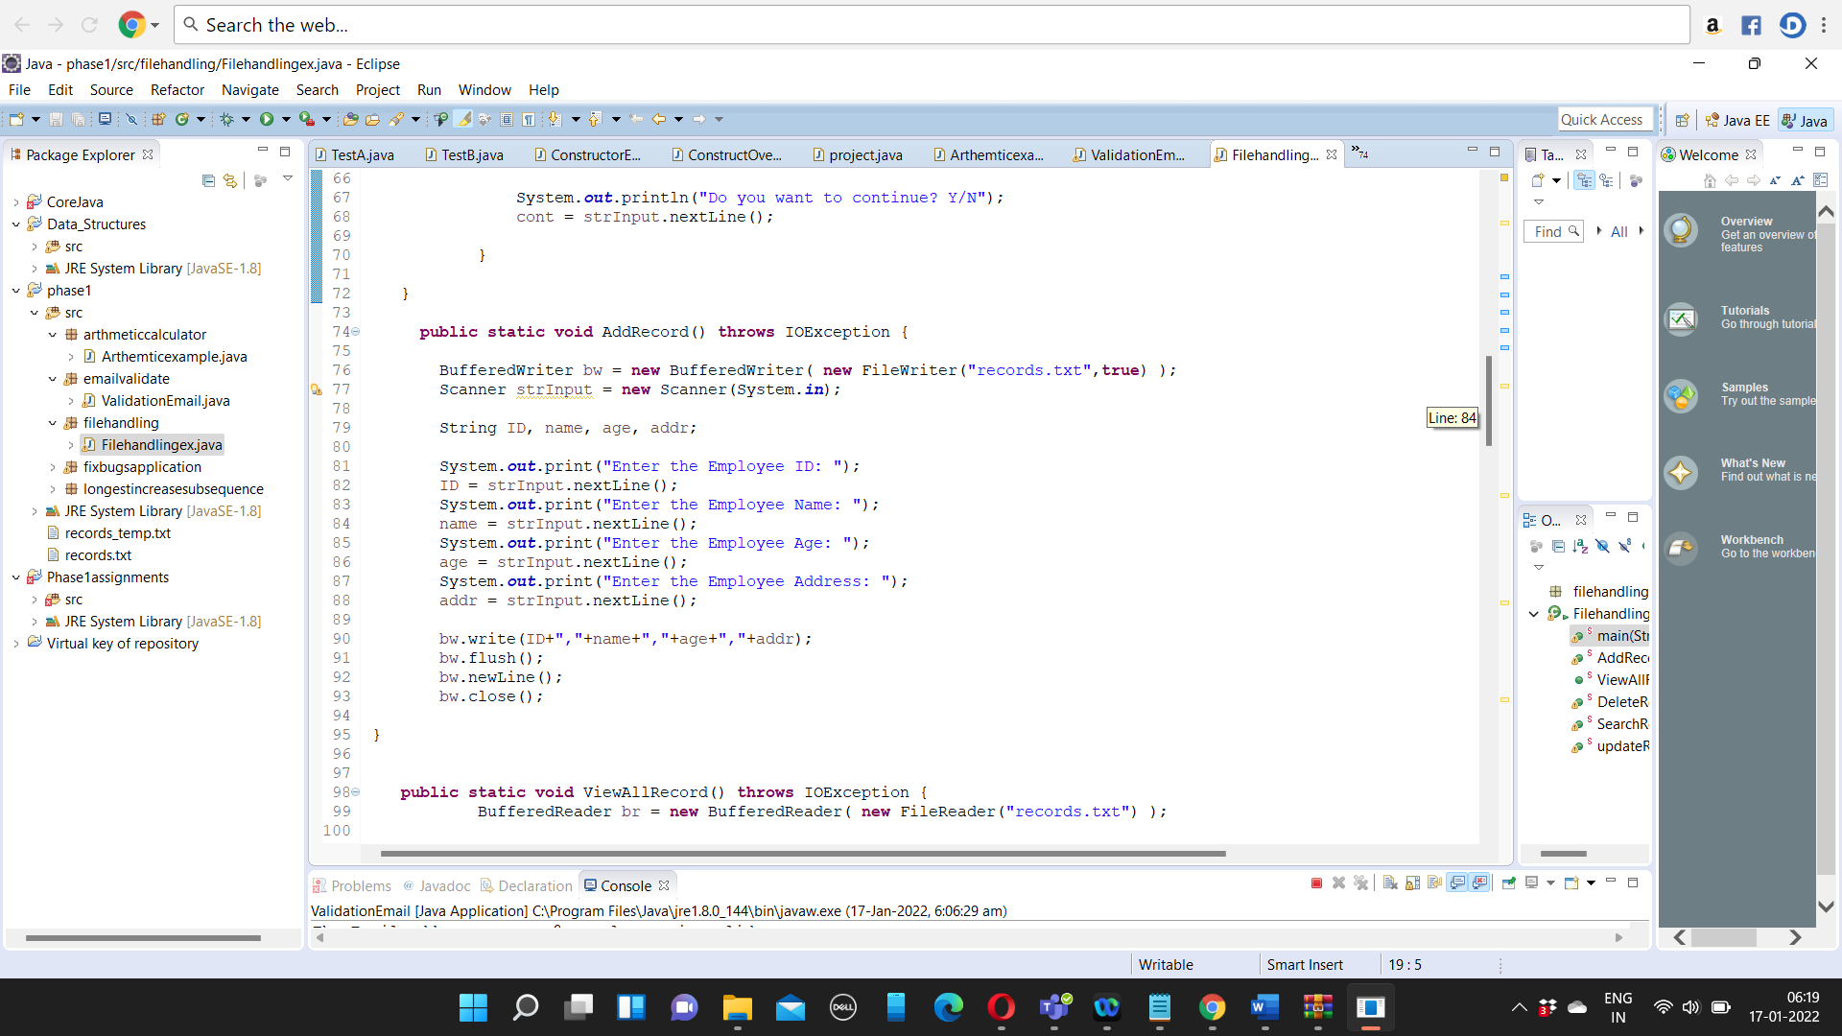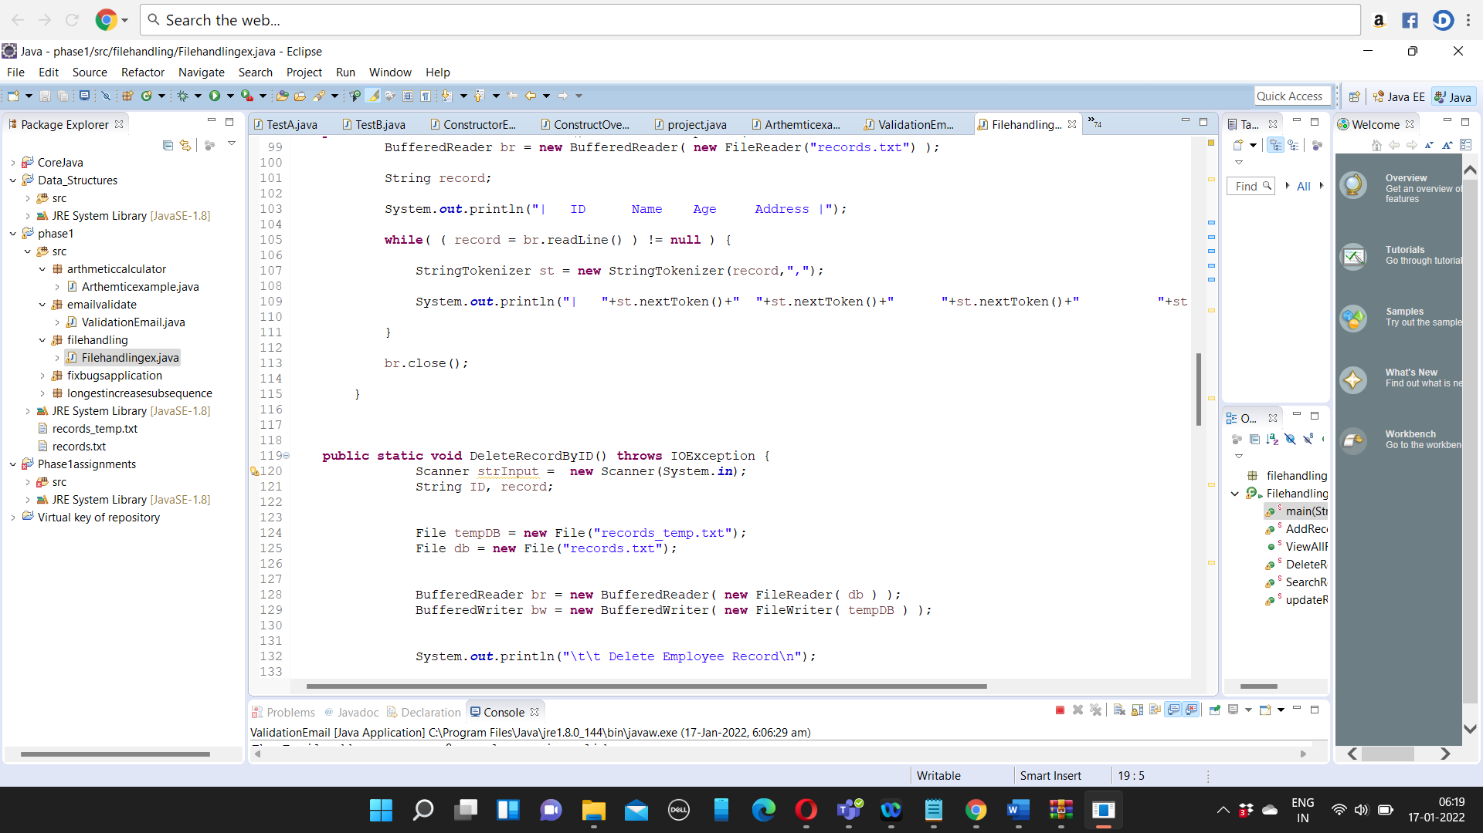

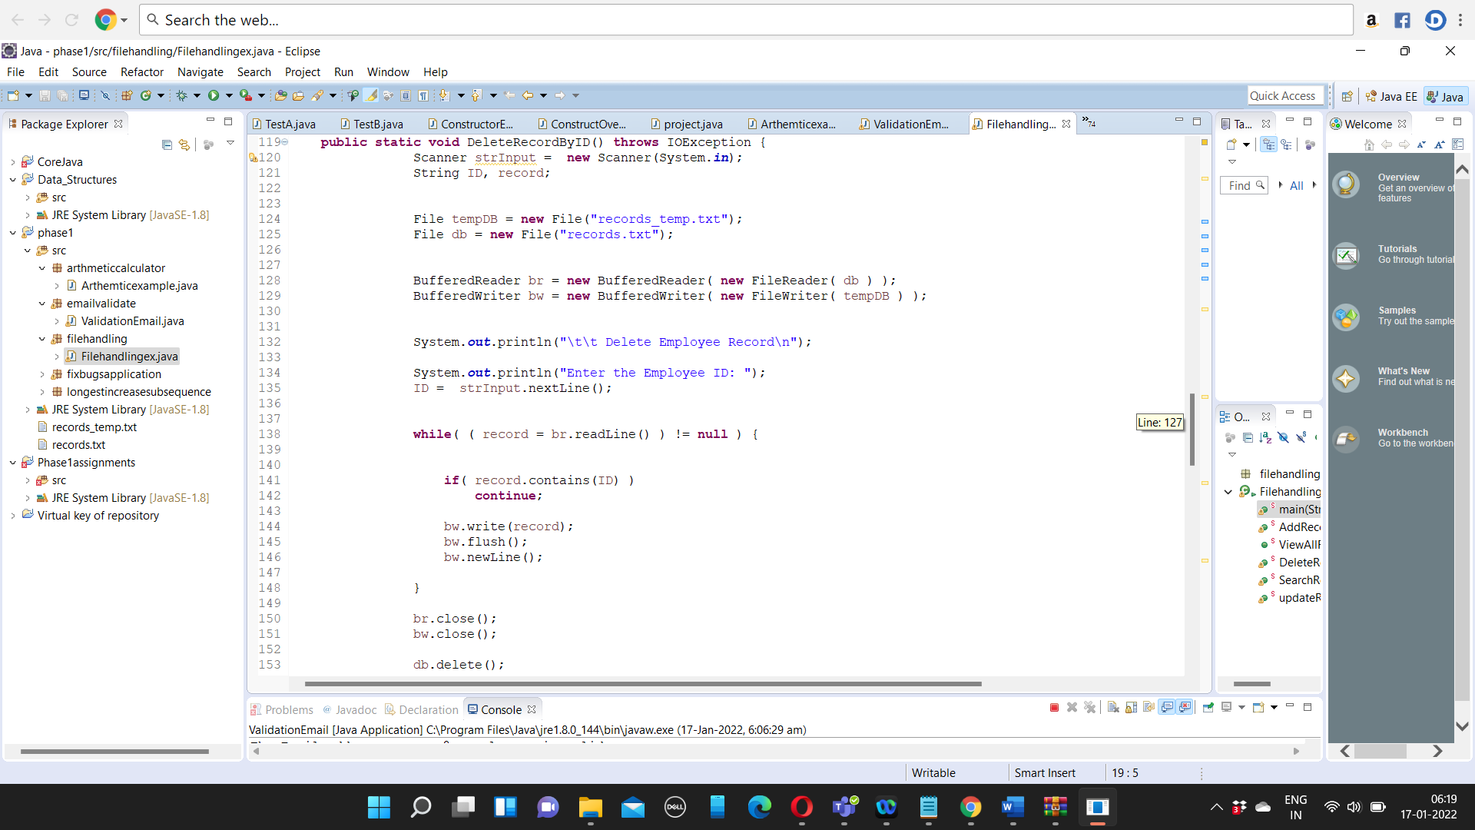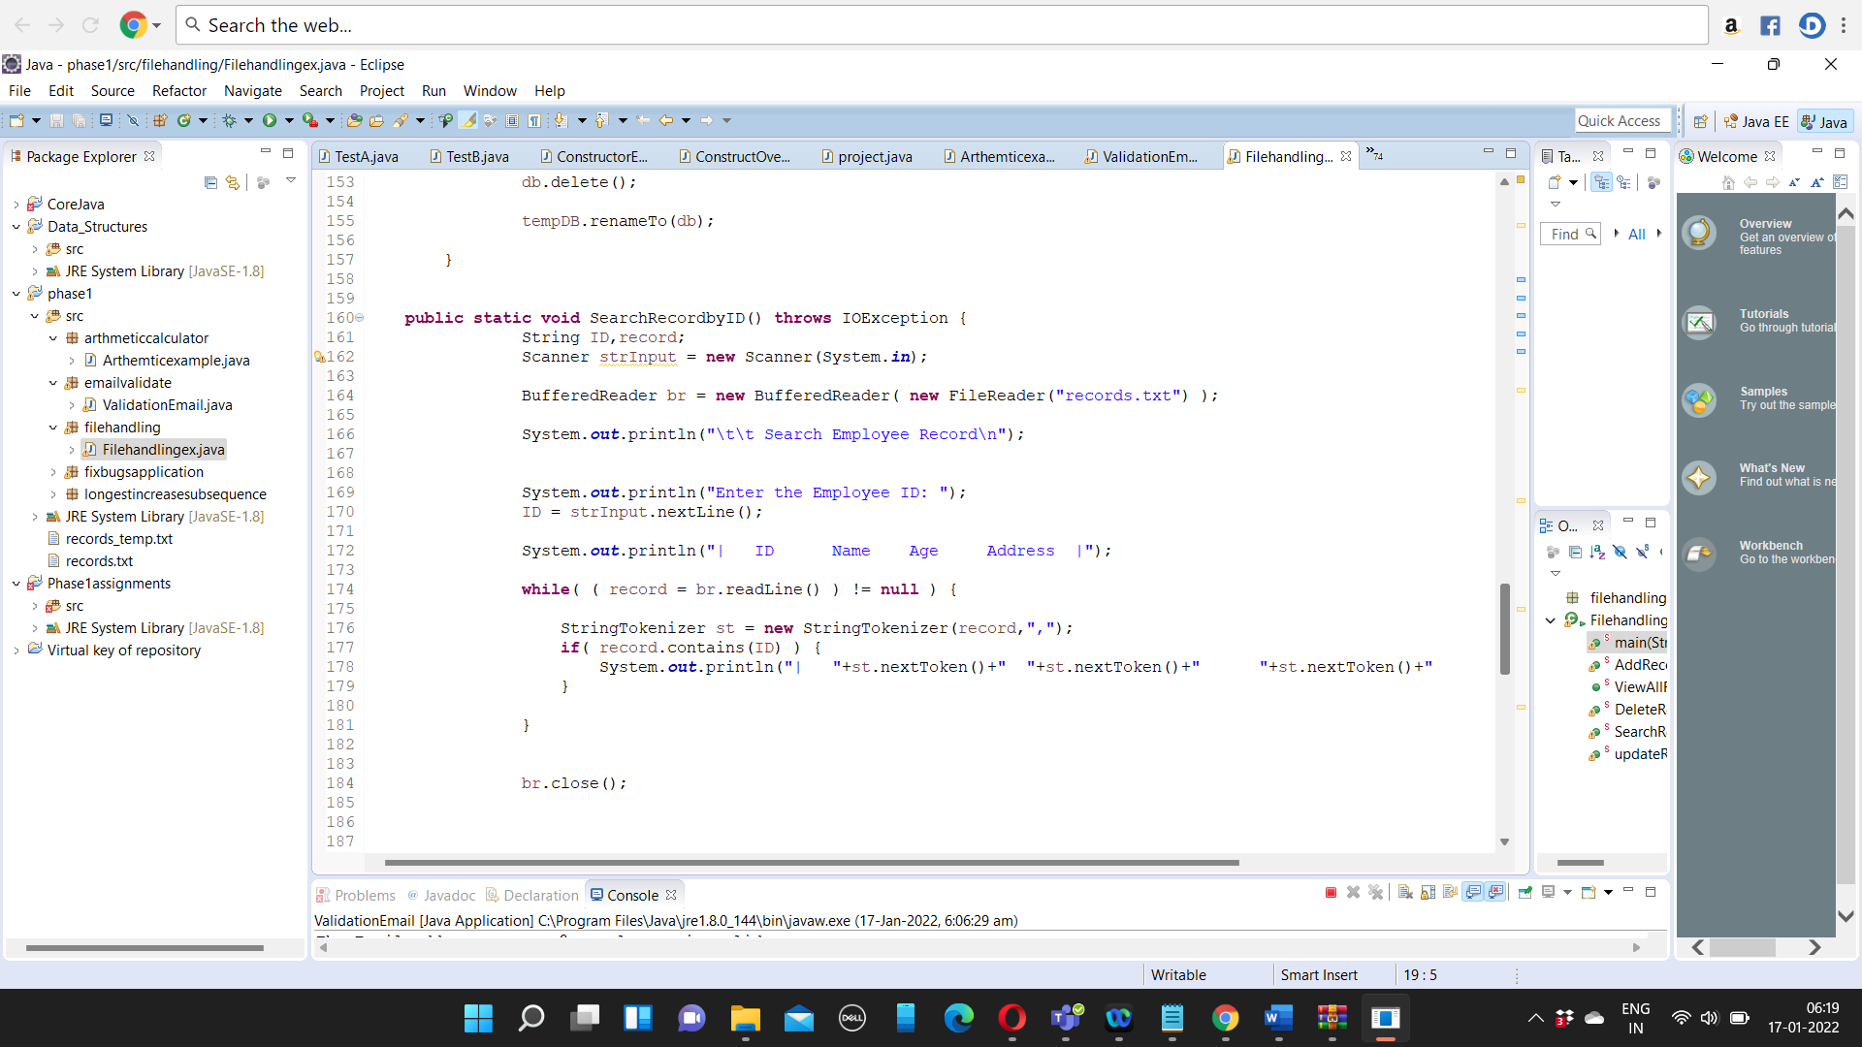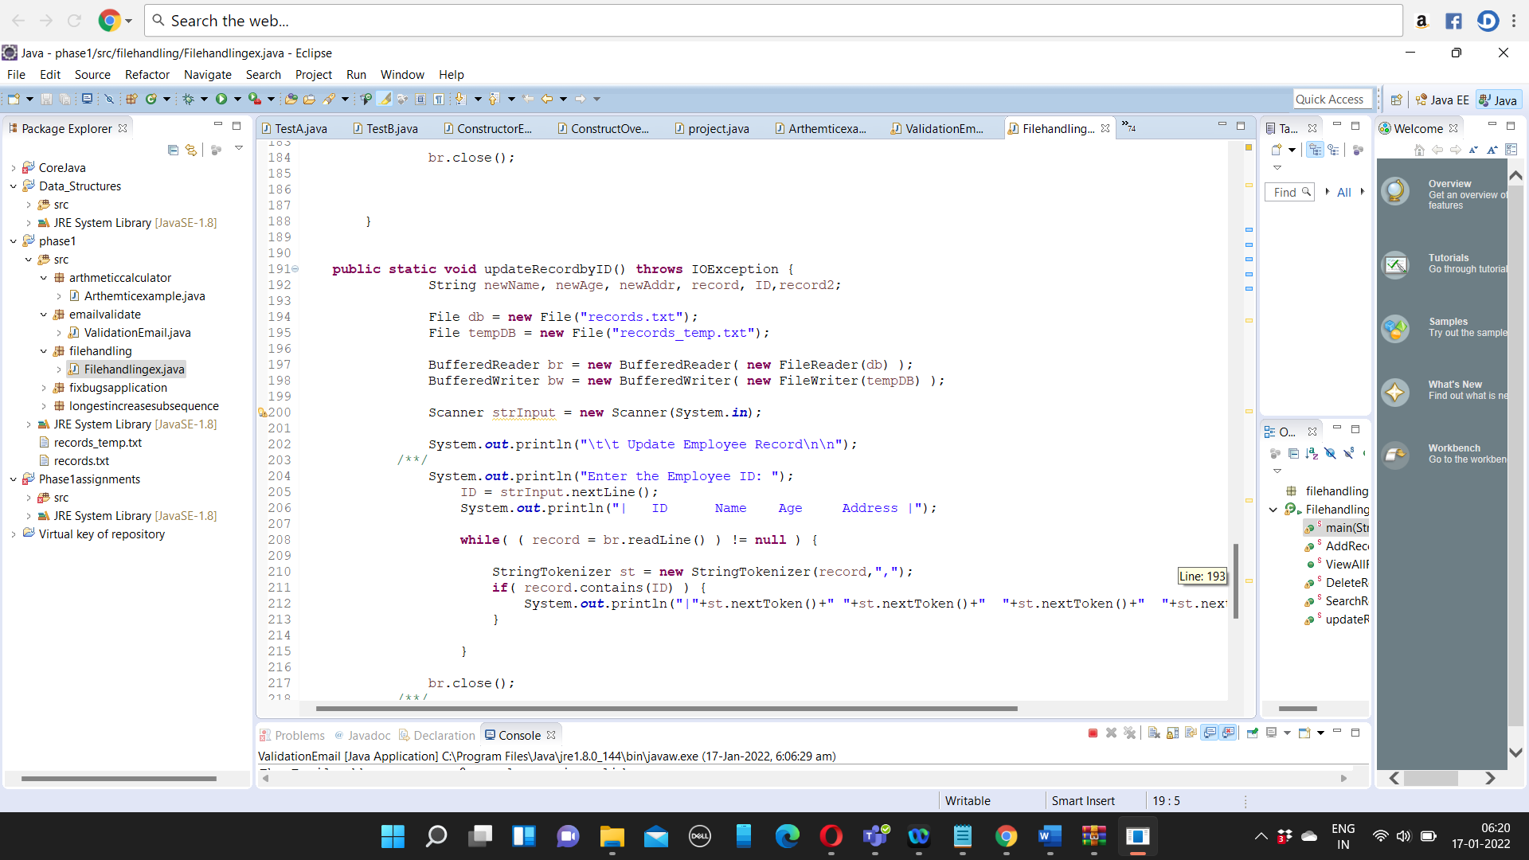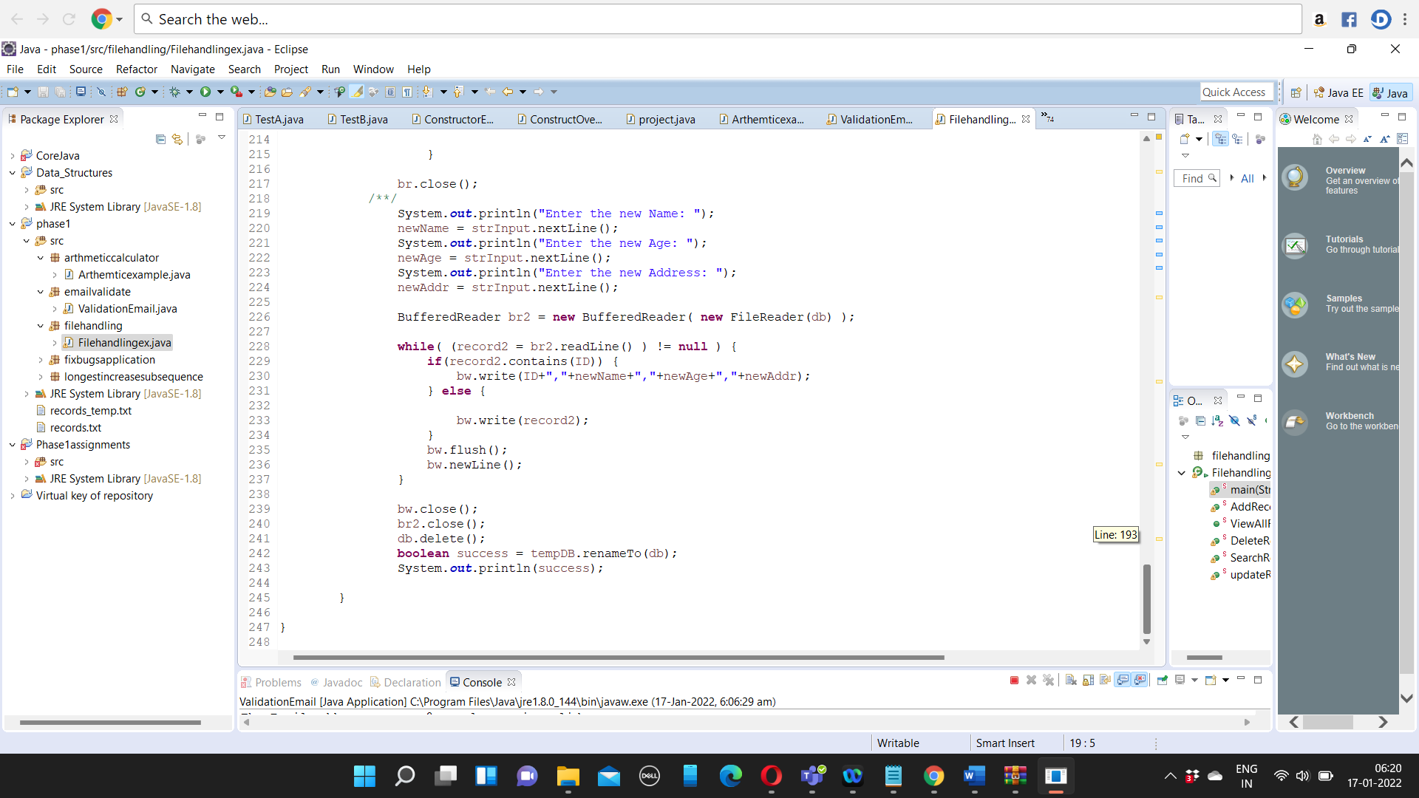

Output:

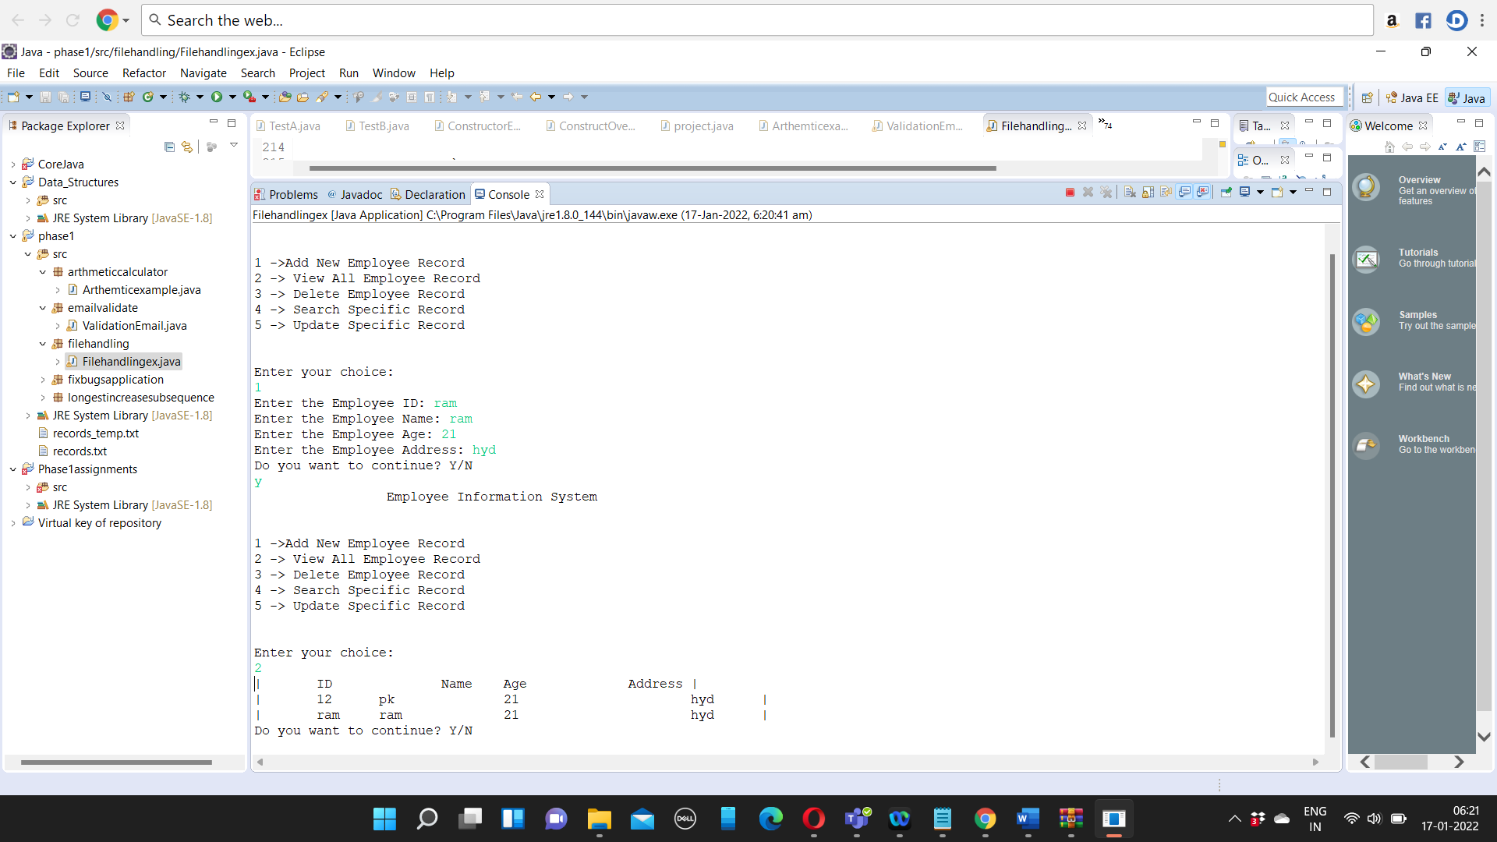

Program:

**package** filehandling;

**import** java.io.BufferedReader;

**import** java.io.BufferedWriter;

**import** java.io.File;

**import** java.io.FileReader;

**import** java.io.FileWriter;

**import** java.io.IOException;

**import** java.util.Scanner;

**import** java.util.StringTokenizer;

**public** **class** Filehandlingex {

**public** **static** **void** main(String[] args) {

Scanner strInput = **new** Scanner(System.***in***);

String choice,cont = "y";

**while**( cont.equalsIgnoreCase("y") ) {

System.***out***.println("\t\t Employee Information System\n\n");

System.***out***.println("1 ->Add New Employee Record ");

System.***out***.println("2 -> View All Employee Record ");

System.***out***.println("3 -> Delete Employee Record ");

System.***out***.println("4 -> Search Specific Record ");

System.***out***.println("5 -> Update Specific Record ");

System.***out***.print("\n\n");

System.***out***.println("Enter your choice: ");

choice = strInput.nextLine();

**if**( choice.equals("1") ) {

**try** {

*AddRecord*();

} **catch** (IOException e) {

// **TODO** Auto-generated catch block

e.printStackTrace();

}

} **else** **if**( choice.equals("2") ) {

**try** {

*ViewAllRecord*();

} **catch** (IOException e) {

// **TODO** Auto-generated catch block

e.printStackTrace();

}

} **else** **if**( choice.equals("3") ) {

**try** {

*DeleteRecordByID*();

} **catch** (IOException e) {

// **TODO** Auto-generated catch block

e.printStackTrace();

}

} **else** **if**( choice.equals("4") ) {

**try** {

*SearchRecordbyID*();

} **catch** (IOException e) {

// **TODO** Auto-generated catch block

e.printStackTrace();

}

} **else** **if**( choice.equals("5") ) {

**try** {

*updateRecordbyID*();

} **catch** (IOException e) {

// **TODO** Auto-generated catch block

e.printStackTrace();

}

}

System.***out***.println("Do you want to continue? Y/N");

cont = strInput.nextLine();

}

}

**public** **static** **void** AddRecord() **throws** IOException {

BufferedWriter bw = **new** BufferedWriter( **new** FileWriter("records.txt",**true**) );

Scanner strInput = **new** Scanner(System.***in***);

String ID, name, age, addr;

System.***out***.print("Enter the Employee ID: ");

ID = strInput.nextLine();

System.***out***.print("Enter the Employee Name: ");

name = strInput.nextLine();

System.***out***.print("Enter the Employee Age: ");

age = strInput.nextLine();

System.***out***.print("Enter the Employee Address: ");

addr = strInput.nextLine();

bw.write(ID+","+name+","+age+","+addr);

bw.flush();

bw.newLine();

bw.close();

}

**public** **static** **void** ViewAllRecord() **throws** IOException {

BufferedReader br = **new** BufferedReader( **new** FileReader("records.txt") );

String record;

System.***out***.println("| ID Name Age Address |");

**while**( ( record = br.readLine() ) != **null** ) {

StringTokenizer st = **new** StringTokenizer(record,",");

System.***out***.println("| "+st.nextToken()+" "+st.nextToken()+" "+st.nextToken()+" "+st.nextToken()+" |");

}

br.close();

}

**public** **static** **void** DeleteRecordByID() **throws** IOException {

Scanner strInput = **new** Scanner(System.***in***);

String ID, record;

File tempDB = **new** File("records_temp.txt");

File db = **new** File("records.txt");

BufferedReader br = **new** BufferedReader( **new** FileReader( db ) );

BufferedWriter bw = **new** BufferedWriter( **new** FileWriter( tempDB ) );

System.***out***.println("\t\t Delete Employee Record\n");

System.***out***.println("Enter the Employee ID: ");

ID = strInput.nextLine();

**while**( ( record = br.readLine() ) != **null** ) {

**if**( record.contains(ID) )

**continue**;

bw.write(record);

bw.flush();

bw.newLine();

}

br.close();

bw.close();

db.delete();

tempDB.renameTo(db);

}

**public** **static** **void** SearchRecordbyID() **throws** IOException {

String ID,record;

Scanner strInput = **new** Scanner(System.***in***);

BufferedReader br = **new** BufferedReader( **new** FileReader("records.txt") );

System.***out***.println("\t\t Search Employee Record\n");

System.***out***.println("Enter the Employee ID: ");

ID = strInput.nextLine();

System.***out***.println("| ID Name Age Address |");

**while**( ( record = br.readLine() ) != **null** ) {

StringTokenizer st = **new** StringTokenizer(record,",");

**if**( record.contains(ID) ) {

System.***out***.println("| "+st.nextToken()+" "+st.nextToken()+" "+st.nextToken()+" "+st.nextToken()+" |");

}

}

br.close();

}

**public** **static** **void** updateRecordbyID() **throws** IOException {

String newName, newAge, newAddr, record, ID,record2;

File db = **new** File("records.txt");

File tempDB = **new** File("records_temp.txt");

BufferedReader br = **new** BufferedReader( **new** FileReader(db) );

BufferedWriter bw = **new** BufferedWriter( **new** FileWriter(tempDB) );

Scanner strInput = **new** Scanner(System.***in***);

System.***out***.println("\t\t Update Employee Record\n\n");

/**/

System.***out***.println("Enter the Employee ID: ");

ID = strInput.nextLine();

System.***out***.println("| ID Name Age Address |");

**while**( ( record = br.readLine() ) != **null** ) {

StringTokenizer st = **new** StringTokenizer(record,",");

**if**( record.contains(ID) ) {

System.***out***.println("|"+st.nextToken()+" "+st.nextToken()+" "+st.nextToken()+" "+st.nextToken()+"|");

}

}

br.close();

/**/

System.***out***.println("Enter the new Name: ");

newName = strInput.nextLine();

System.***out***.println("Enter the new Age: ");

newAge = strInput.nextLine();

System.***out***.println("Enter the new Address: ");

newAddr = strInput.nextLine();

BufferedReader br2 = **new** BufferedReader( **new** FileReader(db) );

**while**( (record2 = br2.readLine() ) != **null** ) {

**if**(record2.contains(ID)) {

bw.write(ID+","+newName+","+newAge+","+newAddr);

} **else** {

bw.write(record2);

}

bw.flush();

bw.newLine();

}

bw.close();

br2.close();

db.delete();

**boolean** success = tempDB.renameTo(db);

System.***out***.println(success);

}

}