Name – B.Pravena Class – 5B

SRN – PES2UG19CS076

The code -:

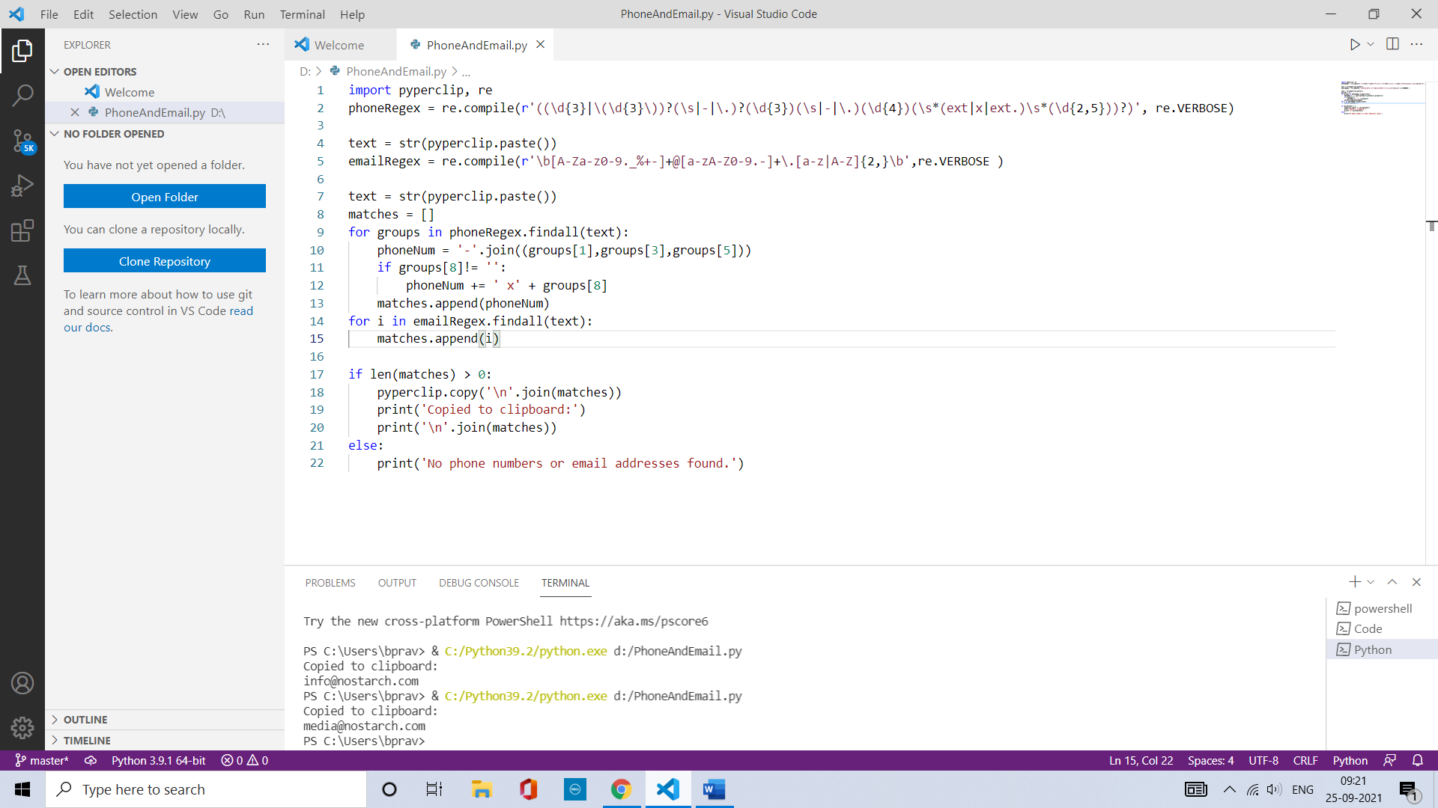

Output -:

