Name : Pravesh Shrivastava
CLass : A4-B3
Roll no. : 37
Practical 7
Aim: Implement Hamiltonian Cycle using Backtracking.
Problem Statement:
The Smart City Transportation Department is designing a night-patrol route for security vehicles.Each area of the city is represented as a vertex in a graph, and a road between two areas is represented as an edge. The goal is to find a route that starts from the main headquarters (Area A), visits each area exactly once, and returns back to the headquarters — forming a Hamiltonian Cycle.
If such a route is not possible, display a suitable message.
1) Adjacency Matrix
A B C D E
A 0 1 1 0 1
B 1 0 1 1 0
C 1 1 0 1 0
D 0 1 1 0 1
E 1 0 0 1 0

1) Adjacency Matrix
T M S H C
T 0 1 1 0 1
M 1 0 1 1 0
S 1 1 0 1 1
H 0 1 1 0 1
C 1 0 1 1 0

Code :
def Hamiltonian_Cycle(n):
hamiltonian_matrix = []
for i in range(n):
hamiltonian_matrix.append([0]*n)
print("Enter the adjacency matrix:")
for i in range(n):
for j in range(n):
print(f"Enter value for vertex {i},{j}:")
hamiltonian_matrix[i][j] = int(input())
return hamiltonian_matrix

def is_valid(v, matrix, path, pos):
if matrix[path[pos-1]][v] == 0:
return False
if v in path:
return False
return True

def backtrack(matrix, path, pos, n):
if pos == n:
if matrix[path[pos-1]][path[0]] == 1:
return True
else:
return False
for v in range(1, n):
if is_valid(v, matrix, path, pos):
path.append(v)
if backtrack(matrix, path, pos+1, n):
return True
path.pop()
return False

def Finding_Hamiltonian_Cycle(matrix, n):
path = [0]
if backtrack(matrix, path, 1, n):
path.append(path[0])
print("Hamiltonian Cycle Found:")
print(path)
else:
print("No Hamiltonian Cycle Found.")

n = int(input("Enter number of vertices: "))
matrix = Hamiltonian_Cycle(n)
Finding_Hamiltonian_Cycle(matrix, n)

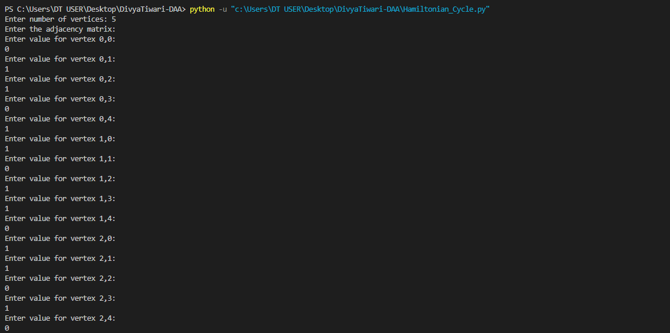
Output :
