Name : Pravesh Shrivastava
Class : A4-B3
Roll no. : 37
Subject : DAA Lab

Practical 6
Aim: Construction of OBST
Problem Statement: Smart Library Search Optimization

Task 1:
Scenario:
A university digital library system stores frequently accessed books using a binary search mechanism. The library admin wants to minimize the average search time for book lookups by arranging the book IDs optimally in a binary search tree. Each book ID has a probability of being searched successfully and an associated probability for unsuccessful searches (when a book ID does not exist between two keys). Your task is to determine the minimum expected cost of searching using an Optimal Binary Search Tree (OBST).
Input Format
First line: integer n — number of book IDs.
Second line: n integers representing the sorted book IDs (keys).
Third line: n real numbers — probabilities of successful searches (p[i]).
Fourth line: n+1 real numbers — probabilities of unsuccessful searches (q[i]).
Keys: 10 20 30 40
P[i]: 0.1 0.2 0.4 0.3
Q[i]: 0.05 0.1 0.05 0.05 0.1

Output Format
Print the minimum expected cost of the Optimal Binary Search Tree, rounded to 4 decimal
Places.
Code:-
import math
def Optimal_Binary_Search_Tree(keys, prob, n):
e = []
w = []
for i in range(n+2):
e.append([0]*(n+2))
w.append([0]*(n+2))
for i in range(1, n+2):
e[i][i-1] = prob[i-1]
w[i][i-1] = prob[i-1]
for l in range(1, n+1):
for i in range(1, n-l+2):
j = i + l - 1
e[i][j] = float('inf')
w[i][j] = w[i][j-1] + keys[j-1] + prob[j]
for r in range(i, j+1):
t = e[i][r-1] + e[r+1][j] + w[i][j]
if t < e[i][j]:
e[i][j] = t
return round(e[1][n])

n = int(input('Enter the size of the successful array keys:-'))
m = int(input('Enter the size of the unsuccessful array keys:-'))
p = []
q = []
print('Enter the elements for successful keys:-')
for i in range(n):
x = float(input())
p.append(x)
print('Enter the elements for unsuccessful search between keys:-')
for i in range(m):
y = float(input())
q.append(y)

length = len(p)
print(Optimal_Binary_Search_Tree(p, q, length))

Output:-
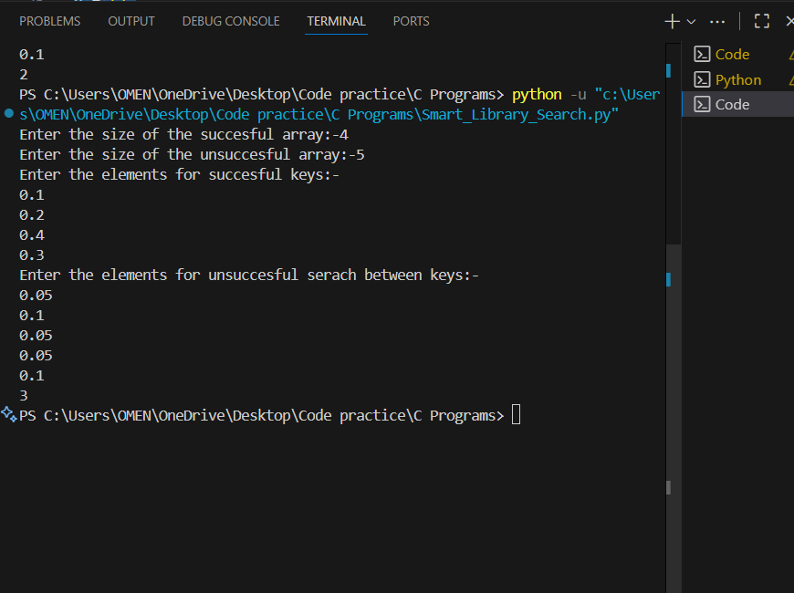

Task2:
https://www.geeksforgeeks.org/problems/optimal-binary-search-tree2214/1

Output:

