Name : Pravesh Shrivastava
Class : A4-B3
Roll no. : 37
Subject : DAA lab
Practical 5
Aim: Implement a dynamic algorithm for Longest Common Subsequence (LCS) to find the length and LCS for DNA sequences.
Problem Statement:
(i) DNA sequences can be viewed as strings of A, C, G, and T characters, which
represent nucleotides. Finding the similarities between two DNA sequences are an important computation performed in bioinformatics.

TASK 1: Find the similarity between the given X and Y sequence.
X=AGCCCTAAGGGCTACCTAGCTT
Y= GACAGCCTACAAGCGTTAGCTTG
Output: Cost matrix with all costs and direction, final cost of LCS and the LCS.
Length of LCS=16

Code :
def Shortest_lenght_LCS(x, y):
n = len(x)
m = len(y)
list_lcs = []
for i in range(0, n+1):
row = [0]*(m+1)
list_lcs.append(row)
for i in range(1, n+1):
for j in range(1, m+1):
if x[i-1] == y[j-1]:
list_lcs[i][j] = list_lcs[i-1][j-1] + 1
else:
list_lcs[i][j] = max(list_lcs[i-1][j], list_lcs[i][j-1])
return list_lcs

def Length_printing(x, y, list_lcs):
i = len(x)
j = len(y)
list_str = []
while i > 0 and j > 0:
if x[i-1] == y[j-1]:
list_str.append(x[i-1])
i -= 1
j -= 1
elif list_lcs[i-1][j] > list_lcs[i][j-1]:
i -= 1
else:
j -= 1
list_str.reverse()
return ''.join(list_str)

s1 = input()
s2 = input()
lcs_table = Shortest_lenght_LCS(s1, s2)
print("Length of LCS:", lcs_table[len(s1)][len(s2)])
print("LCS string:", Length_printing(s1, s2, lcs_table))

Output :
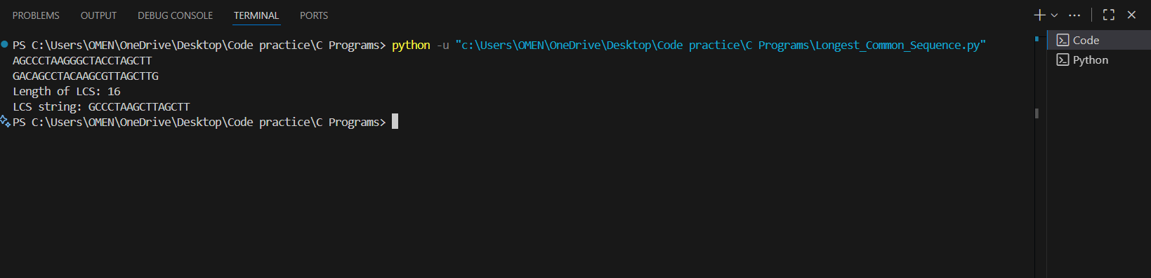

TASK-2: Find the longest repeating subsequence (LRS). Consider it as a variation of the longest common subsequence (LCS) problem.
Let the given string be S. You need to find the LRS within S. To use the LCS framework, you effectively compare S with itself. So, consider string1 = S and string2 = S.
Example:
AABCBDC
LRS= ABC or ABD

Code :
def Longest_repeating_subsequence(s):
n = len(s)
list_lrs = []
for i in range(0, n+1):
row = [0]*(n+1)
list_lrs.append(row)

for i in range(1, n+1):
for j in range(1, n+1):
if s[i-1] == s[j-1] and i != j:
list_lrs[i][j] = list_lrs[i-1][j-1] + 1
else:
list_lrs[i][j] = max(list_lrs[i-1][j], list_lrs[i][j-1])

return list_lrs

def LRS_printing(s, list_lrs):
i = len(s)
j = len(s)
lrs_str = []

while i > 0 and j > 0:
if s[i-1] == s[j-1] and i != j:
lrs_str.append(s[i-1])
i -= 1
j -= 1
elif list_lrs[i-1][j] > list_lrs[i][j-1]:
i -= 1
else:
j -= 1

lrs_str.reverse()
return ''.join(lrs_str)

s = input()
dp_table = Longest_repeating_subsequence(s)
print(dp_table[len(s)][len(s)])
print(LRS_printing(s, dp_table))

Output:
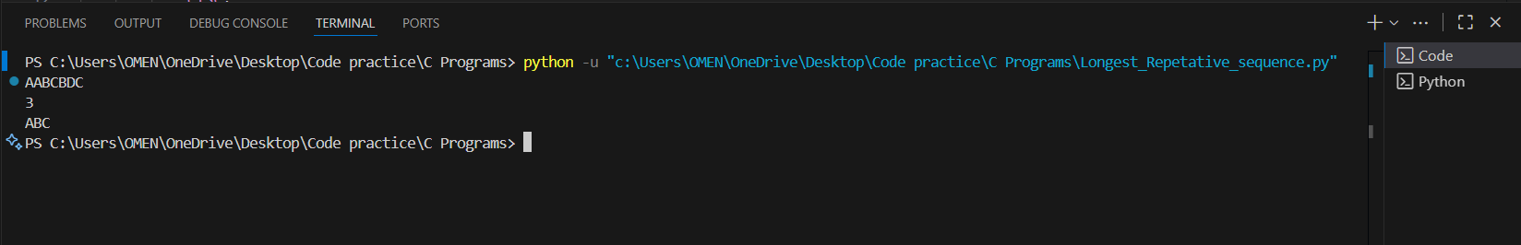

LeetCode : https://leetcode.com/problems/longest-common-subsequence/description/

