Cryptocurrency Fraud Detection Using Transaction Features and Explainable Machine Learning
Praveshika M., Bagadi Anjana, Johanan Joysingh S
M-Tech Integrated with Business Analytics specialization
Vellore Institute of Technology, Chennai
praveshika.m@vitstudent.ac.in, bagadi.anjana2023@vitstudent.ac.in, johananjoysingh.s@vit.ac.in

Abstract—Detecting fraudulent addresses on the Ethereum blockchain requires models that are both accurate and interpretable. This paper presents a machine-learning pipeline for cryptocurrency fraud detection on an address-level dataset of 9,841 records, of which 2,179 (22.14%) are fraudulent. Five transaction-derived features capture sent/received volume, ERC20 activity, unique-address counts, contract creation and average transaction values. The data are split with stratification before resampling and feature scaling; only the training subset is upsampled to balance the classes, and standardisation is fitted on training data alone. Logistic Regression, Decision Tree, K-Nearest Neighbours, Gradient Boosting and Random Forest are compared on an untouched test set of 2,953 records. The proposed 200-tree Random Forest achieves an accuracy of 0.9624, precision of 0.9625, recall of 0.8639, F1-score of 0.9106, ROC-AUC of 0.9895 and PR-AUC of 0.9730. A separate 100-tree Random Forest configuration evaluated with 5-fold stratified cross-validation achieves a mean F1-score of 0.8972 ± 0.0140. Impurity-based feature importance ranks the time span of address activity, average and total values received, the timing of received transactions and the unique address ratio among the leading attributes.
Index Terms—cryptocurrency fraud, Ethereum, machine learning, feature importance, random forest, class imbalance, transaction features.
I. INTRODUCTION
Cryptocurrency transactions are recorded as transfers between addresses, so the activity of an address can be described by how much it sends and receives, how often it transacts, and how many distinct counterparties it interacts with. This work investigates fraudulent Ethereum addresses by applying supervised machine learning to an address-level transaction dataset [1] in which each record carries a binary label (FLAG), where 0 denotes a legitimate address and 1 denotes a fraudulent address.
The investigation follows a leak-free experimental design. The data are split into training and test subsets before resampling and scaling; only the training subset is upsampled to correct class imbalance, and the scaler is fitted on the training data alone. Five classifiers—Logistic Regression, Decision Tree, K-Nearest Neighbours (KNN), Gradient Boosting and Random Forest—are trained on the same balanced and scaled training data and compared on an untouched test set. The proposed model is a 200-tree Random Forest [7]. Its predictions are interpreted using impurity-based feature importance, which ranks attributes used by the fitted model; these scores are not causal explanations and may favour some feature types.
The contributions of this work are as follows:
- Five transaction-derived features (transaction volume ratio, ERC20 transaction ratio, unique address ratio, contract creation flag and average value ratio) are engineered from the address-level transaction attributes.
- A leak-free pipeline is implemented, with a stratified split performed first, upsampling applied to the training subset only, and scaling fitted on training data only.
- Five classifiers are compared using accuracy, precision, recall, F1-score, ROC-AUC and PR-AUC on an untouched test set.
- A separate Random Forest configuration is evaluated using 5-fold stratified cross-validation; the proposed model is interpreted using impurity-based feature importance.
The remainder of this paper is organised as follows. Section II explains the background concepts used in this work, Section III describes the dataset and preprocessing, Section IV presents the methodology, Section V reports the experimental results, Section VI discusses the findings, and Section VII concludes the paper.
II. FUNDAMENTALS AND BACKGROUND
This section explains the ideas the rest of the paper relies on. It assumes only basic computer science and school-level mathematics. Readers already familiar with blockchain and machine learning can move directly to Section III.
A. Blockchain, Ethereum and Addresses
A blockchain is a shared record book, called a ledger, that many computers keep identical copies of. New transactions are grouped into blocks, and each block is linked to the previous one through a cryptographic fingerprint (a hash) of its contents. Changing an old entry would change its fingerprint and break every link after it, so past records are very hard to alter. The ledger is public, and anyone can read it.
Ethereum is a blockchain whose native currency is ether (ETH). Participants are identified by addresses, which are long strings of letters and digits. An address is created by generating a pair of cryptographic keys, and no name, identity document or registration is needed. There are two kinds of address. An externally owned account is controlled by whoever holds its private key. A contract account holds a small program, called a smart contract, that runs automatically when it receives a transaction. The contract-creation flag used in this paper records whether an address has ever created such a contract. Ethereum also supports tokens besides ether. ERC-20 is a widely used technical standard for these tokens, and the “ERC20” attributes in the dataset describe token transfers.
Every transfer is visible, including its sender, receiver, amount and time. From this public record one can compute, for each address, simple summaries such as how many transactions it sent and received, the total ether moved, the average gap between transactions, and the number of distinct addresses it dealt with. These per-address summaries are the attributes of the dataset used here [1].
B. Fraud on Public Blockchains and Why It Is Hard to Detect
Although every transaction is visible, the person behind an address is not. This property is called pseudonymity. Creating a new address costs almost nothing, so one person can operate many addresses, and a fraudster can abandon an address as soon as it has been reported. Transfers are also irreversible. Once ether has been sent to a scam address, there is no bank to ask for a refund. Typical examples are phishing (tricking people into sending funds) and fake investment schemes.
Fraudulent addresses often behave differently from ordinary ones. They may be active for only a short time, receive many payments from different senders, or pass money on quickly. Because behaviour can be summarised in numbers, a learning algorithm can be trained to recognise such patterns. This is a statistical tendency and not proof. A flagged address is a lead for an investigator, not a verdict. In the dataset, each address carries a label called FLAG, which is 1 for a fraudulent address and 0 for a legitimate one, and this study treats the label as the ground truth.
C. Supervised Learning and Classification
Supervised machine learning means learning from examples whose correct answers are already known. Each example is an address, described by a list of numbers called its features, together with its label. During training, the algorithm adjusts itself so that its predictions match the known labels as closely as possible. Afterwards, it is asked to predict the label of addresses it has never seen. When the answer is one of two classes, as here (fraud or legitimate), the task is called binary classification.
Most classifiers do not output a class directly. They output a score between 0 and 1 that can be read as how likely the address is to be fraudulent. A threshold, usually 0.5, turns this score into a decision: scores above the threshold are called fraud and the rest legitimate.
To judge how well a model will work in practice, the data are divided into a training set, used for learning, and a test set, used only for the final evaluation. The test set plays the role of future, unseen addresses. This separation guards against overfitting, which happens when a model memorises the training examples, including their noise, instead of learning general patterns. An overfitted model scores very well on the data it has seen and poorly on new data.
D. Features and Feature Engineering
A feature is a measurable property of an address, such as the number of transactions it sent or the total ether it received. Feature engineering means creating new features from existing ones when a combination describes behaviour better than the raw numbers do.
Ratios are a common example. Suppose one address sent 10 ETH and received 100 ETH, while another sent 1 ETH and received 10 ETH. The raw amounts differ by a factor of ten, but both addresses forward one tenth of what they receive. The ratio captures this shared behaviour and ignores the size of the amounts.
This study uses five engineered features. The transaction volume ratio divides the ether sent by the ether received, and it shows whether an address mostly accumulates funds or passes them on. The ERC20 transaction ratio is the share of an address’s transactions that are token transfers. The unique address ratio divides the number of distinct addresses it sent to by the number of distinct addresses it received from, which indicates whether it pays out to many parties or collects from many. The contract creation flag is 1 if the address has ever created a contract and 0 otherwise. The average value ratio divides the average amount sent by the average amount received.
A tiny constant, 10⁻⁶, is added to every denominator. An address that never received anything would otherwise cause a division by zero. The constant is so small that it does not noticeably change any other ratio. All five features are computed from per-address counts and totals. This study does not build a transaction graph.
E. Class Imbalance and Upsampling
In the dataset, 22.14% of the addresses are fraudulent and 77.86% are legitimate. This imbalance makes accuracy a misleading measure. A model that labels every address as legitimate would be right about 78% of the time while detecting no fraud at all. Models trained on imbalanced data also tend to favour the majority class, because ignoring the minority costs them little.
One remedy is upsampling, also called random oversampling. Fraudulent training records are copied at random, with replacement, until both classes are the same size. In this paper, the 1,525 fraudulent training records are resampled to 5,363, matching the number of legitimate ones. Upsampling adds no new information, since it only repeats existing records, and it must therefore be applied carefully, as the next subsection explains. A second remedy is class weighting, where the algorithm is told that mistakes on the rare class cost more. This is used in the cross-validation configuration (class_weight = ‘balanced’).
Upsampling has a side effect worth remembering. The model now sees 50% fraud during training, while real-world prevalence is about 22%, so it becomes somewhat more willing to flag addresses. For this reason precision is examined separately from recall in the results.
F. Data Splitting, Standardisation and Data Leakage
The data are divided 70% for training and 30% for testing. The split is stratified, which means each subset keeps the same share of fraud as the original data (22.14%) instead of leaving it to chance. A fixed random seed (random state 42) makes the shuffle repeatable, so the experiment can be reproduced exactly.
Features also need to be put on a comparable scale. In this dataset, time gaps are measured in minutes and can reach hundreds of thousands, while many ether values are small decimals. Methods that rely on distances or weighted sums, such as K-Nearest Neighbours and Logistic Regression, would be dominated by the large-valued features. Standardisation fixes this by rewriting each feature as
x′ = (x − μ) / σ
where μ is the feature’s mean and σ its standard deviation, both measured on the training data. After this change the feature has an average of 0 and a typical spread of 1. For example, if μ = 100 and σ = 50, a value of 200 becomes 2.0, meaning two standard deviations above average. Tree-based models do not need this step, but the same scaled data are given to all five models so that the comparison is fair.
Data leakage means that information from the test data influences the training process, which makes test results look better than they really are. It is like a student who has seen the exam questions in advance. Two kinds of leakage are avoided here. The first is resampling before splitting. Copies of the same fraudulent address could then land in both the training and test sets, and the model would be tested on records it has already seen. The second is fitting the scaler on all the data. The mean and standard deviation would then contain information about the test set. The pipeline therefore follows a strict order: split first, upsample the training set only, fit the scaler on the training set, and apply that scaler unchanged to the test set. The test set keeps its original class ratio and is never touched by resampling or by scaling statistics.
G. Classification Algorithms
Five classifiers of increasing sophistication are compared.
Logistic Regression. Despite its name, this is a classification method. It computes a weighted sum of the features, z = w₁x₁ + w₂x₂ + … + b, and passes it through the sigmoid function p = 1 / (1 + e^(−z)). The sigmoid squeezes any number into the range 0 to 1, so p can be read as the probability of fraud. The weights are learned from the training labels. The boundary between the two classes is a straight line, or a flat plane in many dimensions, so the model cannot capture curved or interacting patterns. It is fast and easy to interpret, which makes it a useful baseline.
Decision Tree. A decision tree asks a chain of yes/no questions about the features, for example “is the time between the first and last transaction below some number of minutes?”, and each answer leads to a further question until a final leaf gives the class. At every step the tree picks the question that separates the classes best. A common measure of how mixed a group is is the Gini impurity, G = 1 − Σ pₖ², where pₖ is the fraction of class k in the group. A pure group has G = 0, and a 50/50 group has G = 0.5. The depth limit used here (max_depth = 10) caps the length of the question chain so the tree cannot memorise noise. A tree can capture non-linear patterns, but a single tree is unstable, because small changes in the data can produce a very different tree.
K-Nearest Neighbours (KNN). KNN [9] stores the training examples and does no learning in the usual sense. To classify a new address, it finds the k = 5 training addresses closest to it and takes a majority vote of their labels. Closeness is measured by Euclidean distance, d = √(Σ (aᵢ − bᵢ)²), which is the ordinary straight-line distance extended to many features. The idea is that an address resembles its neighbours. Because it depends on distances, KNN relies on standardisation.
Gradient Boosting. Gradient Boosting [8] builds many small trees one after another. The first tree makes a rough prediction, and the next tree is trained to correct what the first got wrong, more precisely to move the prediction in the direction that reduces the loss (the gradient). Its contribution is added in small steps, and the process repeats. The final prediction is the combined contribution of all the trees. Boosting is often very accurate, and in this study it detects more fraud than the other models.
Random Forest. A Random Forest [7] grows many decision trees independently and lets them vote. Two kinds of randomness make the trees different from one another. Each tree is trained on a bootstrap sample, which is a random sample of the training data drawn with replacement. At every split, only a random subset of the features is considered. Because the trees make different mistakes, their errors tend to cancel out in the vote. The result is more stable and less prone to overfitting than a single tree. The proposed model uses 200 trees, and its fraud score is the fraction of trees that vote for fraud. The two ensemble methods differ in how they combine trees: boosting builds them sequentially, each correcting the last, while a forest builds them in parallel and averages them.
H. Evaluation Metrics
Because of class imbalance, results are reported with several metrics derived from the confusion matrix. Taking “fraud” as the positive class, it contains four counts:
- TP (true positives): fraudulent addresses correctly flagged.
- TN (true negatives): legitimate addresses correctly passed.
- FP (false positives): legitimate addresses wrongly flagged, which are false alarms.
- FN (false negatives): fraudulent addresses that were missed.
From these counts:
Accuracy = (TP + TN) / (TP + TN + FP + FN), the share of all addresses classified correctly.
Precision = TP / (TP + FP), the share of flagged addresses that are really fraudulent. It reflects how much effort investigators waste on false alarms.
Recall = TP / (TP + FN), the share of all fraudulent addresses that were found. It reflects how much fraud slips through.
F1-score = 2 × Precision × Recall / (Precision + Recall), which is high only when both precision and recall are high.
As a worked example, the proposed Random Forest on the 2,953 test addresses has TN = 2,277, FP = 22, FN = 89 and TP = 565 (Table VI). Then accuracy is (2,277 + 565) / 2,953 = 0.9624, precision is 565 / 587 = 0.9625, recall is 565 / 654 = 0.8639, and the F1-score is 0.9106. In words, when this model flags an address it is right about 96 times in 100, and it finds about 86 of every 100 fraudulent addresses.
Precision and recall pull against each other. Lowering the decision threshold flags more addresses, which raises recall and lowers precision. Raising the threshold does the opposite. The right balance depends on whether a missed fraud or a false alarm is more costly.
Two further metrics do not depend on any single threshold. The ROC curve [10] plots the true positive rate (which is the recall) against the false positive rate, FP / (FP + TN), as the threshold is swept from high to low. The area under it, ROC-AUC, equals the probability that a randomly chosen fraudulent address receives a higher score than a randomly chosen legitimate one. A value of 0.5 corresponds to random guessing and 1.0 to perfect ranking. The precision–recall curve [11] plots precision against recall, and its area is the PR-AUC, also called average precision. A model that guesses at random scores a PR-AUC equal to the fraud rate (here 0.2214), which is the dashed baseline in Fig. 7. PR-AUC is especially informative under class imbalance because it ignores the very large number of true negatives, which can make ROC-AUC look optimistic.
I. Cross-Validation
A single train/test split can be lucky or unlucky. In k-fold cross-validation, the data are divided into k equal parts called folds. The model is trained on k − 1 folds and tested on the remaining one, and this is repeated until every fold has served as the test set once. The k scores are then summarised by their mean and standard deviation. A small standard deviation means the model performs consistently across different slices of the data. This paper uses 5 folds, which are stratified so that each fold keeps the fraud proportion, and shuffled before splitting.
Upsampling inside cross-validation must be done separately within each training fold. Otherwise copies of the same record would again end up on both sides of a split. Class weighting avoids this problem because it needs no copied records, which is why it suits the cross-validation configuration. As noted in Section III, this configuration differs from the proposed model, so its results are supplementary context and not a direct validation of the final model.
J. Feature Importance and Its Limits
After training, it is natural to ask which features the model relied on. In a Random Forest, impurity-based importance answers this. Every time a feature is used to split a group of addresses, the resulting drop in impurity is recorded. These drops are added up over all splits in all trees and scaled so that the importances of all features sum to 1. A higher value means that the feature did more of the work of separating fraud from legitimate addresses.
These scores have clear limits. They describe how this particular fitted model uses its features and do not establish what causes fraud. They also do not show direction, meaning whether a larger value makes fraud more or less likely. They tend to favour features with many distinct values, because such features offer more possible split points. When two features carry similar information, the importance may be shared between them. The ranking should therefore be read as a model-specific summary and a starting point for investigation, not as definitive evidence about how fraud works.
K. Summary of the Pipeline
Putting these pieces together, the study proceeds as follows. Per-address transaction summaries are cleaned and extended with five ratio features. The data are split with stratification. Only the training portion is upsampled and standardised, and the same scaling is then applied to the test portion. Five classifiers are trained and compared on the untouched test set using accuracy, precision, recall, F1-score, ROC-AUC and PR-AUC. A separate cross-validation checks stability, and impurity-based importance indicates which features the proposed Random Forest relies on. The next sections describe each of these steps and report the results.

II. DATASET AND PREPROCESSING
A. Dataset
The experiments use the Ethereum fraud detection dataset [1], loaded from the file transaction_dataset.csv with the first column treated as an index. The dataset contains 9,841 records and 50 columns, including the target column FLAG. The attributes describe the transactional behaviour of each address, for example the average time between sent and received transactions, the time difference between the first and last transaction, the numbers of sent and received transactions, the number of created contracts, the numbers of unique addresses received from and sent to, and ether and ERC20 token value statistics. The class distribution is imbalanced, with 7,662 legitimate records (FLAG = 0) and 2,179 fraudulent records (FLAG = 1), i.e. 22.14% fraud.
B. Preprocessing
The identifier column (Address) and the ERC20 token-name columns (unique sent token name, unique received token name, most sent token type and most received token type) were dropped, as they are non-numeric descriptors. The remaining columns formed the feature matrix, and FLAG was separated as the target. The row-number column (Index) and constant columns, which carry no predictive information, were removed, leaving 43 features for model training. The dataset was handled with pandas [3] and NumPy [4].
TABLE I
DATASET SUMMARY
Property | Value
Records | 9,841
Columns (including FLAG) | 50
Legitimate (FLAG = 0) | 7,662
Fraudulent (FLAG = 1) | 2,179
Fraud proportion | 22.14%
Final feature count | 43

III. METHODOLOGY
A. Transaction Feature Engineering
Five features were engineered from the address-level transaction attributes to summarise sending and receiving behaviour. The unique address ratio compares the number of unique addresses sent to with the number of unique addresses received from. These are address-level count attributes; this study does not construct a transaction-graph data structure or apply graph algorithms. A small constant (10^-6) is added to each ratio denominator to avoid division by zero. The definitions are given in Table II.
TABLE II
ENGINEERED FEATURES
Feature | Definition
tx_volume_ratio | total Ether sent / (total ether received + 1e-6)
erc20_tx_ratio | Total ERC20 tnxs / (total transactions (including tnx to create contract) + 1e-6)
unique_addr_ratio | Unique Sent To Addresses / (Unique Received From Addresses + 1e-6)
has_contract | 1 if Number of Created Contracts > 0, else 0
avg_val_ratio | avg val sent / (avg val received + 1e-6)

B. Leak-Free Data Preparation
The data were first divided into training (70%) and test (30%) subsets using a stratified split with random state 42, so that the original fraud ratio is preserved in both subsets. This yielded 6,888 training records (5,363 legitimate and 1,525 fraudulent) and 2,953 test records (2,299 legitimate and 654 fraudulent). Only the training subset was then balanced by upsampling the minority (fraud) class with replacement to the size of the majority class, giving 10,726 training records with 5,363 per class. Features were standardised using StandardScaler [2], which was fitted on the balanced training data and then applied unchanged to the test data. The test subset therefore retains its original class ratio and is untouched by resampling and scaling statistics. Table III and Fig. 1 summarise the class distributions.
TABLE III
CLASS DISTRIBUTION AT EACH STAGE
Subset | Legitimate (0) | Fraud (1)
Original dataset | 7,662 | 2,179
Training (before upsampling) | 5,363 | 1,525
Training (after upsampling) | 5,363 | 5,363
Test (original ratio) | 2,299 | 654

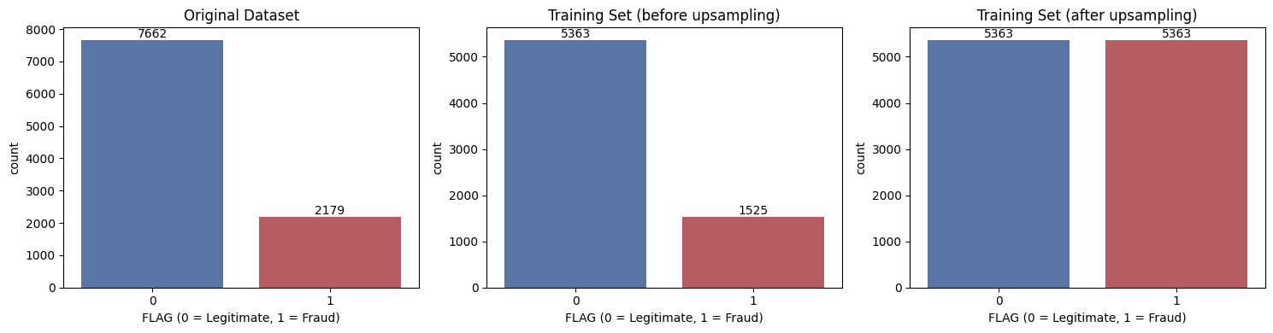
Fig. 1. Class distribution of the original dataset, the training set before upsampling and the training set after upsampling.
C. Classification Models
Five classifiers from scikit-learn [2] were trained on the same balanced and scaled training data: Logistic Regression, a Decision Tree, K-Nearest Neighbours [9], Gradient Boosting [8] and Random Forest [7]. Random Forest is the proposed model. The configurations are listed in Table IV; unspecified parameters take the library defaults.
TABLE IV
MODEL CONFIGURATIONS
Model | Configuration
Logistic Regression | max_iter = 2000, random_state = 42
Decision Tree | max_depth = 10, random_state = 42
KNN | n_neighbors = 5
Gradient Boosting | random_state = 42
Random Forest (Proposed) | n_estimators = 200, random_state = 42

D. Evaluation Protocol
All models were evaluated on the untouched test set using accuracy, precision, recall, F1-score, ROC-AUC [10] and PR-AUC (average precision) [11]. Confusion matrices and ROC and precision-recall curves were also produced. Separately, 5-fold stratified cross-validation (shuffled, random state 42) was performed on the original, non-upsampled training subset using a 100-tree Random Forest with class_weight='balanced'. This cross-validation configuration differs from the proposed 200-tree Random Forest, which is trained on the upsampled and scaled training data; therefore, the cross-validation scores should not be interpreted as direct validation of the exact proposed model configuration. Results were visualised with Matplotlib [5] and seaborn [6].
IV. EXPERIMENTAL RESULTS
A. Preliminary Random Forest Evaluation
A first Random Forest with 100 trees, trained on the leak-free data, was evaluated on the test set of 2,953 records. It achieved an accuracy of 0.96, with precision 0.96, recall 0.99 and F1-score 0.98 for the legitimate class, and precision 0.96, recall 0.86 and F1-score 0.91 for the fraud class (macro-average F1 of 0.94 and weighted-average F1 of 0.96). The ROC-AUC was 0.9890. Of the 2,299 legitimate addresses, 2,276 were classified correctly and 23 were flagged as fraud, and of the 654 fraudulent addresses, 564 were detected and 90 were missed (Fig. 2). The corresponding ROC curve is shown in Fig. 3.
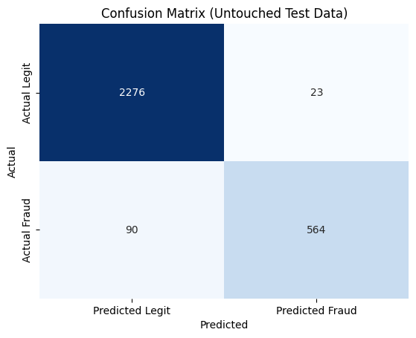
Fig. 2. Confusion matrix of the preliminary Random Forest (100 trees) on the untouched test data.
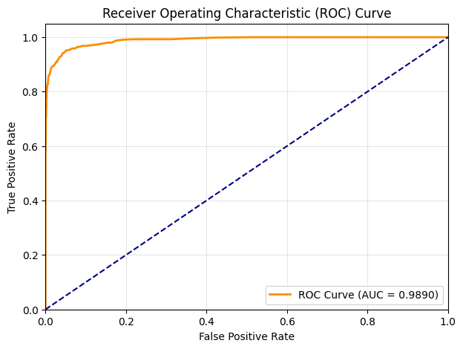
Fig. 3. ROC curve of the preliminary Random Forest (AUC = 0.9890).
B. Model Comparison
Table V compares the five classifiers on the untouched test set. The proposed Random Forest obtained the highest accuracy (0.9624), precision (0.9625), F1-score (0.9106), ROC-AUC (0.9895) and PR-AUC (0.9730). Gradient Boosting obtained the highest recall (0.9159) and the second-best values on the remaining metrics (F1-score 0.8900, ROC-AUC 0.9877, PR-AUC 0.9683). Logistic Regression performed worst, with an accuracy of 0.6278, a precision of 0.3575 and an F1-score of 0.5038, although its recall of 0.8532 was comparable to those of the Decision Tree (0.8578) and Random Forest (0.8639). The comparison is visualised in Figs. 4 and 5.
TABLE V
Model | Accuracy | Precision | Recall | F1-Score | ROC-AUC | PR-AUC
Logistic Regression | 0.6278 | 0.3575 | 0.8532 | 0.5038 | 0.8443 | 0.6587
Decision Tree | 0.9262 | 0.8178 | 0.8578 | 0.8373 | 0.9224 | 0.7841
KNN | 0.9089 | 0.7490 | 0.8853 | 0.8115 | 0.9336 | 0.8248
Gradient Boosting | 0.9499 | 0.8656 | 0.9159 | 0.8900 | 0.9877 | 0.9683
Random Forest (Proposed) | 0.9624 | 0.9625 | 0.8639 | 0.9106 | 0.9895 | 0.9730
MODEL COMPARISON ON THE UNTOUCHED TEST SET
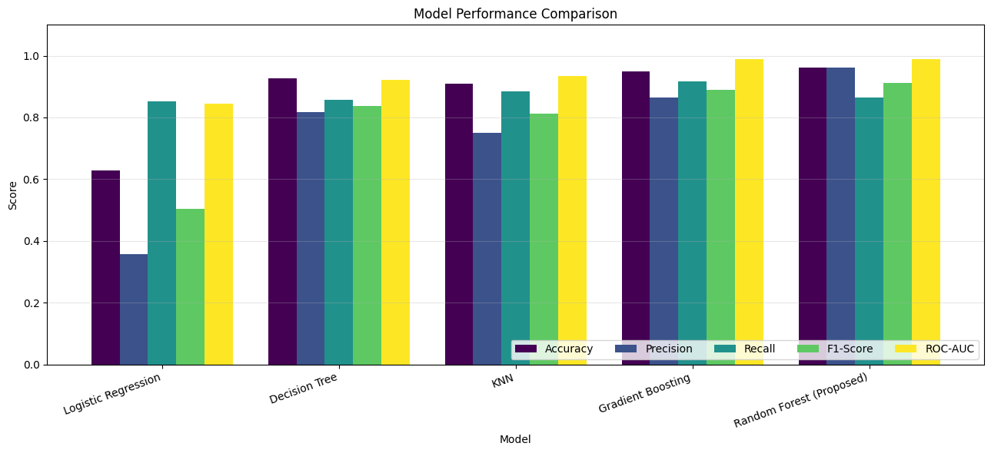
Fig. 4. Performance comparison of the five models across accuracy, precision, recall, F1-score and ROC-AUC.
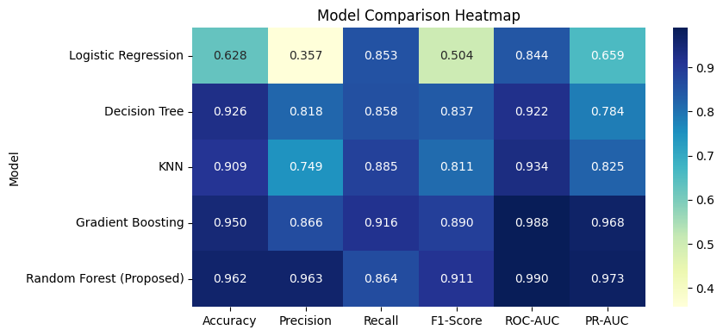
Fig. 5. Heatmap of all evaluation metrics for the five models.
The confusion matrices of all models are given in Table VI and Fig. 6. The proposed Random Forest produced the fewest false positives (22), whereas Gradient Boosting produced the fewest false negatives (55). Normalised by row, the Random Forest correctly classified 99.04% of legitimate addresses (0.96% false positives) and 86.39% of fraudulent addresses (13.61% false negatives).
TABLE VI
CONFUSION MATRIX COUNTS ON THE TEST SET
Model | TN | FP | FN | TP
Logistic Regression | 1296 | 1003 | 96 | 558
Decision Tree | 2174 | 125 | 93 | 561
KNN | 2105 | 194 | 75 | 579
Gradient Boosting | 2206 | 93 | 55 | 599
Random Forest (Proposed) | 2277 | 22 | 89 | 565

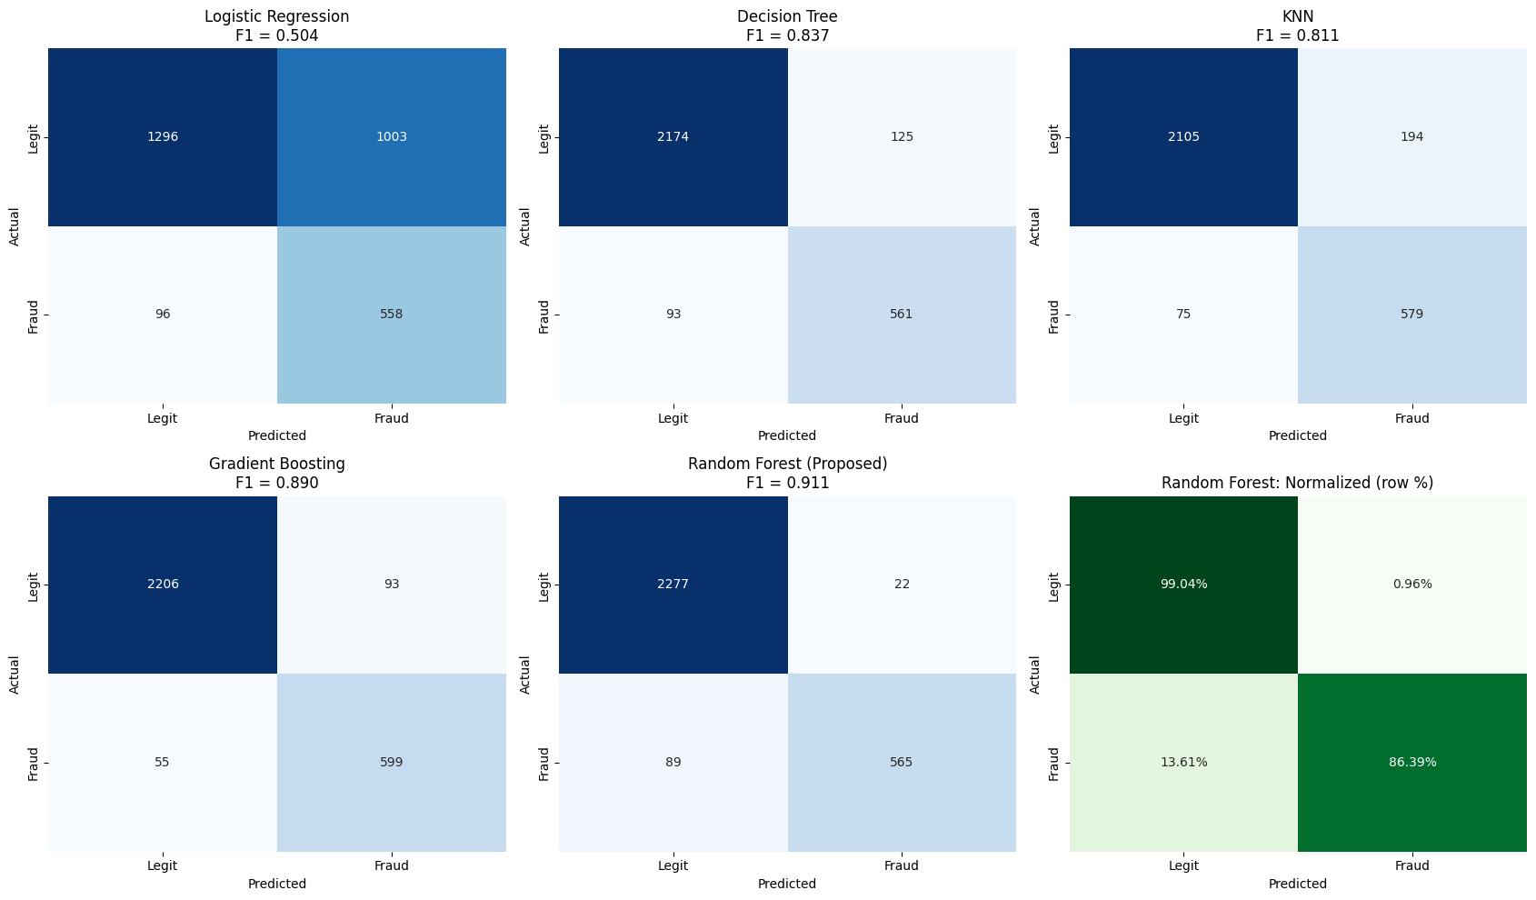
Fig. 6. Confusion matrices of all five models, including the row-normalised matrix of the Random Forest.
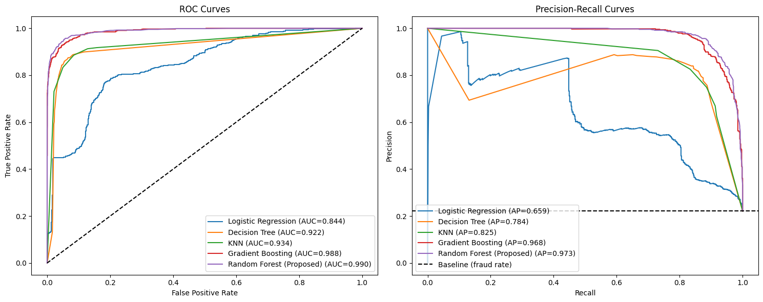
Fig. 7. ROC curves (left) and precision-recall curves (right) of the five models. The dashed line in the precision-recall plot is the fraud-rate baseline.
C. Detailed Report and Cross-Validation
Table VII gives the classification report of the proposed 200-tree Random Forest. The separate 100-tree, class-weighted Random Forest configuration evaluated by five-fold stratified cross-validation on the original, non-upsampled training subset gave a mean F1-score of 0.8972 with a standard deviation of 0.0140 and a mean ROC-AUC of 0.9869 with a standard deviation of 0.0025 (Table VIII, Fig. 8). Because the cross-validation and proposed-model training configurations differ, these scores provide supplementary context rather than direct validation of the exact proposed model.
TABLE VII
CLASSIFICATION REPORT OF THE PROPOSED RANDOM FOREST
Class | Precision | Recall | F1-Score | Support
Legitimate | 0.96 | 0.99 | 0.98 | 2299
Fraud | 0.96 | 0.86 | 0.91 | 654
Accuracy |  |  | 0.96 | 2953
Macro avg | 0.96 | 0.93 | 0.94 | 2953
Weighted avg | 0.96 | 0.96 | 0.96 | 2953

TABLE VIII
5-FOLD CROSS-VALIDATION (RANDOM FOREST)
Metric | Mean | Std. Dev.
F1-Score | 0.8972 | 0.0140
ROC-AUC | 0.9869 | 0.0025

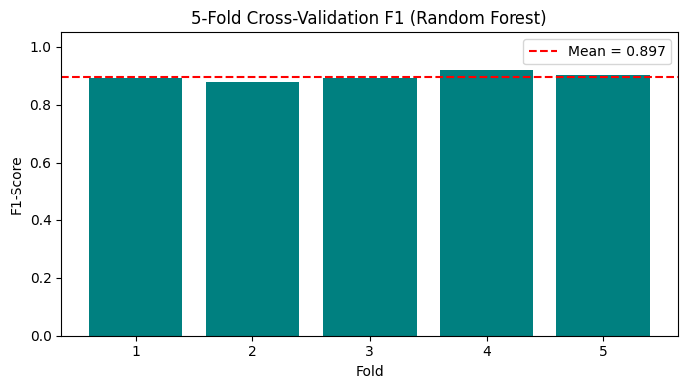
Fig. 8. F1-score of the Random Forest in each of the five cross-validation folds (mean = 0.897).
D. Feature Importance
Impurity-based Random Forest feature importance was used to rank attributes associated with the fraud predictions; SHAP values or SHAP plots are not reported in this study. For the preliminary model, the leading features were the time difference between the first and last transaction (0.095461), the average value received (0.092592), the total ether received (0.081616), the average time between received transactions (0.068719) and the engineered unique address ratio (0.054632) (Fig. 9). For the proposed model, the leading features are shown in Table IX and Fig. 10: time difference between first and last transaction (0.094146), average value received (0.081748), total ether received (0.079417), average time between received transactions (0.067623) and the unique address ratio (0.058301). The engineered features unique_addr_ratio (0.058301) and avg_val_ratio (0.040242) are among the top fifteen. These impurity-based rankings describe how the fitted forest uses features, are not causal evidence, and can be biased toward features with more possible split points.
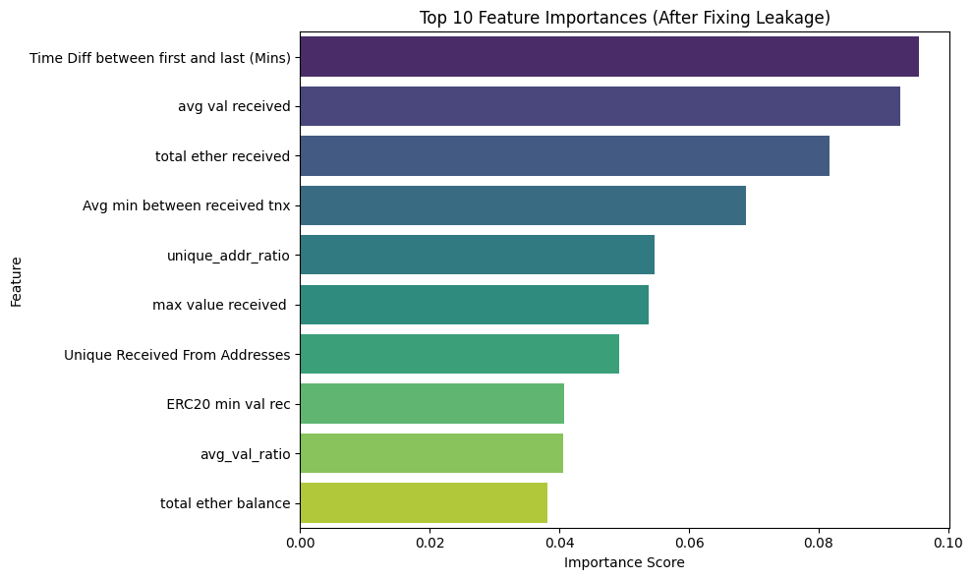
Fig. 9. Top 10 feature importances of the preliminary Random Forest.
TABLE IX
TOP 15 FEATURE IMPORTANCES (PROPOSED RANDOM FOREST)
Rank | Feature | Importance
1 | Time Diff between first and last (Mins) | 0.094146
2 | avg val received | 0.081748
3 | total ether received | 0.079417
4 | Avg min between received tnx | 0.067623
5 | unique_addr_ratio | 0.058301
6 | max value received | 0.052732
7 | Unique Received From Addresses | 0.046725
8 | total ether balance | 0.043064
9 | total Ether sent | 0.042086
10 | ERC20 min val rec | 0.040956
11 | avg_val_ratio | 0.040242
12 | total transactions (including tnx to create contract) | 0.036483
13 | min value received | 0.031586
14 | Avg min between sent tnx | 0.027993
15 | Received Tnx | 0.026289

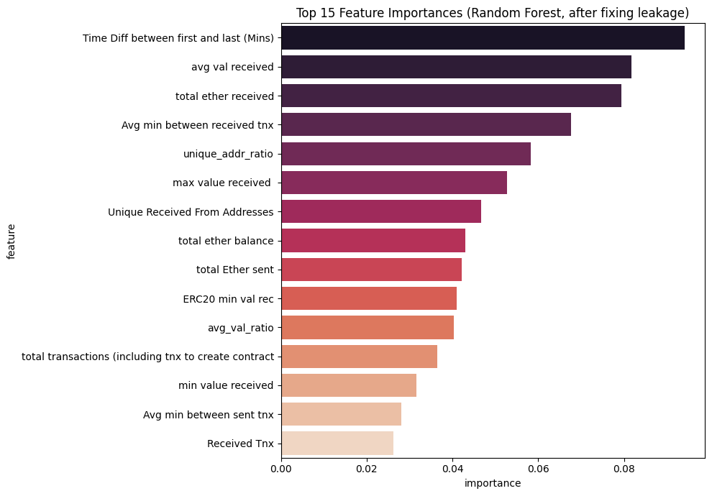
Fig. 10. Top 15 feature importances of the proposed Random Forest.
V. DISCUSSION
The comparison shows that the ensemble tree methods, Random Forest and Gradient Boosting, separate fraudulent from legitimate addresses more effectively than Logistic Regression, the Decision Tree and KNN. The Random Forest combines the highest precision (0.9625) with a recall of 0.8639, and it raises the fewest false alarms (22 of 2,299 legitimate addresses). Gradient Boosting detects more fraudulent addresses (599 of 654 against 565) at the cost of more false positives (93 against 22). The choice between the two therefore depends on the relative cost of missed fraud and false alarms. The Random Forest was selected as the proposed model because it leads on accuracy, precision, F1-score, ROC-AUC and PR-AUC.
Logistic Regression reaches a recall of 0.8532 but flags 1,003 legitimate addresses as fraud, which gives a precision of only 0.3575. This indicates that a linear decision boundary is insufficient for these features.
The impurity-based feature-importance ranking is dominated by temporal and value-based received-transaction attributes, together with the unique address ratio. These scores describe the model's split-based use of features, not the direction or causal effect of a feature. They can also favour features with many possible split points, so the ranking should be treated as a model-specific summary rather than definitive evidence about fraud mechanisms.
The main limitation visible in the results is the recall for the fraud class: 89 of 654 fraudulent addresses (13.61%) were not detected by the Random Forest on the test set.
VI. CONCLUSION
This paper investigated fraud detection on Ethereum addresses using five transaction-derived features and a machine-learning pipeline in which the data were split before upsampling and scaling. Among five classifiers, the proposed 200-tree Random Forest achieved an accuracy of 0.9624, a precision of 0.9625, a recall of 0.8639, an F1-score of 0.9106, a ROC-AUC of 0.9895 and a PR-AUC of 0.9730 on an untouched test set. A separate 100-tree, class-weighted Random Forest configuration achieved a mean cross-validated F1-score of 0.8972 and ROC-AUC of 0.9869. Impurity-based feature importance ranked the time span of an address’s activity, the values and totals received, the timing of received transactions and the unique address ratio among the leading attributes. Future work can address the 13.61% of fraudulent addresses that were missed and investigate explicit graph-based methods.
REFERENCES
[1] V. Aliyev, “Ethereum fraud detection dataset,” Kaggle. [Online]. Available: https://www.kaggle.com/datasets/vagifa/ethereum-frauddetection-dataset
[2] F. Pedregosa et al., “Scikit-learn: Machine learning in Python,” J. Mach. Learn. Res., vol. 12, pp. 2825–2830, 2011.
[3] W. McKinney, “Data structures for statistical computing in Python,” in Proc. 9th Python in Science Conf., 2010, pp. 56–61.
[4] C. R. Harris et al., “Array programming with NumPy,” Nature, vol. 585, no. 7825, pp. 357–362, 2020.
[5] J. D. Hunter, “Matplotlib: A 2D graphics environment,” Comput. Sci. Eng., vol. 9, no. 3, pp. 90–95, 2007.
[6] M. L. Waskom, “seaborn: Statistical data visualization,” J. Open Source Softw., vol. 6, no. 60, p. 3021, 2021.
[7] L. Breiman, “Random forests,” Mach. Learn., vol. 45, no. 1, pp. 5–32, 2001.
[8] J. H. Friedman, “Greedy function approximation: A gradient boosting machine,” Ann. Statist., vol. 29, no. 5, pp. 1189–1232, 2001.
[9] T. Cover and P. Hart, “Nearest neighbor pattern classification,” IEEE Trans. Inf. Theory, vol. 13, no. 1, pp. 21–27, 1967.
[10] T. Fawcett, “An introduction to ROC analysis,” Pattern Recognit. Lett., vol. 27, no. 8, pp. 861–874, 2006.
[11] J. Davis and M. Goadrich, “The relationship between precision-recall and ROC curves,” in Proc. 23rd Int. Conf. Mach. Learn. (ICML), 2006, pp. 233–240.

