Kubernetize - Deploy the application to kubernetes cluster

In this lab, we will deploy the application by leveraging the docker image, to a kubernetes cluster.

Learning Outcomes
After completing the lab, you will be able to:
- Describe how to create Kubernetes Objects
- Describe how to write yaml files for pods, deployments and services
- Run your Spring boot application within a kubernetes cluster
- Basics of K8s service discovery concepts

Starting to Kubernetize
Before starting the lab, verify the pages image created in the previous lab exists in docker hub
Below the inital version of our deployment architecture which will evolve as our application evolves.
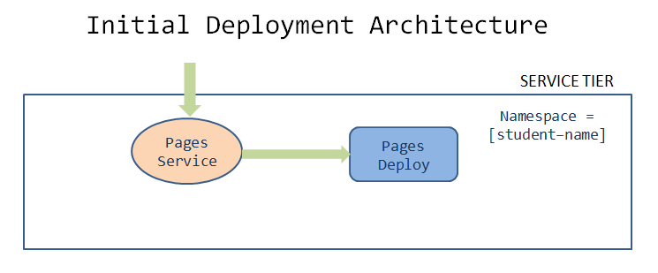

Complete the following tasks to implement the above architecture
- All the below tasks are assumed to be implemented inside ~/.workspace/pages directory
- Get your cluster namespace from the instructors, which will be used in the next steps.
- Create a deployment/pages-namespace.yaml with the below manifest file.
apiVersion: v1
kind: Namespace
metadata:
name: [student-name]
- Create deployment/pages-deployment.yaml from the root project folder
apiVersion: apps/v1
kind: Deployment
metadata:
labels:
app: pages
name: pages
namespace: [student-name]
spec:
replicas: 1
selector:
matchLabels:
app: pages
strategy: {}
template:
metadata:
labels:
app: pages
spec:
containers:
- image: [docker-username]/pages:[tag]
name: pages
ports:
- containerPort: 8080
- Create deployment/pages-service.yaml to expose the deployment as type NodePort
apiVersion: v1
kind: Service
metadata:
labels:
app: pages
name: pages
namespace: [student-name]
spec:
ports:
- port: 8080
protocol: TCP
targetPort: 8080
selector:
app: pages
type: NodePort

Deploy to minikube cluster
- Start minikube locally minikube start --driver=virtualbox
- Verify the kubectl context kubectl config get-contexts is set to minikube. If not, set it to minikube kubectl config use-context minikube
- Create kubernetes objects
kubectl create namespace [student-name]
kubectl apply -f deployment/pages-service.yaml
kubectl apply -f deployment/pages-deployment.yaml
- Verify the created objects
kubectl get deployment pages --namespace [student-name]
kubectl get service pages --namespace [student-name]
- Set up [student-name] namespace to point to the current context
kubectl config set-context --current --namespace=[student-name]
- Access the application by port-forwarding on localhost:8080
kubectl port-forward svc/pages 8080:8080

curl localhost:8080

Deploy the application to production cluster
- Get the list of clusters configured inside kubeconfig file
kubectl config get-contexts
- Copy the full name of the cluster emitted from command above. If you are using EKS (public cloud), it might look similar to arn:aws:---:cluster/*cluser-name*
Check with the instructors for the cluster name if you get more than one cluster apart from minikube from the previous command
- Switch the kubectl context to point to the production cluster
kubectl config use-context [name of the cluster]

kubectl config set-context --current --namespace [student-name]
- Create Kubernetes objects
- Verify the created objects
- Access the application by port-forwarding kubectl onto localhost:8080
- Commit code changes to the git repository
git add .
git commit -m "Kubernetizing Spring Boot Application"
git push -u origin master

