Externalize Configuration in Kubernetes

Learning Outcomes
After completing the lab, you will be able to:
- Use environment variables to configure an application running locally
- Describe how to configure a Spring Boot application on Kubernetes with ConfigMap
Before starting the lab, cherry pick the config-start tag.
git cherry-pick config-start --strategy-option theirs
In case you get an error when you cherry-pick, open intellij, right-click on the project, select git → resolve-conflicts → accept theirs

Externalize the welcome message
- As a result of cherry-pick some test cases have been updated. Have a look at HomeControllerTest class.
- Externalize the message being displayed into an environment variable called PAGE_CONTENT
- The goal is to ensure that your test cases are passing before dockerizing.
- Update HomeController class to externalize the welcome message through constructor injection
private String pageContent;

public HomeController(@Value("${page.content}") String pageContent){
this.pageContent=pageContent;
}

@GetMapping
public String getPage(){
return "Hello from page : "+pageContent+" ";
}
- Set the environment variable in build.gradle file for test and dev environments
bootRun.environment([
"PAGE_CONTENT": "YellowPages",
])

test.environment([
"PAGE_CONTENT": "YellowPages",
])
- Build and test the application just like you did in previous labs.
- Dockerize the application and tag it appropriately. For example, you can tag it as config
docker build -t [docker_username]/pages:[tag] .
- Push the image to docker
docker push [docker_username]/pages:[tag]

Kubernetize the application
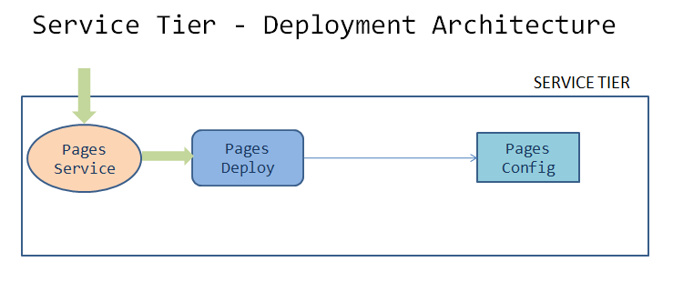

Below are the 2 tasks to be completed within the kubernetes cluster
- Create a config map object with the following specifications.
name -> page-config-map
namespace -> [student-name]
config data key-value pair:
PAGE_CONTENT -> "Green-Pages from Yellow World!"
- Edit the pages deployment in the namespace [student-name] & add an environment variable to the container
name -> PAGE_CONTENT
value -> fetch it from configmap name page-config-map [key is PAGE_CONTENT]

Implement the above tasks by creating manifest/yaml files
- Create deployment/pages-config.yaml
apiVersion: v1
data:
PAGE_CONTENT: Green-Pages coming from Yellow-World!
kind: ConfigMap
metadata:
name: pages-config-map
namespace: [student-name]
- Update deployment/pages-deployment.yaml
containers:
- image: [docker-username]/pages:[tag]
name: pages
ports:
- containerPort: 8080
env:
- name: PAGE_CONTENT
valueFrom:
configMapKeyRef:
name: pages-config-map
key: PAGE_CONTENT

Deploy and test locally on minikube
- If minikube has been stopped, start it by running the command minikube start --driver=virtualbox
- Verify the kubectl context kubectl config get-contexts is set to minikube. If not, set it to minikube kubectl config use-context minikube
- Set up [student-name] namespace to point to the current context
kubectl config set-context --current --namespace=[student-name]
- Create kubernetes objects
kubectl apply -f deployment/pages-config.yaml
kubectl apply -f deployment/pages-deployment.yaml
- Verify the created objects
kubectl get deployment pages
kubectl get configmap pages-config-map
kubectl get pods -o wide
- Access the application by port-forwarding on localhost:8080
kubectl port-forward svc/pages 8080:8080

curl localhost:8080
- Stop the port-forwarding

Deploy the application to production cluster
- Switch kubectl to point to production cluster
- Verify the kubectl context is set to the production cluster
kubectl config get-contexts
- Skip this step if the kubectl prod context is set to your respective namespace
Set up [student-name] namespace to point to the current context
kubectl config set-context --current --namespace=[student-name]
- Create the kubernetes objects
- Verify the created objects
- Access the application by port-forwarding on localhost:8080
kubectl port-forward svc/pages 8080:8080

curl localhost:8080
- Stop the port-forwarding
- Commit code changes to the github repository
git add .
git commit -m "Externalized config"
git push -u origin master

Advanced usecase challenges
- Enable refresh scope for automatic synchronization of config map properties in spring boot
- Watch for changes in kubernetes api resources and objects, for dynamic loading
- Security concerns

