Design and Develop Service Tier

We will make use of the database tier created in the previous lab and implement our service tier to communicate with MySql database.

Learning Outcomes
After completing the lab, you will be able to:
- Develop the service-tier consisting of a single microservice using TDD approach.
- Implement Repository pattern
- Deploy the service tier
- Understand native K8s service discovery by using labels and selectors to discover database service deployed in the previous lab.
Before starting the lab, checkout the service-tier-start task.
git status
# Ensure the source code is checked in to github
# You can take a back up of your codebase, to keep your deployment files from being overwritten
# Checkout into a feature branch
git checkout service-tier-start -b service
# You are on branch service
In case you get an error when you cherry-pick/check-out, open intellij, right-click on the project, select git → resolve-conflicts → View changes and merge them based on the differences

Develop the pages microservice
- Few test classes were added to the test package. IPagesRepository interface is provided to implement the repository pattern. Observe these changes in intellij. The source code will not compile at this stage.
The first step is to ensure the code compiles without erorrs and then implement the code so that all the test cases pass.
- Create a class src/org/dell/kube/pages/Page with the below fields
public Long id;
public String businessName;
public Long categoryId;
public String address;
public String contactNumber;
Generate getters,setters & constructor/s as expected by the test classes
- Create a repository class MySqlPageRepository which implements IPageRepository as expected by the test class MySqlPageRepositoryTest. Annotate the class with @Repository
- Create PageController class and implement methods as expected by the test class PageApiTest. Inject the dependency of type MySqlPageRepository in the constructor of the controller class.
Refer to the Reference Implementation for the code snippets if you get stuck.

Building locally
- Ensure that you have created the database pages locally, which was done in the previous lab. Otherwise follow the previous lab instructions to create the database and run the flyway migrations for the pages table to be created.
- Provide the spring datasource url in application.properties for both development and testing.
spring.datasource.url=jdbc:mysql://localhost:3306/pages?useSSL=false
spring.datasource.username=pages_user
spring.datasource.password=password
We are using the same database for both development and testing for demonstration purposes. However, we recommend using separate database for development, testing and production in real projects.
- Ensure that your application builds and all the test cases pass.
- Build the docker image & push it to docker hub.
docker build -t [docker-username]/pages:service

docker push [docker-username]/pages:service

Connecting service tier with database tier
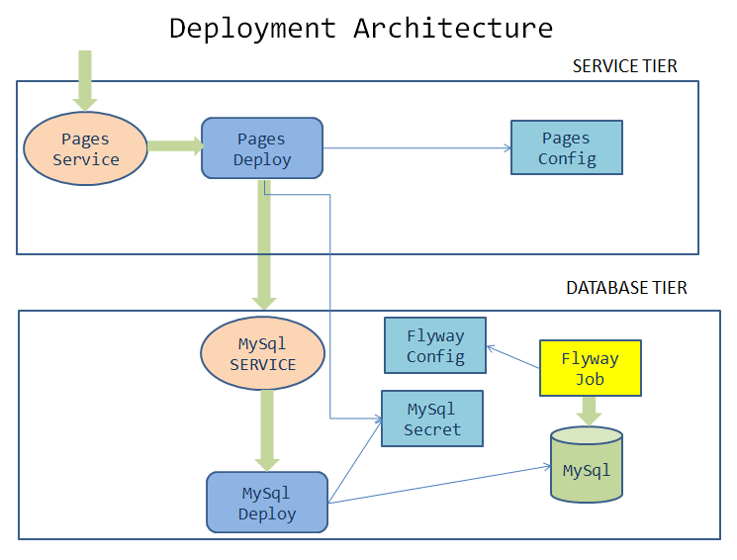

Kubernetize
- The pages service needs to connect to the mysql database. The communication happens through mysql service that we created in the previous lab. However, the pages deployment should be aware of the spring datasource related properties.
- Update the pages deployment by adding environment variables to the container
SPRING_DATASOURCE_URL |  | jdbc:mysql://pages-mysql/pages
SPRING_DATASOURCE_USERNAME |  | "root"
SPRING_DATASOURCE_PASSWORD |  | Value from secret name mysql-pass with key name password
 | With the above environment variables, spring boot can auto-configure the things necessary for database connectivity.
- Refer to the below updated env section
env:
- name: PAGE_CONTENT
valueFrom:
configMapKeyRef:
name: pages-config-map
key: PAGE_CONTENT
- name: SPRING_DATASOURCE_URL
value: jdbc:mysql://pages-mysql/pages
- name: SPRING_DATASOURCE_USERNAME
value: "root"
- name: SPRING_DATASOURCE_PASSWORD
valueFrom:
secretKeyRef:
name: mysql-pass
key: password
- Delete the pages deployment. This is not recommended in production, however we want to ensure that we have a fresh deployment for local testing. kubectl delete deploy pages
- Update the pages deployment with the appropriate namespace, image & tag name that you created while dockerizing

Testing locally on minikube
- Switch the kubectl context to minikube - kubectl config use-context minikube
Set the kubectl context namespace to your namespace - kubectl config set-context --current --namespace [student-name]
- Since the pages service is updated with new labels, updating the immutable propery of the service is not allowed. Delete the service
kubectl delete svc pages
- Create the service
kubectl apply -f deployment/pages-service.yaml
- Create pages deployment.
kubectl apply -f deployment/pages-deployment.yaml
- Test the pages application by performing CRUD operations using curl/postman. Refer Pages Curl Guide for testing.
- Update the docker image tag in pipeline.yaml and pages-deployment.yaml and verify they are same

Deploy to the production cluster
- Ensure that the tag names are the same in deployment and pipeline.
- In the pipeline.yml file update the branch to pick up the commit from the feature branch. Replace it with the branch name service
- Commit your changes and push them to github. The pipeline will deploy your new image to the production cluster.
- Pushing the souce code to github
git status
git add .
git commit -m "service-tier"
git push -u origin service
- Ci/CD pipeline will trigger the build and deployment. Wait for it to succeed.
- Switch the kubectl context to production cluster pointing to your namespace
- Port forward to connect to pages service running inside K8s from the local machine
kubectl port-forward svc/pages 8080:8080
- Test the pages application by performing CRUD operations using curl/postman. Refer Pages Curl Guide for testing.

Task Accomplished
We completed integrating the service-tier with the database-tier & successfully deployed a two-tier cloud native application to K8s cluster.

