Design and Develop Database Tier

The architecture of pages microservice consists of two major components, database tier and service tier. In this lab, we will focus only on the database tier. The database tier will be developed and deployed first, which paves the way for developing the application/service tier.
We will use database migrations for versioning our schema changes as our database evolves. There are various automation tools for implementing the database migrations. We will be using Flyway, as it is well adopted and widely accepted in the spring boot community.

Learning Outcomes
After completing the lab, you will be able to:
- Develop the Database Tier using MySql
- Create MySql deployment in K8s
- Expose MySql to be discovered by other services within the cluster
- Implement Database Migrations using Flyway locally and on the production cluster
- Leverage the concept of K8s Jobs for background processing
Ensure the source code is checked in to github.
git status
You should be able to see this:
nothing to commit, working tree clean
You can take a back up of your codebase, to keep your deployment files from being overwritten. Checkout into a feature branch
git checkout database-tier-start -b db
You are on branch db
In case you get an error when you cherry-pick/check-out, open intellij, right-click on the project, select git → resolve-conflicts → View changes and merge them based on the differences

Creating the database locally
- The updated codebase contains the refactored and re-organized pipeline. It also brings in database folder containing the DDL and DML scripts for creating the database and schema migrations. Take some time to walk-through them.
- database/create_database.sql contains sql script for creating the database pages and user pages_user for developing and testing locally.
- database/migrations/V1__initial_schema.sql contains the script for creating the schema.
- Create the database locally.
mysql -uroot < database/create_database.sql
They do not have any tables yet.
- Run the flyway database migration command to create the schema
flyway -url="jdbc:mysql://localhost:3306/pages" -user=pages_user -password=password -locations=filesystem:database migrate
- Inspect the database created locally using mysql client.
mysql -u pages_user -p
Enter password: ********
use pages;
describe pages;

Kubernetize the Database Tier
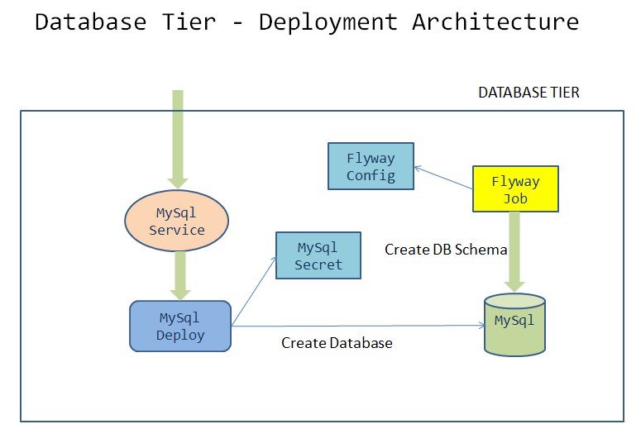
- Create the secret manifest file deployment/mysql-secret.yaml
Specification:
name | mysql-pass
namespace | [your namespace]
spring.datasource.password | [base64 encoded password]
password | [base64 encoded password]
- For generating base64 encoded password use one of the 2 methods below
  - Use dry-run option to get the yaml for the secret in imperative way
kubectl create secret generic mysql-pass --namespace=[student-name] --from-literal=spring.datasource.password=password --from-literal=password=password --dry-run=client -o yaml
  - Use the command echo -n password | base64 and copy that into the yaml file if you want to write the yaml from scratch.
For more information refer to http://kubernetes.io/docs
- Create the file deployment/mysql-deployment.yaml containing the manifest for mysql deployment
Specification:
name | mysql
namespace | [your namespace]
labels | app:pages, tier:database
image | mysql:8.0
container-name | mysql
containerPort | 3306
volume Name | mysql-persistent-storage
volume Type | emptyDir{}
mountPath | mountPath: /docker-entrypoint-initdb.d
EnvironmentVariables | - MYSQL_SERVICE_HOST: "pages-mysql"  - MYSQL_SERVICE_PORT: 3306  - MYSQL_DATABASE: pages  - MYSQL_USER: root  - MYSQL_ROOT_PASSWORD: value from a secret called mysql-pass with key-name as password.
Solution
apiVersion: apps/v1
kind: Deployment
metadata:
name: mysql
namespace: [student-name]
labels:
app: pages
tier: database
spec:
selector:
matchLabels:
app: pages
tier: database
strategy:
type: Recreate
template:
metadata:
labels:
app: pages
tier: database
spec:
containers:
- image: mysql:8.0
name: mysql
env:
- name: MYSQL_ROOT_PASSWORD
valueFrom:
secretKeyRef:
name: mysql-pass
key: password
- name: MYSQL_SERVICE_HOST
value: "pages-mysql"
- name: MYSQL_SERVICE_PORT
value: "3306"
- name: MYSQL_DATABASE
value: "pages"
- name: MYSQL_USER
value: "root"
ports:
- containerPort: 3306
name: mysql
volumeMounts:
- name: mysql-persistent-storage
mountPath: /docker-entrypoint-initdb.d
volumes:
- name: mysql-persistent-storage
emptyDir: {}
- Create the deployment/mysql-service.yaml with the manifest for exposing the mysql deployment with following specs:
apiVersion: v1
kind: Service
metadata:
name: pages-mysql
namespace: student-name
labels:
app: pages
tier: database
spec:
ports:
- port: 3306
selector:
app: pages
tier: database
type: ClusterIP
- Create the file deployment/flyway-configmap.yaml containing the manifest for configmap used by flyway
Specification:
name | flyway-configmap
namespace | [your namespace]
data | - spring.datasource.username: root  - V1__inital_schema.sql: This should be the content of your database/migrations/V1__inital_schema.sql
If you are not sure how to create the configmap, refer to the earlier examples.
- Create the file deployment/flyway-job.yaml containing the manifest for running a K8s job to execute flyway migration commands
apiVersion: batch/v1
kind: Job
metadata:
name: flyway-job
namespace: [student-name]
labels:
app: pages
spec:
template:
spec:
containers:
- name: flyway
image: flyway/flyway:6.4.4
args:
- info
- migrate
- info
env:
- name: FLYWAY_URL
value: jdbc:mysql://pages-mysql/pages
- name: FLYWAY_USER
value: root
- name: FLYWAY_PASSWORD
valueFrom:
secretKeyRef:
name: mysql-pass
key: password
- name: FLYWAY_PLACEHOLDER_REPLACEMENT
value: "true"
- name: FLYWAY_PLACEHOLDERS_USERNAME
valueFrom:
configMapKeyRef:
name: flyway-configmap
key: spring.datasource.username
- name: FLYWAY_PLACEHOLDERS_PASSWORD
valueFrom:
secretKeyRef:
name: mysql-pass
key: spring.datasource.password
volumeMounts:
- mountPath: /flyway/sql
name: sql
volumes:
- name: sql
configMap:
name: flyway-configmap
restartPolicy: Never

Testing locally
- Switch the kubectl context to minikube and set the context to point to your namespace.
- Create all the 5 resources inside your namespace. Wait for some time for the migration job to complete. Verify the resources were created without errors.
- To verify the database was created with the table pages use kubectl exec to get a shell to the mysql container
kubectl get pods
#copy the name of mysql pod
kubectl exec -it <pod-name> -- sh
mysql -uroot -p
password

show databases;
use pages;
show tables;
describe pages;
exit ;
- Verify scripts/deploy-to-k8s.sh is updated to create all the 5 resources
- Update the docker image tag in pipeline.yaml and pages-deployment.yaml and verify they are same

Deploy to the production cluster
- In the pipeline.yml file update the branch to pick up the commit from the feature branch. Replace it with the branch name db
- Pushing the souce code to github
git status
git add .
git commit -m "database-tier"
git push -u origin db --tags
- Ci/CD pipeline will trigger the build and deployment. Wait for it to succeed.
- Switch the kubectl context to production cluster pointing to your namespace
- Verify the database is provisioned as per the deployment architecture. Use kubectl exec into mysql pod through the terminal and verify the table pages is created with 1 successful migration. Also, you can check the logs from the flyway job.
The background job will not be deleted automatically. You will have to manually delete the flyway job by running kubectl delete job flyway-job once its has completed successfully.

The database tier is now ready to accept requests.

