7 4 9 8 5 7 1 2 0 2 PRAVIN PINJARKAR
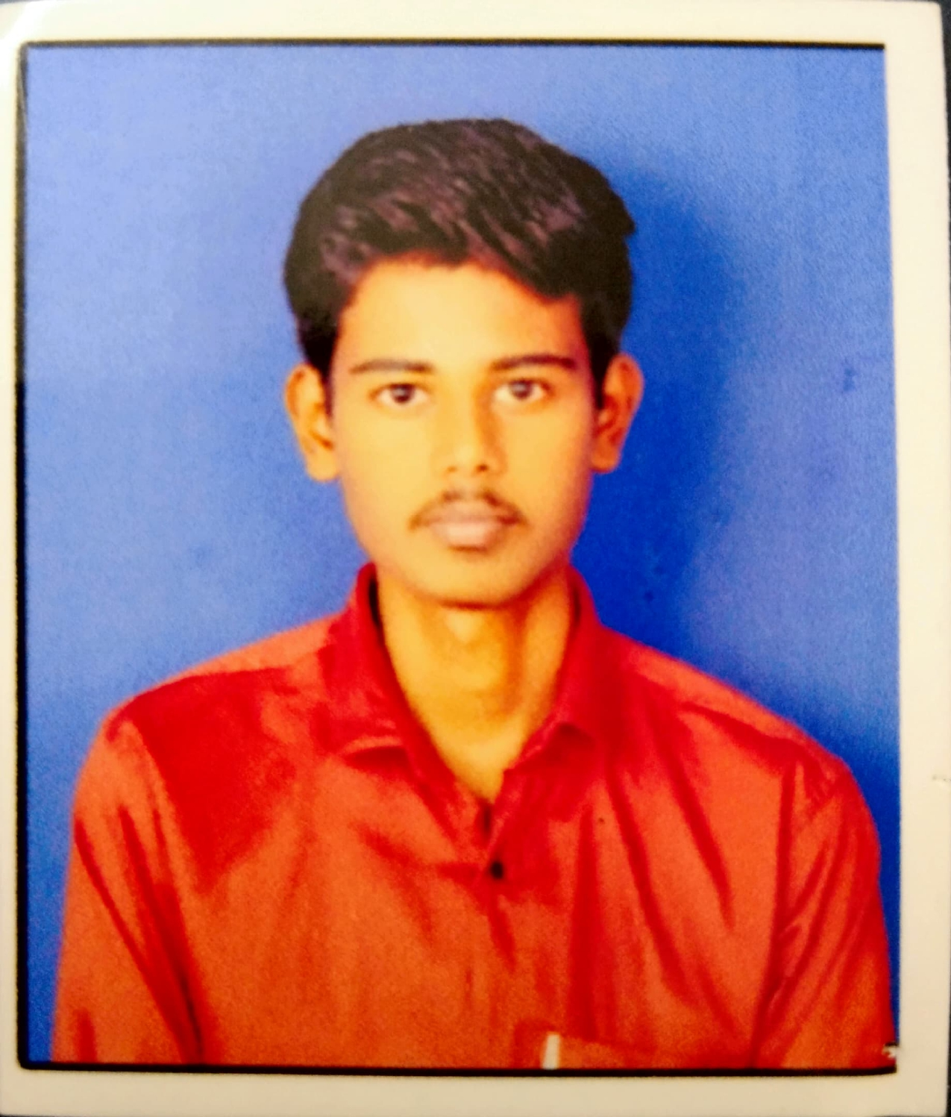
pravinpinjarkar2705@gmail.com https://github.com/pravin-pinjarkar
 https://www.linkedin.com/in/pravin-pinjarkar-a71aab281/
 https://leetcode.com/u/Pravin_Pinjarkar/

Education
- Vishwakarma Institute Of Technology, Pune Sep 2024 - Jun 2027
B. Tech in Computer Engineering - Current CGPA-8.51
- Government Polytechnic, Amravati Aug 2021 – Jun 2024
Diploma in Computer Engineering Percentage-89.47%
- Shri Samarth High School, Amravati Jun 2015 – May 2021
10th Standard Percentage-88%

Skills
- Programming Languages: Java, Python, C, C++
- Core Concepts: Data Structures and Algorithms (DSA)
- Web Technologies: HTML, CSS, JavaScript, React.js, Node.js, Express.js
- Databases: MongoDB, SQL, MySQL
- Other Technologies: PHP

Projects

Doc-Genie The Microsoft Word AI Assistant

Developed a Python-based AI assistant that performs tasks through voice and text commands.

Opening apps, searching Google, generating content, playing music, and creating documents/presentations.

Tech Stack-Python, SpeechRecognition, pyttsx3, Webbrowser API, OS Module, Automation Libraries

End-to-End Secure Tracking System of Precursor Chemicals using Blockchain with Anomaly Detection
- Built a blockchain-powered supply chain tracking system to securely monitor chemical movement with tamper-proof records.
- Integrated anomaly detection to identify suspicious activities and ensured real-time transparency through a full-stack web application.
- Tech Stack-Solidity, Blockchain, Node.js, Express.js, MongoDB, HTML, CSS, JavaScript
- AI-Powered Self-Adjustable & Self-Cleaning Solar (PV) Cell System
- Developed an intelligent solar panel system using computer vision to automatically adjust panel angles for maximum sunlight and detect dust/debris for automated cleaning.
- Tech Stack- Python, YOLOv8, OpenCV, Computer Vision, IoT Sensors, Embedded Systems

Experience
MDB Electrosoft Internship
- I completed a 2-month internship at MDB Electrosoft, where I worked on real-world IoT projects.
- I gained practical experience with sensors, microcontrollers, and hardware–software integration, and improved my troubleshooting and problem-solving skills.
Achievements
- Winner – Inter-College Cricket Tournament (Overall College Champion)
- Achieved Runner-Up in the college-level Carrom Competition.
- Published Research Paper in IEEE Conference - Link-https://ieeexplore.ieee.org/document/11308545

