MICRO-PROJECT REPORT ON

Develop Nursery Management System
In partial fulfillment of Diploma in Computer Engineering (Fifth Semester)
In the subject Advanced Java Programming(AJP)
(FC5464)
By
Pravin Sham Pinjarkar (21CM047)
Tanay Sham Raundale (21CM051)
Submitted to



Government Polytechnic, Amravati
(An Autonomous Institute of Govt. of Maharashtra)
Under the guidance of

Prof. R.G.Belsare
(Lecturer in Computer Engineering)

Computer Engineering Department, Government Polytechnic Amravati,
(2023-2024)

Government Polytechnic, Amravati.
(An Autonomous Institute of Govt. of Maharashtra)

Department of Computer Engineering

Certificate

This is to certify that Pravin Pinjarkar,Tanay Raundale Identity Code
21CM047, 21CM051 respectively of Fifth Semester Diploma in Computer Engineering have satisfactorily completed the micro project entitled “Develop Nursery Management System” in (FC5464) Advanced Java Programming (AJP) the academic year 2023-24 as prescribed in curriculum.

Prof. R.G.Belsare Dr P. P. Karde Lecturer, Head of department
Department of Computer Computer Engineering Engineering

Govt. Polytechnic, Amravati
(An Autonomous Institute of Govt. Of Maharashtra)
VISION
Vision to be a vibrant technical institute of global reputes contributing towards the needs
of industries & society.

MISSION
- To develop competent diploma engineers suitable for contemporary industrial environment.
- To inculcate socially accepted ethics & values among budding engineers.
- To Nurture innovations and entrepreneurship.
- To produce engineers with psychomotor & cognitive skills committed to lifelong learning.

Computer Department

VISION
Provide skilled professionals in Computer Engineering to contribute towards the advancement of technology useful for society and industrial environment.

MISSION

- Impart need based and value based education by providing exposure of latest tools and technologies
in The area of Computer Engineering to satisfy the stakeholders.

- Upgrade and maintain facilities for quality technical education with continuous effort for excellence
in Computer Engineering.

- Train students with Computer Engineering knowledge to apply it in the general disciplines of design,
deployment of software and integration of existing technologies. For E- governance and for benefit
of society.

- Provide a learning ambience to enhance innovations, problem solving skills, leadership qualities,
team spirit and ethical responsibilities.

- Provide an academic environment and consultancy services to the industry and society in the area
Of Computer Engineering.

Annexure-I PART A-Plan
Title of Micro-Project:

Develop Nursery Management System
1.0 Brief Introduction

- Nursery Management System will help you manage your business by improving efficiencies within
your nursery, utilizing the many modules available in the software.

- Nursery Management System is user friendly and takes the hard work out of running your nursery
setting facilities to remember all the things that are important to your business.

- Helps to maintain customer records, preferences, and communication history, improving customer
service and loyalty.

- It Also Helps Plant Seller to manage their plant records or history of each plant that which he sold it.

- It is Important and useful software for Nursery Management.

2.0 Aim of the Micro-Project
The Project aims at:

    - To get all the information about Nursery Management System.

    - To get idea of how the Plant Records manage in Database.

    - It is Perfect Software for Nursery management to keep.

    - History of each plant and it is useful for both seller and customers.

    - All doubts are clear regarding to the Nursery management system.

    - All the Things related to Java Programming are understood.

3.0 Course outcomes integrated

1.Implement a Swing class component in Java Program.

2.Implement an Event Handling in Java Program.

4.Develop and interactive program base on JDBC for Database.

4.0 Actual Procedure Followed (Sequence and time required for major activities for 8 weeks)

Sr.no | Details of Activity | Planned start Date | Planned Finish Date | Code and Name of  The team  Memebers
1. | Search and collect  Information about selected  microproject. | 20/10/23 | 25/10/23 | 21CM047-Pravin Sham Pinjarkar
2. | Creating the actual code of the project | 26/10/23 | 05/11/23 | 21CM051-Tanay Sham Raundale
3. | Testing the GUI part | 06/11/23 | 10/11/23 | 21CM047-Pravin Sham Pinjarkar
4. | Analyzing the whole code | 11/11/23 | 13/11/23 | 21CM051-Tanay Sham Raundale
5. | Integrating the application modules | 14/11/23 | 16/11/23 | 21CM047-Pravin S.Pinjarkar.
6. | Prepare report with editing word file. | 17/11/23 | 17/11/23 | 21CM051-Tanay S.Raundale

5.0 Resources Required (major resources such as raw material, some machining facility, software etc.)

S.N. | Name of  Resource/material | Specifications | Qty/size | Remarks
1. | Computer Operating  system(hp,64 bit) | Windows 11
2. | Laptop | Device | 2
3. | Internet Access | Google  Chrome | 500 MB
4. | Ms word | Software | 1
5. | Netbeans IDE | Software Version 17 | 1
6. | Resource | Oracle 11G | 1

6.0 Name of the Team Member with Id Code:-

Name of Member | ID Code | Signature
1)Pravin S. Pinjarkar | 21CM047
2)Tanay S. Raundale | 21CM051

Annexure-II PART B-Plan

Develop Nursery Management System

1.0 Brief Introduction

- Nursery Management System will help you manage your business by improving efficiencies within
your nursery, utilizing the many modules available in the software.

- Nursery Management System is user friendly and takes the hard work out of running your nursery
setting facilities to remember all the things that are important to your business.

- Helps to maintain customer records, preferences, and communication history, improving customer
service and loyalty.

- It Also Helps Plant Seller to manage their plant records or history of each plant that which he sold it.

- It is Important and useful software for Nursery Management.

2.0 Aim of the Micro-Project
This Micro-Project aims at:

- To get all the information about Nursery Management System.

- To get idea of how the Plant Records manage in Database.

- It is Perfect Software for Nursery management to keep.

- History of each plant and it is useful for both seller and customers.

- All doubts are clear regarding to the Nursery management system.

- All the Things related to Java Programming are understood.

3.0 Course Outcomes Integrated

1.Implement a Swing class component in Java Program.

2.Implement an Event Handling in Java Program.

4.Develop and interactive program base on JDBC for Database.

4.0 Action Plan

Sr.no | Details of Activity | Planned start Date | Planned Finish Date | Code and Name  Of the team Memebers
1. | Search and collect  Information about selected  microproject. | 20/10/23 | 25/10/23 | 21CM047-Pravin Sham Pinjarkar
2. | Creating the actual code of the project | 26/10/23 | 05/11/23 | 21CM051-Tanay Sham Raundale
3. | Testing the GUI part | 06/11/23 | 10/11/23 | 21CM047-Pravin Sham Pinjarkar
4. | Analyzing the whole code | 11/11/23 | 13/11/23 | 21CM051-Tanay Sham Raundale
5. | Integrating the application modules | 14/11/23 | 16/11/23 | 21CM047-Pravin S.Pinjarkar.
6. | Prepare report with editing word file. | 17/11/23 | 17/11/23 | 21CM051-Tanay S.Raundale

5.0 Actual Resources used :-

S.N. | Name of  Resource/material | Specifications | Qty/size | Remarks
1. | Computer Operating  system(hp,64 bit) | Windows 11
2. | Laptop | Device | 2
3. | Internet Access | Google  Chrome | 500 MB
4. | Ms word | Software | 1
5. | Netbeans IDE | Software Version 17 | 1
6. | Resource | Oracle 11G | 1

6.0 Output of the Micro-Project
Output of this Micro-Project is attached to this file. How the Plant Records manage and how this software
is helpful and useful we will see in that Program Output.

7.0 Skill Developed / Learning outcomes of this Micro-Project

After successful completion of this microproject we have developed our common skills like:
    - Communication skills
    - Planning skills
    - Time management skills
    - Programming skills
Although, we have developed some subject specific (related to topic) skills like:
    - Learned how the Records are Manage into the Database using Oracle 11G software.
    - Implement Various SQL Commands and used that Commands in Our Project.

8.0 Assessment by Faculty as per Rubrics

Process Assessment (06) | Product Assessment  (04) | Total Marks (10) | Signature of Faculty

INTRODUCTION

- What is there inside the Nursery Management System?

In the dynamic and evolving field of nursery and plant management, the effective organization and coordination of various activities are crucial for success. The Nursery Management System (NMS) emerges as a comprehensive solution designed to streamline and enhance the operations of nurseries, plant nurseries, and related establishments.

NMS is a technologically advanced software platform tailored to meet the unique needs of nursery businesses, offering an integrated approach to manage various aspects of plant production, sales, and overall nursery operations. This system leverages cutting-edge technologies to automate processes, optimize resource utilization, and provide a centralized platform for seamless communication and data management.

Key Features of Nursery Management System:

1. Inventory Management: NMS facilitates real-time tracking of plant inventory, including stock levels, species information, and growth stages. This ensures efficient planning for production and sales.

2. Plant Growth Monitoring: The system allows users to monitor and record the growth and health status of plants. This feature aids in timely decision-making regarding pruning, fertilization, and other essential cultivation practices.

3. Sales and Customer Management: NMS provides tools for managing customer information, sales transactions, and order processing. This feature enables nurseries to maintain customer relationships, process orders efficiently, and analyze sales data for strategic planning.

4. Task Scheduling: Efficient scheduling of tasks such as planting, watering, and harvesting is critical in a nursery setting. NMS helps in organizing and automating these tasks, ensuring optimal resource utilization and timely completion.

5. Reporting and Analytics: Robust reporting tools within the system offer insights into key performance indicators, allowing nursery managers to make informed decisions. Analytics features enable trend analysis and forecasting for better business planning.

6. Communication Hub: The system serves as a central hub for communication within the nursery, facilitating collaboration among team members. This enhances overall coordination and ensures that everyone is well-informed about ongoing activities.

7. Compliance and Record Keeping: NMS helps nurseries stay compliant with industry regulations by maintaining accurate records of plant varieties, treatments, and other relevant data. This feature is essential for audits and regulatory inspections.

8. Mobile Accessibility: With the increasing need for flexibility, NMS often includes mobile accessibility, allowing users to manage nursery operations on-the-go. This is particularly beneficial for field staff and managers who need real-time access to information.

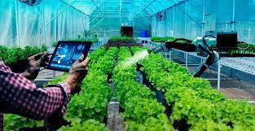

- Some Key Points Related to NMS(Nursery Management System):

Certainly! Here are some important points to consider in a Nursery Management System (NMS):

1. Inventory Tracking:
- Real-time monitoring of plant inventory.
- Detailed information on species, quantities, and growth stages.

2. Plant Growth Monitoring:
- Tools to track and record the growth and health status of plants.
- Alerts for optimal care interventions such as pruning or fertilization.

3. Sales and Customer Management:
- Efficient order processing and sales transaction management.
- Customer relationship management tools for better communication and engagement.

4. Task Scheduling:
- Automated scheduling of planting, watering, harvesting, and other tasks.
- Resource optimization to ensure timely completion of activities.

5. Reporting and Analytics:
- Comprehensive reporting tools for key performance indicators.
- Analytics features for trend analysis and informed decision-making.

6. Communication Hub:
- Centralized platform for internal communication among nursery staff.
- Notifications and alerts for important updates and tasks.

7. Compliance and Record Keeping:
- Maintenance of accurate records for regulatory compliance.
- Easy retrieval of historical data for audits and inspections.

8. Mobile Accessibility:
- Access to the system from mobile devices for on-the-go management.
- Field staff can input data and receive updates remotely.

9. Resource Planning:
- Efficient allocation of resources such as labor, equipment, and materials.
- Tools for budgeting and cost tracking.

10. Weather Integration:
- Integration with weather data for better decision-making.
- Alerts for adverse weather conditions that may affect plant health.

11. Multi-location Support:
- Ability to manage multiple nurseries or locations from a centralized system.
- Consistent data synchronization across different sites.

These points collectively contribute to the efficiency, organization, and overall success of a Nursery Management System, ensuring that nurseries can meet the demands of the industry while maintaining the health and quality of their plant inventory.

- Let us think about the programming concepts now.

1.Using the Netbeans IDE:

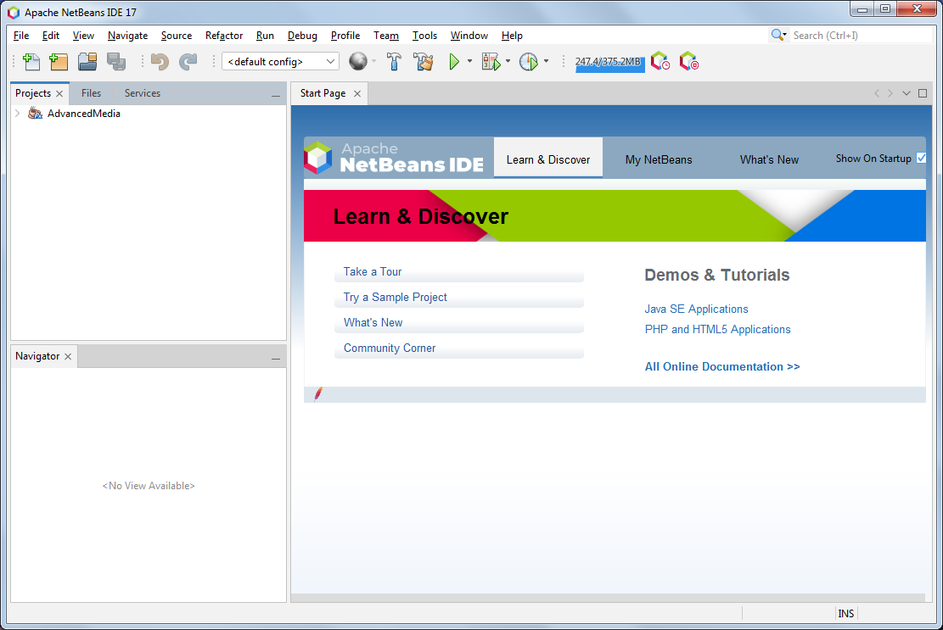

Certainly! NetBeans is a popular integrated development environment (IDE) for Java development, and it also supports other programming languages. Here are the general steps for using NetBeans IDE:

Step 1: Install NetBeans

1. Download and Install:
- Visit the official NetBeans website (https://netbeans.apache.org/).
- Download the installer suitable for your operating system.
- Run the installer and follow the on-screen instructions to install NetBeans.

Step 2: Launch NetBeans

1. Open NetBeans:
- Once installed, launch NetBeans from your applications or desktop.

Step 3: Create a New Project

1. Click on "File":
- In the menu bar, click on "File."

2. Select "New Project":
- Choose "New Project" from the drop-down menu.

3. Choose Project Type:
- Select the type of project you want to create (e.g., Java application, JavaFX application, PHP project, etc.).

4. Configure Project:
- Follow the wizard to configure your project settings, such as project name, location, and other options.

5. Finish:
- Click "Finish" to create the project.

Step 4: Write Code

1. Open Source Files:
- In the "Projects" window, you will see your newly created project. Open the source files (e.g., Main.java) to start writing code.

2. Code Editor:
- Use the code editor to write, edit, and debug your code.

Step 5: Build and Run

1. Build Project:
- Click on the "Build" button (hammer icon) to compile your code.

2. Run Project:
- Click on the "Run" button (green arrow) to execute your program.

Step 6: Manage Libraries and Dependencies

1. Library Manager:
- Use the Library Manager to add external libraries to your project.

Step 7: Customize IDE (Optional)

1. Preferences/Options:
- Explore and customize NetBeans preferences or options based on your preferences.

Step 8: Documentation and Support

1. NetBeans Documentation:
- Refer to the NetBeans documentation for detailed information on specific features and functionalities.

2. Community Support:
- Join the NetBeans community for forums, discussions, and support.

Step 11: Save and Close

1. Save Your Work:
- Make sure to regularly save your work using the "Save" option or shortcut (Ctrl + S on Windows, Command + S on macOS).

2. Close NetBeans:
- Close NetBeans when you're done working on your project.

These steps provide a general overview of using NetBeans for development. Depending on the type of project you're working on, you may need to explore additional features and tools specific to your chosen programming language or framework.

2. What is JDBC?:

JDBC stands for Java Database Connectivity. It is a Java-based API (Application Programming Interface) that allows Java applications to interact with relational databases. JDBC provides a standard interface for connecting to databases, sending SQL queries, and processing the results within Java applications. It acts as a bridge between the Java programming language and various database management systems (DBMS).

Key components and concepts of JDBC include:

1. Driver Manager:
- The DriverManager class manages a list of database drivers. It is responsible for establishing a connection to the database.

2. JDBC Drivers:
- JDBC drivers are platform-specific implementations that enable Java applications to communicate with different types of databases. There are four types of JDBC drivers:
- Type 1 (JDBC-ODBC Bridge Driver): Uses ODBC (Open Database Connectivity) to connect to the database.
- Type 2 (Native API Driver): Directly communicates with the database using the native database API.
- Type 3 (Network Protocol Driver): Communicates with a middleware server that connects to the database.
- Type 4 (Thin Driver or JDBC Native Protocol Driver): Directly communicates with the database using a vendor-specific protocol.

3. Connection:
- The Connection interface represents a connection to the database. It is used to create statements, execute queries, and manage transactions.

4. Statement:
- The Statement interface is used to execute SQL queries on the database. There are three types of statements:
- Statement: Used for executing simple SQL queries.
- PreparedStatement: Used for precompiled SQL queries, improving performance.
- CallableStatement: Used for calling database stored procedures.

5. ResultSet:
- The ResultSet interface represents the result set of a query. It allows the application to iterate over the rows and retrieve data from the query result.

6. SQLException:
- SQLException is an exception class in Java that handles database-related exceptions. It provides information about errors that occur during database operations.

- Advantages of Nursery Management System:

The Nursery Management System (NMS) offers various advantages for nurseries and plant management businesses. Here are some key benefits:

1. Efficient Inventory Management:
- NMS allows for real-time tracking of plant inventory, enabling nurseries to maintain accurate records of plant species, quantities, and growth stages. This helps in efficient planning and utilization of resources.

2. Optimized Resource Utilization:
- With features like task scheduling and automated processes, NMS helps in optimizing the use of resources such as labor, water, and fertilizers. This leads to increased productivity and cost-effectiveness.

3. Improved Plant Health Monitoring:
- NMS provides tools to monitor and record the growth and health status of plants. This proactive approach allows for timely interventions, such as pruning or fertilization, to ensure the well-being of the plants.

4. Streamlined Sales and Customer Management:
- The system facilitates the management of customer information, sales transactions, and order processing. This leads to improved customer relationships, efficient order fulfillment, and better analysis of sales data.

5. Enhanced Task Scheduling and Automation:
- NMS automates various tasks such as planting, watering, and harvesting through efficient scheduling. This automation reduces manual effort, minimizes errors, and ensures that tasks are completed on time.

Program Codes and Outputs:

Welcome.java:

public class Welcome extends javax.swing.JFrame {

/**

* Creates new form Welcome

*/

public Welcome() {

super("NURSERY MANAGEMENT SYSTEM");

initComponents();

}

@SuppressWarnings("unchecked")

// <editor-fold defaultstate="collapsed" desc="Generated Code">

private void initComponents() {

jPanel1 = new javax.swing.JPanel();

jLabel2 = new javax.swing.JLabel();

jLabel3 = new javax.swing.JLabel();

jButton1 = new javax.swing.JButton();

jLabel4 = new javax.swing.JLabel();

jButton2 = new javax.swing.JButton();

jLabel5 = new javax.swing.JLabel();

setDefaultCloseOperation(javax.swing.WindowConstants.EXIT_ON_CLOSE);

getContentPane().setLayout(new org.netbeans.lib.awtextra.AbsoluteLayout());

jPanel1.setBackground(new java.awt.Color(255, 255, 255));

jPanel1.setLayout(new org.netbeans.lib.awtextra.AbsoluteLayout());

jLabel2.setBackground(new java.awt.Color(51, 51, 51));

jLabel2.setFont(new java.awt.Font("Agency FB", 1, 48)); // NOI18N

jLabel2.setForeground(new java.awt.Color(255, 255, 255));

jLabel2.setText("Welcome ");

jPanel1.add(jLabel2, new org.netbeans.lib.awtextra.AbsoluteConstraints(170, 60, 170, 50));

jLabel3.setFont(new java.awt.Font("Agency FB", 1, 48)); // NOI18N

jLabel3.setForeground(new java.awt.Color(255, 255, 255));

jLabel3.setText("To");

jPanel1.add(jLabel3, new org.netbeans.lib.awtextra.AbsoluteConstraints(430, 140, 80, 40));

jButton1.setBackground(new java.awt.Color(204, 204, 204));

jButton1.setFont(new java.awt.Font("Segoe UI", 1, 14)); // NOI18N

jButton1.setText("LOGIN");

jButton1.setBorderPainted(false);

jButton1.addActionListener(new java.awt.event.ActionListener() {

public void actionPerformed(java.awt.event.ActionEvent evt) {

jButton2ActionPerformed(evt);

}

});

jPanel1.add(jButton2, new org.netbeans.lib.awtextra.AbsoluteConstraints(630, 420, -1, -1));

jLabel5.setIcon(new javax.swing.ImageIcon(getClass().getResource("/welcome.jpg"))); // NOI18N

jPanel1.add(jLabel5, new org.netbeans.lib.awtextra.AbsoluteConstraints(30, 0, 1020, 490));

getContentPane().add(jPanel1, new org.netbeans.lib.awtextra.AbsoluteConstraints(-30, 0, 1050, 490));

pack();

}// </editor-fold>

private void jButton2ActionPerformed(java.awt.event.ActionEvent evt) {

// TODO add your handling code here:

this.dispose();

java.awt.EventQueue.invokeLater(new Runnable() {

public void run() {

signUp s = new signUp();

s.setVisible(true);

s.setLocationRelativeTo(null);

}

});

}

private void jButton1ActionPerformed(java.awt.event.ActionEvent evt) {

// TODO add your handling code here:

this.dispose();

java.awt.EventQueue.invokeLater(new Runnable() {

public void run() {

Login a = new Login();

a.setVisible(true);

a.setLocationRelativeTo(null);

}

});

}

public static void main(String args[]) {

try {

for (javax.swing.UIManager.LookAndFeelInfo info : javax.swing.UIManager.getInstalledLookAndFeels()) {

if ("Nimbus".equals(info.getName())) {

javax.swing.UIManager.setLookAndFeel(info.getClassName());

break;

}

}

} catch (ClassNotFoundException ex) {

java.util.logging.Logger.getLogger(Welcome.class.getName()).log(java.util.logging.Level.SEVERE, null, ex);

} catch (InstantiationException ex) {

java.util.logging.Logger.getLogger(Welcome.class.getName()).log(java.util.logging.Level.SEVERE, null, ex);

} catch (IllegalAccessException ex) {

java.util.logging.Logger.getLogger(Welcome.class.getName()).log(java.util.logging.Level.SEVERE, null, ex);

} catch (javax.swing.UnsupportedLookAndFeelException ex) {

java.util.logging.Logger.getLogger(Welcome.class.getName()).log(java.util.logging.Level.SEVERE, null, ex);

}

java.awt.EventQueue.invokeLater(new Runnable() {

public void run() {

Welcome w = new Welcome();

w.setVisible(true);

w.setLocationRelativeTo(null);

}

});

}

private javax.swing.JButton jButton1;

private javax.swing.JButton jButton2;

private javax.swing.JLabel jLabel2;

private javax.swing.JLabel jLabel3;

private javax.swing.JLabel jLabel4;

private javax.swing.JLabel jLabel5;

private javax.swing.JPanel jPanel1;

}

Login.java:

import javax.swing.*;

import java.sql.*;

public class Login extends javax.swing.JFrame {

public Login() {

initComponents();

}

@SuppressWarnings("unchecked")

// <editor-fold defaultstate="collapsed" desc="Generated Code">

private void initComponents() {

jToolBar1 = new javax.swing.JToolBar();

jSlider1 = new javax.swing.JSlider();

jScrollPane1 = new javax.swing.JScrollPane();

jPanel1 = new javax.swing.JPanel();

jLabel1 = new javax.swing.JLabel();

jLabel2 = new javax.swing.JLabel();

username1 = new javax.swing.JTextField();

jLabel3 = new javax.swing.JLabel();

password = new javax.swing.JPasswordField();

jButton1 = new javax.swing.JButton();

jButton2 = new javax.swing.JButton();

jSeparator1 = new javax.swing.JSeparator();

jSeparator2 = new javax.swing.JSeparator();

jPanel2 = new javax.swing.JPanel();

jLabel4 = new javax.swing.JLabel();

jLabel5 = new javax.swing.JLabel();

jToolBar1.setRollover(true);

setDefaultCloseOperation(javax.swing.WindowConstants.EXIT_ON_CLOSE);

setResizable(false);

getContentPane().setLayout(new org.netbeans.lib.awtextra.AbsoluteLayout());

j

getContentPane().add(jPanel2, new org.netbeans.lib.awtextra.AbsoluteConstraints(430, 0, 440, 420));

pack();

}// </editor-fold>

private void username1ActionPerformed(java.awt.event.ActionEvent evt) {

// TODO add your handling code here:

}

private void jButton1ActionPerformed(java.awt.event.ActionEvent evt) {

String user, pass, rpass;

user = username1.getText();

pass = new String(password.getPassword());

Connection con;

String query = ("SELECT Password FROM nursery.signup where username = '" + user + "';");

Statement st;

ResultSet rs;

if (user.equals("") && pass.equals("")) {

JOptionPane.showMessageDialog(this, "Enter some details");

} else {

try {

con = DriverManager.getConnection("jdbc:mysql://localhost:3306/nursery", "root", "tanay123");

st = con.createStatement();

rs = st.executeQuery(query);

while (rs.next()) {

rpass = rs.getString("Password");

if (pass.equals(rpass)) {

JOptionPane.showMessageDialog(this, "Login Successull");

this.dispose();

java.awt.EventQueue.invokeLater(new Runnable() {

public void run() {

Menu m = new Menu();

m.setVisible(true);

m.setLocationRelativeTo(null);

}

});

} else {

JOptionPane.showMessageDialog(this, "Enter correct username or password");

}

}

} catch (Exception e) {

JOptionPane.showMessageDialog(this, e);

}

}

}

private void jButton2ActionPerformed(java.awt.event.ActionEvent evt) {

this.dispose();

java.awt.EventQueue.invokeLater(new Runnable() {

public void run() {

Welcome w = new Welcome();

w.setVisible(true);

w.setLocationRelativeTo(null);

}

}); // TODO add your handling code here:

}

Update.java:

^{import javax.swing.*;}

^{import java.sql.*;}

public class Update extends javax.swing.JFrame {

^{String table;}

^{public Update() {}

^{initComponents();}

}

^{@SuppressWarnings("unchecked")}

// <editor-fold defaultstate="collapsed" desc="Generated Code">

private void initComponents() {

buttonGroup1 = new javax.swing.ButtonGroup();

jPanel2 = new javax.swing.JPanel();

jLabel1 = new javax.swing.JLabel();

jLabel3 = new javax.swing.JLabel();

jLabel4 = new javax.swing.JLabel();

jLabel5 = new javax.swing.JLabel();

upid = new javax.swing.JTextField();

upname = new javax.swing.JTextField();

upqty = new javax.swing.JTextField();

jButton1 = new javax.swing.JButton();

jButton2 = new javax.swing.JButton();

nonflowering = new javax.swing.JCheckBox();

flowering = new javax.swing.JCheckBox();

jSeparator1 = new javax.swing.JSeparator();

jSeparator2 = new javax.swing.JSeparator();

jSeparator3 = new javax.swing.JSeparator();

jPanel1 = new javax.swing.JPanel();

jLabel6 = new javax.swing.JLabel();

setDefaultCloseOperation(javax.swing.WindowConstants.EXIT_ON_CLOSE);

^{setResizable(false);}

getContentPane().setLayout(new org.netbeans.lib.awtextra.AbsoluteLayout());

getContentPane().add(jPanel2, new org.netbeans.lib.awtextra.AbsoluteConstraints(0, 0, 500, 380));

jPanel1.setBackground(new java.awt.Color(255, 255, 255));

jPanel1.setForeground(new java.awt.Color(255, 255, 255));

jPanel1.setLayout(new org.netbeans.lib.awtextra.AbsoluteLayout());

jLabel6.setIcon(new javax.swing.ImageIcon(getClass().getResource("/update.jpg"))); // NOI18N

jPanel1.add(jLabel6, new org.netbeans.lib.awtextra.AbsoluteConstraints(0, 20, 470, 610));

getContentPane().add(jPanel1, new org.netbeans.lib.awtextra.AbsoluteConstraints(500, 0, 470, 380));

^{pack();}

^{}// </editor-fold>}

private void upqtyActionPerformed(java.awt.event.ActionEvent evt) {

// TODO add your handling code here:

}

private void jButton1ActionPerformed(java.awt.event.ActionEvent evt) {

// TODO add your handling code here:

^{Connection con;}

^{String id,name,qty;}

^{id=upid.getText();}

^{name = upname.getText();}

^{qty = upqty.getText();}

String query = ("update nursery."+table+" set plantname = '"+name+"' , quantity = '"+qty+"' where (plantid='"+id+"')");

^{Statement st;}

^{try}

{

con = DriverManager.getConnection("jdbc:mysql://localhost:3306/nursery","root","tanay123");

^{st = con.createStatement();}

int n = st.executeUpdate(query);

^{if(n == 1)}

{

^{upid.setText("");}

^{upname.setText("");}

^{upqty.setText("");}

JOptionPane.showMessageDialog(this,"RECORD UPDATED SUCCESSFULLY");

}

^{else}

{

JOptionPane.showMessageDialog(this,"RECORD NOT UPDATED");

}

}

^{catch(Exception e)}

{

JOptionPane.showMessageDialog(this,e);

}

}

private void jButton2ActionPerformed(java.awt.event.ActionEvent evt) {

// TODO add your handling code here:

^{this.dispose();}

java.awt.EventQueue.invokeLater(new Runnable() {

^{public void run() {}

^{Menu m = new Menu();}

^{m.setVisible(true);}

^{m.setLocationRelativeTo(null);}

}

^{});}

}

private void floweringItemStateChanged(java.awt.event.ItemEvent evt) {

// TODO add your handling code here:

^{if(evt.getStateChange() == 1)}

{

^{table = "flowering";}

}

Outputs:

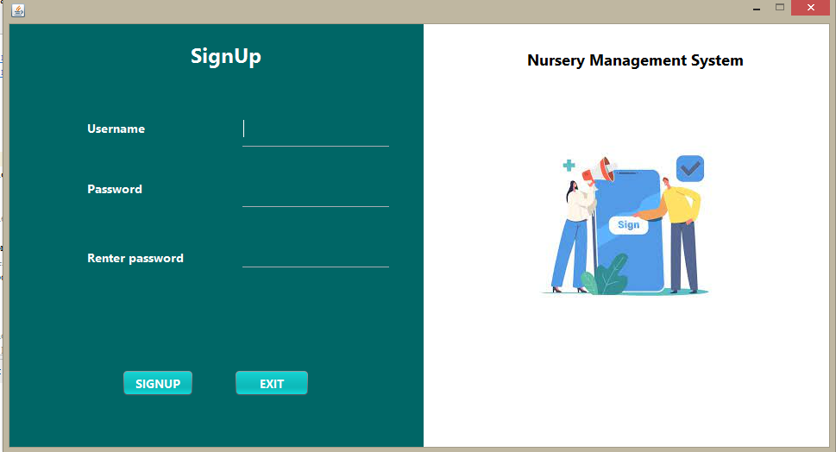

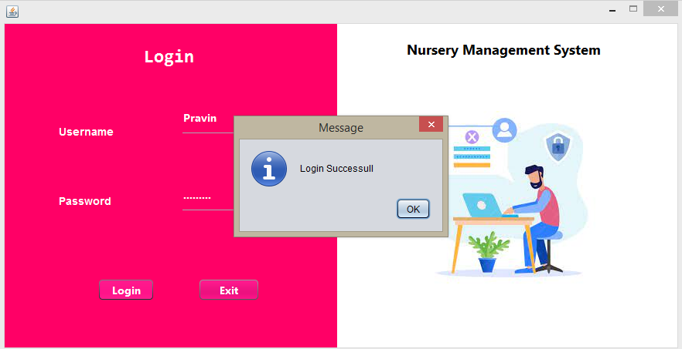

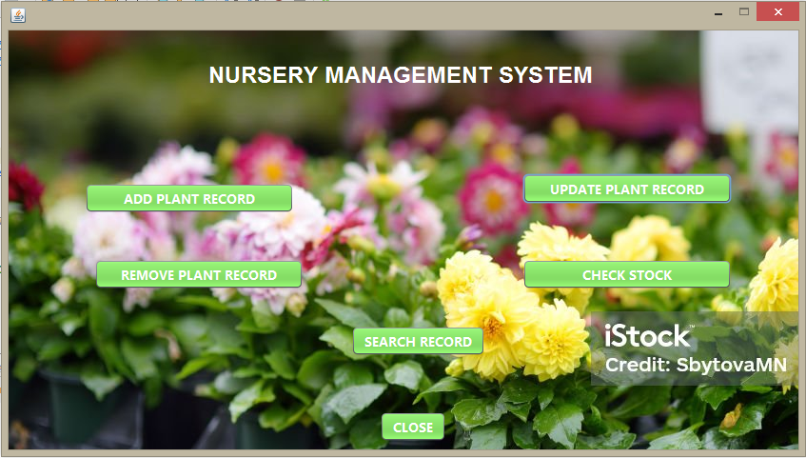

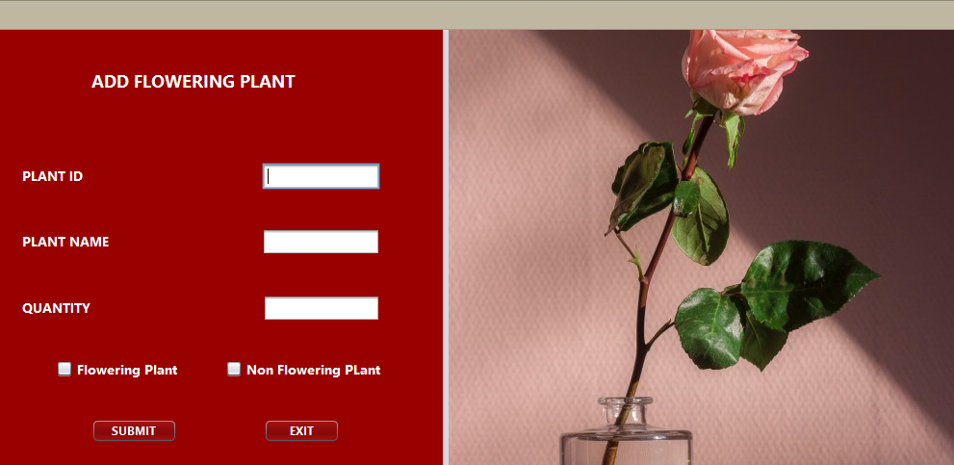

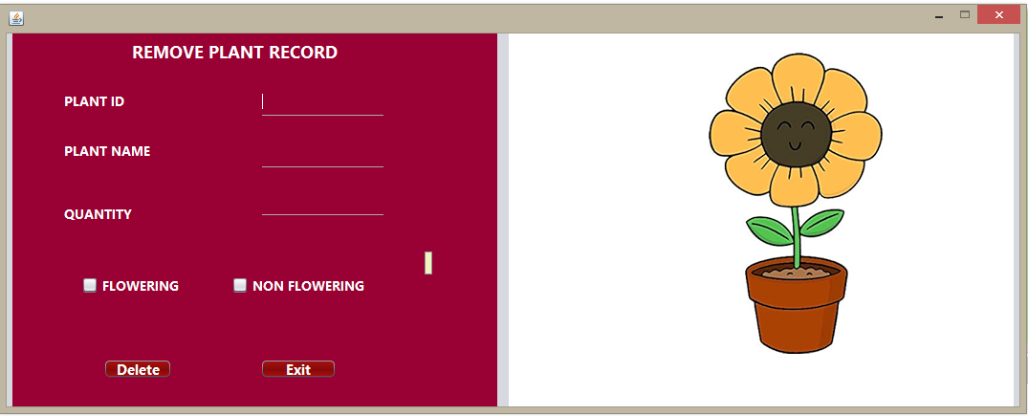

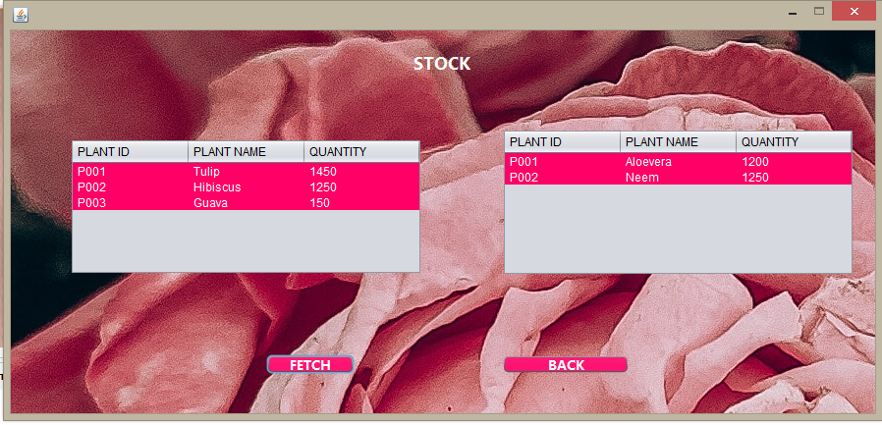

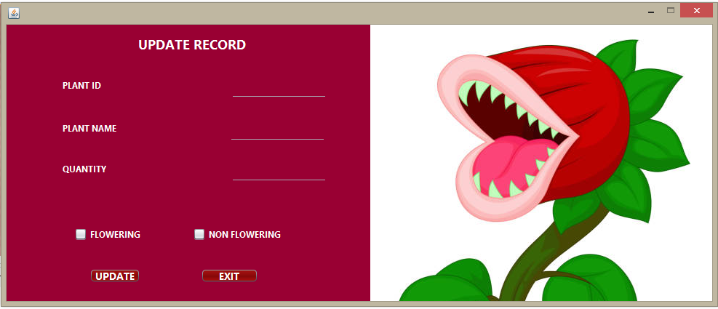

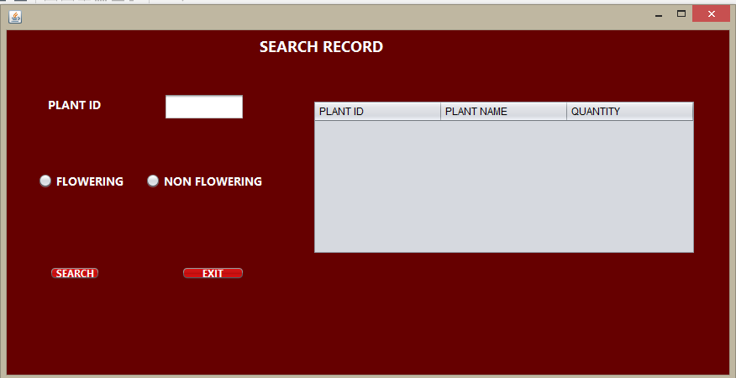

Conclusion

In this way we have successfully covered all the aspects regarding our project topic that is Nursery Management System(NMS)and we have also covered the related programming aspects such JDBC and swing.

With the help of this project we are now able to create sustainable web applications and we can now create the stable GUI based applications with database connectivity

The project gave us the knowledge about the programming skills and the related concepts of GUI application development. We learnt various programming skills such as the team work and unity we have successfully covered our learning topics from this project and it helped us gain more knowledge about JAVA programming and its important aspects such as JAVA swing and JDBC that is Java Database Connectivity.

References:

Websites:

Wikipedia

https://en.wikipedia.org/wiki/Special:Search?go=Go&search=Nursery+Management+system+&ns0=1

Google Scholars

https://books.google.co.in/books?hl=en&lr=&id=o9SAQQuZD-EC&oi=fnd&pg=PP7&dq=nursery+management+system&ots=VzPcfCcm21&sig=GTU-5g798Wh1R-qtacKhg88SikA&redir_esc=y#v=onepage&q=nursery%20management%20system&f=false

