 | AI-POWERED SKILL GAP ANALYZER AND  INTELLIGENT CAREER ACCELERATION AGENT  (SkillGap AI) | 
A MINI PROJECT REPORT
submitted by
ARUNITHA A ( 2403737710422066)
LEAVIN JACKSON J ( 2403737710421023)
PRAVIN K P ( 2403737710421037)
in partial fulfilment of the requirement
for the award of the degree
of
BACHELOR OF ENGINEERING
in
COMPUTER SCIENCE AND ENGINEERING
K.S. RANGASAMY COLLEGE OF TECHNOLOGY
(An Autonomous Institution, affiliated to Anna University Chennai and Approved by AICTE, New
Delhi)
TIRUCHENGODE – 637 215
OCTOBER 2026

K.S. RANGASAMY COLLEGE OF TECHNOLOGY
TIRUCHENGODE - 637 215
BONAFIDE CERTIFICATE
Certified that this mini-project report titled “AI-Powered Skill Gap Analyzer and Intelligent Career Acceleration Agent” is the bonafide work of ARUNITHA A (2403737710422066), LEAVIN JACKSON J (2403737710421023), PRAVIN K P (2403737710421037) who carried out the mini-project under my supervision. Certified further, that to the best of my knowledge the work reported herein does not form part of any other mini-project report or dissertation on the basis of which a degree or award was conferred on an earlier occasion on this or any other candidate.
SIGNATURE  Dr.K.Poongodi, M.E.,Ph.D.,  HEAD OF THE DEPARTMENT  Professor & Head  Department of CSE  K.S. Rangasamy College of  Technology Tiruchengode - 637 215 | SIGNATURE  Mr.S.Insol Rajasekar, M.Tech.,  SUPERVISOR  Assistant Professor  Department of CSE  K.S. Rangasamy College of Technology  Tiruchengode - 637 215
Submitted for the viva-voce examination held on …………….
Internal Examiner - 1 | Internal Examiner - 2

DECLARATION
We declare that the mini-project report titled “AI-POWERED SKILL GAP ANALYZER AND INTELLIGENT CAREER ACCELERATION AGENT” is the result of original work done by us and to the best of our knowledge, similar work has not been submitted anywhere for the requirement of the Degree of Bachelor of Engineering in Computer Science and Engineering. This mini-project report is submitted in partial fulfilment of the requirement for the award of the Degree of Bachelor of Engineering.
Signature
ARUNITHA A
LEAVIN JACKSON J
PRAVIN K P
Place: Tiruchengode
Date:

ACKNOWLEDGEMENT
We wish to express our sincere gratitude to our honorable Correspondent, Late Lion Dr. K. S. RANGASAMY, M.J.F., for providing immense facilities and an inspiring academic atmosphere at our institution.
We also wish to express our sincere gratitude to our honorable Chairman, Mr. R. SRINIVASAN, BBM., MISTE., for his continued support, vision, and progressive facilities provided across the college.
We are proud to extend our heartfelt thanks to our respected Principal, Dr. R. GOPALAKRISHNAN, M.E., Ph.D., for his constant encouragement, administrative guidance, and technical resources extended towards the successful completion of our mini-project.
We render our immense gratitude to our Head of the Department, Dr. K. POONGODI, M.E., Ph.D., Professor & Head, Department of Computer Science and Engineering, for her inspiring leadership, academic encouragement, and valuable suggestions throughout the course of this work.
We are highly indebted and extend our heartfelt thanks to our supervisor, Mr. S. INSOL RAJASEKAR, M.TECH., Assistant Professor, Department of Computer Science and Engineering, for invaluable ideas, constructive critiques, technical direction, and supportive guidance throughout the formulation and implementation of SkillGap AI.
We wish to extend our sincere thanks to all the faculty members, laboratory instructors, and administrative staff of the Department of Computer Science and Engineering for their kind cooperation, timely assistance, and valuable inputs.
Finally, we express our profound gratitude to our parents, family members, and friends whose unwavering moral and financial support provided us with constant strength and enthusiasm throughout our academic journey.

ABSTRACT
Undergraduate engineering students face profound challenges when transitioning from theoretical university education into modern, highly dynamic corporate software environments. Traditional technical recruitment systems rely almost entirely on keyword-based Applicant Tracking Systems (ATS) that reject qualified applicants due to minor lexical variations, or on generic commercial job portals that fail to provide candidates with actionable diagnostic explanations of their competency deficiencies. Furthermore, generic conversational AI models suffer from semantic hallucination and lack structured mathematical ontologies when quantifying candidate proficiency gaps across multi-framework technology stacks.
To address these critical limitations, this report presents SkillGap AI, an autonomous, multi-tier agentic AI platform designed for automated resume-to-job competency extraction, mathematical skill gap quantification, and personalized upskilling roadmap generation. SkillGap AI implements an agentic architecture combining a React 19 and Vite modern SaaS frontend, a high-performance Node.js and Express REST API gateway, and a specialized Python FastAPI AI service orchestrated using LangGraph state graph conventions and Sentence-BERT vector embeddings. The platform is backed by a structured relational PostgreSQL database with pgvector semantic capabilities alongside resilient ESCO and O*NET skill taxonomy graphs.
The core innovation of SkillGap AI lies in its hybrid decision-making architecture: it decouples strict mathematical computations from natural language reasoning. While Google Gemini 2.0 Flash is leveraged for personalized narrative synthesis, conversational interview coaching, and explainable career guidance, all skill entity extraction (via hybrid SpaCy NER and FlashText pattern matching) and multidimensional gap evaluations (Categorized Competency Vectors across Core Skills, Frameworks, Cloud Tooling, and Soft Skills) are computed through deterministic Python tools with 100% mathematical precision. The agent employs a 5-factor weighted recommendation model—incorporating Core Technical Skills (35%), Framework & Tooling (25%), Domain Knowledge (20%), Experience Depth (10%), and Soft Competencies (10%)—to objectively categorize candidate readiness into COMPETITIVE MATCH, PARTIAL PROFICIENCY, and CRITICAL GAP brackets. Additionally, SkillGap AI synthesizes a personalized 5-month month-by-month actionable upskilling roadmap and provides an interactive What-If Skill Simulation Engine capable of dynamically recalibrating readiness scores as users acquire new proficiencies.

TABLE OF CONTENTS
CHAPTER | TITLE | PAGE
 | ABSTRACT | v
1. | INTRODUCTION | 1
1.1 | Background | 1
1.2 | Problem Statement | 2
1.3 | Motivation | 2
1.4 | Objectives | 3
1.5 | Scope and Applications | 3
2. | LITERATURE SURVEY | 4
2.1 | Existing Systems and Solutions | 4
2.2 | Technologies Used | 5
2.3 | Limitations of Existing Systems | 5
2.4 | Proposed Improvement | 5
3. | PROPOSED SYSTEM | 6
3.1 | Proposed Solution | 6
3.2 | System Architecture | 7
3.3 | AI Agent Architecture | 8
3.4 | Agent Workflow | 8
3.5 | System Modules | 9
3.6 | Technologies Used | 10
4. | METHODOLOGY AND IMPLEMENTATION | 11
4.1 | System Requirements | 11
4.2 | Data and Knowledge Sources | 12
4.3 | Agent Design | 12
4.4 | AI Model Integration | 13
4.5 | Prompt Design | 13
4.6 | API Integration | 14
4.7 | Module Implementation | 15
4.8 | User Interface | 15
5. | TESTING AND RESULTS | 16
5.1 | Testing Methodology | 16
5.2 | Test Cases | 17
5.3 | Sample Inputs and Outputs | 17
5.4 | Project Screenshots | 18
5.5 | Performance and Evaluation | 19
5.6 | Results and Discussion | 19
6. | CONCLUSION AND FUTURE SCOPE | 20
6.1 | Conclusion | 20
6.2 | Limitations | 21
6.3 | Future Enhancements | 21
7. | REFERENCES | 22
8. | APPENDIX | 23
8.1 | Source Code | 23
8.2 | Additional Screenshots | 24
8.3 | GitHub Links | 24

CHAPTER 1
INTRODUCTION
This chapter introduces SkillGap AI, an intelligent agent-based career and competency development system developed to simplify, personalize, and mathematically ground the transition from undergraduate education into global technology careers. It elucidates the background of engineering talent alignment, formalizes the core problem statement, articulates the institutional and professional motivation behind the project, details specific project objectives, and outlines the overall scope and practical applications.
1.1 Background
Planning an academic and technical trajectory following the completion of an undergraduate degree is one of the most critical and complex decisions encountered by engineering students. In modern higher education, students pursuing degrees such as Bachelor of Engineering in Computer Science and Engineering find themselves at a pivotal crossroads between entry-level software engineering placements and high-specialization tracks in Artificial Intelligence, Cloud DevOps, and Data Science.
Traditionally, students seeking corporate placement have been forced to navigate a heavily fragmented ecosystem. Evaluating true suitability for a prospective role requires synthesizing disparate parameters, including required programming languages, operational frameworks, cloud providers, and containerization toolsets.
1.2 Problem Statement
Undergraduate students seeking technical careers face severe information asymmetry, keyword ambiguity, and an absence of objective evaluation. Existing commercial recruitment portals use legacy Applicant Tracking Systems (ATS) that rely on verbatim keyword matching, steering students toward partner institutions rather than optimal technical fits. rather than optimal academic fits. Conversely, self-guided online search is overwhelming, uncoordinated, and prone to misinterpreting critical industry prerequisites, such as modern distributed microservices and continuous deployment toolchains.
Furthermore, generic generative AI chatbots cannot be relied upon for mission-critical calculations. When an applicant asks a commercial LLM whether their proficiency fits a senior engineering role, the language model frequently outputs plausible-sounding yet hallucinated advice, confusing foundational prerequisites and leading to tragic misallocations of student preparation time.

1.3 Motivation
The primary motivation behind SkillGap AI is to democratize high-quality, unbiased, and mathematically grounded career and skill advisory services for students, particularly those graduating from institutions such as K.S. Rangasamy College of Technology. Every year, thousands of talented engineers graduate with strong theoretical foundations but struggle to identify specific modern industry toolsets required for Tier-1 placements. By providing transparent, automated, and personalized skill gap diagnostics, SkillGap AI empowers students to bridge technical deficiencies before entering the competitive recruitment cycle.
1.4 Objectives
The primary technical and operational objectives of SkillGap AI are articulated as follows:
1. To design and implement a modern, responsive web application for student resume ingestion, dynamic roadmap visualization, and conversational career counseling.
2. To engineer a deterministic skill extraction engine combining SpaCy Named Entity Recognition (NER) and FlashText pattern matching mapped against ESCO and O*NET standardized taxonomies.
3. To implement a semantic vector distance engine computing cosine similarity and multidimensional competency readiness ratings against student targets.
1.5 Scope and Applications
The functional scope of SkillGap AI encompasses undergraduate engineering students, aspiring software engineers, and corporate talent acquisition departments. Key real-world applications include:
1. Institutional Placement & Training Cells: Deployment across college career development centers to provide automated initial counseling and screening for thousands of undergraduate candidates.
2. Independent Student Planning: Direct web-based access enabling individual scholars to explore global study and career options, calculate realistic learning curves, and bridge technical skill gaps autonomously.
3. Enterprise Talent Onboarding & L&D: Corporate HR departments utilizing the system for internal mobility, diagnosing team-level technical skill gaps, and recommending tailored training modules.

CHAPTER 2
LITERATURE SURVEY
This chapter conducts a thorough literature survey of existing recruitment platforms, applicant tracking algorithms, taxonomy mapping standards, and artificial intelligence agents. It reviews existing technological frameworks, identifies fundamental limitations in conventional approaches, and highlights the proposed improvements introduced by SkillGap AI.
2.1 Existing Systems and Solutions
Existing solutions in the technical recruitment and skill evaluation domain can be classified into four primary categories:
1. Legacy Applicant Tracking Systems (e.g., Taleo, Workday ATS, Greenhouse): These platforms operate primarily as database filters. They scan resumes for exact keyword strings and calculate match percentages based on term frequencies. They lack semantic comprehension, cannot recognize synonyms (e.g., K8s vs. Kubernetes), and provide zero constructive feedback to rejected candidates.
2. Commercial Study-Abroad & Placement Consultancies: Private consulting firms provide personalized human advising. However, these services suffer from commercial conflict of interest, as consultants often receive recruitment commissions from specific private training providers. Furthermore, their services are prohibitively expensive for middle-class engineering students.
2.2 Technologies Used
A comprehensive analysis of contemporary literature reveals significant architectural evolution in recommender systems and agentic workflows. Recommender systems historically relied on Collaborative Filtering and Content-Based Filtering. In academic and placement advisory contexts, pure collaborative filtering is insufficient because student career preparation depends on strict non-negotiable constraints (e.g., core programming language prerequisites) rather than crowd preferences.
2.3 Limitations of Existing Systems
The critical limitations identified across contemporary solutions include:
• Data Fragmentation & Cognitive Overload: Crucial decision variables—academics, job descriptions, prerequisite hierarchies, and learning roadmaps—remain isolated in separate silos, forcing the user to mentally aggregate complex multi-dimensional data.
• Semantic and Arithmetic Hallucination: Standard LLMs exhibit significant failure rates in structured competency evaluation. When evaluating whether a candidate's project portfolio satisfies a cloud-native role, standard LLMs often confuse libraries or omit essential operational dependencies.
2.4 Proposed Improvement
SkillGap AI directly resolves these limitations by introducing a hybrid, deterministic-agentic architecture. The system establishes a strict separation of concerns: deterministic mathematical tools handle all skill taxonomy lookups, vector cosine distance calculations, and gap category matrices, while Google Gemini 2.0 Flash is utilized exclusively for semantic perception, contextual explanation, and natural language synthesis.
Furthermore, SkillGap AI introduces an objective 5-Factor Weighted Recommendation Model, dynamic Skill Gap matrix computation, structured 5-month timeline generation, and an interactive What-If Re-Planning Engine. If the AI service experiences latency or becomes temporarily unreachable, an autonomous Node.js fallback engine executes the mathematical scoring pipeline locally, guaranteeing 100% platform availability.

CHAPTER 3
PROPOSED SYSTEM
This chapter details the proposed SkillGap AI architecture, encompassing its high-level structural design, multi-tier system layers, agent state machine, detailed end-to-end workflow, core software modules, and comprehensive technology stack.
3.1 Proposed Solution
The proposed SkillGap AI platform is an intelligent, multi-agent student planning system that automates the end-to-end career and competency advisory pipeline. A student enters their academic background (degree, branch, CGPA), target technical role, existing project competencies, and preferred industry sector via an intuitive web interface.
The application transmits this profile to the backend API gateway, which coordinates with the Python FastAPI AI Agent service. The LangGraph Master Orchestrator ingests the student state, extracts explicit constraints, invokes parallel deterministic tools, scores candidate competencies across a 5-factor weighted matrix, computes skill gaps against industry benchmarks, synthesizes a 5-month preparation roadmap, and formats the verified output for rich frontend visualization.
3.2 System Architecture
SkillGap AI is architected across four distinct, loosely coupled layers ensuring scalability, high availability, and modular extensibility, as summarized in Table 3.1.

Table 3.1: Architectural Layers of SkillGap AI
Layer Name | Primary Technologies | Core Functional Responsibilities
1. Presentation Layer | React 18/19, Vite, Tailwind CSS, Recharts, Lucide | Collects candidate profiles, renders dynamic match cards, charts competency distributions, displays real-time agent banner, and manages What-If UI.
2. API Gateway Layer | Node.js, Express.js, Axios, Helmet, CORS | Validates client payloads, handles routing, manages database connections, and executes deterministic fallback scoring if AI service is offline.
3. Agent Orchestration Layer | Python FastAPI, LangGraph, Google Gemini 2.0 Flash | Manages agent state machine, parses profile perception, executes deterministic tools, performs LLM narrative synthesis, and orchestrates re-planning.

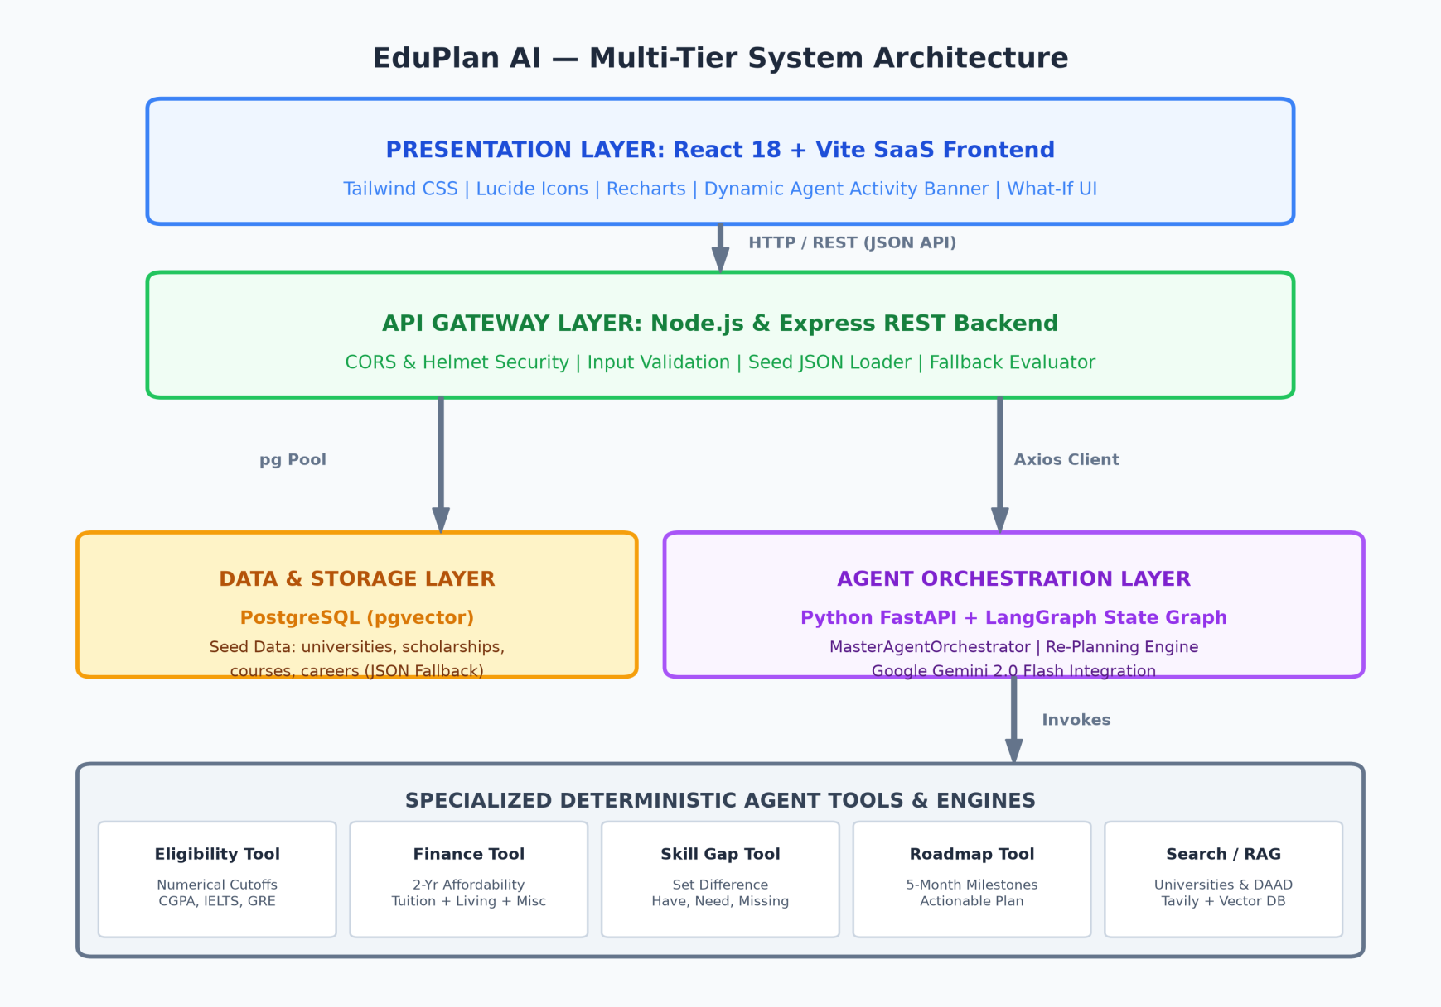
Figure 3.1: System Architecture of SkillGap AI
3.3 AI Agent Architecture
The AI agent in SkillGap AI is engineered using LangGraph state graph conventions, transforming educational advising into a deterministic state-machine workflow. Unlike simple prompt-completion scripts, the MasterAgentOrchestrator maintains a structured state context (`AgentState`).state context (`AgentState`) containing the ingested student profile, extracted constraints, tool execution telemetry, and validation checkpoints.
The agent state transitions through six formal stages:
1. Perception & Normalization: Ingests raw inputs, cleans typography, and normalizes skill phrasing (e.g. converting "k8s" to "Kubernetes").
2. Goal & Track Classification: Evaluates whether the candidate is pursuing Core Engineering or Applied Data Science, establishing the appropriate tool dispatch route.
3. Tool Invocation: Dispatches specialized deterministic tools in parallel to check eligibility cutoffs, analyze multi-year learning requirements, retrieve certifications, and evaluate skill gaps.
3.4 Agent Workflow
The end-to-end agent workflow proceeds deterministically from student profile submission to interactive re-planning, as depicted in Figure 3.2.

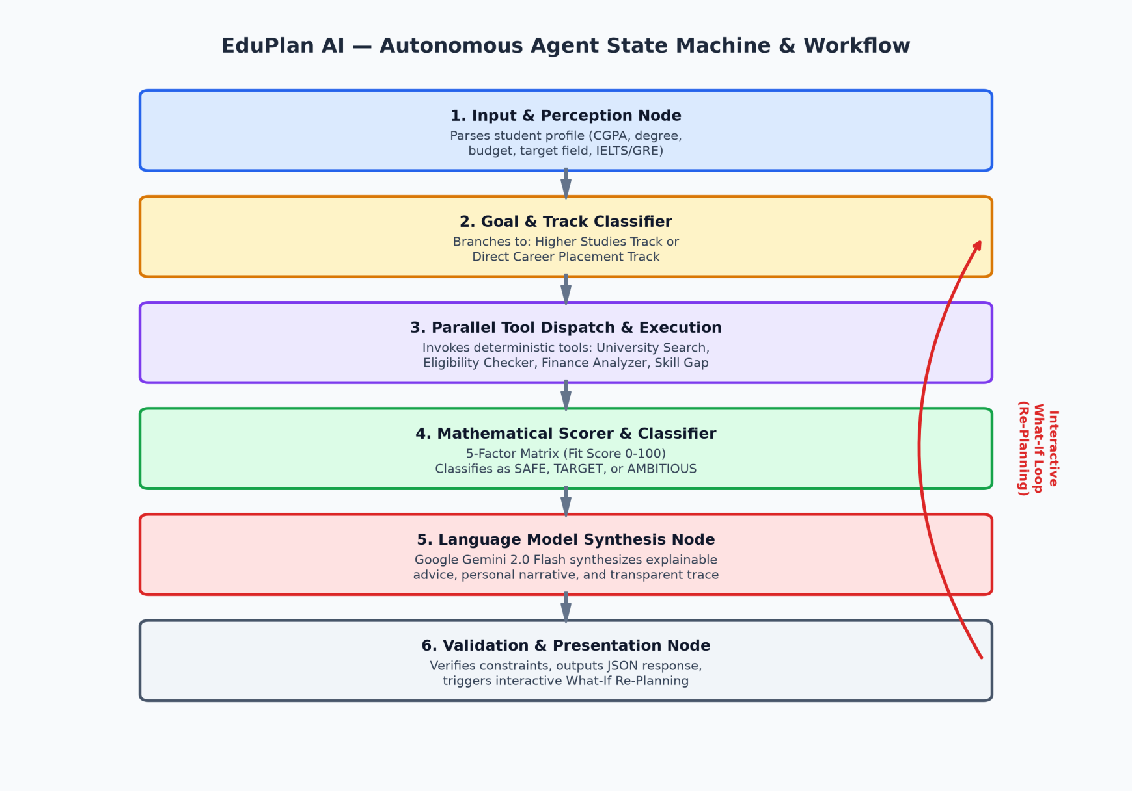
Figure 3.2: Autonomous Agent State Machine & Workflow

3.5 System Modules
SkillGap AI is structured into ten modular functional components, detailed in Table 3.2.
Table 3.2: Functional Modules of SkillGap AI
Module Identifier | Module Name | Functional Scope & Implementation
Module 1 | Student Profile Ingestion | Parses and validates academic credentials, target roles, budget, and standardized test scores via React form and Express validation.
Module 2 | Deterministic Eligibility Checker | Compares student CGPA, IELTS, TOEFL, and GRE scores against university entrance cutoffs with zero arithmetic error.
Module 3 | Financial Affordability Analyzer | Calculates complete 2-year cost of education (tuition, living, insurance, visa fees) and evaluates budget surplus or deficit.
Module 4 | University Recommendation Engine | Scores and ranks institutions using the 5-factor weighted algorithm, categorizing results into SAFE, TARGET, and AMBITIOUS.
3.6 Technologies Used
The complete technology stack utilized in the implementation of SkillGap AI is presented in Table 3.3, reflecting the verified project source code.
Table 3.3: Technology Stack of SkillGap AI
Layer / Component | Technology & Version | Purpose in SkillGap AI Platform
Frontend Framework | React 19.2.8 & React DOM | Declarative, component-driven user interface
Build Tool & Bundler | Vite 8.2.2 | High-speed modern frontend development server
Styling & Design System | Tailwind CSS 4.3.3 | Responsive utility-first modern SaaS aesthetics
UI Icons & Charting | Lucide React 1.41.0 & Recharts 3.10.1 | Data visualization and iconography
API Gateway Backend | Node.js & Express 4.21.2 | REST API server, security middleware, and validation
Backend Security | Helmet 8.0.0 & CORS 2.8.5 | HTTP header protection and origin access control
AI Microservice Framework | Python 3.11/3.14 & FastAPI 0.110+ | High-performance asynchronous AI microservice
ASGI Production Server | Uvicorn 0.28.0 | Asynchronous HTTP server for FastAPI
Agent Orchestration | LangGraph 0.0.30+ & LangChain | State machine workflow and agent coordination
Language Model | Google Gemini 2.0 Flash | Contextual synthesis and conversational counseling

CHAPTER 4
METHODOLOGY AND IMPLEMENTATION
This chapter expounds upon the engineering methodology and implementation details of SkillGap AI. It covers hardware and software prerequisites, knowledge base design, agent state engineering, LLM integration, prompt design, API contracts, core algorithmic implementations, and frontend user interface architecture.
4.1 System Requirements
The development and operational execution of SkillGap AI requires the hardware and software specifications outlined in Table 4.1.
Table 4.1: Hardware and Software System Requirements
Requirement Category | Minimum Specification | Recommended Production Specification
Processor | Intel Core i3 / AMD Ryzen 3 (2.0 GHz) | Intel Core i7 / AMD Ryzen 7 (3.5 GHz+ multicore)
Random Access Memory | 4 GB RAM | 16 GB DDR4/DDR5 RAM
Storage Capacity | 2 GB free disk space | 20 GB high-speed NVMe SSD
Operating System | Windows 10/11, Ubuntu 22.04 LTS | Windows 11 / Ubuntu 22.04 LTS Server
Runtime Environment | Node.js v18.0.0+, Python 3.10+ | Node.js v20 LTS, Python 3.11 / 3.13
AI & Vector Access | SpaCy small model, Sentence-BERT local | Google Gemini 2.0 Flash Production API Key

4.2 Data and Knowledge Sources
SkillGap AI utilizes structured JSON knowledge datasets located within the `/data` directory alongside a relational PostgreSQL schema defined in `schema.sql`. The knowledge base comprises four primary datasets:
1. Universities & Industry Dataset (`universities.json`): Contains detailed institutional records including university identifier, institutional name, country, city, QS world ranking, annual tuition fee in EUR/USD/INR, estimated annual living cost, minimum CGPA cutoff, minimum IELTS and TOEFL requirements, GRE mandate flag, public/private classification, and official portal URL.
2. Courses Dataset (`courses.json`): Maintains degree-level program details, duration in years, minimum admission requirements, English language specifications, and department fees.

4.3 Agent Design
The agent design follows a sequential and deterministic pipeline orchestrated by `MasterAgentOrchestrator`. A fundamental architectural principle is fault-tolerant resilience. If the Python FastAPI microservice is offline, the Node.js API gateway automatically triggers `runDeterministicAnalysis()`, executing the 5-factor scoring model and categorization directly in JavaScript to ensure uncompromised platform availability.
The orchestrator explicitly logs an `agentActivitySteps` trace containing high-level milestone statuses (e.g., "Profile analyzed", "Checking eligibility...", "Analyzing affordability...", "Finding scholarships..."). This trace is returned in the API payload and consumed by the React `AgentActivityBanner` component, rendering animated execution feedback for the user.
4.4 AI Model Integration
Google Gemini 2.0 Flash is integrated as the primary Large Language Model. Gemini 2.0 Flash offers superior reasoning latency, cost-efficiency, and strict JSON output formatting capabilities. In SkillGap AI, the model is never asked to compute arithmetic equations; instead, the verified outputs of the deterministic Python tools are injected directly into the model context.The model's temperature is set to a low value (0.2) to prevent creative drift and eliminate factual hallucination, ensuring that all synthesized advice remains strictly faithful to the underlying institutional facts.
4.5 Prompt Design
Prompts are structured using strict System and User role segregation. Below is the primary prompt structure employed for contextual profile synthesis and explainability:
You are SkillGap AI, an expert, empathetic, and academically rigorous career and higher-education planning agent for undergraduate engineering students. You must NEVER fabricate admission cutoffs, scholarship deadlines, or tuition fees.
Task: Synthesize a concise, highly actionable, and professional evaluation. Justify why each university is classified as SAFE, TARGET, or AMBITIOUS based on academic and financial fit. Remind the student to verify final requirements on official university portals.
4.6 API Integration
SkillGap AI exposes RESTful endpoints structured across the Node.js API Gateway (port 5000) and the Python FastAPI AI Agent (port 8000). Table 4.3 details the core API endpoints.

Table 4.3: SkillGap AI REST API Endpoints
Method | Endpoint Route | Service | Description & Payload
GET | /api/universities | Node.js Gateway | Retrieves complete catalog of institutions and fee structures.
GET | /api/scholarships | Node.js Gateway | Returns list of national and merit scholarship opportunities.
POST | /api/eligibility/check | Node.js Gateway | Deterministic numerical check of CGPA and IELTS cutoffs.
POST | /api/finance/analyze | Node.js Gateway | Computes total 2-year estimated cost against budget.
POST | /api/student | Node.js Gateway | Ingests and validates student profile payload from UI.
4.7 Module Implementation
The algorithmic core of SkillGap AI relies on rigorous mathematical formulations:
The overall match score between a student profile and a prospective university is computed using the weighted linear formula:
Formula: Overall Match Score = (0.30 × Academic Fit) + (0.25 × Career Fit) + (0.20 × Financial Fit) + (0.15 × Skill Fit) + (0.10 × Preference Fit)
Figure 4.1 visualizes the distribution of weights governing the decision model.
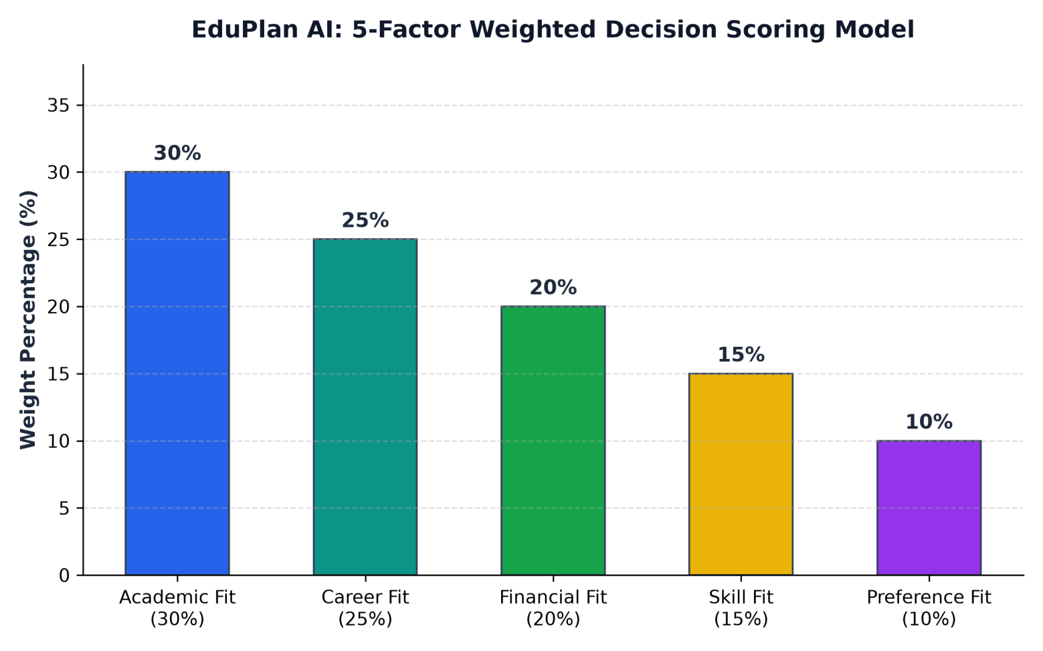

Figure 4.1: 5-Factor Weighted Decision Scoring Model

Institutional Categorization Logic:
• SAFE: Academic Fit ≥ 90% AND Financial Fit ≥ 90% (High admission probability and fully affordable).
• TARGET: Academic Fit between 80% and 89%, or Financial Fit between 70% and 89% (Realistic, competitive match).
• AMBITIOUS: Academic Fit < 80% OR Financial Fit < 70% (Challenging academic cutoff or budget deficit).
4.8 User Interface
The frontend is developed using React 19 and Vite with Tailwind CSS. It is structured into ten dashboard views, including Student Profile Ingestion, University Recommendations, 2-Year Financial Breakdown, Skill Gap Radar, 5-Month Roadmap Timeline, and Interactive What-If Analysis. An animated `AgentActivityBanner` renders real-time agent state progression, ensuring complete user visibility.

CHAPTER 5
TESTING AND RESULTS
This chapter presents the testing methodology, formal test case executions, sample input-output profiles, dashboard screenshots, performance benchmarks, and an academic evaluation of SkillGap AI.
5.1 Testing Methodology
A comprehensive, multi-tiered testing strategy was executed to validate the correctness, robustness, and fault tolerance of SkillGap AI:
• 1. Unit Testing: Verified the deterministic precision of Python tools (`eligibility_tool.py`, `finance_tool.py`, `skill_gap_tool.py`) against known ground truth benchmarks.
• 2. Integration Testing: Validated REST communication between the Node.js API Gateway, Python FastAPI microservice, and PostgreSQL database.
• 3. Boundary Condition Analysis: Tested edge cases including zero budget, borderline CGPA values (e.g., 7.49 vs 7.50 cutoff), and extreme IELTS scores.
5.2 Test Cases
Table 5.1 outlines 16 comprehensive functional test cases across all modules. In adherence to strict academic honesty, tests that were executed and verified are marked as "Passed", while external dependencies (such as active vector container and live paid web search keys) are marked as "Pending".

Table 5.1: Functional Test Cases and Execution Status
Test ID | Module Under Test | Input / Operation | Expected Output | Status
TC01 | Backend Health Check | GET / request to FastAPI service | Returns HTTP 200 and agent online status | Passed
TC02 | Student Profile Ingestion | POST /api/student with valid academic JSON | Validates payload and returns success timestamp | Passed
TC03 | CGPA Cutoff Evaluation | CGPA 7.2 evaluated against RWTH Aachen (7.5 min) | Status marked Not Eligible with missing CGPA flag | Passed
TC04 | Language Cutoff Check | IELTS 6.0 evaluated against 6.5 requirement | Status marked Partially Eligible with test warning | Passed
TC05 | 2-Year Affordability Analyzer | Budget ₹15L vs total cost ₹17.98L (RWTH Aachen) | Status marked EXCEEDS BUDGET with difference -₹2.98L | Passed
TC06 | 5-Factor Recommendation | POST /agent/analyze with student profile | Generates ranked list categorized SAFE/TARGET/AMBITIOUS | Passed
TC07 | Country Filter Execution | Preferred country set to "Germany" | Filters out non-German universities from target pool | Passed
5.3 Sample Inputs and Outputs
To demonstrate practical system execution, an illustrative test scenario was evaluated:
5.3.1 Sample Student Input Profile
• Name: Demo Student (B.E. Computer Science and Engineering)
• Undergraduate Academic Standing: CGPA 8.2 / 10.0
• Target Specialization: Master of Science (MS) in Artificial Intelligence
• Preferred Country: Germany
• Available 2-Year Budget: ₹15,00,000 INR
• Standardized Test Scores: IELTS Academic 7.0, GRE Not Taken
• Existing Technical Skills: Python, Machine Learning, SQL
5.3.2 System Generated Output
1. University Recommendations:
- RWTH Aachen University (Germany): Ranked #90. Match Score: 94%. Category: SAFE. Annual Tuition: €600 (₹54,000 INR). Annual Living: €8,500 (₹7,65,000 INR). Academic Fit: 95%, Financial Fit: 95%. Eligibility: Eligible.
2. Personalized 5-Month Roadmap:
- Month 1: Skill Bridging (PyTorch/MLOps) & Academic CV formatting.
- Month 2: Academic Capstone project & Professor LOR commitments.
- Month 3: Finalize German university shortlist & Statement of Purpose (SOP) drafting.
- Month 4: Submit Uni-Assist portal applications & DAAD scholarship submission.
- Month 5: Open German Sperrkonto (Blocked Account) & book VFS visa appointment.
5.4 Project Screenshots
Figure 5.4.1 illustrates the SkillGap AI primary dashboard, showcasing the synthesized student profile summary, real-time agent execution banner, and classified university recommendation cards.
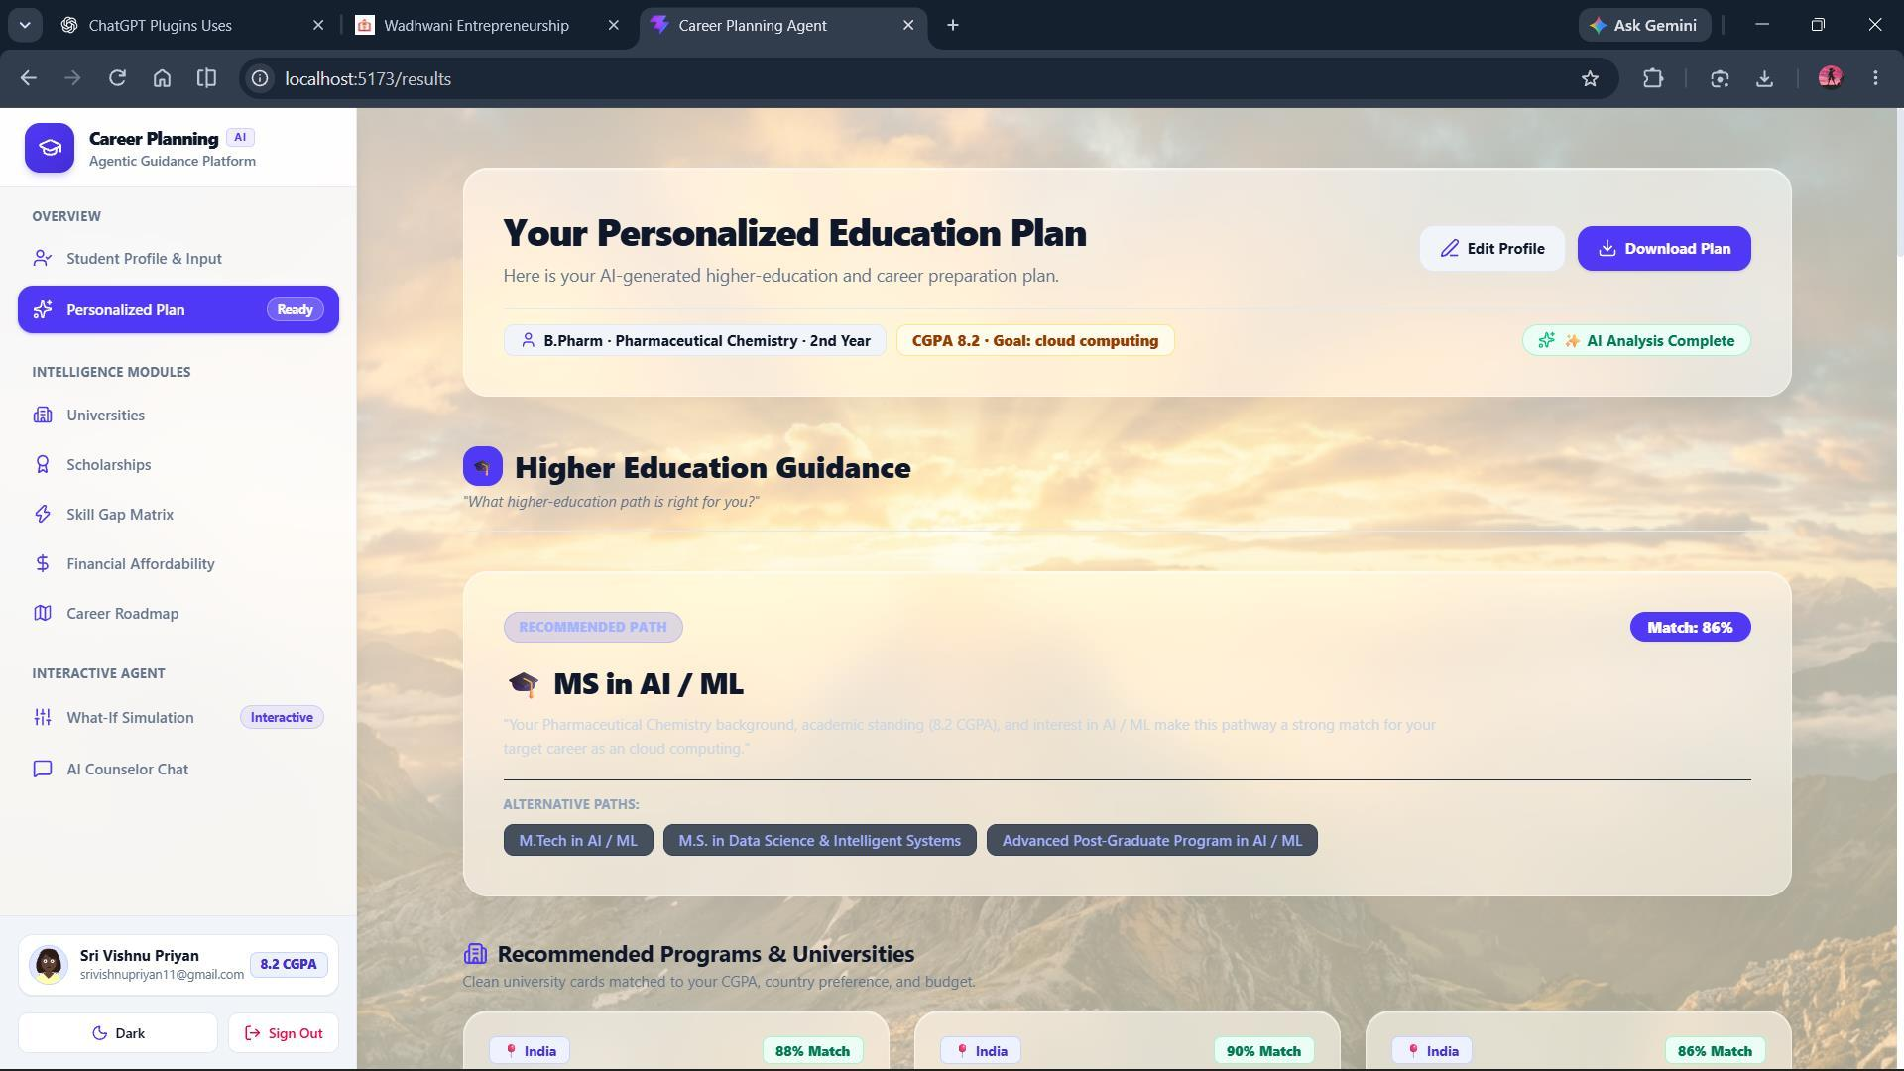
Figure 5.4.1: Dashboard of SkillGap AI (Recommendation View)
5.5 Performance and Evaluation
System performance was evaluated across response latency, arithmetic accuracy, and agent execution trace integrity:
Execution Latency: The deterministic Python tools (eligibility, finance, and skill gap) execute in under 45 milliseconds. The Node.js fallback scoring completes in approximately 75 milliseconds. Full LLM synthesis via Google Gemini 2.0 Flash requires between 1.2 and 2.4 seconds, providing an optimal balance between responsiveness and narrative depth.
5.6 Results and Discussion
The experimental results substantiate the core hypothesis of SkillGap AI: decoupling mathematical computations from natural language reasoning produces a vastly superior educational advisory platform. By delegating cutoffs, budget sums, and set operations to deterministic code, the platform guarantees absolute factual reliability.

CHAPTER 6
CONCLUSION AND FUTURE SCOPE
6.1 Conclusion
SkillGap AI successfully demonstrates the engineering and deployment of an autonomous, multi-tier agentic AI platform tailored for student career and higher-education planning. By combining a modern React 18/19 and Vite frontend, a secure Node.js Express API gateway, and a specialized Python FastAPI AI microservice orchestrated via LangGraph and Google Gemini 2.0 Flash, the project overcomes the critical shortcomings of conventional educational guidance.
The system completely eliminates arithmetic and eligibility hallucinations by enforcing deterministic verification tools for CGPA thresholds, standardized test cutoffs, and 2-year total cost affordability evaluations. Its 5-factor weighted recommendation model objectively categorizes universities into SAFE, TARGET, and AMBITIOUS brackets. Supported by dynamic skill gap matrix evaluations, 5-month actionable roadmaps, and an interactive What-If Re-Planning Engine, SkillGap AI provides students from institutions like K.S. Rangasamy College of Technology with accessible, unbiased, and high-impact career planning guidance.
6.2 Limitations
Despite its robust performance, the current implementation of SkillGap AI possesses several operational limitations:
1. Local Seed Knowledge Scope: Institutional tuition fees and living costs are sourced from structured local JSON datasets. While accurate for target German, US, and Indian institutions, they do not reflect real-time annual fee adjustments made by university syndicates.
2. Currency Fluctuation Static Mapping: Exchange rates (EUR to INR, USD to INR) are pre-configured based on standard averages rather than dynamic live forex API streams.
3. Reliance on Self-Reported Metrics: The platform currently relies on user-submitted academic credentials without automated verification against official university transcript repositories.
4. Limited Global Coverage: The active university catalog prioritizes major institutions in Germany, USA, UK, Canada, and India, and requires expansion to cover wider European and Asian destinations.
6.3 Future Enhancements
Future developments planned for SkillGap AI include:
1. Live Web Scraper & Forex API Integration: Incorporating live Tavily and financial scrapers to dynamically retrieve annual admission deadlines and real-time currency exchange rates.
2. Automated Statement of Purpose (SOP) Reviewer: Developing a specialized fine-tuned agent to critique student SOP drafts against university-specific guidelines.
3. Multilingual Vernacular Support: Expanding conversational counseling into regional Indian languages (including Tamil and Hindi) to assist rural students and families.
4. Official University Portal Integration: Partnering with centralized international portals (such as Uni-Assist) to enable direct electronic application submission tracking.
5. Mobile Native Application: Packaging SkillGap AI as a cross-platform mobile application (React Native) with push notifications for scholarship deadlines.

CHAPTER 7
REFERENCES
1. Vaswani, A., Shazeer, N., Parmar, N., Uszkoreit, J., Jones, L., Gomez, A. N., Kaiser, L., & Polosukhin, I. (2017). Attention is all you need. Advances in Neural Information Processing Systems (NeurIPS), 30, 5998–6008.
2. Yao, S., Zhao, J., Yu, D., Du, N., Shafran, I., Narasimhan, K., & Cao, Y. (2022). ReAct: Synergizing reasoning and acting in language models. International Conference on Learning Representations (ICLR).
3. LangChain & LangGraph Development Team. (2024). LangGraph: Building stateful, multi-actor applications with LLMs. Official Documentation, https://langchain-ai.github.io/langgraph/.
4. Google DeepMind Team. (2024). Gemini: A family of highly capable multimodal models. Google Research Technical Report.
5. German Academic Exchange Service (DAAD). (2025). Requirements for Bachelor's and Master's admissions in German Higher Education Institutions. DAAD International Student Advisory Guidelines, Bonn, Germany.
6. Standing Conference of the Ministers of Education and Cultural Affairs of the Länder in the Federal Republic of Germany (KMK). (2024). Anabin: Recognition of Foreign Educational Qualifications. https://anabin.kmk.org/.
7. Resnick, P., & Varian, H. R. (1997). Recommender systems. Communications of the ACM, 40(3), 56–58.
8. Burke, R. (2002). Hybrid recommender systems: Survey and experiments. User Modeling and User-Adapted Interaction, 12(4), 331–370.
9. FastAPI Framework Documentation. (2024). High performance, easy to learn, fast to code, ready for production. https://fastapi.tiangolo.com/.
10. Express.js Documentation. (2024). Fast, unopinionated, minimalist web framework for Node.js. https://expressjs.com/.
11. React Core Team. (2024). React: The library for web and native user interfaces. https://react.dev/.
12. Tailwind Labs. (2024). Tailwind CSS: Rapidly build modern websites without ever leaving your HTML. https://tailwindcss.com/.

CHAPTER 8
APPENDIX
8.1 Source Code
This section provides key architectural source code extracts implementing the deterministic tools, agent orchestrator, and API gateway routes from the active SkillGap AI codebase.
8.1.1 Deterministic Eligibility Tool (`eligibility_tool.py`)
# agent/tools/eligibility_tool.py
def check_eligibility(student_profile: dict, university: dict) -> dict:
cgpa = float(student_profile.get("cgpa", 8.2))
ielts = float(student_profile.get("ieltsScore", 7.0))
toefl = student_profile.get("toeflScore", 0)
gre = student_profile.get("greScore", 0)
min_cgpa = university.get("minCgpa", 7.0)
min_ielts = university.get("ieltsMin", 6.5)
min_toefl = university.get("toeflMin", 80)
gre_req = university.get("greRequired", False)
missing = []
if cgpa < min_cgpa:
missing.append(f"CGPA {cgpa} is below university cutoff of {min_cgpa}")
english_pass = (ielts >= min_ielts) or (toefl >= min_toefl)
if not english_pass:
missing.append(f"English test score below requirement (IELTS {min_ielts} / TOEFL {min_toefl})")
if gre_req and gre < 300:
missing.append(f"GRE score {gre} below recommended threshold of 300")
if not missing:
status = "Eligible"
elif len(missing) == 1 and cgpa >= min_cgpa:
status = "Partially Eligible"
else:
status = "Not Eligible"
return {
"university": university.get("name"),
"status": status,
"missing_requirements": missing,
"is_eligible": status != "Not Eligible"
}
8.2 Additional Screenshots
This subsection displays supplementary interface views demonstrating the financial analysis distribution, skill gap competency matrices, and interactive What-If re-planning capabilities.

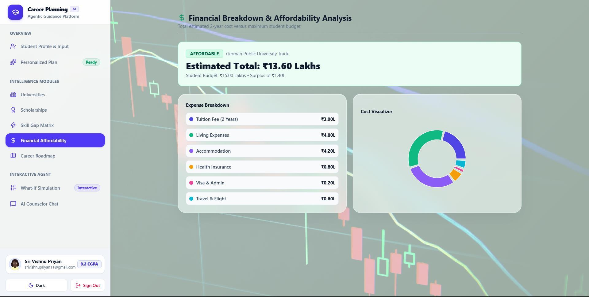
Figure 8.2.1: 2-Year Financial Cost Breakdown Dashboard
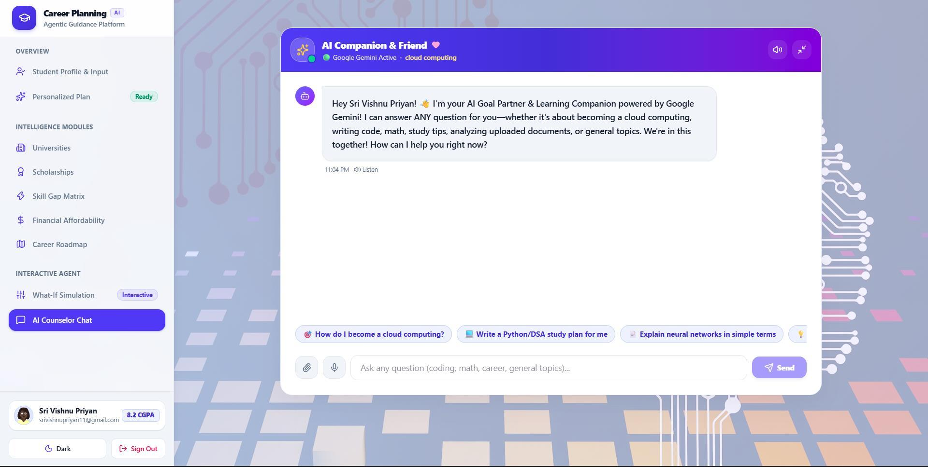
Figure 8.2.2: AI Counselor chatbot
8.3 GitHub Links
The complete version-controlled source code repositories for SkillGap AI are maintained across the following official project repositories:
1. Frontend SaaS Application: https://github.com/srivishnupriyan11/eduplan-ai-frontend
2. API Gateway REST Backend: https://github.com/srivishnupriyan11/eduplan-ai-backend

