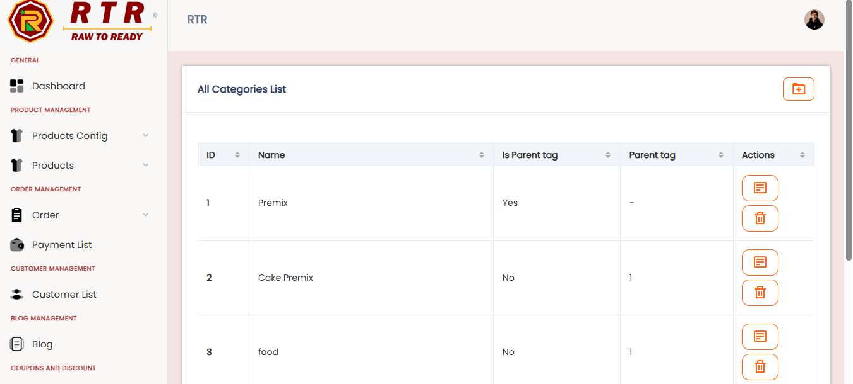
1.product config -> tag => change heading …. 4 option edit button not click

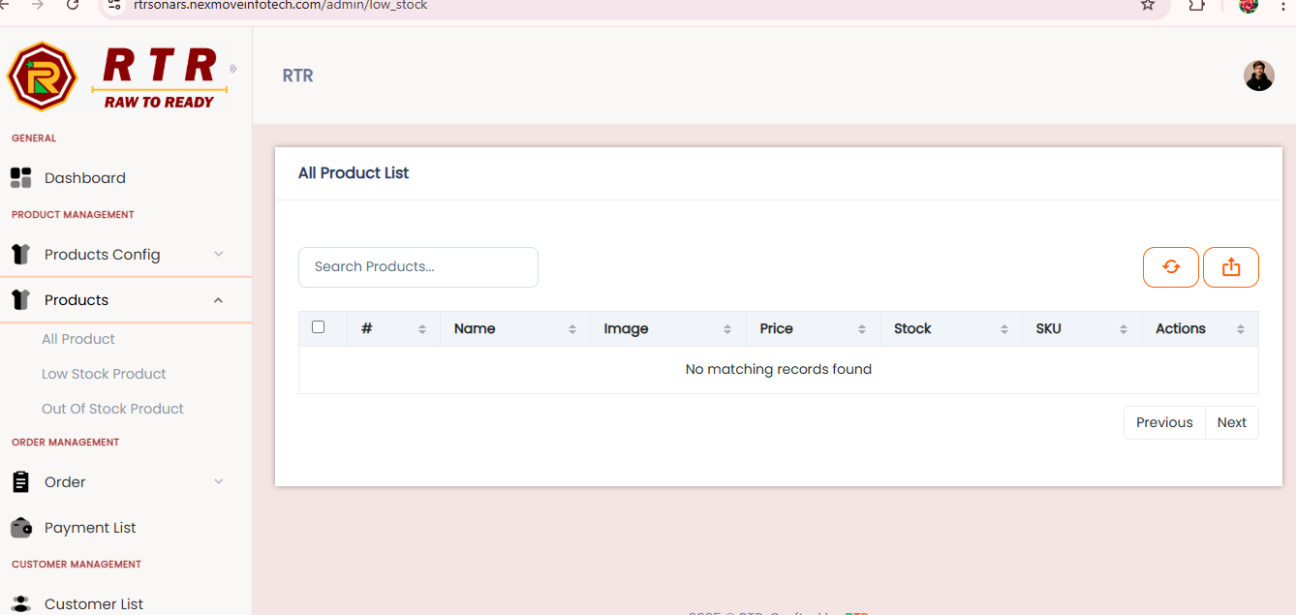
2. product -> low stock produt-- heading change -----& click a refresh button then all products list .show
3. same in out of stock products

4. order= pending -> heading chang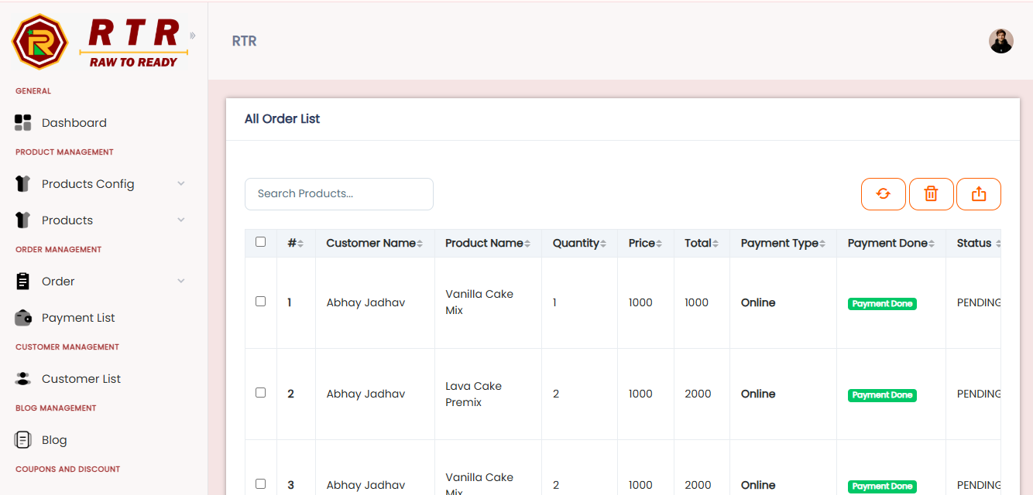

5. pickup , Deliver, return cancel --- heading change

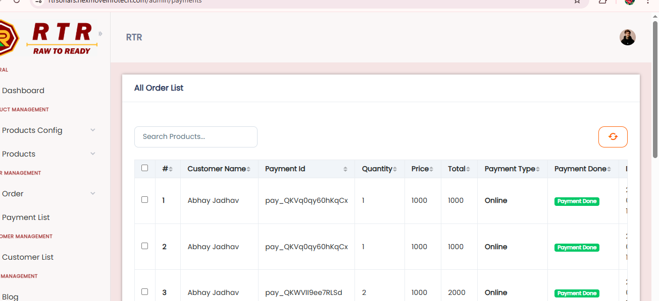
6…payment list --- heading change

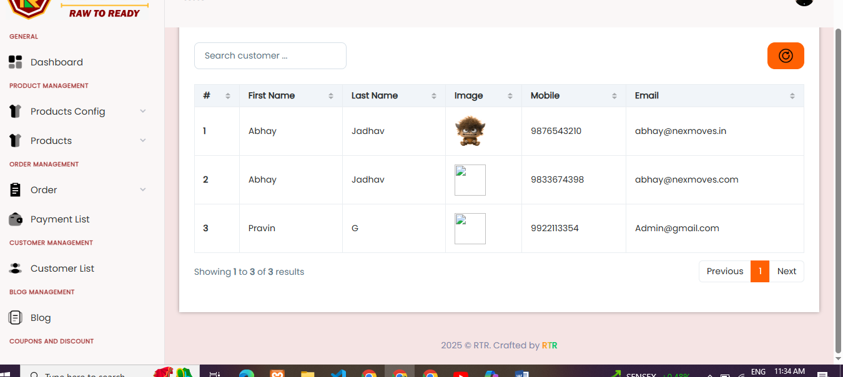
7. customer list - 2nd & 3rd image not show
8. logout photo change
<!-- Font Awesome CDN -->
<link rel="stylesheet" href="https://cdnjs.cloudflare.com/ajax/libs/font-awesome/6.5.0/css/all.min.css">

<!-- Counter Section Styled Like Image -->
<section class="ca-about-section pt-100 pb-100"
style="background-image: url('./assets/img/your-folder/bg-image.png'); background-size: cover; background-position: center; background-repeat: no-repeat;">

<div class="container">
<div class="row text-center text-white">
<!-- Counter Item -->
<div class="col-md-3 mb-4">
<i class="fa-solid fa-gears fa-3x mb-3"></i>
<h6 class="mb-2">Years Of Experience</h6>
<div style="border-bottom: 1px solid #fff; width: 50px; margin: 0 auto 10px;"></div>
<h3 class="fw-bold">15+</h3>
</div>

<!-- Counter Item -->
<div class="col-md-3 mb-4">
<i class="fa-solid fa-trophy fa-3x mb-3"></i>
<h6 class="mb-2">Success Projects</h6>
<div style="border-bottom: 1px solid #fff; width: 50px; margin: 0 auto 10px;"></div>
<h3 class="fw-bold">600+</h3>
</div>

<!-- Counter Item -->
<div class="col-md-3 mb-4">
<i class="fa-solid fa-users fa-3x mb-3"></i>
<h6 class="mb-2">Team Members</h6>
<div style="border-bottom: 1px solid #fff; width: 50px; margin: 0 auto 10px;"></div>
<h3 class="fw-bold">40+</h3>
</div>

<!-- Counter Item -->
<div class="col-md-3 mb-4">
<i class="fa-solid fa-user-shield fa-3x mb-3"></i>
<h6 class="mb-2">Clients Satisfactions</h6>
<div style="border-bottom: 1px solid #fff; width: 50px; margin: 0 auto 10px;"></div>
<h3 class="fw-bold">500+</h3>
</div>
</div>
</div>
</section>

https://pisumfoods.com/

