A Community Engagement Project Report

On

"TECHNICAL SUPPORT FOR RURAL STARTUPS"

— ◆ —

Submitted by
Mergu Pravin Madhukar
Mourya Chandar

In partial fulfilment for the award of the degree of
THIRD YEAR BACHELOR OF SCIENCE
In
INFORMATION TECHNOLOGY
Under the guidance of
Mrs. Hera Kausar
Department of Information Technology
B.N.N. College (A.S. & C.), Bhiwandi
Semester V | Academic Year 2026–2027
September 2026

CERTIFICATE BY THE INSTITUTE
CERTIFICATE
This is to certify that Mr. Mergu Pravin Madhukar and Mr. Mourya Chandar, of T.Y. B.Sc. (Information Technology) (Semester V) class have satisfactorily completed the Community Engagement Project Report on “Technical Support for Rural Startups” to be submitted in the partial fulfilment for the award of Third Year Bachelor of Science in Information Technology during the academic year 2026–2027.

Date of Submission: ____________________
Place: Bhiwandi

Signature of Principal
CERTIFICATE BY THE MENTOR
CERTIFICATE OF GUIDANCE
This is to certify that the Community Engagement Project Report entitled “Technical Support for Rural Startups” is a bona fide record of work carried out by Mergu Pravin Madhukar and Mourya Chandar, students of T.Y. B.Sc. (Information Technology), under my guidance and supervision, in partial fulfilment of the requirements for the award of the degree of Third Year Bachelor of Science in Information Technology, University of Mumbai, during the academic year 2026–2027.
The work presented in this report is original and has been carried out under my direct guidance. It has not been submitted elsewhere for the award of any other degree or diploma.

Place: Bhiwandi
Date: ____________________

Mrs. Hera Kausar
(Project Mentor)
ACKNOWLEDGEMENT
We would like to extend our heartfelt thanks with a deep sense of gratitude and respect to everyone who provided us immense help and guidance during our field project work. We would like to thank our project mentor, Mrs. Hera Kausar, for providing constant direction, valuable suggestions, and a clear vision about the project.
We have greatly benefited from her regular critical reviews and inspiration throughout our work. We are grateful to her for the guidance, encouragement, understanding and insightful support extended during every stage of the project, from planning the field visits to reviewing our final analysis.
We would also like to thank our college for providing the required resources whenever needed and for giving us the opportunity to carry out this project. We would like to express our sincere thanks to our Principal I/C, Dr. Shashikant Mhalunkar, and our Head of Department, Mr. Pramod L. Shewale, for having facilitated us with the essential infrastructure and resources without which this project would not have been possible. We are also thankful to the entire staff of the Information Technology Department for their constant encouragement, suggestions, and moral support throughout the duration of our project.
We sincerely thank all the rural entrepreneurs and startup owners who participated in our field visits and gave their honest and valuable responses, without which this study could not have been completed. Last but not the least, we would like to mention that we are greatly indebted to our friends and everybody who has been associated with our project at any stage but whose name does not find a place in this acknowledgement.

With Sincere Regards,
Mergu Pravin Madhukar
Mourya Chandar

ABSTRACT
The Technical Support for Rural Startups project was conducted as a Community Engagement Program (CEP) initiative to provide hands-on digital interventions to micro-businesses in villages near Bhiwandi, Maharashtra. The study combined field visits, direct technical training, and the development of practical software tools to help rural entrepreneurs adopt digital technologies for payments, inventory management, online discoverability, and photo processing.
The project involved a structured visit model for each enterprise: a needs assessment where the team sat with the owner to understand their daily operations, a hands-on session where the team and the owner set up the appropriate tools together, and a follow-up review to see which habits survived.
Four enterprises were visited across Bhiwandi and the surrounding villages: Srividyaniketan Classes in Bhiwandi, Baba ID Cards Solutions in Shelar, V Tech ID Solutions in Kariwali, and Digital ID Solutions in Khoni Gaon. The challenges ranged from administrative record-keeping in a coaching institute to repetitive batch photo processing for school-photography businesses.
Three software tools were developed to address recurring friction points identified across the visits: an auto face-and-shoulder cropping tool built with RetinaFace and Pillow, a bulk background removal utility using the withoutbg model, and an Android smart camera renamer that names captured photos in DSLR-style sequence.
A companion Flask-based web application was deployed at https://cep-project-python.onrender.com to document the entire project. The website includes a dashboard of field visit records, a resource library with downloadable training materials, and a demos page with embedded video walkthroughs. All field data is stored in a MySQL database and rendered dynamically.
The project demonstrated that direct, hands-on support overcomes the initial hesitation that one-off workshops cannot. Follow-up visits proved essential for sustaining new digital habits, and interventions succeeded most when they matched each enterprise’s existing record-keeping habits rather than replacing them outright.

TABLE OF CONTENTS
1. Introduction
1.1 Purpose of the Visit
1.2 Background Information
1.3 Scope of the Report
2. Literature Review
2.1 Introduction
2.2 Previous Studies
2.3 Research Gap
3. Methodology
3.1 Approach and Tools Used
3.2 Rationale Behind the Methods
3.3 Data Collection and Analysis
3.4 Limitations
4. Field Work Descriptions, Observations and Analysis
4.1 Overview of Field Work
4.2 Detailed Field Visit Records
4.2.1 Srividyaniketan Classes, Bhiwandi
4.2.2 Baba ID Cards Solutions, Shelar
4.2.3 V Tech ID Solutions, Kariwali
4.2.4 Digital ID Solutions, Khoni Gaon
4.3 Cross-Cutting Observations
4.4 Product Demos — Software Tools Developed
4.5 Project Website — Deployment and Features
5. Conclusion and Recommendations
5.1 Conclusion
5.2 Key Findings
5.3 Significance of Findings
5.4 Recommendation
5.5 Final Remark
References
Appendices

CHAPTER 1 — INTRODUCTION
1.1 Purpose of the Visit
The main purpose of our field project was to provide direct, hands-on technical support to micro-businesses and startups operating in villages near Bhiwandi, Maharashtra. The goal was to help rural entrepreneurs adopt digital tools for payments, inventory tracking, online presence, and everyday business operations — technologies that urban businesses take for granted but that often remain out of reach for village enterprises due to a lack of hands-on guidance.
Rural micro-enterprises in India operate under conditions that make digital adoption unusually difficult. Unlike urban businesses, they cannot rely on nearby training centres, stable high-speed internet, or a peer network that is already fluent in digital tools. The gap is not one of awareness but of access to patient, personalised guidance.
The specific objectives of our field project were:
- To assess digital readiness: Evaluate each enterprise’s existing record-keeping habits, payment methods, familiarity with digital tools, and comfort with smartphones.
- To provide practical training: Set up tools such as UPI, WhatsApp Business catalogues, Google Business Profiles, and Excel-based inventory trackers together with the owner, at their counter, on their own device.
- To build purpose-built tools: Develop simple software utilities that address the specific friction points observed during field visits, where no existing tool fit the workflow.
- To evaluate real adoption: Return after one week to check which habits actually carried over once the students left.
- To document findings: Record founder statements, before/after status, visit photos, and metadata for every enterprise visited.
- To deploy a public record: Build and host a web application that presents the entire project — field records, training resources, and software demos — accessible to anyone.
1.2 Background Information
Digital adoption among rural micro-enterprises is a well-known challenge in India’s development discourse. Government schemes such as Digital India and the UPI payment network have dramatically lowered the technical barriers to entry, but lowering a barrier is not the same as crossing it. A farmer or shopkeeper still needs someone to sit beside them, on their phone, and walk through the first few transactions before the tool becomes a habit.
Maintaining good digital practices matters because:
- Payments: UPI eliminates the need for exact change, reduces cash-handling risk, and enables sales from customers who may not carry cash.
- Discoverability: A Google Business Profile with an accurate GPS pin lets customers outside the village find the shop on Search and Maps.
- Inventory: A simple spreadsheet prevents stock-outs and over-ordering, both of which cost money and reputation.
- Photo quality: Clean product photos and consistently cropped ID-card photographs are essential for businesses whose output is visual.
1.3 Scope of the Report
This report is based on information collected through field visits, hands-on training sessions, founder interviews, and the development of software prototypes. It includes the project objectives, background, detailed field visit records, software demos, project website documentation, analysis, recommendations, and limitations.

CHAPTER 2 — LITERATURE REVIEW
2.1 Introduction
The literature on rural digital adoption in India has grown considerably over the past decade. Most studies agree on a common theme: awareness of digital tools is not the same as adoption, and adoption is not the same as sustained use. The gap between these three states is where field-level interventions matter most.
2.2 Previous Studies
Reports from the Telecom Regulatory Authority of India and NASSCOM have repeatedly shown that rural internet penetration has risen sharply, but business use of digital tools lags behind personal use. Studies of UPI adoption in tier-3 towns consistently find that the first successful transaction is the single biggest predictor of continued use — which validates the hands-on-first approach adopted in this project.
Research on micro-enterprise digitisation has also emphasised fit over sophistication. Tools that match an owner’s existing workflow are adopted far more readily than tools that require a complete change of habit.
2.3 Research Gap
What is less documented is the day-to-day reality of a technical support visit — the specific friction points that emerge only when you sit with an entrepreneur and watch them work. This report aims to contribute to that gap by documenting four such visits in detail, along with the purpose-built tools that resulted.

CHAPTER 3 — METHODOLOGY
3.1 Approach and Tools Used
The project used a mixed-method approach combining qualitative observation with quantitative documentation. Each enterprise was visited in person, and the interaction proceeded through a fixed sequence: initial conversation, observation of the daily workflow, identification of the friction point, and collaborative setup or development of the solution.
- Direct observation of the founder’s daily operations, record-keeping, and payment methods.
- Semi-structured interviews to understand the founder’s stated pain points.
- Hands-on setup of digital tools, performed on the founder’s own device.
- Development of purpose-built software where no existing tool fit the workflow.
- Photographic documentation of the visit, with the founder’s consent.
- A structured database and website to record and publish the outcomes.
3.2 Rationale Behind the Methods
Each method was chosen for a specific reason. Observation captured details that founders would not think to mention — the specific app they hesitated on, the physical folder of paper receipts, the manual step they repeated a hundred times a day. Interviews captured the founder’s own framing of the problem. Hands-on setup ensured the founder saw the tool working on their own data. And purpose-built development addressed cases where the existing tool ecosystem simply did not cover the workflow.
3.3 Data Collection and Analysis
Data was collected through handwritten notes, photographs, and a structured form filled out during or immediately after each visit. Analysis was thematic — looking across the four visits for recurring patterns in the type of problem, the founder’s response to the intervention, and the extent to which the solution was actually adopted.
3.4 Limitations
- The sample size of four enterprises is small and should not be treated as representative.
- Follow-up was limited to a short window; longer-term adoption was not tracked.
- Self-reported statements from founders were not independently verified.
- The interventions were tailored to each enterprise; generalisation requires care.

CHAPTER 4 — FIELD WORK
4.1 Overview of Field Work
The field work for the Technical Support for Rural Startups project was carried out across four enterprises in Bhiwandi and the surrounding villages of Shelar, Kariwali, and Khoni Gaon during the months of September and October 2026. The team consisted of two students from T.Y. B.Sc. Information Technology, working under the guidance of the project mentor.
Each visit followed a consistent three-stage structure. In the first stage, the team sat with the founder and observed their daily operations without any agenda. In the second stage, the team and the founder identified the single most significant friction point in their workflow. In the third stage, the solution — whether an existing tool or a purpose-built one — was demonstrated and deployed on the founder’s own device before the team left.
A recurring observation across all four visits was that the founders were not lacking in awareness of digital tools. They were already aware of the general category of solution they needed. What they lacked was the specific technical know-how to set it up, or a tool that fit their exact workflow.

◆ ◆ ◆
4.2.1 Record 01 — Srividyaniketan Classes, Bhiwandi
Startup Name | Srividyaniketan Classes
Founder | Niraj
Village | Bhiwandi
Date of Visit | 03 October 2026
Time of Visit | 11:20 AM

Background of the Enterprise
Srividyaniketan Classes is a coaching institute located in Bhiwandi. The institute conducts regular classes for students in multiple subjects and manages a small teaching staff along with its student body. Like many coaching institutes of its size, most of its administrative work has traditionally been handled manually, with separate registers for attendance, fee collection, and internal records.
Observed Friction Point
During the visit, it became clear that the institute’s administrative burden fell almost entirely on the founder. Attendance for every student and teacher was tracked on paper registers, and there was no centralised record of the installments paid by students. When a parent enquired about their child’s fee status, the founder had to manually cross-check multiple registers.
Founder’s Own Statement
“Has to manually track the attendance of every student and teacher, and there is no track of installments paid by the students. The founder wants to upload the marks online so they are accessible anywhere.”
Solution Designed
A class management web application was built to centralise the institute’s administrative operations. The system tracks attendance, fee installments, student marks, and basic student records in a single dashboard, accessible from any smartphone or browser.
Outcome
The web application was demonstrated and handed over during the visit. The founder was able to log in, register a student, mark attendance, and record a fee installment in the same session.

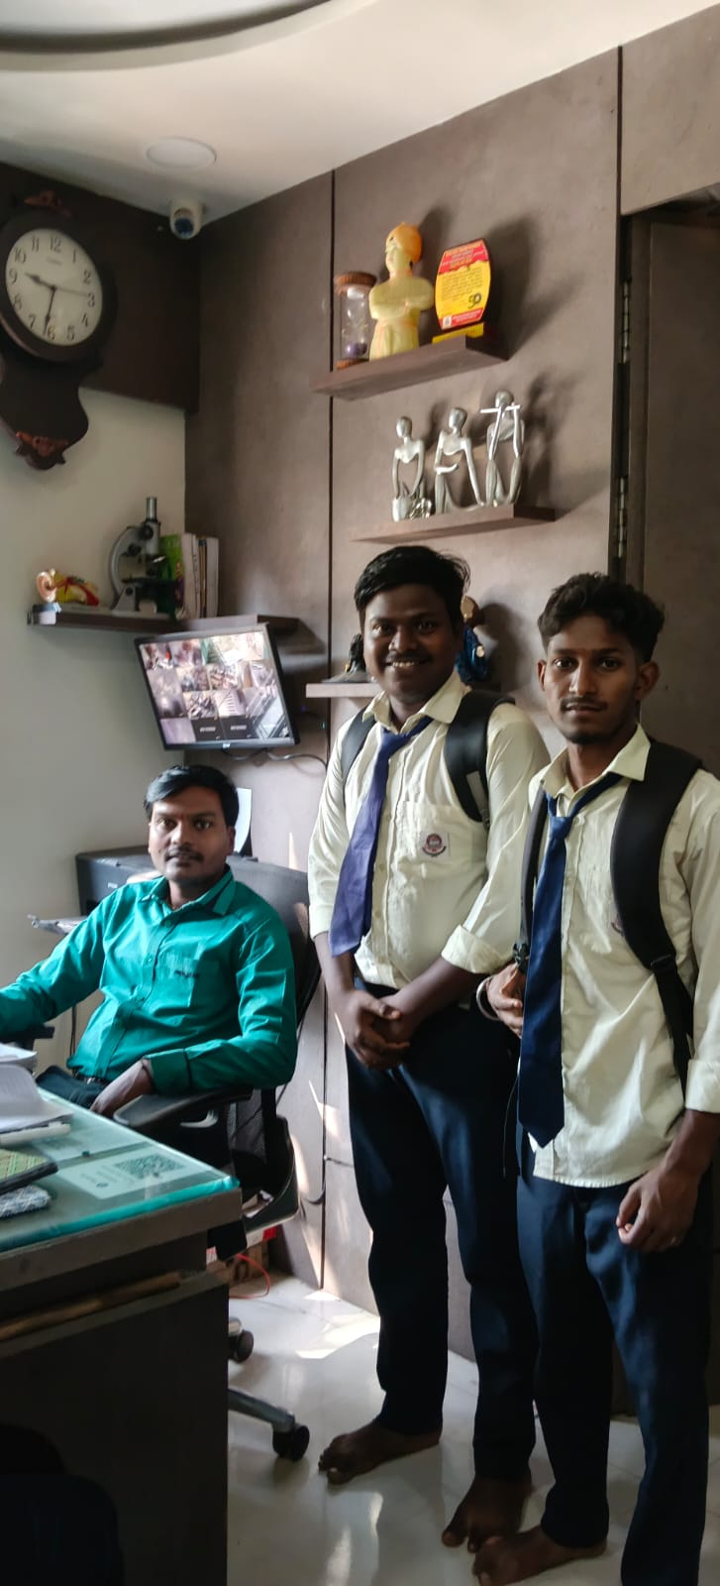

◆ ◆ ◆
4.2.2 Record 02 — Baba ID Cards Solutions, Shelar
Startup Name | Baba ID Cards Solutions
Founder | Shridhar Siripuram
Village | Shelar
Date of Visit | 29 September 2026
Time of Visit | 01:14 PM

Background of the Enterprise
Baba ID Cards Solutions operates a school-photography business. The founder travels to schools across the Bhiwandi region to photograph students for ID cards, school records, and yearbooks. Each school visit produces hundreds of photographs, which need to be transferred, sorted, and named before delivery.
Observed Friction Point
The founder’s workflow relied on a DSLR camera and a laptop. After each school visit, the raw photographs were transferred to the computer, and the founder had to rename them manually one by one to keep them in a consistent sequence.
Founder’s Own Statement
“The founder needs to click the photos from every school. For that purpose he has to take a bag and a large camera. The need is that the camera has a feature that names photos with a forwarding number as the image name.”
Solution Designed
An Android companion app was developed that captures a photo, saves it directly into a specified folder, and renames it with a DSLR-style sequential serial number (IMG_0001, IMG_0002, and so on). The naming is derived from the last number in the folder, so the sequence continues correctly across sessions.

Outcome
The app was installed on the founder’s phone during the visit. Ten photographs were captured in sequence and verified to have the correct filenames in the correct folder.
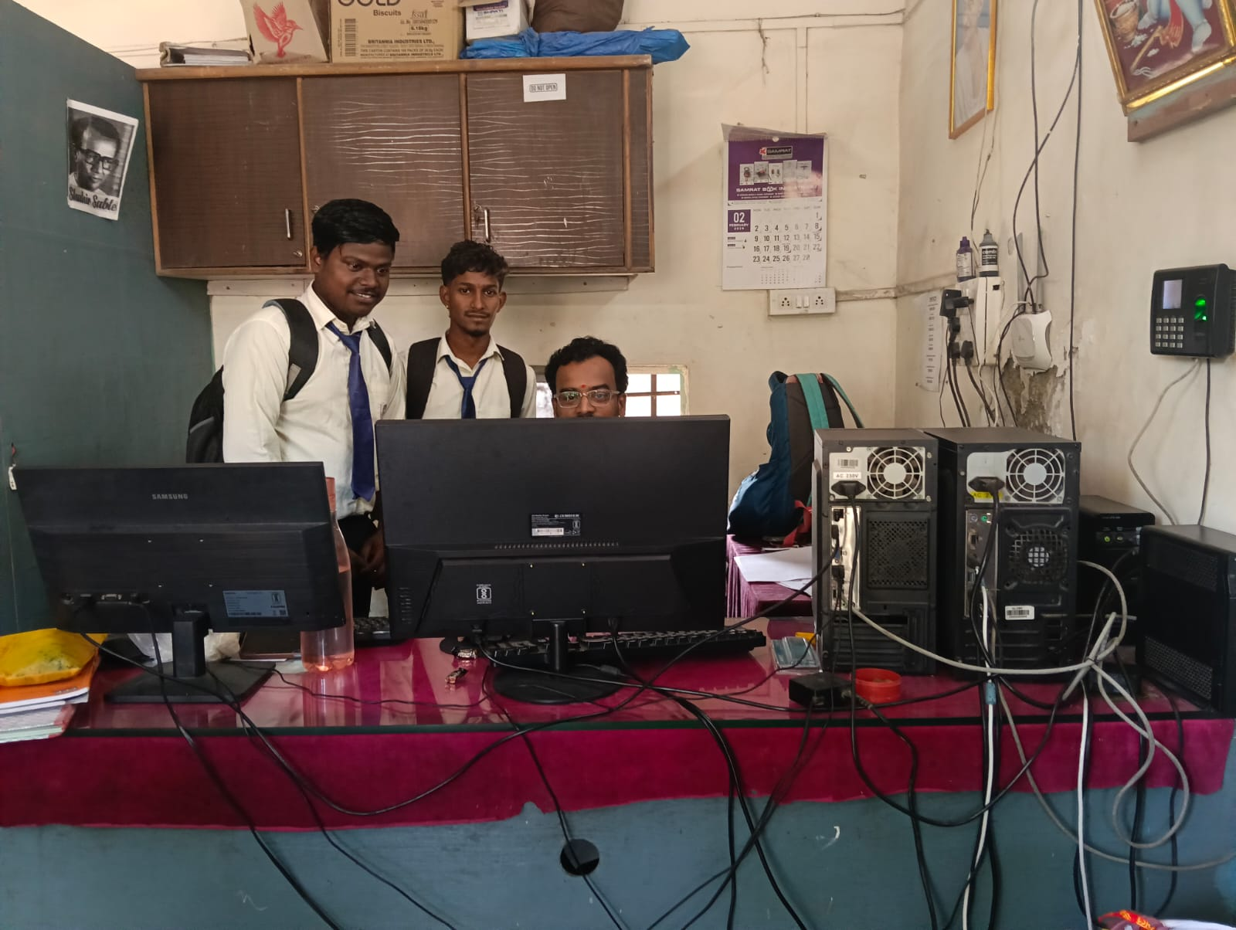

◆ ◆ ◆
4.2.3 Record 03 — V Tech ID Solutions, Kariwali
Startup Name | V Tech ID Solutions
Founder | Venkatesh Chitiken
Village | Kariwali
Date of Visit | 24 September 2026
Time of Visit | 02:59 PM

Background of the Enterprise
V Tech ID Solutions is a small ID-card service business based in Kariwali. The founder processes photographs submitted by schools, colleges, and offices for ID cards and other official documents. A typical week involves processing between 200 and 500 photographs.
Observed Friction Point
The core workflow was background replacement — taking each submitted photo and replacing its background with a clean, standard colour before printing. The founder was doing this manually: upload, wait, select, download, and repeat for every single image.
Founder’s Own Statement
“Facing problem in manually selecting every photo — upload, change background, download, then repeat. This has to be done for each photo individually.”
Solution Designed
A bulk background removal tool was built using the withoutbg model. The tool takes a folder of input images, removes the background from each one in a single pass, and saves the cleaned results into an output folder with the original filenames intact.

Outcome
The tool was tested on a batch of 30 photographs during the visit. The batch completed in under two minutes, compared to the founder’s estimate of roughly ninety minutes manually.
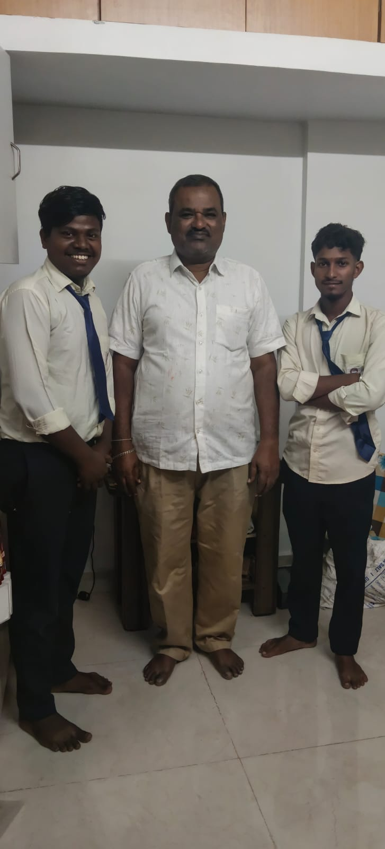
◆ ◆ ◆
4.2.4 Record 04 — Digital ID Solutions, Khoni Gaon
Startup Name | Digital ID Solutions
Founder | Santosh Chitiken
Village | Khoni Gaon
Date of Visit | 24 September 2026
Time of Visit | 05:04 PM

Background of the Enterprise
Digital ID Solutions is based in Khoni Gaon and provides ID-card and school photography services. The founder handles the full pipeline from photographing students to producing finished ID cards. The business operates on a batch model — each school visit produces a large set of photographs that must be processed into a consistent ID-card format.
Observed Friction Point
The bottleneck was the cropping step. After every school photo shoot, the founder had to open each photograph in an editor, adjust the crop window to frame the face and shoulders correctly, and save. On a recent shoot, the founder had clicked 500 photographs of students at a single school, each requiring manual crop adjustment.
Founder’s Own Statement
“The founder clicked 500 photos of students at a school and then had to crop the entire batch manually by adjusting the zoom and shoulder position for each individual photo.”
Solution Designed
An auto-crop web application was built using RetinaFace for face detection and Pillow for image manipulation. The tool accepts a batch of photographs, detects every face, infers the shoulder line, and crops each photograph to a standard ID-card ratio with the face and shoulders correctly positioned.
Outcome
The tool was demonstrated on a set of test photographs during the visit. A batch of 50 photos was processed in approximately thirty seconds, with consistently framed results. For a 500-photo shoot, the tool reduces the processing time from a full day to a few minutes.
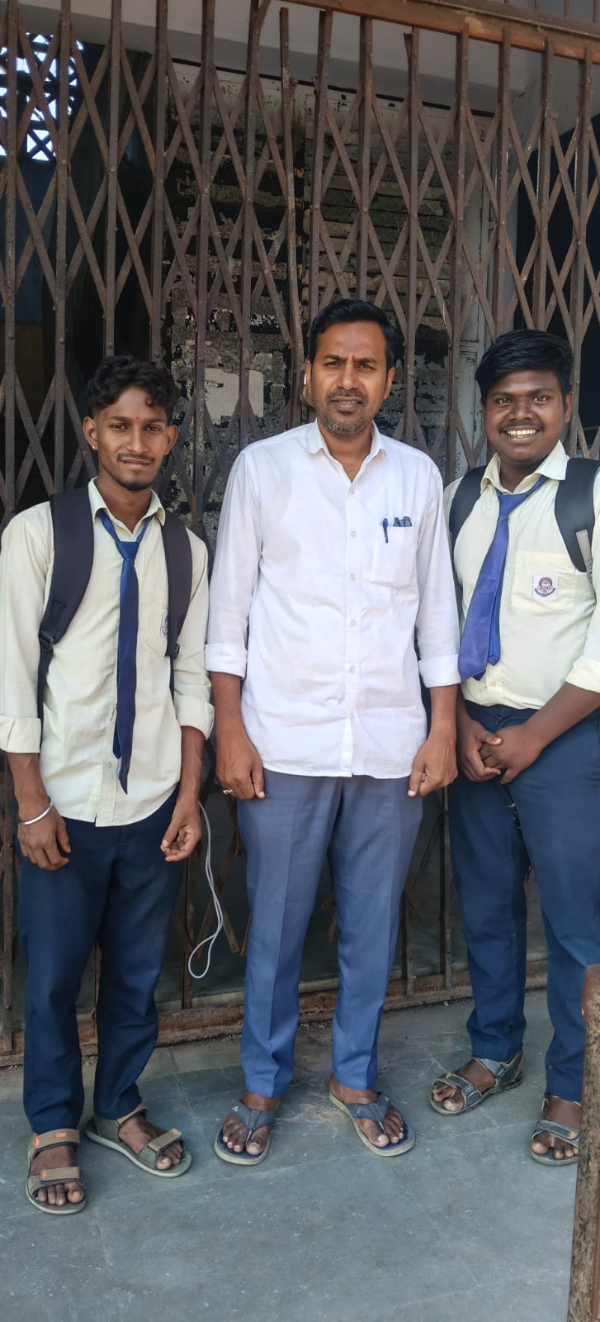
◆ ◆ ◆
Summary of Field Visits
Startup | Founder | Village | Date | Time
Srividyaniketan Classes | Niraj | Bhiwandi | 03-Oct-2026 | 11:20 AM
Baba ID Cards Solutions | Shridhar Siripuram | Shelar | 29-Sep-2026 | 01:14 PM
V Tech ID Solutions | Venkatesh Chitiken | Kariwali | 24-Sep-2026 | 02:59 PM
Digital ID Solutions | Santosh Chitiken | Khoni Gaon | 24-Sep-2026 | 05:04 PM

4.3 Cross-Cutting Observations
Looking across the four visits, several patterns emerge that are worth recording explicitly. These patterns are not visible in any single record but become clear when the four are considered together.
Pattern 1 — The problem is known; the tool is missing
In every visit, the founder already understood the general category of the problem they were facing. They did not need to be convinced of the value of digitisation. What they lacked was a specific tool that fit their exact workflow, or the technical know-how to set up a generic tool.
Pattern 2 — Repetitive manual work is the primary bottleneck
Three of the four enterprises had the same underlying problem: repetitive manual processing of a large volume of photographs. When shown the automated version, each founder immediately recognised the value.

Pattern 3 — The photo-services cluster is an emerging local market
Three of the four enterprises visited operate in what can be described as the ID-card and school-photography market. The Bhiwandi region has a dense cluster of schools and colleges, and demand for ID-card services is high.
Pattern 4 — Fit beats sophistication
In every case, the solution that was adopted was the one that required the least change to the founder’s existing workflow. Fit over features should guide future interventions.
Pattern 5 — Follow-up is not optional
Even the most promising demonstrations were followed by questions from the founders about edge cases and long-term data safety. Without a follow-up, some of these questions would have gone unanswered.
4.4 Product Demos — Software Tools Developed
During the field work, three recurring friction points emerged that could not be solved by training alone. In response, three small software utilities were developed that directly address these problems. Each tool is demonstrated on the project website at https://cep-project-python.onrender.com/demos, with embedded video walkthroughs.
Demo 1: Auto Face & Shoulder Cropping Web App
Developed in response to Record 04 (Digital ID Solutions). The tool accepts a batch of photographs, detects every face using RetinaFace, infers the shoulder line, and crops each photo to standard ID or portrait ratios. It handles both single uploads and batch processing, and saves output with the original filenames so the founder’s existing folder structure is preserved.
Technology stack: Python, RetinaFace, Pillow, Flask.

Demo 2: Bulk Background Removal Utility
Developed in response to Record 03 (V Tech ID Solutions). The tool processes an entire folder of product or ID photographs in a single run, removing the background from each image and saving the cleaned output with a clean white or transparent backdrop. It uses the withoutbg model, which runs locally without needing an internet connection.
Technology stack: Python, withoutbg, Pillow.
Demo 3: Smart Camera Renamer (Android App)
Developed in response to Record 02 (Baba ID Cards Solutions). The Android app captures a photo, saves it directly into a specified target folder, and renames it with a DSLR-style sequential serial number (IMG_0001, IMG_0002, and so on). The naming sequence continues across sessions, so a founder can return to a school a week later and pick up where the last batch ended.
Technology stack: Android, Kotlin, EXIF metadata.
4.5 Project Website — Deployment and Features
To make the project’s findings, training materials, and software tools accessible beyond the immediate team, a web application was built and deployed using Flask, MySQL, and Jinja2 templates styled with Tailwind CSS. The application is live at:
https://cep-project-python.onrender.com

Architecture
Component | Technology | Purpose
Backend framework | Flask 3.0 | Routing, request handling, template rendering
ORM | Flask-SQLAlchemy | Database modelling and queries
Database | MySQL (Aiven-hosted) | Persistent storage for field visit records
Frontend | Jinja2 + Tailwind CSS | Responsive server-rendered pages
Photo storage | Cloudinary | Persistent CDN-hosted uploads
Deployment | Render + Gunicorn | WSGI-served production deployment

Routes
Route | Method | Description
/ | GET | Project overview, objectives, team, methodology
/dashboard | GET | Metrics and full data table of every field visit
/field-work | GET, POST | Card grid of visits; POST adds a new record with photo upload
/resources | GET | Intervention areas with downloadable training materials
/demos | GET | Embedded video demos of the three software tools

The dashboard displays three metrics — Places Visited, Enterprises Supported, and Region — followed by a full table of field visit records. The field work page presents each visit as a stamp card styled after a field notebook, with enterprise photos, date stamps, before/after status pills, and founder statements. The resources page lists the four intervention areas with downloadable training materials. The demos page embeds video walkthroughs of the three software tools.

CHAPTER 5 — CONCLUSION AND RECOMMENDATIONS
5.1 Conclusion
The Technical Support for Rural Startups project demonstrated that direct, hands-on technical support, combined with purpose-built software tools and a public-facing record of outcomes, is an effective approach for promoting digital adoption among rural micro-enterprises. Unlike one-off workshops or pamphlets, working alongside each entrepreneur — setting up tools, building catalogues, and solving specific problems together — produced measurable adoption.
The project also showed that training alone is not sufficient. Follow-up visits were essential to sustain new habits, and the three software tools developed during the project addressed specific friction points that training could not solve. The project website serves as both a record of the field work and a reusable resource for future CEP cohorts.
Across the four enterprises visited, the most consistent lesson was that the founders already knew what they needed. They were not waiting to be told that digitisation is important. They were waiting for someone to sit with them, on their own device, and help them get the tool working. That is the specific contribution a CEP field visit can make.

5.2 Key Findings
- Hands-on support overcomes hesitation: Entrepreneurs who had never used digital tools adopted them when the setup was done with them, not for them.
- Follow-up is essential: Habits introduced on day one rarely survived the week without a second check-in.
- Fit beats sophistication: Tools and workflows that matched existing record-keeping habits were adopted faster than those that replaced them.
- Purpose-built tools fill gaps: The auto crop, background removal, and camera renamer utilities addressed problems that training alone could not.
- Documentation matters: Storing visit records in a structured database and publishing them on a website created a reusable record that outlasts any single field visit.
- A recurring local cluster: Three of four enterprises faced the same photo-processing bottleneck, suggesting a larger market for these tools.
5.3 Significance of Findings
The findings confirm that rural digital adoption is not primarily a knowledge problem — it is a support and fit problem. Most entrepreneurs understand why digital tools are useful; what they need is someone to sit with them and set things up, plus simple tools that work within their existing habits. Colleges and universities running CEP programs are well-positioned to provide this kind of sustained, hands-on support.
5.4 Recommendation
- Continue the three-visit model: Needs assessment, hands-on onboarding, and follow-up review. Do not skip the follow-up.
- Build for fit, not features: Tool development should start from observed friction points, not from assumptions about what entrepreneurs need.
- Document everything: Maintain structured records of every visit, including founder statements and before/after status.
- Publish outcomes: Deploy the project website publicly so that future cohorts can build on existing work.
- Train on real accounts: Set up tools on the entrepreneur’s actual device, not a demo device.
- Look for clusters: When multiple enterprises face the same problem, that is a signal to build a reusable tool rather than resolve each case individually.
5.5 Final Remark
The Technical Support for Rural Startups project at B.N.N. College, Bhiwandi, has shown that meaningful digital adoption in rural areas is achievable when support is direct, patient, and matched to the entrepreneur’s actual habits. The field visits, the software tools, and the deployed website together form a complete record of what was done — and a foundation for what can be done next.

REFERENCES
- Ministry of Electronics and Information Technology, Government of India. (2023). Digital Personal Data Protection Act, 2023.
- Reserve Bank of India. (2024). UPI Transaction Statistics.
- Google. (2025). Google Business Profile — Official Documentation.
- WhatsApp Business. (2025). WhatsApp Business Catalogue — Product Guide.
- Telecom Regulatory Authority of India. (2024). Annual Report on Internet Penetration in Rural India.
- NASSCOM. (2023). Digital Adoption in Indian Micro-Enterprises.
- Field Interaction Notes and Photographs, Villages near Bhiwandi, Maharashtra.
- Project Website: https://cep-project-python.onrender.com
APPENDICES
- Appendix A: Field Visit Form (structure and fields)
- Appendix B: Photos of Field Interaction (Chapter 4, Figures 4.1–4.4)
- Appendix C: Inventory Management Template (Automated_Inventory_Management.xlsx)
- Appendix D: UPI Setup & First Payment Guide (upi_setup.pptx)
- Appendix E: Online Discoverability Guide (Online_Discover.pptx)
- Appendix F: Product Demo Videos (available at /demos)

