SMART FUEL DISPATCH & FLEET TELEMETRY SYSTEM
23CS54C – MODERN WEB TECHNOLOGIES
Submitted by
PRAVIN N 24104080
In partial fulfillment for the award of the degree
of
BACHELOR OF ENGINEERING/TECHNOLOGY
in
COMPUTER SCIENCE AND ENGINEERING/ INFORMATION TECHNOLOGY

NATIONAL ENGINEERING COLLEGE
(An Autonomous Institution affiliated to Anna University, Chennai)
K.R.NAGAR, KOVILPATTI - 628503
OCTOBER - 2026

NATIONAL ENGINEERING COLLEGE
(An Autonomous Institution affiliated to Anna University, Chennai)
K.R.NAGAR, KOVILPATTI - 628503
BONAFIDE CERTIFICATE
This is to certify that this project report, “Smart Fuel Dispatch & Fleet Telemetry System”, is the bonafide work of PRAVIN N (24104080) who carried out the project work under my supervision.
Course Instructor/Guide
Submitted to the 23CS54C – MODERN WEB TECHNOLOGIES Viva-Voce examination held at National Engineering College, K.R.Nagar, Kovilpatti on __________________

Internal Examiner Co Examiner
TABLE OF CONTENTS
CH NO TITLE PAGE NO
1 INTRODUCTION 3
2 OBJECTIVES 4
3 DESCRIPTION 5
4 CLASS DIAGRAM 7
5 TABLE STRUCTURES 9
6 ER DIAGRAM 14
7 TECH STACK 16
8 MODULES 18
9 CONCLUSION 54
CHAPTER 1

INTRODUCTION
Fuel distribution is a time-sensitive operation in which order processing, vehicle assignment, stock availability and delivery visibility must work together. When these activities are coordinated manually, it becomes difficult to know which tanker is carrying an order, where the driver currently is, whether enough fuel is available in the depot tank, and whether a delivery has reached the customer.
The Smart Fuel Dispatch & Fleet Telemetry System is a full-stack web application built for bulk fuel delivery operations. Inside the application, the user interface and the API it is named the Fuel Delivery Management System (FDMS). It combines corporate customer registration and approval, fuel ordering, depot-manager order approval, driver and tanker assignment, a smart dispatch recommendation, live GPS tracking, depot tank monitoring, fuel pricing, notifications, audit logs, reports and a rule-based logistics assistant in one platform.
The frontend is implemented with React 18 and Vite. React Router handles navigation, the Context API with useReducer and React hooks manages shared state, Axios communicates with the REST API, the Socket.IO client receives real-time events, and Leaflet with OpenStreetMap tiles draws the fleet map. The interface is available in English, Tamil and Hindi and supports dark and light themes.
The backend is implemented with Node.js and Express 5. The API is split into domain-specific route and controller modules for authentication, orders, inventory, drivers, vehicles and fleet, customers, registrations, pricing, notifications, reports, activity logs and GPS data. MongoDB is the persistent database and is accessed through Mongoose schemas. Passwords are hashed with bcryptjs, sessions use JSON Web Tokens (JWT), uploaded company documents are handled by Multer, and Socket.IO pushes notifications and location updates to connected users.
Six user roles are supported: Admin, Depot Manager, Customer, Driver, Support Executive and Auditor. The project also contains a Jenkins pipeline (checkout, install, build and deploy) and a Vercel configuration that deploys the frontend and the Express backend as two services. This report documents the design, implementation and features of the system as they exist in the project source.
CHAPTER 2

OBJECTIVES
- To digitize fuel delivery operations: Replace fragmented manual coordination with a centralized web-based dispatch system.
- To provide secure authentication and role-based access: Support Admin, Depot Manager, Customer, Driver, Support Executive and Auditor roles using JWT, bcrypt-hashed passwords, Google sign-in and mobile OTP login, with protected pages and role-restricted API routes.
- To onboard corporate customers through a verified workflow: Collect company, GST/PAN and address details with supporting documents, and let a reviewer approve or reject each application before the customer can log in.
- To manage the fuel order lifecycle: Create, price, approve, reject, assign, dispatch, deliver and cancel orders with clear status tracking, delivery proof and an invoice.
- To improve dispatch decisions: Recommend the nearest depot, the nearest available tanker and an estimated delivery time using the Haversine great-circle distance.
- To provide live fleet telemetry: Record vehicle and driver location, speed, heading and timestamp, store the history separately, and show live movement on a map through Socket.IO.
- To monitor depot inventory: Track tank capacity, current stock, reserved stock, minimum thresholds and refill history, raise low-stock alerts, and check stock before an order is approved.
- To manage fuel pricing: Keep fuel code, price, tax rate and delivery charge as managed data and use them to calculate quotes and order totals.
- To keep users informed and accountable: Create role-targeted notifications with read and unread state, and record significant actions in an activity log with user, role, entity and IP address.
- To support analysis and usability: Provide dashboards and reports, a multilingual interface, theme switching and a role-aware assistant.
- To enable automated build and deployment: Use a Jenkins pipeline and Vercel configuration so that the application can be built and deployed consistently.
CHAPTER 3

DESCRIPTION
The system is organized as a layered full-stack application. The React client provides the user interface, the Express backend provides REST APIs and a Socket.IO gateway, and MongoDB stores operational records. The system consists of eight functional areas.

1. Authentication and Access Control
Users sign in with email and password, with Google sign-in, or with a one-time password. Passwords are stored as bcrypt hashes and a JWT is issued on success. Customer accounts that are still pending or were rejected are refused at login. On the frontend, AuthContext keeps the session and ProtectedRoute redirects unauthenticated users to the login page and keeps customers and drivers inside their own portals. On the backend, the protect and authorize middleware validate the token and the role on selected routes.

2. Customer and Registration Management
A company registers with its contact, GST, PAN, address and fuel-requirement details and uploads supporting documents. The application stays in a Pending state until a reviewer approves or rejects it. Approval creates a Customer user account and notifies the customer. The Applications and Customer Registrations pages support this review.

3. Order and Dispatch Management
Orders are the central transaction. An order holds the customer, fuel type, quantity, delivery address, city, delivery slot, assigned driver and tanker, financial values and lifecycle timestamps. The controller prices the order from the FuelPricing collection, reserves tank stock on approval, assigns a driver and tanker, advances the status to delivery and deducts stock when the delivery is completed. A smart dispatch endpoint recommends the nearest depot, the nearest available tanker and an estimated time of arrival.

4. Driver and Fleet Management
Driver records hold name, phone, assigned vehicle, duty state, delivery count, licence number and email. Vehicle records hold the vehicle number, driver name, status, cargo type, fuel level, tyre pressure, engine temperature, destination, ETA and current position. The Drivers and Vehicles pages allow managers to register resources and change availability.

5. GPS and Telemetry Management
Location updates arrive through the REST API or through Socket.IO. Each update is validated, stored as a time-stamped record in VehicleLocation or DriverLocation, copied to the current vehicle state, and broadcast to connected clients so that the Fleet Map moves in real time. Each vehicle keeps a trail of its last 1,000 points for route display.

6. Inventory and Fuel Pricing
Depot tanks are stored in the tanks collection with capacity, current stock, reserved quantity, minimum threshold, temperature, pressure and a refill history. Low-stock alerts are classified as warning or critical. Fuel prices, the 18% tax rate and the delivery charge are stored in FuelPricing and are used for quotes and order totals.

7. Notifications, Audit Logs and Reports
Business events create notifications targeted at a role or user and push them in real time. Significant actions, such as login, order creation, approval and delivery, are written to an activity log that can be searched and filtered. The report module aggregates orders, revenue, fuel usage, city and customer summaries for the dashboard and the Reports page.

8. Dashboard, Settings, Localisation and Assistant
Role-specific dashboards summarize orders, deliveries, tank levels and applications. Settings control the theme, language and notification preferences, which persist in the browser. English, Tamil and Hindi dictionaries are provided. A floating Fuel Logistics Assistant answers common questions from live order and inventory data and offers different quick actions to managers and customers.
CHAPTER 4

CLASS DIAGRAM
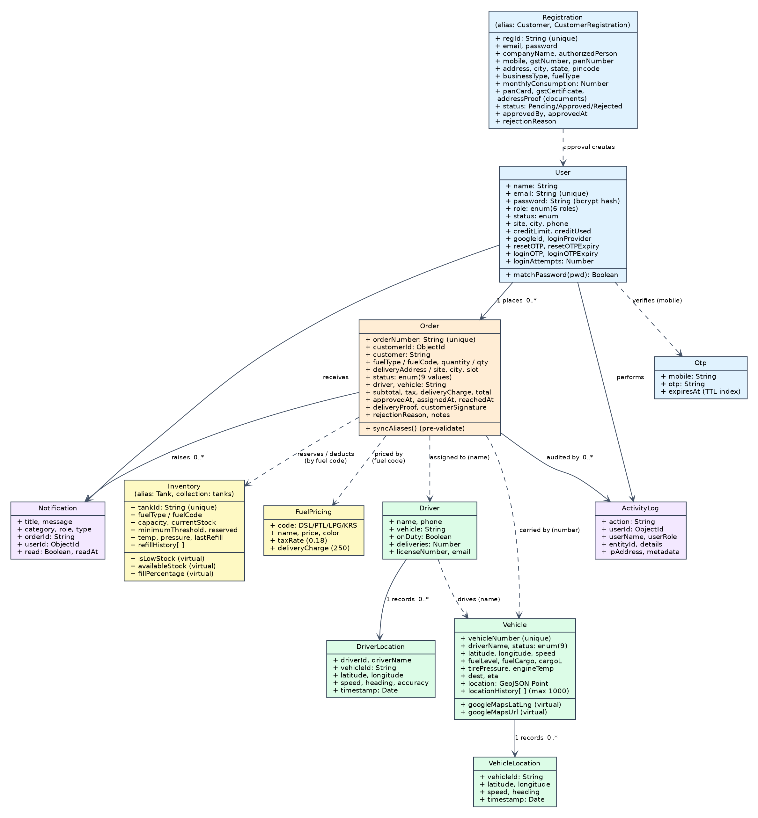
Fig 4.1 Class diagram of the Smart Fuel Dispatch & Fleet Telemetry System

The class diagram is drawn from the Mongoose models in backend/models. Solid arrows are references stored as MongoDB ObjectIds (Order.customerId, Notification.userId, ActivityLog.userId) or one-to-many ownership of time-stamped records. Dashed arrows are logical associations that are resolved through a name, number or code rather than an ObjectId: an order stores the driver name and the vehicle number, and it is linked to tank stock and to pricing through the fuel code.
The central Order class connects the customer, fuel requirement, dispatch status, driver and vehicle. User represents every role. Driver and Vehicle are the fleet resources, and VehicleLocation and DriverLocation keep history apart from the master records. Inventory and FuelPricing support the commercial side of an order, Notification and ActivityLog support communication and audit, and Registration holds a company application and creates the User when it is approved.
Tank.js is an alias of Inventory, and Customer.js and CustomerRegistration.js are aliases of Registration, so the 15 model files contain 12 distinct schemas.
CHAPTER 5

TABLE STRUCTURES
MongoDB stores each model as a collection of documents. The tables below list the fields of every schema in the project. Every collection also receives an _id (ObjectId) and, where timestamps: true is set, the createdAt and updatedAt fields.
User (collection: users)
Field | Type | Required | Default / constraints
name | String | Yes | trimmed
email | String | Yes | unique, lowercase, must match an email pattern
password | String | Yes | minimum 6 characters; stored as a bcrypt hash
role | String (enum) | No | Admin, Depot Manager, Customer, Driver, Support Executive, Auditor; default Customer
status | String (enum) | No | Pending, Approved, Rejected, Active; default Active
site, city, phone | String | No | default empty
creditLimit, creditUsed | Number | No | default 0
googleId, profileImage | String | No | default null / empty
loginProvider | String (enum) | No | local or google; default local
resetPasswordToken, resetPasswordExpires | String, Date | No | default null
resetOTP, resetOTPExpiry | String, Date | No | password-reset OTP and its expiry
loginOTP, loginOTPExpiry | String, Date | No | login OTP and its expiry
loginAttempts | Number | No | default 0; counts wrong login-OTP entries

Order (collection: orders)
Field | Type | Required | Default / constraints
orderNumber | String | No | unique; format ORD-YYMMDD-NNN
customerId | ObjectId → User | No | default null
customer | String | No | default “Customer”
fuelType (alias fuelCode) | String | Yes | uppercase; DSL, PTL, LPG or KRS
quantity (alias qty) | Number | Yes | minimum 1 litre
deliveryAddress (alias site) | String | Yes | trimmed
status | String (enum) | No | Pending, Approved, Rejected, Assigned, In Transit, InTransit, Dispatched, Delivered, Cancelled; default Pending
driver, vehicle | String | No | default “Unassigned”
city, slot | String | No | default Chennai, 08:00-10:00
subtotal, tax, total | Number | No | default 0; calculated from FuelPricing
deliveryCharge | Number | No | default 250
rejectionReason, notes | String | No | default empty
approvedAt, rejectedAt, assignedAt, reachedAt | Date | No | lifecycle timestamps
deliveryProof, customerSignature | String | No | delivery evidence; default empty
A pre-validate hook keeps the alias pairs (fuelType/fuelCode, quantity/qty, deliveryAddress/site) in sync so that older and newer client code both work.
Driver (collection: drivers)
Field | Type | Required | Default / constraints
name | String | Yes | trimmed
phone | String | Yes | trimmed
vehicle | String | No | assigned vehicle number; default empty
onDuty | Boolean | No | default true
deliveries | Number | No | default 0, minimum 0
licenseNumber | String | No | default empty
email | String | No | lowercase; default empty

Vehicle (collection: vehicles)
Field | Type | Required | Default / constraints
vehicleNumber (alias vehicle) | String | Yes | unique
driverName (alias driver) | String | No | default “Unassigned”
latitude (alias lat) | Number | Yes | −90 to 90; default 13.0827
longitude (alias lng) | Number | Yes | −180 to 180; default 80.2707
speed | Number | No | default 0, minimum 0
fuelLevel | Number | No | 0 to 100; default 100
status | String (enum) | No | Available, Assigned, In Transit, Delivered, InTransit, Idle, Dispatched, Delivering, Maintenance; default Available
location | GeoJSON Point | No | [longitude, latitude]; 2dsphere index
locationHistory[ ] | Array | No | latitude, longitude, speed, timestamp (last 1,000 kept)
fuelCargo, cargoL | String (enum), Number | No | DSL, PTL, LPG, KRS or None; litres on board
tirePressure, engineTemp | Number | No | default 110 and 85
dest, eta, phone | String | No | default “Depot Base”, “Stationary”, empty
Two virtual fields, googleMapsLatLng and googleMapsUrl, expose the position in a Google Maps compatible form.
VehicleLocation (collection: VehicleLocation)
Field | Type | Required | Default / constraints
vehicleId | String | Yes | indexed
latitude | Number | Yes | −90 to 90
longitude | Number | Yes | −180 to 180
speed, heading | Number | No | default 0
timestamp | Date | No | default now; indexed
A compound index on (vehicleId, timestamp descending) serves history queries.
DriverLocation (collection: DriverLocations)
Field | Type | Required | Default / constraints
driverId | Mixed | No | default null; indexed
driverName, vehicleId | String | No | vehicleId indexed
latitude, longitude | Number | Yes | range checked
speed, heading, accuracy | Number | No | default 0
timestamp | Date | No | default now; indexed
Compound indexes on (vehicleId, timestamp) and (driverId, timestamp) serve history queries.
Inventory (collection: tanks; also exported as Tank)
Field | Type | Required | Default / constraints
fuelType (alias fuelCode) | String | Yes | uppercase
capacity | Number | Yes | minimum 0
currentStock (alias current) | Number | Yes | minimum 0
minimumThreshold (alias threshold) | Number | Yes | minimum 0; default 5000
reserved | Number | No | default 0; stock held for approved orders
tankId | String | No | unique; default TK-<code>-<nn>
name | String | No | default “Depot Storage Tank - <fuel>”
temp, pressure | Number | No | default 25.0 and 1.0
lastRefill | String | No | date; default today
refillHistory[ ] | Subdocuments | No | quantity (≥1, required), requestedBy, supplier, status (Requested, In Transit, Completed), notes, refillDate
Virtual fields isLowStock, availableStock and fillPercentage are calculated on read.
FuelPricing (collection: fuelpricings)
Field | Type | Required | Default / constraints
code | String | Yes | unique; DSL, PTL, LPG or KRS
name | String | Yes | for example Diesel
price | Number | Yes | minimum 0; price per litre
color | String | No | UI colour; default #f59e0b
taxRate | Number | No | default 0.18
deliveryCharge | Number | No | default 250

Notification (collection: notifications)
Field | Type | Required | Default / constraints
title, message | String | Yes | trimmed
category | String (enum) | No | order, delivery, inventory, registration, general, request, dispatch; default general
role | String (enum) | No | Admin, Depot Manager, Customer, Driver, All; default All
type | String (enum) | No | info, success, warning, danger; default info
orderId | String | No | order number; default empty
userId | ObjectId → User | No | default null
read, readAt | Boolean, Date | No | default false, null

ActivityLog (collection: activitylogs)
Field | Type | Required | Default / constraints
action | String | Yes | for example Login, Order Created, Customer Approved
userId | ObjectId → User | No | default null
userName, userRole | String | No | default “System”, “Admin”
entityId, details | String | No | order number or email; description
ipAddress | String | No | caller IP
metadata | Mixed | No | extra context; default {}
Indexes: createdAt descending, and (action, createdAt descending).
Otp (collection: otps)
Field | Type | Required | Default / constraints
mobile | String | Yes | indexed
otp | String | Yes | six-digit code
expiresAt | Date | Yes | TTL index: MongoDB deletes the record after expiry (5 minutes)

Registration (collection: customerregistrations; also exported as Customer and CustomerRegistration)
Field | Type | Required | Default / constraints
regId | String | No | unique; format REG-YYYY-NNNN
email | String | Yes | must match an email pattern
password | String | Yes | stored as a bcrypt hash
companyName, authorizedPerson | String | Yes | trimmed
contactPerson, phone, address1, postalCode | String | No | kept in sync with authorizedPerson, mobile, address, pincode
mobile, gstNumber, panNumber | String | Yes | GST and PAN are upper-cased
address, city, state, pincode | String | Yes | default Chennai, Tamil Nadu, 600001
businessType, designation, companyRegNo | String | No | default Commercial, Director, empty
fuelType, monthlyConsumption | String, Number | No | default DSL, 0
panDocument, panCard, gstCertificate, companyRegistrationCertificate, addressProof | Document subdocument | No | fileName, originalName, filePath, mimetype, size, uploadedAt
additionalSupportingDocuments[ ], documents[ ] | Arrays | No | same document structure; documents also has a type label
status | String (enum) | No | Pending, Approved, Rejected, Pending Review; default Pending
submittedAt, approvedAt, rejectedAt | Date | No | review timeline
approvedBy, rejectionReason, reviewNotes | String | No | reviewer information

CHAPTER 6

ER DIAGRAM
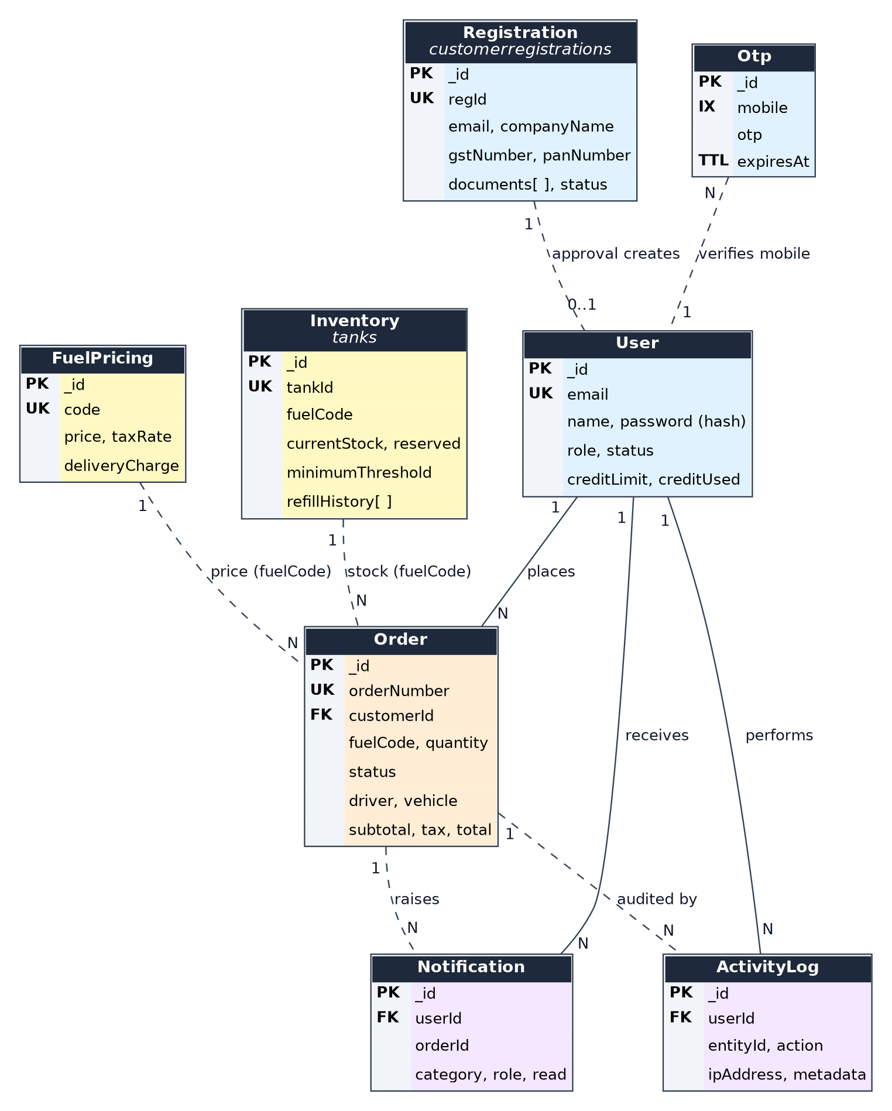
Fig 6.1 Core entity-relationship diagram (PK = primary key, UK = unique, FK = reference, IX = index, TTL = expiry index)
The entity-relationship design separates three groups. Master entities (User, Registration, Driver, Vehicle, Inventory and FuelPricing) describe the people and resources of the depot network. Transactional entities (Order, Notification, ActivityLog and Otp) record what happens. Time-series entities (VehicleLocation and DriverLocation) store location history so that current fleet state can be read quickly without losing past movement.
Solid lines in the diagram are ObjectId references. Dashed lines are logical links that MongoDB does not enforce: the application resolves them in the controllers by name, number or code. The fleet and telemetry entities are drawn separately in Fig 6.2, and the table lists every relationship.
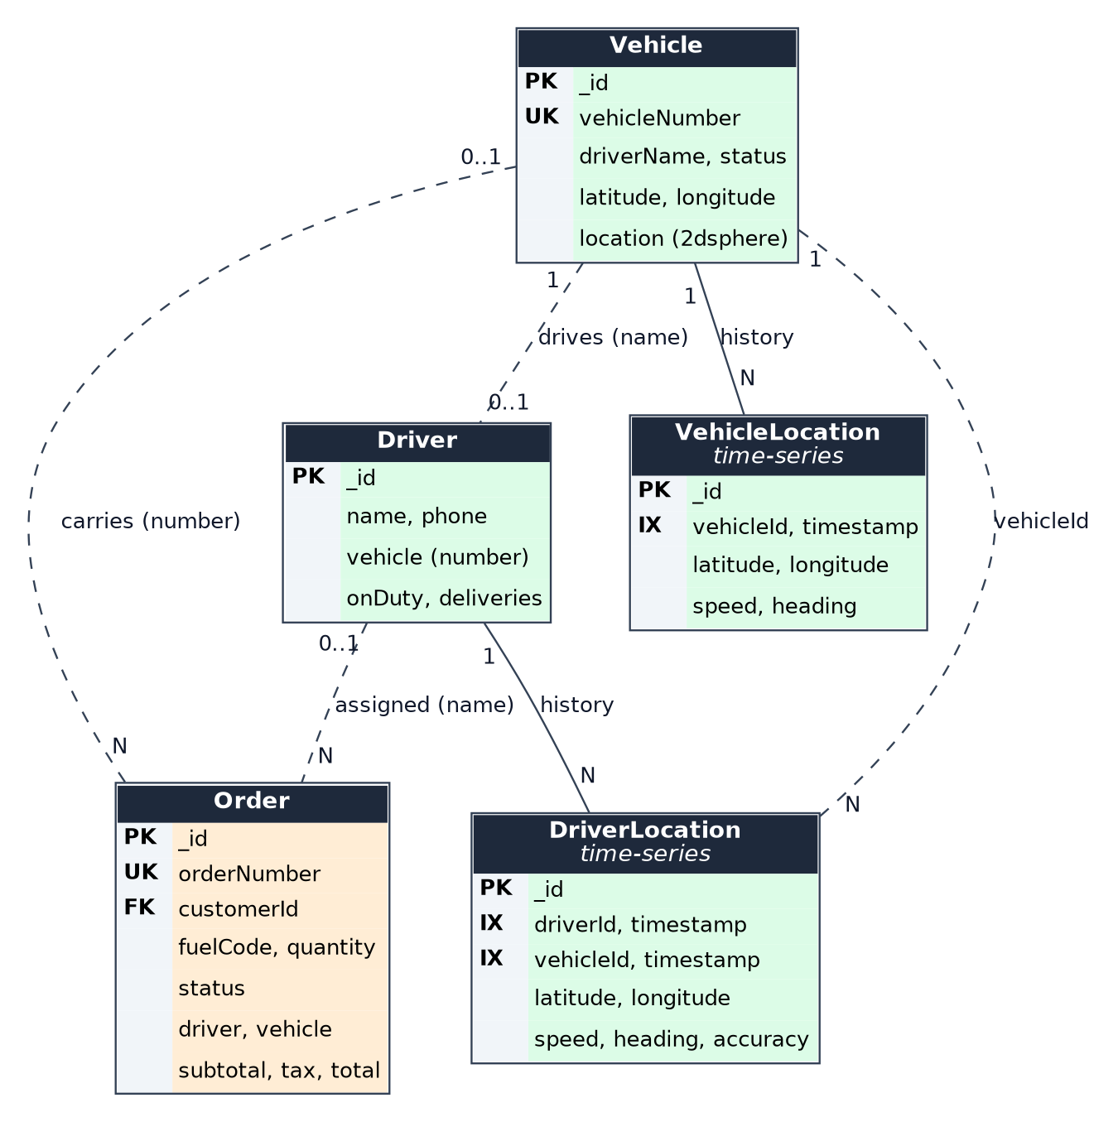
Fig 6.2 Fleet and telemetry entities and their link to Order
Entity A | Cardinality | Entity B | Linking field | Kind
User | 1 : N | Order | customerId (ObjectId) | Reference
User | 1 : N | Notification | userId (ObjectId) | Reference
User | 1 : N | ActivityLog | userId (ObjectId) | Reference
Registration | 1 : 0..1 | User | email (user is created on approval) | Logical
Order | 1 : N | Notification | orderId = orderNumber | Logical
Order | 1 : N | ActivityLog | entityId = orderNumber | Logical
Driver | 0..1 : N | Order | driver (name) | Logical
Vehicle | 0..1 : N | Order | vehicle (vehicle number) | Logical
Vehicle | 1 : 0..1 | Driver | driverName / vehicle | Logical
Inventory (tanks) | 1 : N | Order | fuelCode (stock reserve and deduction) | Logical
FuelPricing | 1 : N | Order | fuelCode = code (price lookup) | Logical
Vehicle | 1 : N | VehicleLocation | vehicleId = vehicleNumber | Logical
Driver | 1 : N | DriverLocation | driverId | Logical

Because an order stores the driver and vehicle as text, later changes to a driver or vehicle record do not alter past orders, which keeps each delivery record true to the day of delivery.
CHAPTER 7

TECH STACK

7.1 TECH STACK
Layer | Technology | Purpose
Frontend | React 18.2 with Vite 5 | Single-page application with a component-based interface
Routing | React Router DOM 6 | Client-side routes, protected routes and role-aware redirects
State management | Context API, useReducer, hooks | Eight context providers; reducers in the Auth and Orders contexts
HTTP client | Axios 1.x | REST calls with a request interceptor that adds the Bearer token
Real time | Socket.IO 4.8 (server and client) | Notifications and live GPS updates
Maps | Leaflet 1.9, React Leaflet 4, OpenStreetMap tiles | Fleet map and delivery tracking
Client authentication | @react-oauth/google, jwt-decode | Google sign-in button and token decoding
UI icons | lucide-react | Icon set
Backend | Node.js with Express 5.2 | RESTful API server
Database | MongoDB with Mongoose 9 | Document storage, schema validation, indexes and virtual fields
Server authentication | jsonwebtoken 9, bcryptjs 3, google-auth-library | JWT issue and verification, password hashing, Google ID-token verification
File upload | Multer 2 | Multipart document upload; PDF, DOC, DOCX, JPEG and PNG up to 10 MB each
Configuration | dotenv, CORS | Environment variables and cross-origin access
CI/CD | Jenkins (Jenkinsfile) | Checkout, install, build and deploy stages
Deployment | Vercel (vercel.json) | Two services: Vite frontend and Express backend, with /api rewrites
Testing | Node.js test scripts | Nine scripts for end-to-end, approval, role, OTP/Google and driver-location flows

7.2 ARCHITECTURE OVERVIEW
Layer | Technology | Purpose
Model | Mongoose schemas and MongoDB | Define the data structure, validation, indexes and virtual fields, and run the database queries
View | React pages, components and contexts | Render the interface, hold client state, call the API and receive Socket.IO events
Controller | Express routes and controllers | Receive HTTP requests, apply business rules, update models and emit notifications
Real-time gateway | Socket.IO server | Pushes notifications and location updates to role, user and vehicle rooms

7.3 PROJECT SIZE
The counts below were taken from the project source.
Quantity | Count | Basis
Frontend pages | 20 | Files in src/pages
Reusable components | 14 | Files in src/components
Context providers | 8 | Auth, Orders, Inventory, Notification, Theme, Language, Settings, Simulation
Client services | 3 | api.js, socket.js, recentAccess.js
Backend route files | 13 | 12 mounted API groups; /vehicles and /fleet share one router
Controllers | 13 | Files in backend/controllers
Model files / schemas | 15 / 12 | Tank, Customer and CustomerRegistration are aliases
Supported languages | 3 | English, Tamil, Hindi
User roles | 6 | Admin, Depot Manager, Customer, Driver, Support Executive, Auditor
CHAPTER 8

MODULES

8.0 DESIGN APPROACH
The modules are organized around the main operational responsibilities of a fuel dispatch system. Each module is documented in the same nine steps so that the design can be reviewed consistently.
Step | Content
8.x.0 Purpose & Scope | What the module is responsible for and where it stops
8.x.1 Functional requirements | What the module must do
8.x.2 Non-functional requirements | Security, consistency, performance and maintainability expectations
8.x.3 Tech stack | Technologies chosen and why they fit
8.x.4 Back-of-the-envelope estimation | Sizing based on stated assumptions
8.x.5 Low-level architecture | Components and request flow
8.x.6 API design | Endpoints and contracts
8.x.7 DB design | Collections, keys, indexes and key fields
8.x.8 Screenshots | Pages from the running application

Shared baseline for all modules
Request path. A request from the React client passes through CORS and the JSON body parser and reaches a domain router mounted under /api. The router calls a controller, the controller uses Mongoose models, and the response returns as JSON. A shared notFound and errorHandler pair returns consistent error responses, and /api/health reports service health.
Security baseline. Passwords are stored only as bcrypt hashes. JWT validation (protect) and role checks (authorize) are applied to the profile, password-change, user-listing, role-test, customer status/delete and activity-log routes. Mongoose schemas validate types, enums and ranges, and Multer restricts uploads to PDF, DOC, DOCX, JPEG and PNG files up to 10 MB each. The remaining operational routes are open in the current version, which is listed as a limitation in Chapter 9.
Consistency and scaling. The system uses one MongoDB deployment, so reads and writes go to a single primary and consistency is preferred over availability. The API keeps no server-side session, because identity travels in the JWT, so additional API instances can be added behind a load balancer. Socket.IO would need a shared adapter such as Redis once more than one instance is used.
Sizing baseline. Estimates in this report use the assumptions below. They are illustrative design estimates, not production capacity measurements.
Item | Value | Basis
Registered customer companies | ≈ 200 | Assumption for a regional distributor
Staff users (admin, managers, support, auditor) | ≈ 25 | Assumption
Tankers and drivers | ≈ 40 and ≈ 40 | Assumption; the demonstration data has 6 tankers and 4 drivers
Depots | 5 | Chennai, Salem, Madurai, Trichy and Coimbatore, as configured in smart dispatch
Orders per day | ≈ 150 (≈ 45,000 per year) | Assumption; 300 working days
Tankers sending GPS at one time | ≈ 30 | Assumption
Peak concurrent web users | ≈ 100 | Assumption

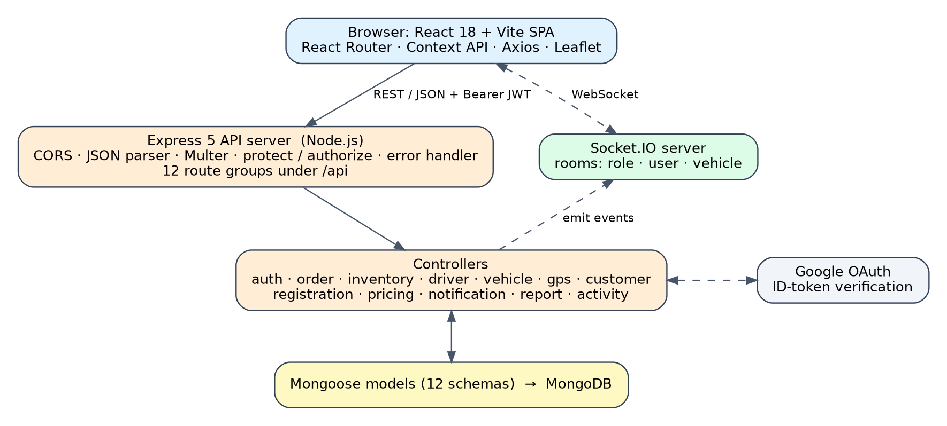
Fig 8.0 Overall architecture and request flow of the Smart Fuel Dispatch & Fleet Telemetry System

8.1 FOLDER STRUCTURE
The project is divided into a React/Vite client and a Node/Express server. Frontend code is grouped into pages, components, contexts, services, layouts, data and internationalisation resources. The backend separates routes, controllers, models, middleware and configuration.

Project root
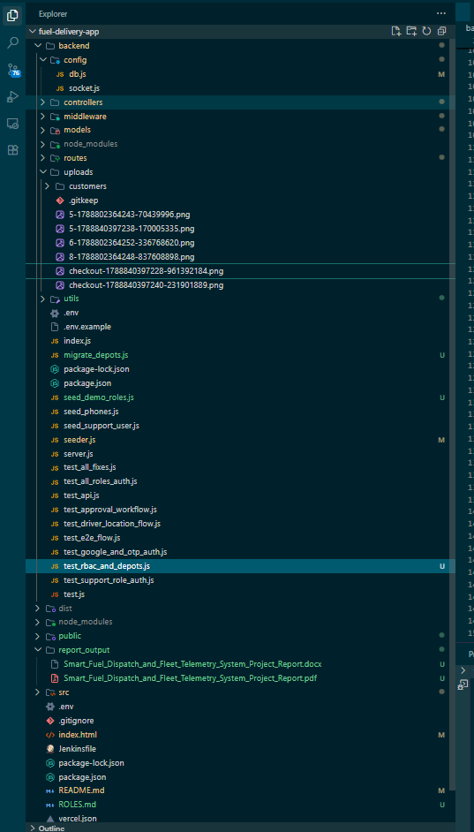

Backend organization
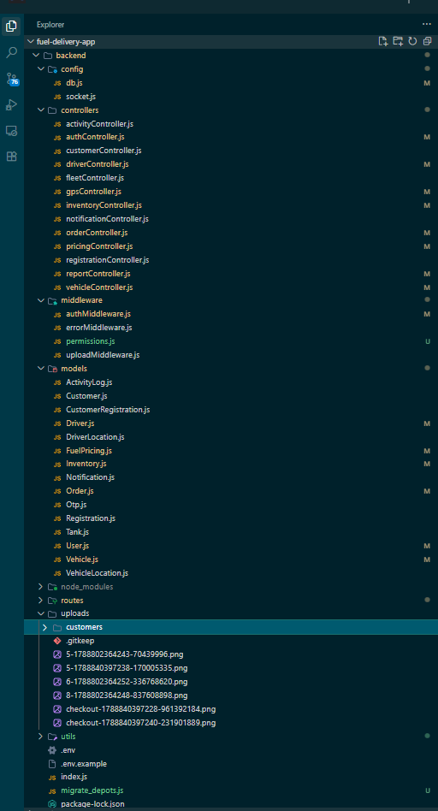

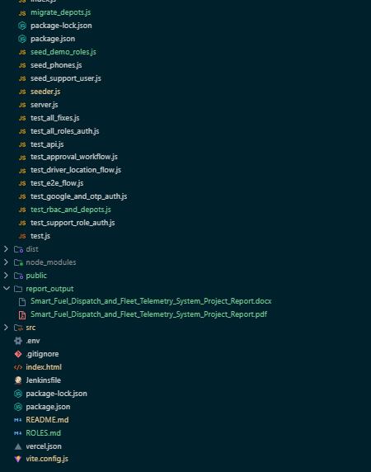

Frontend organization
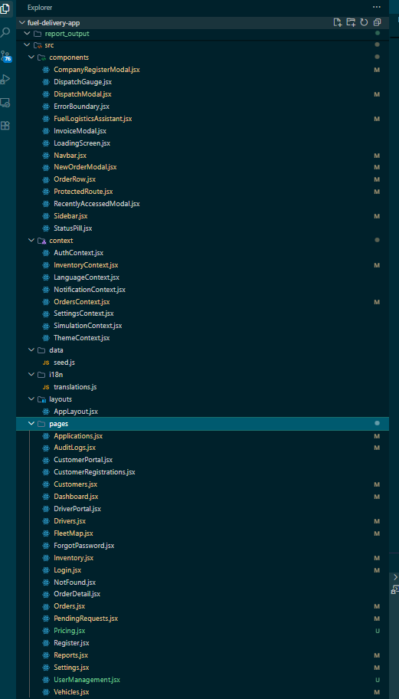

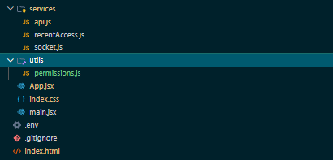

Boundary and low-level flow
The frontend never reads MongoDB directly. Every data access passes through the backend, which keeps validation and authorization in one place.
- Browser request → React route → page or component → context or service → Axios or Socket.IO → Express route → controller → Mongoose model → MongoDB → JSON response → state update → UI render.
- Provider composition in App.jsx wraps the router with the theme, language, settings, authentication, notification, orders, inventory and simulation providers, so any page can use them.
- ProtectedRoute wraps the authenticated pages and the AppLayout shell supplies the sidebar and navigation bar.
Non-functional requirements: the structure should stay modular, easy to navigate and independently testable, so that mock or local data can be replaced by real services without changing the pages.

8.2 AUTHENTICATION & ACCESS CONTROL

Purpose & Scope
This module handles sign-in, account recovery and access control. It supports email and password login, Google sign-in and one-time-password (OTP) login, issues a JWT for each session, and makes the user's role decide which pages and which protected API routes are available.

Functional Requirements
- Login: email and password are checked against the stored bcrypt hash. A customer account whose status is Pending or Rejected is refused with an explanatory message. A successful login returns a JWT and the user profile and is written to the activity log.
- Account creation: POST /api/auth/register creates a user account. Corporate customers register through the Registration module and are reviewed before they can sign in.
- Google sign-in: the Google ID token is verified on the server with the Google auth library, and the matching user is signed in or created.
- OTP login: a six-digit code is generated and stored with a 5-minute expiry. Five wrong entries invalidate the attempt and a new code is required.
- Password recovery: forgot-password creates an OTP, verify-reset-otp checks it and reset-password stores a new hashed password.
- Profile and password: a signed-in user can read the profile, update it and change the password.
- Role-aware navigation: ProtectedRoute sends unauthenticated users to the login page, keeps customers on the Customer Portal and drivers on the Driver Portal, and shows staff the dashboard. The authorize(...roles) middleware returns HTTP 403 when a role is not allowed.
- Session restoration: on reload the stored token is read from local storage, the user is restored and a loading screen is shown while this happens.

Non-Functional Requirements
- Password protection: passwords are hashed with bcryptjs (salt rounds 10) before they are saved and the hash is not returned to the client.
- Token handling: the JWT is signed with a secret read from the environment and expires after the period set in JWT_EXPIRE (30 days by default). The secret must be set per deployment and never be committed.
- OTP safety: codes expire after 5 minutes, the Otp collection deletes expired records through a TTL index, and login OTP attempts are limited to five.
- Statelessness: no server session is stored, so the API can scale horizontally.
- Known limits: OTP delivery through an SMS gateway and rate limiting are not part of this version. In the demonstration build, the OTP response includes a preview value so that the flow can be shown without SMS.

Tech Stack
Concern | Choice | Why it fits this module
Password storage | bcryptjs | Salted one-way hashing, with a comparison method on the User model
Session | JSON Web Token | Stateless; the token carries the user id and is verified on protected routes
Authorization | protect and authorize middleware | One place that decides who may call a route
Social login | Google OAuth (React OAuth provider and google-auth-library) | Server-side verification of the Google ID token
Recovery | OTP fields and Otp collection with TTL index | Short-lived codes that clean themselves up
Client session | AuthContext with useReducer, ProtectedRoute | Single source of truth for the signed-in user

Back-of-the-Envelope Estimation
The figures below are design estimates based on stated assumptions. They are not measurements of a production deployment.
Quantity | Estimate | Basis
User records | ≈ 265 | 200 customers + 25 staff + 40 drivers (assumptions)
User collection size | ≈ 160 KB | 265 documents × about 0.6 KB
Logins per day | ≈ 300 | Each user signs in about once, some twice
Peak login burst | 60 logins in 5 minutes ≈ 0.2 per second | Start of a shift (assumption)
CPU for the burst | ≈ 6 CPU-seconds, about 2% of one core | 60 logins × about 100 ms per bcrypt comparison (assumption)
OTP guess probability | ≈ 5 / 900,000 ≈ 0.0006% per code | Six-digit codes give 900,000 values; five attempts allowed
Token lifetime | 30 days by default | Value of JWT_EXPIRE when it is not set

Low-Level Architecture
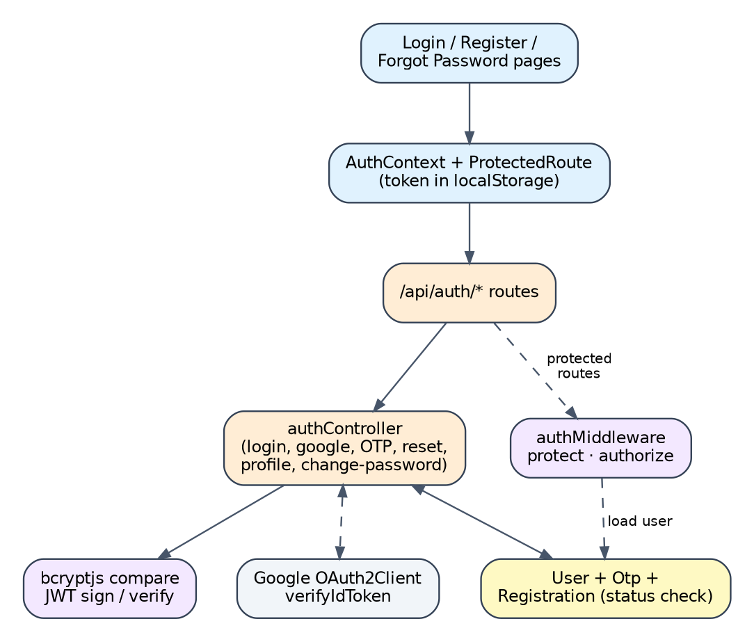
Fig 8.2.A Low-level architecture – AUTHENTICATION & ACCESS CONTROL
Request flow
- Login form → POST /api/auth/login → user lookup by email → status check → bcrypt comparison (or Google token verification) → JWT creation → token and user stored by AuthContext → role-aware navigation.
- Protected request → Authorization: Bearer <token> → protect verifies the token and loads the user → authorize(...roles) checks the role → controller runs.
- OTP login → request code → code stored with expiry on the user → verify code (attempt counter) → JWT.

API Design
Method | Endpoint | Purpose / contract
POST | /api/auth/register | Create a user account
POST | /api/auth/login | Email and password login; refuses Pending and Rejected customers
POST | /api/auth/google | Sign in with a Google ID token
POST | /api/auth/send-otp, /verify-otp | Mobile OTP for a registered mobile number
POST | /api/auth/send-login-otp, /verify-login-otp | OTP login with a five-attempt limit
POST | /api/auth/forgot-password, /verify-reset-otp, /reset-password | Three-step password recovery
GET / PUT / POST | /api/auth/me, /profile, /change-password | Profile and password for the signed-in user (protect)
GET | /api/auth/users | List users; Admin, Depot Manager, Support Executive and Auditor
GET | /api/auth/admin, /depot-manager, /customer, /driver, /support-executive | Role-guard endpoints that demonstrate authorize()

DB Design
Collection / Model | Keys & indexes | Key fields
User | _id, unique email | role, status, password hash, OTP fields, loginAttempts, googleId
Otp | _id, mobile, TTL on expiresAt | mobile, otp, expiresAt
Registration | _id, unique regId | status is read during login for customer accounts

- The email field is unique and stored in lower case.
- OTP records are removed automatically by MongoDB when expiresAt passes.

Screenshots

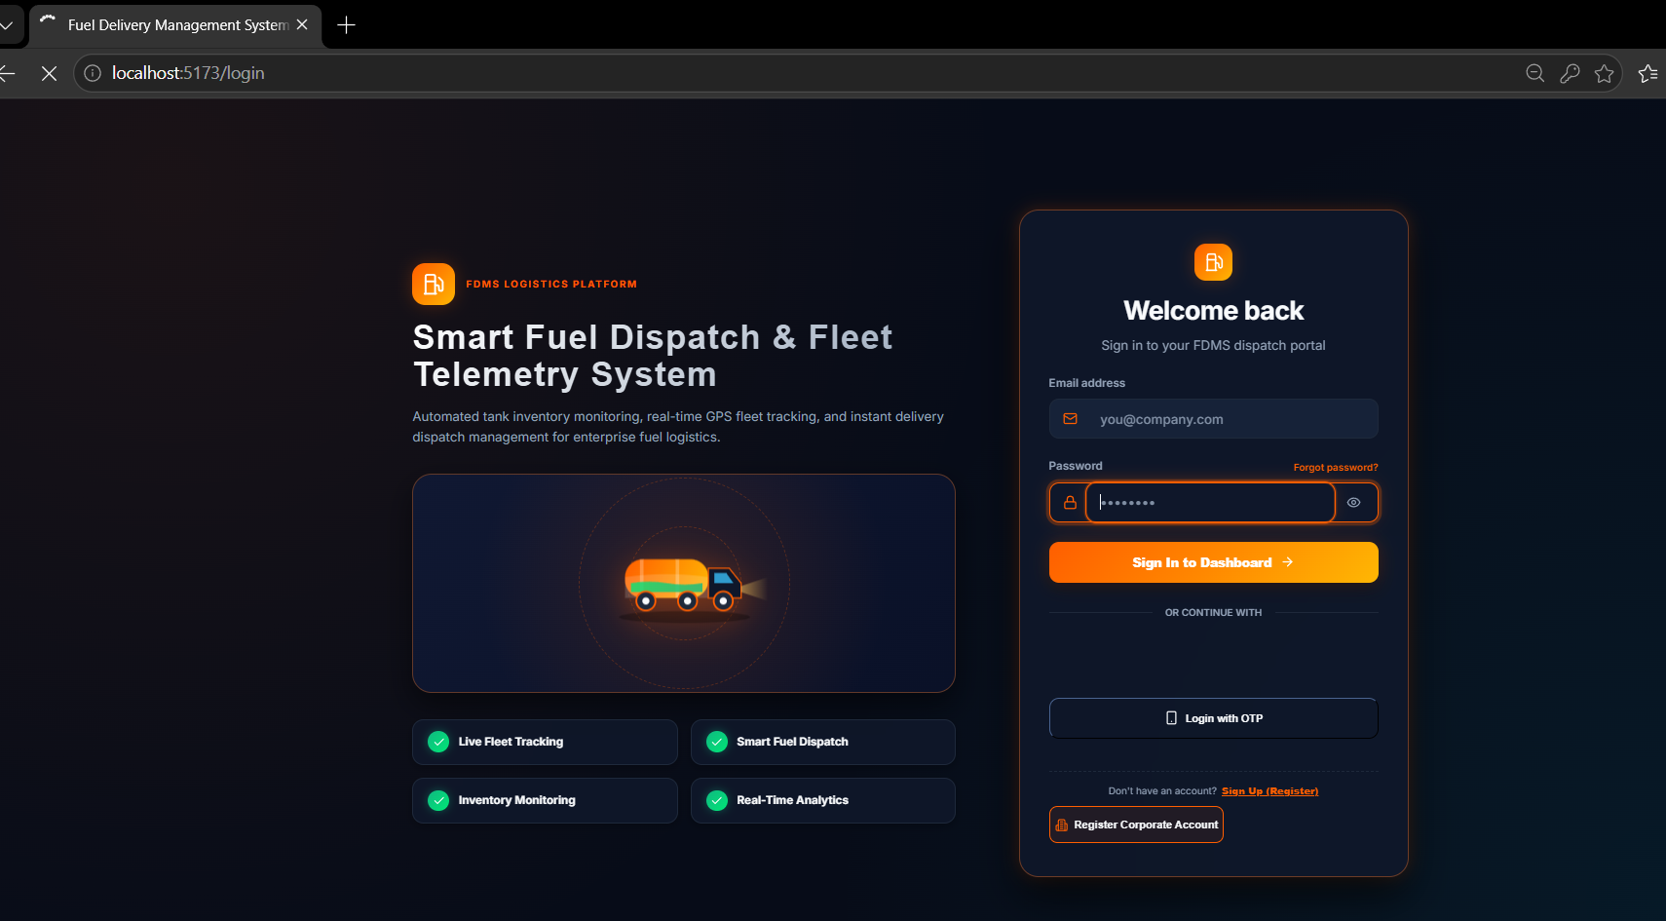
Fig 8.2.1 Login page with email and password, Google sign-in, OTP login and corporate registration
The left panel introduces the platform and its four highlights: live fleet tracking, smart fuel dispatch, inventory monitoring and real-time analytics. The right card offers email and password login, a Forgot password link, Continue with Google, Login with OTP and a Register Corporate Account button.

8.3 ORDER & DISPATCH MANAGEMENT

Purpose & Scope
This module manages the complete life of a fuel delivery order, from the customer's request to the signed delivery. It prices the order, checks and reserves depot stock, lets the Depot Manager approve or reject it, assigns a driver and a tanker, tracks the status and produces an invoice. A smart dispatch service recommends the best depot, tanker and arrival time.

Functional Requirements
- Create an order: validate fuel type, quantity (at least 1 litre) and delivery address, set city, delivery slot and notes, calculate subtotal, tax and total from the pricing data, and generate an order number in the form ORD-YYMMDD-NNN.
- Review requests: the Pending Requests page lists orders waiting for approval; the Orders page lists every order with search, filters and CSV export.
- Approve: only a Pending order can be approved. The controller checks the available stock of that fuel (current stock minus reserved stock), reserves the quantity, stores approvedAt and notifies the customer.
- Reject: a rejection reason is stored with rejectedAt. Any reservation is released and the customer is notified.
- Assign: choose a driver and a tanker for an approved order. The order becomes Assigned with assignedAt, the driver name and vehicle number are stored on the order, an activity record is written, and the driver and customer are notified.
- Advance status: Assigned → In Transit → Delivered. Delivery stores reachedAt, delivery proof and the customer signature, deducts the litres from the tank and releases the reservation.
- Cancel: an order can be cancelled and its reservation is released.
- Smart dispatch: recommend the nearest depot, the nearest available tanker, a driver and an estimated arrival time (see 8.3.9).
- Invoice and detail: OrderDetail shows the order with a status timeline, and InvoiceModal produces a Tax Invoice and Delivery Note.
- Audit and notification: every create, approve, reject, assign and delivery event writes an activity record and a notification.

Non-Functional Requirements
- Uniqueness: orderNumber is unique, so an order can always be identified.
- Valid data: the status field is an enumeration, quantity must be positive, and the schema keeps alias fields consistent.
- Stock integrity: stock is reserved when an order is approved and only deducted when it is delivered, so approved orders cannot oversell a tank.
- Traceability: lifecycle timestamps and activity logs show who changed an order and when.
- Consistency across pages: the dashboard, list and detail views read the same order data through OrdersContext.

Tech Stack
Concern | Choice | Why it fits this module
State | OrdersContext with useReducer and Axios | One order store shared by the dashboard, lists and portals
Navigation | React Router dynamic route /orders/:id | Deep links to a single order
Lifecycle | Explicit status enumeration | Prevents arbitrary status values
Pricing | FuelPricing collection | Prices and taxes are data, not constants in the interface
Distance | Haversine formula in the controller | Great-circle distance needs no external service
Events | Socket.IO and Notification model | Customers and staff see changes without refreshing

Back-of-the-Envelope Estimation
The figures below are design estimates based on stated assumptions. They are not measurements of a production deployment.
Quantity | Estimate | Basis
Orders per year | ≈ 45,000 | 150 per day × 300 working days (assumption)
Order document size | ≈ 1.2 KB | Assumption from the schema fields
Order storage per year | ≈ 54 MB | 45,000 × 1.2 KB
Average creation rate | ≈ 15 per hour | 150 orders over a 10-hour day
Peak creation rate | ≈ 45 per hour (0.0125 per second) | 30% of the day's orders in one hour (assumption)
Status-change calls | ≈ 750 per day | About five per order: approve, assign, in transit, delivered and one view
Notifications and logs | ≈ 750 each per day | About five events per order
Worked price example | ₹5,45,410 | 5,000 L of diesel at ₹92.40: subtotal ₹4,62,000 + 18% tax ₹83,160 + delivery ₹250

Low-Level Architecture
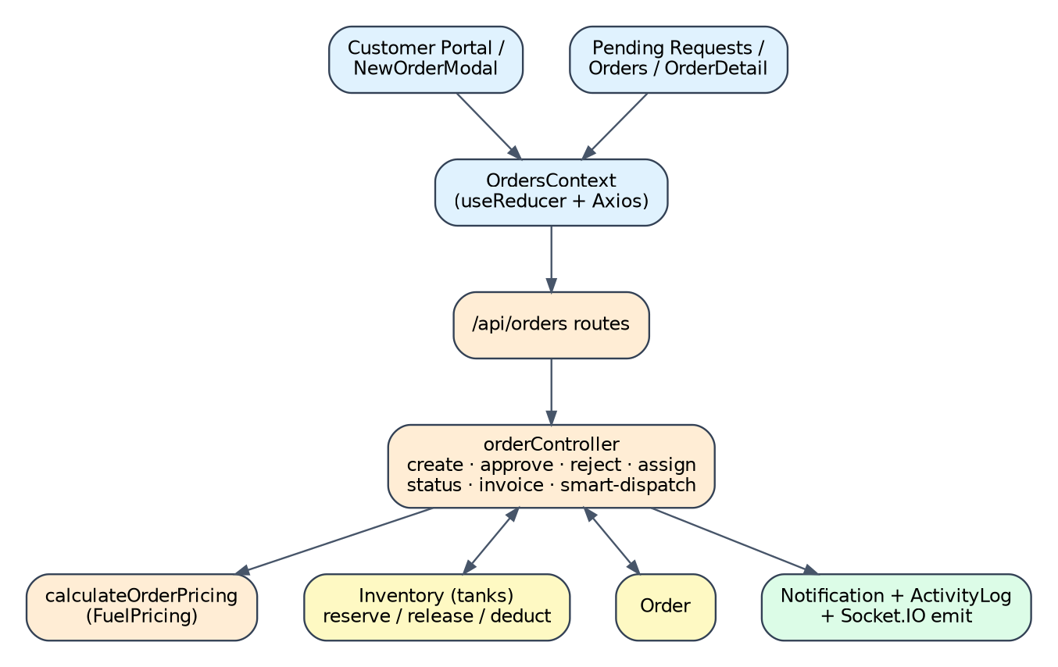
Fig 8.3.A Low-level architecture – ORDER & DISPATCH MANAGEMENT
Request flow
- Customer Portal or Pending Requests → OrdersContext → POST /api/orders → validation → price calculation → order saved → notification and activity log → Socket.IO event.
- Approval → stock check on the matching tank → quantity reserved → status Approved → customer notified.
- Dispatch Modal → smart dispatch suggestion → assign driver and tanker → status Assigned → driver notified.
- Driver Portal or manager → status update → delivery proof and signature → tank stock deducted and reservation released → status Delivered.

API Design
Method | Endpoint | Purpose / contract
POST | /api/orders | Create an order and calculate its totals
GET | /api/orders | List orders
GET | /api/orders/pending | Orders waiting for approval
GET | /api/orders/delivery-queue | Orders waiting for delivery
GET | /api/orders/:id | Read one order
PATCH | /api/orders/:id/approve | Approve and reserve stock
PATCH | /api/orders/:id/reject | Reject with a reason
PATCH / PUT | /api/orders/:id/assign | Assign driver and tanker
PATCH | /api/orders/:id/status | Advance or change the status; accepts delivery proof and signature
GET | /api/orders/:id/invoice | Data for the Tax Invoice and Delivery Note
GET | /api/orders/:id/smart-dispatch | Depot, tanker, driver and ETA recommendation
PUT / DELETE | /api/orders/:id | Update or delete an order

DB Design
Collection / Model | Keys & indexes | Key fields
Order | _id, unique orderNumber | customerId, fuelCode, quantity, status, driver, vehicle, totals, timestamps
Inventory (tanks) | _id, unique tankId | currentStock and reserved are changed by approve, reject, cancel and deliver
FuelPricing | _id, unique code | price, taxRate, deliveryCharge used in the total
Driver, Vehicle | _id | read by smart dispatch; the order itself stores the driver name and vehicle number as text

- The order total is price × quantity plus tax (default 18%) plus the delivery charge (default ₹250). If pricing records are not yet seeded, the controller falls back to default prices.
- The status enumeration has nine values: Pending, Approved, Rejected, Assigned, In Transit, InTransit, Dispatched, Delivered and Cancelled. In Transit and InTransit are the same state written two ways.

8.3.1 Screenshots

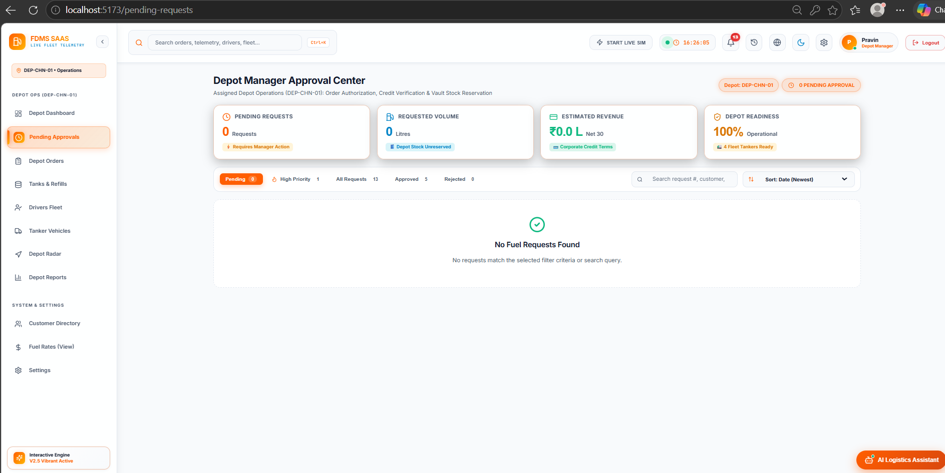
Fig 8.3.1 Depot Manager Approval Center (Pending Requests)
The page shows the number of pending requests, the requested volume, the estimated revenue and depot readiness, with filter tabs for Pending, High Priority, All, Approved and Rejected, a search box and a sort control. When no request is waiting, an empty-state message is shown.
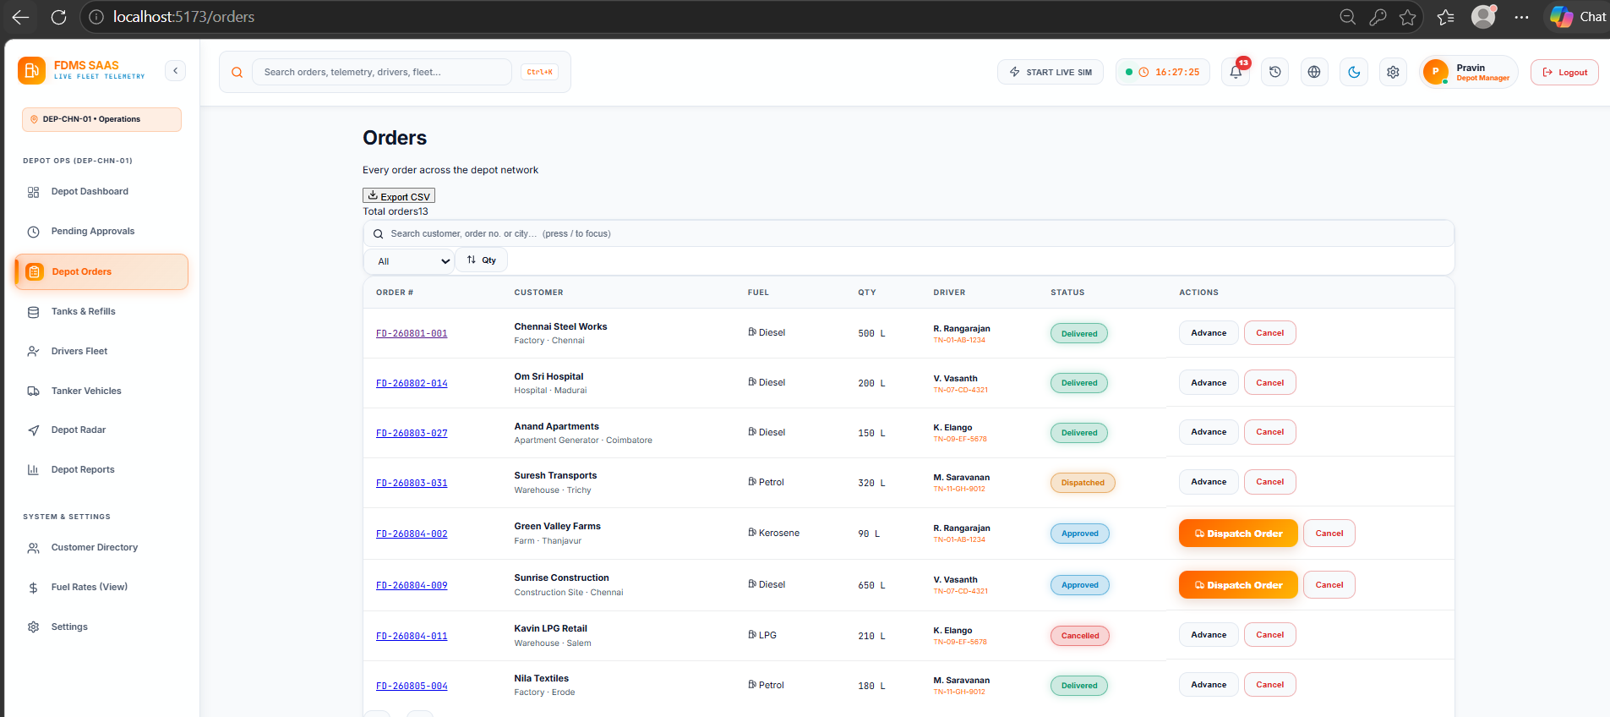
Fig 8.3.2 Orders page with search, filters, CSV export and status actions
Every order in the depot network is listed with order number, customer, fuel, quantity, driver, status and an action column. Approved orders offer Dispatch Order, and the Advance and Cancel buttons move or stop an order.

Order lifecycle
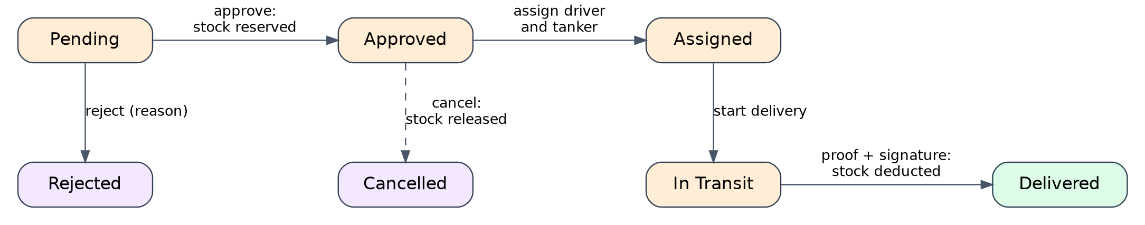
Fig 8.3.3 Order lifecycle and its effect on tank stock
An order starts as Pending. Approval reserves stock and cancellation of an approved order releases it. Rejection ends the order. An approved order is assigned, goes in transit and ends as Delivered, at which point the tank stock is reduced.

Smart dispatch
Smart dispatch is implemented in orderController.getSmartDispatchSuggestion. It works in four steps:
- Nearest depot. The delivery city is converted to coordinates from a table of nine cities. The Haversine great-circle distance is calculated to each of the five configured depots (Chennai, Salem, Madurai, Trichy and Coimbatore) and the closest is chosen.
- Nearest tanker. Among vehicles that are Available or Idle, the one closest to the chosen depot is selected.
- Driver. The driver linked to that vehicle is suggested.
- Estimated arrival. Total distance (depot to destination plus tanker to depot) is divided by an average speed of 35 km/h and 15 minutes of loading time is added. The result is never below 25 minutes.
Illustrative example. For a delivery point near Hosur (assumed coordinates 12.7409° N, 77.8253° E), the nearest depot is Salem at about 124.7 km. With a tanker 14 km from the depot the total is 138.7 km, so the time is 138.7 ÷ 35 × 60 ≈ 238 minutes plus 15 minutes of loading, an ETA of about 253 minutes. These are straight-line distances, so road times will be longer.

8.4 FLEET, DRIVER & GPS TELEMETRY

Purpose & Scope
This module maintains the driver roster and the tanker fleet and tracks where every vehicle is. Locations arrive from the Driver Portal or the API, are validated and stored as history, update the current vehicle state and are pushed to the Fleet Map in real time.

Functional Requirements
- Driver roster: register drivers with name, phone and licence number, mark them on duty or off duty, and see the orders assigned to each driver.
- Vehicle master: register tankers with a vehicle number, model and payload capacity, assign a driver, and change status between Available, In Transit and Maintenance.
- Telemetry record: store latitude, longitude, speed, heading, fuel level, tyre pressure, engine temperature, destination and ETA for a vehicle.
- Location updates: accept updates from POST /api/gps/update and POST /api/drivers/location, reject missing or out-of-range coordinates with HTTP 400, and save a time-stamped history record.
- Current state and trail: copy the latest position to the vehicle document and keep a trail of its last 1,000 points.
- Live push: broadcast every accepted update with Socket.IO so the Fleet Map moves without a refresh.
- Fleet Map: show vehicles on an OpenStreetMap map with a telemetry diagnostics panel, status filters and an SOS action.
- Driver Portal: let a driver share the browser's GPS position and update delivery progress.

Non-Functional Requirements
- Valid coordinates: latitude must be between −90 and 90 and longitude between −180 and 180, enforced by the schema and by the controller.
- Time order: location records carry a timestamp and are indexed by vehicle or driver and time, so history can be read in order.
- Separation of state and history: the current position lives on the vehicle document and the history lives in separate collections, so reading fleet state stays fast.
- Bounded growth: the embedded trail is limited to 1,000 points per vehicle. The separate history collections have no automatic expiry yet, so a retention policy is recommended.
- Responsiveness: updates are pushed to clients instead of being polled.

Tech Stack
Concern | Choice | Why it fits this module
Map | Leaflet and React Leaflet with OpenStreetMap tiles | Free tiles and a light client library; markers, circles and trails
Real time | Socket.IO events location_update and vehicle-location-update | Push updates to every open Fleet Map
Device position | Browser Geolocation API in the Driver Portal | No special hardware is needed for the demonstration
Current state | Vehicle model with GeoJSON location and a 2dsphere index | Supports geographic queries
History | VehicleLocation and DriverLocation collections | Compound indexes on id and time

Back-of-the-Envelope Estimation
Telemetry estimates are very sensitive to the sampling interval, as the 10 s and 60 s rows show.
Quantity | Estimate | Basis
Active tankers | ≈ 30 | Assumption
Update rate at a 10 s interval | 3 updates per second | 30 tankers ÷ 10 s
Records per day | ≈ 108,000 | 3 per second × 36,000 s in a 10-hour shift
Storage per day | ≈ 13 MB | 108,000 × about 120 bytes (assumption, data only)
Storage per 300-day year | ≈ 3.9 GB | 13 MB × 300; indexes add to this
Storage at a 60 s interval | ≈ 0.65 GB per year | 18,000 records per day × 120 bytes × 300; a longer interval cuts volume six times
Embedded trail per vehicle | ≈ 50 KB | 1,000 points × about 50 bytes (assumption)
Socket fan-out | ≈ 300 messages per second | 3 updates per second × 100 connected clients, because updates are broadcast to all

Low-Level Architecture
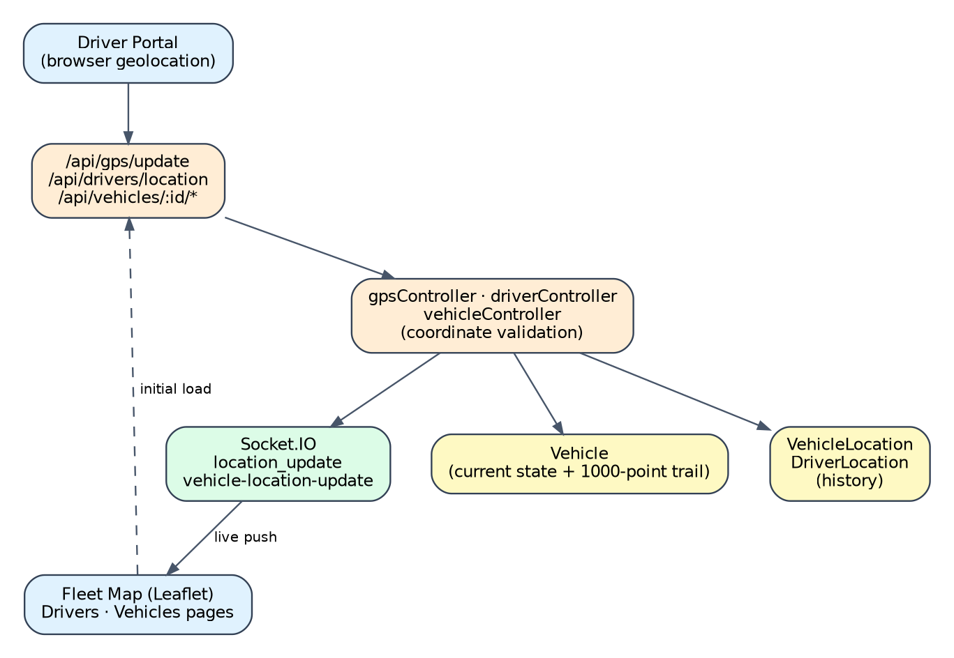
Fig 8.4.A Low-level architecture – FLEET, DRIVER & GPS TELEMETRY
Request flow
- Driver Portal reads the device position → POST /api/gps/update → coordinates validated → VehicleLocation record created → vehicle document updated and trail trimmed to 1,000 points → Socket.IO event emitted.
- Fleet Map loads the vehicle list from GET /api/gps/vehicles and then moves markers from live events.
- Driver locations are saved through POST /api/drivers/location into DriverLocation and can be read back as history.

API Design
Method | Endpoint | Purpose / contract
POST | /api/gps/update | Validate and store a vehicle location, update the vehicle and broadcast it
GET | /api/gps/vehicles | Current position and state of all vehicles
GET | /api/gps/history/:vehicleId | Stored location history of one vehicle
POST | /api/drivers/location | Store a driver's location
GET | /api/drivers/location/history | Driver location history
GET / POST | /api/drivers | List or register drivers
GET / PUT / DELETE | /api/drivers/:id | Read, update or remove a driver
GET / POST | /api/vehicles (also /api/fleet) | List or register vehicles
PATCH / PUT | /api/vehicles/:id/location | Update a vehicle's position
PATCH / PUT | /api/vehicles/:id/status | Change a vehicle's status
GET | /api/vehicles/:id/tracking | Tracking data for one vehicle
GET / PUT / DELETE | /api/vehicles/:id | Read, update or remove a vehicle
Socket.IO | join_room, join_vehicle, update_location | Client events: join a role, user or vehicle room, or send a position
Socket.IO | location_update, vehicle-location-update | Server events broadcast to connected clients

8.4.7 DB Design
Collection / Model | Keys & indexes | Key fields
Vehicle | _id, unique vehicleNumber, 2dsphere on location | latitude, longitude, speed, fuelLevel, status, locationHistory
VehicleLocation | _id, (vehicleId, timestamp desc) | latitude, longitude, speed, heading, timestamp
DriverLocation | _id, (vehicleId, timestamp), (driverId, timestamp) | latitude, longitude, speed, heading, accuracy, timestamp
Driver | _id | name, phone, vehicle, onDuty, deliveries, licenseNumber

- The history collections are append-only, so past movement is never overwritten.

8.4.1 Screenshots
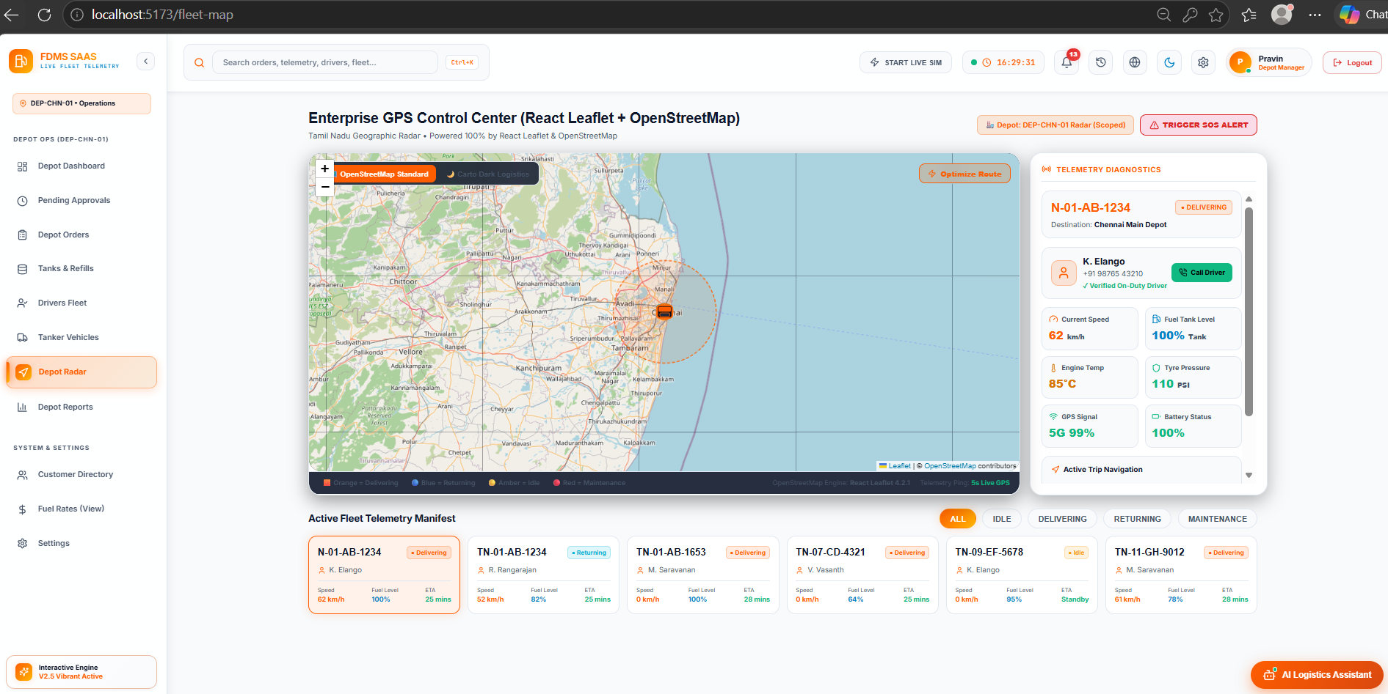
Fig 8.4.1 Fleet GPS Control Center
A Leaflet map of Tamil Nadu shows the selected tanker with a coverage circle. The side panel gives telemetry diagnostics: speed, fuel level, engine temperature, tyre pressure, GPS signal and battery. The manifest below filters vehicles by All, Idle, Delivering, Returning and Maintenance, and an SOS alert button is available.
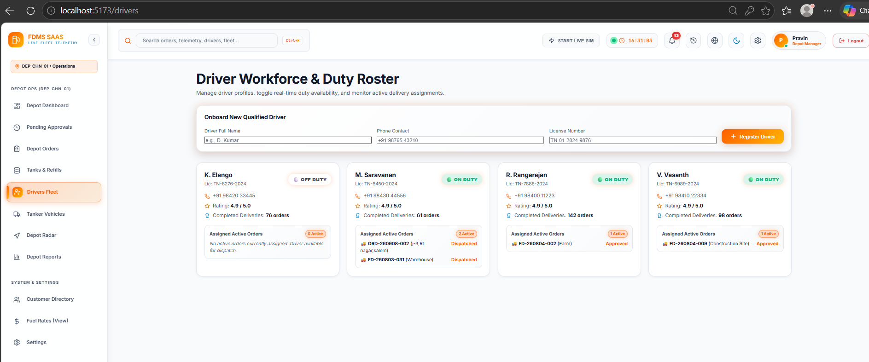
Fig 8.4.2 Driver Workforce and Duty Roster
A form onboards a driver with name, phone and licence number. Each driver card shows the licence, phone, duty state (On Duty or Off Duty), completed deliveries and the orders currently assigned.
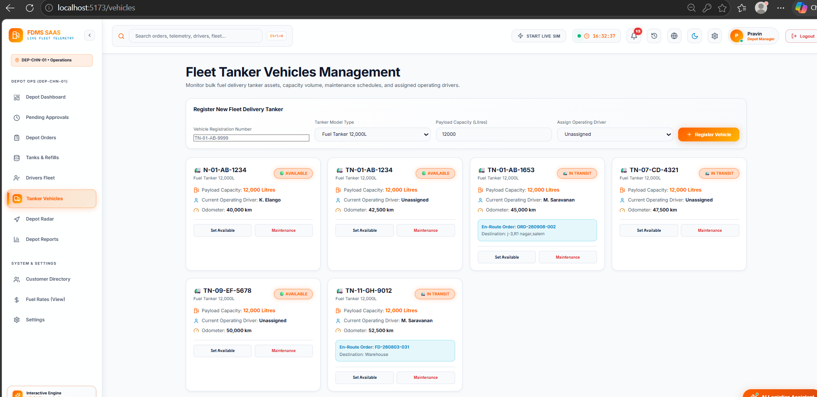
Fig 8.4.3 Fleet Tanker Vehicles Management
A form registers a tanker with a vehicle number, model, payload capacity and driver. Each vehicle card shows its status (Available or In Transit), payload, driver, odometer and the order it is carrying, with Set Available and Maintenance buttons.

8.5 INVENTORY & FUEL PRICING

Purpose & Scope
This module keeps the stock of every depot tank and the commercial values used to price orders. It shows capacity and current stock, holds reserved quantities for approved orders, raises low-stock alerts and records refills. Pricing stores the price, tax rate and delivery charge of each fuel.

Functional Requirements
- Tank view: show fuel, capacity, current stock, reserved stock, threshold, temperature, pressure and last refill for each tank, with a fill percentage.
- Low-stock alerts: a tank is in alert when its stock is at or below the minimum threshold. The alert is CRITICAL when stock is at or below half of the threshold and WARNING otherwise.
- Refill: record a refill with quantity, supplier and notes. The tank's stock increases by the quantity but never beyond its capacity, and the refill is added to the history.
- Stock check: GET /api/inventory/check-stock tells whether a quantity of a fuel can be served.
- Reservation: approving an order reserves stock, rejection or cancellation releases it, and delivery deducts it (see module 8.3).
- Pricing: list prices, update a fuel's price by code, and calculate a quote for a fuel and quantity.

Non-Functional Requirements
- Consistent stock: stock and reserved values are numbers with a minimum of zero, and available stock is always calculated as current minus reserved.
- Visible thresholds: low stock is calculated by the model, so every page shows the same condition.
- Data-driven prices: prices, tax and delivery charges are stored records and are not hard-coded in the interface.
- Traceability: every refill is stored in the tank's history with a date and status.

Tech Stack
Concern | Choice | Why it fits this module
Stock visibility | Inventory model (collection tanks) | One source of truth for tank stock
Derived values | Mongoose virtuals isLowStock, availableStock, fillPercentage | Calculated on read, never stored twice
Refill tracking | Embedded refillHistory array | History stays with its tank
Commercial values | FuelPricing model | Price, taxRate and deliveryCharge per fuel code
Client state | InventoryContext and the Inventory page | Shared tank data for the dashboard, assistant and inventory page

Back-of-the-Envelope Estimation
The figures below are design estimates based on stated assumptions. They are not measurements of a production deployment.
Quantity | Estimate | Basis
Tanks in the demonstration | 4 | Diesel, Petrol, LPG and Kerosene
Total capacity | 130,000 L | 50,000 + 40,000 + 25,000 + 15,000 litres in the demonstration data
Daily demand per depot | ≈ 24,000 L | 150 orders × 800 L average ÷ 5 depots (assumptions)
Days of cover | ≈ 5.4 days | 130,000 L ÷ 24,000 L per day
Default low-stock threshold | 5,000 L | Model default; CRITICAL at 2,500 L or less
Refill history growth | ≈ 1 record per tank per refill | A few hundred bytes each; negligible storage
Price records | 4 | DSL, PTL, LPG and KRS

Low-Level Architecture
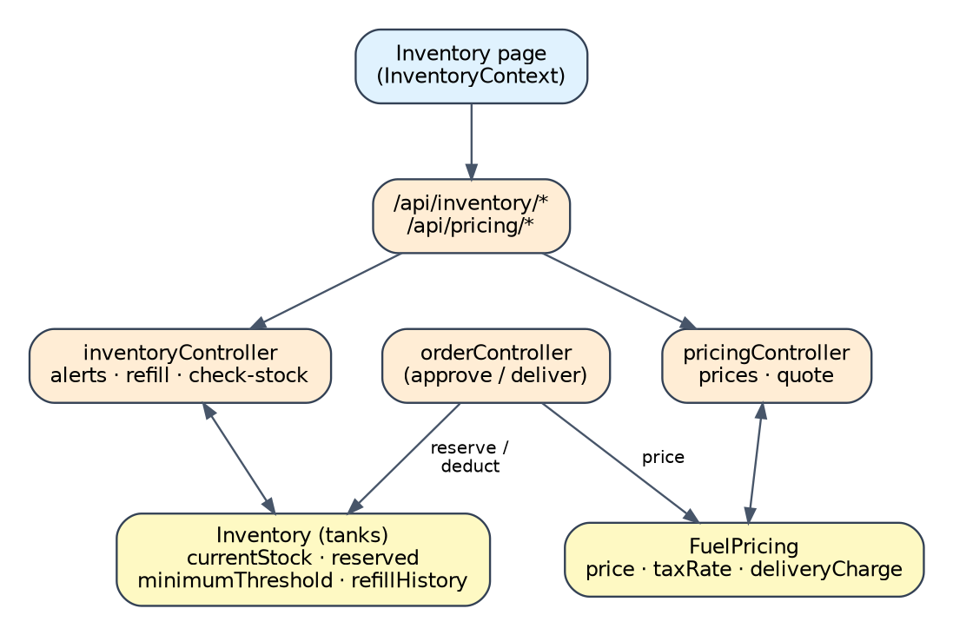
Fig 8.5.A Low-level architecture – INVENTORY & FUEL PRICING
Request flow
- Inventory page → GET /api/inventory → tank documents with virtual fields → stock cards and alerts.
- Refill → POST /api/inventory/refill → stock increased up to capacity → history record added → updated tank returned.
- Order creation → pricing lookup by fuel code → subtotal, 18% tax, delivery charge and total.
- Order approval and delivery → reserve and deduct stock in the matching tank.

API Design
Method | Endpoint | Purpose / contract
GET | /api/inventory (also /api/inventory/tanks) | List tanks
GET | /api/inventory/alerts (also /low-stock) | Tanks at or below their threshold with a severity
POST | /api/inventory/refill (also /refill-request) | Record a refill
GET | /api/inventory/refills (also /refill-history) | Refill history
GET | /api/inventory/check-stock | Check whether a quantity can be served
GET / PUT / PATCH | /api/inventory/:id (also PUT /api/inventory/tanks/:id) | Read or update a tank
GET | /api/pricing | List fuel prices
PUT | /api/pricing/:code | Update a fuel price
POST | /api/pricing/calculate | Calculate a quote

DB Design
Collection / Model | Keys & indexes | Key fields
Inventory (tanks) | _id, unique tankId | fuelCode, capacity, currentStock, reserved, minimumThreshold, refillHistory
FuelPricing | _id, unique code | price, taxRate, deliveryCharge
Order | _id | quantity and fuel code feed reservation and pricing

- The Tank model file is an alias of Inventory, so both names read the same collection.
- The depot is not stored on a tank in the current model; the demonstration uses one set of four tanks.

8.5.1 Screenshots
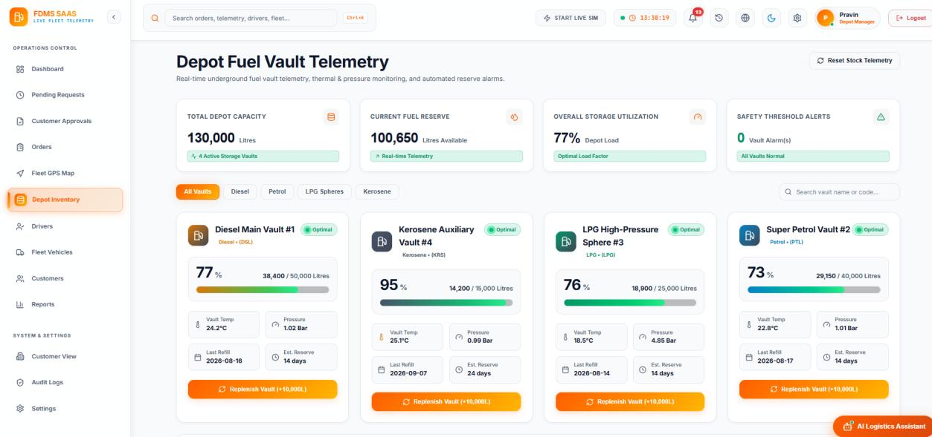
Fig 8.5.1 Depot Fuel Vault Telemetry
Summary cards show total depot capacity, current fuel reserve, overall storage utilization and safety alerts. Tabs filter by fuel. Each vault card shows fill percentage and litres, temperature, pressure, last refill date, estimated reserve in days and a Replenish Vault button.

8.6 CUSTOMER, REGISTRATION & DOCUMENT MANAGEMENT

Purpose & Scope
This module onboards corporate customers. A company submits its details and documents, a reviewer approves or rejects the application, and approval creates the customer's login. It also provides the customer list with order and revenue summaries.

Functional Requirements
- Registration: capture company name, authorized person, mobile, email, GST and PAN numbers, address, business type, designation, fuel type and monthly consumption.
- Document upload: accept PAN, GST, company registration, address proof and supporting documents as multipart files.
- Review: the Applications and Customer Registrations pages list applications by status. A reviewer can open an application, approve it or reject it with a reason.
- Approval: the controller creates a User with the Customer role and Approved status (or updates an existing user), copies the already-hashed password, records the reviewer and time, writes an activity record and notifies the customer.
- Rejection: the status becomes Rejected with the reason and time, and the customer cannot sign in.
- Customer directory: the Customers page combines users and orders to show each customer's orders, delivered litres, revenue and credit use. Admin and Depot Manager can change a customer's status or delete a customer.
- Customer Portal: an approved customer places orders and follows them from /customer-portal.

Non-Functional Requirements
- Controlled uploads: only PDF, DOC, DOCX, JPEG and PNG files up to 10 MB are accepted and each is stored with its metadata.
- Secrets stay out of the code: the database connection string and token secret are read from environment variables.
- Access to approval: customer status changes and deletion use authorize('Admin', 'Depot Manager').
- No access before approval: a Pending or Rejected customer is refused at login.

Tech Stack
Concern | Choice | Why it fits this module
Uploads | Multer middleware with a 10 MB limit and type filter | Handles multipart forms and stores files on the server
Review workflow | Registration status field and Applications pages | Separates onboarding from daily operations
Identity | Registration then User | A User exists only after approval
File serving | Express static route /uploads | Reviewers can open the submitted documents
Real time | Socket.IO event new_registration_request | Staff see a new application without refreshing

Back-of-the-Envelope Estimation
The figures below are design estimates based on stated assumptions. They are not measurements of a production deployment.
Quantity | Estimate | Basis
Registered customers | ≈ 200 | Assumption
New applications per day | ≈ 3 | Assumption
Documents per application | 5 | PAN, GST, company registration, address proof and one supporting file
Typical document size | ≈ 0.5 MB | Scanned PDF (assumption); upload limit is 10 MB
Storage per application | ≈ 2.5 MB | 5 × 0.5 MB
Storage for 200 customers | ≈ 500 MB | 200 × 2.5 MB
Worst case | ≈ 10 GB | 200 customers × 5 files × 10 MB

Low-Level Architecture
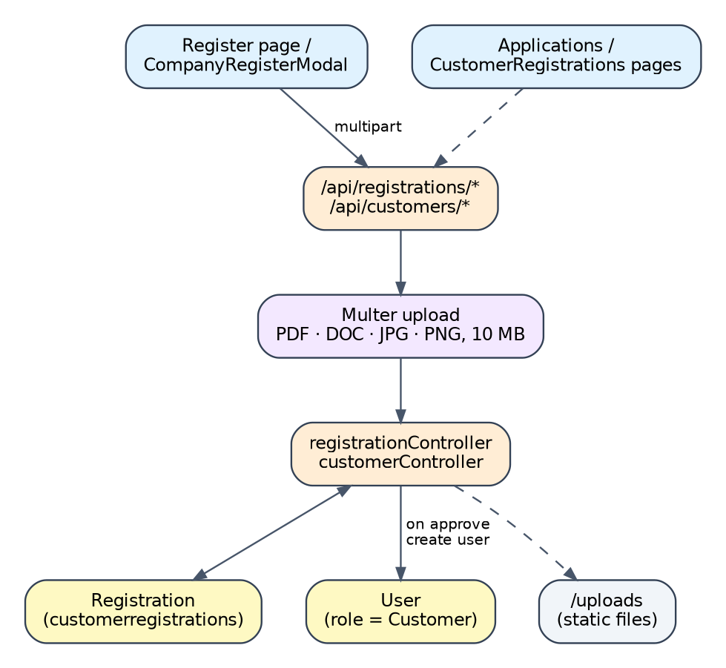
Fig 8.6.A Low-level architecture – CUSTOMER, REGISTRATION & DOCUMENT MANAGEMENT
Request flow
- Register page → multipart POST /api/registrations → Multer saves files → registration saved with status Pending → staff notified.
- Reviewer opens the application → approves → User created or updated → status Approved → customer notified.
- Customer signs in → login checks the status → Customer Portal.

API Design
Method | Endpoint | Purpose / contract
POST | /api/registrations (also /register) | Submit a registration with documents
GET | /api/registrations, /api/registrations/:id | List or read applications
PUT | /api/registrations/:id/approve | Approve and create the customer user
PUT | /api/registrations/:id/reject | Reject with a reason
PATCH / DELETE | /api/registrations/:id/status, /:id | Change status or delete
GET / POST | /api/customers, /api/customers/register | Customer directory and direct customer creation
GET | /api/customers/:id | Customer profile with order summary
PATCH / DELETE | /api/customers/:id/status, /:id | Change status or delete; Admin and Depot Manager
GET | /uploads/* | Serve uploaded documents

DB Design
Collection / Model | Keys & indexes | Key fields
Registration (customerregistrations) | _id, unique regId | company, contact, GST, PAN, address, documents, status, review fields
User | _id, unique email | role Customer and status Approved after approval
Order | _id | used to total each customer's orders and revenue

- Customer and CustomerRegistration are aliases of the Registration model.
- Uploaded files are stored on the server's disk and their paths are stored in the registration document.

8.6.1 Screenshots
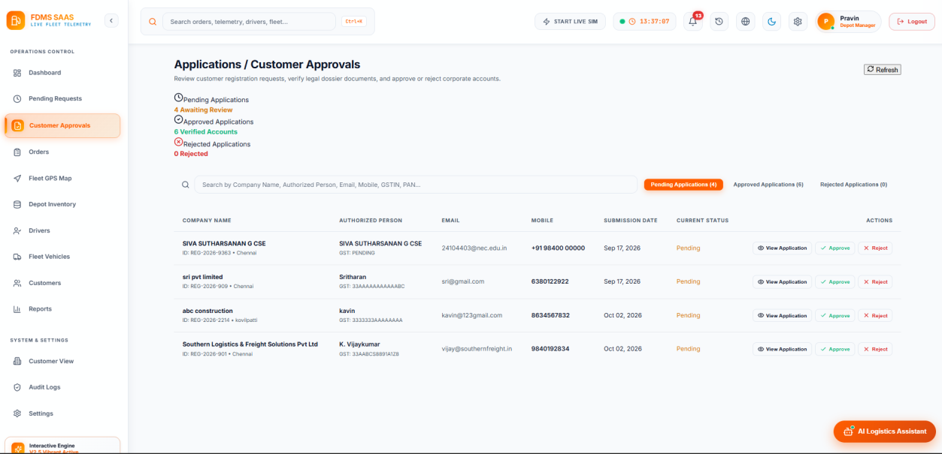
Fig 8.6.1 Applications and Customer Approvals
Counters show pending, approved and rejected applications. A table lists company, authorized person, email, mobile, submission date and status, with View Application, Approve and Reject buttons. Tabs switch between Pending, Approved and Rejected applications.
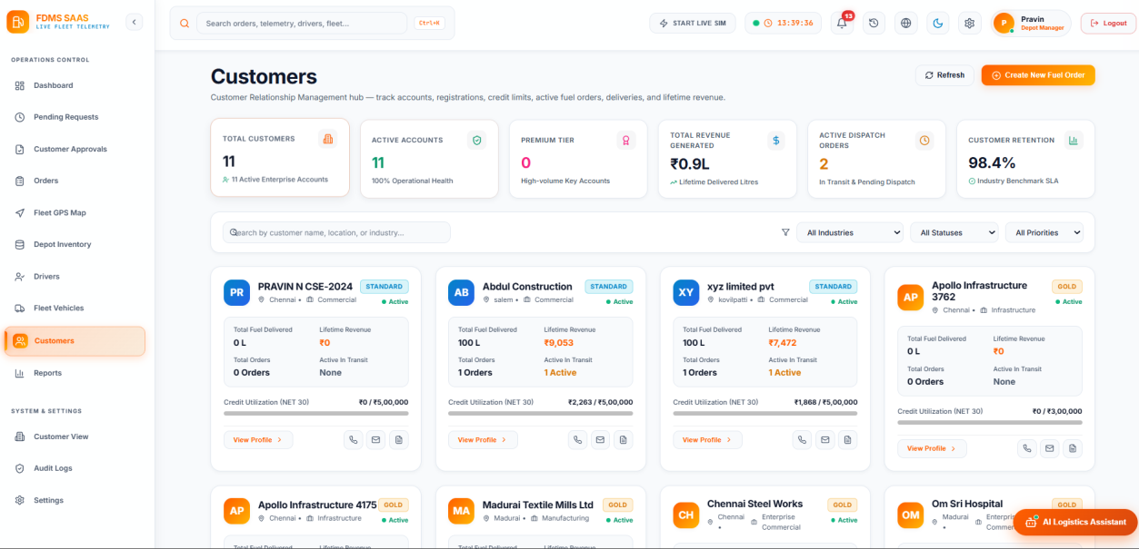
Fig 8.6.2 Customers directory
Summary cards show total customers, active accounts, premium tier accounts, revenue, active dispatch orders and retention. Filters narrow by industry, status and priority. Each card shows the customer's tier, fuel delivered, revenue, orders, credit utilization and a View Profile button.

8.7 NOTIFICATIONS, AUDIT LOGS & REPORTS

Purpose & Scope
This module informs users of events, records who did what, and summarizes the business. Notifications are targeted at a role or user and delivered in real time. The activity log keeps an audit trail. The report controller compiles customer, order, delivery and inventory summaries.

Functional Requirements
- Notifications: create notifications with title, message, category, role, type and order reference; list them for the signed-in role; mark one or all as read.
- Real-time delivery: after a notification is saved, Socket.IO pushes it to the matching role or user room.
- Audit log: record the action, user, role, entity, details, IP address and metadata for logins, orders, approvals, assignments and deliveries.
- Audit screen: search the log and filter by All, Registrations, Orders, Logistics and Security.
- Reports: executive analytics with revenue, delivered litres, success rate and cancelled value; fuel-type breakdown; top customers; and customer, order, delivery and fuel inventory reports.
- Output: filter by time range and export the report as CSV or print it to PDF.

Non-Functional Requirements
- Append-oriented audit: log entries are written once and are not edited by the application.
- Searchable audit: the log is indexed by time and by action and time, and the API returns at most 100 entries per request (50 by default).
- Access control: the activity-log route requires a valid token.
- Efficient notification updates: read state is changed with targeted updates.
- Report cost: the report controller currently loads whole collections and aggregates them in memory, which suits demonstration volumes and should move to database aggregation for large histories.

Tech Stack
Concern | Choice | Why it fits this module
User communication | Notification model and NotificationContext | Events can be targeted to a role or user and shown in a bell menu
Push | Socket.IO rooms | Delivery without polling
Traceability | ActivityLog model and logActivity helper | One call records an action from any controller
Analytics | reportController | One place for report calculations
Views | Reports and AuditLogs pages | Tabs, filters, CSV export and print

Back-of-the-Envelope Estimation
The figures below are design estimates based on stated assumptions. They are not measurements of a production deployment.
Quantity | Estimate | Basis
Audit events per day | ≈ 1,150 | 300 logins + 750 order events + about 100 others
Audit record size | ≈ 0.5 KB | Assumption
Audit storage per year | ≈ 170 MB | 1,150 × 0.5 KB × 300 days
Notifications per day | ≈ 750 | About five per order
Order data loaded by one report | ≈ 54 MB for a full year | 45,000 orders × 1.2 KB, because reports read all orders

Low-Level Architecture
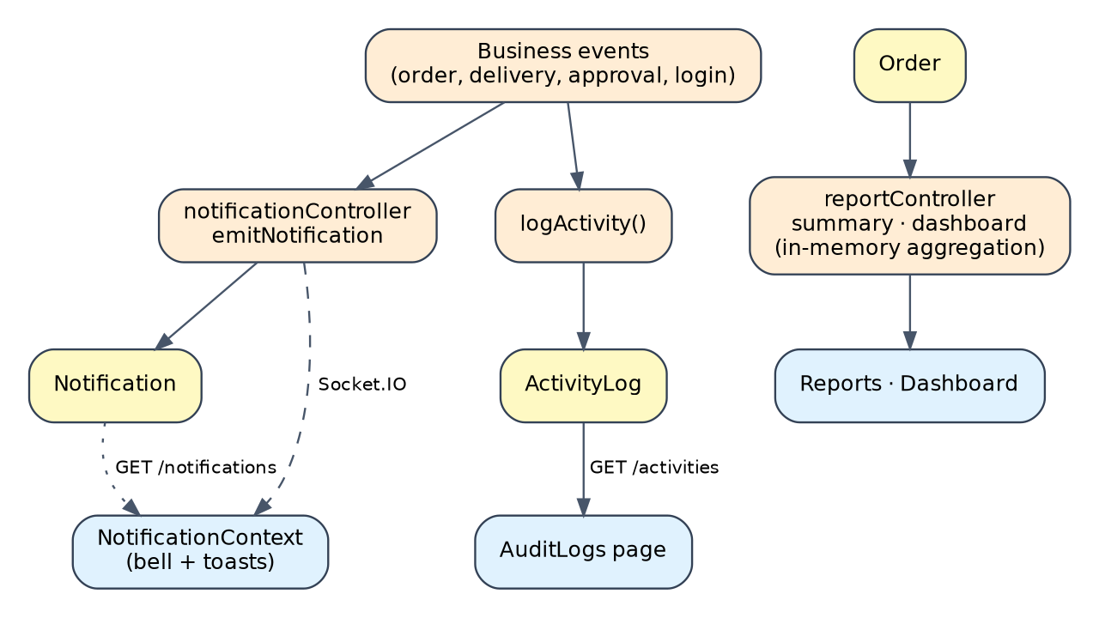
Fig 8.7.A Low-level architecture – NOTIFICATIONS, AUDIT LOGS & REPORTS
Request flow
- Business event in a controller → Notification.create and emitNotification → Socket.IO event to the role or user → NotificationContext shows it.
- The same event calls logActivity → ActivityLog record → visible on the Audit Logs page.
- Reports page → GET /api/reports → controller reads orders, customers, drivers and tanks → summaries returned to the page.

API Design
Method | Endpoint | Purpose / contract
GET / POST | /api/notifications | List notifications or create one
PATCH | /api/notifications/read-all | Mark all notifications as read
PATCH | /api/notifications/:id/read | Mark one notification as read
GET | /api/activities | Audit log with filters, search and paging (token required)
GET | /api/reports | Compiled customer, order, delivery and inventory reports
GET | /api/reports/summary, /dashboard | Summary data for the dashboard and reports

DB Design
Collection / Model | Keys & indexes | Key fields
Notification | _id, userId | title, message, category, role, type, orderId, read, readAt
ActivityLog | _id, (createdAt desc), (action, createdAt desc) | action, userId, userRole, entityId, details, ipAddress, metadata
Order | _id | status, totals, city and customer feed the reports

- Notification roles are Admin, Depot Manager, Customer, Driver and All. Support Executive and Auditor are not separate notification roles in this version.

8.7.1 Screenshots
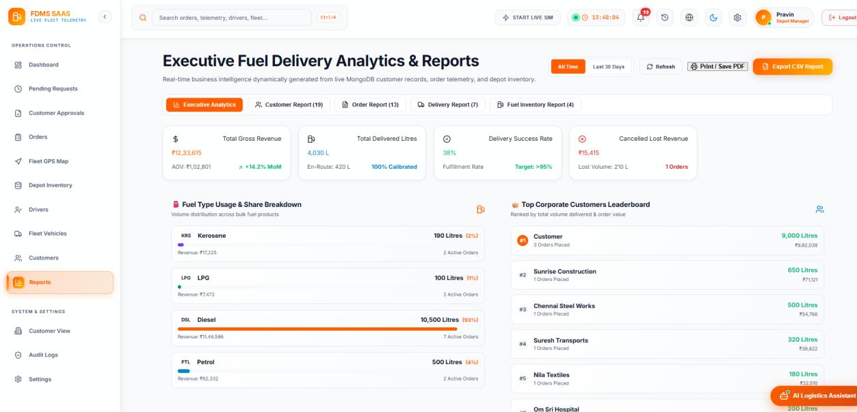
Fig 8.7.1 Executive Fuel Delivery Analytics and Reports
Tabs switch between Executive Analytics, Customer Report, Order Report, Delivery Report and Fuel Inventory Report. Cards show gross revenue, delivered litres, delivery success rate and cancelled value. Panels show fuel-type usage and the top corporate customers. Buttons offer the time range, Print / Save PDF and Export CSV.
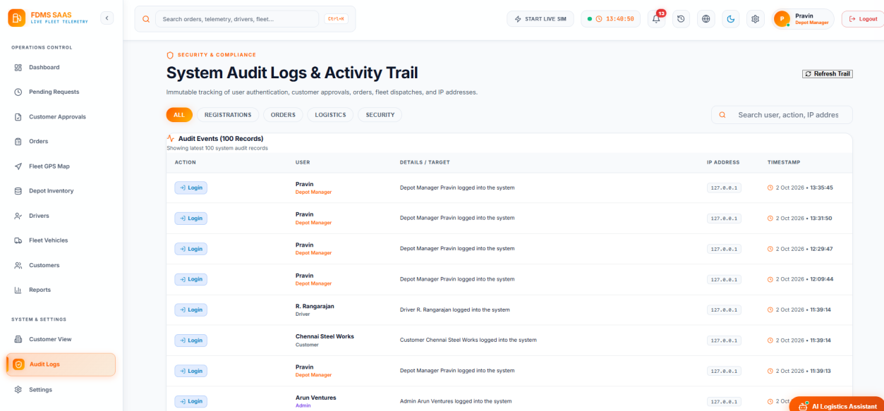
Fig 8.7.2 System Audit Logs and Activity Trail
The table lists the action, user and role, details, IP address and timestamp. Tabs filter by All, Registrations, Orders, Logistics and Security, and a search box finds users, actions or addresses.

8.8 DASHBOARD, SETTINGS, LOCALISATION & ASSISTANT

Purpose & Scope
This module gives each role an overview of the operation and lets users choose how the application looks and speaks. It includes the dashboards, the Settings page, the English, Tamil and Hindi dictionaries, the theme, and the Fuel Logistics Assistant.

Functional Requirements
- Dashboards: the Depot Manager dashboard shows reserved stock, orders, deliveries, active drivers and tankers, capacity loaded, tank telemetry, the pending request queue and the dispatch queue. The Admin dashboard shows customers, drivers, vehicles, orders today, revenue, application counts, a revenue and volume trend and the fuel-type distribution.
- Settings: show the profile, change the password, choose the theme and language, set notification preferences and clear locally stored data.
- Localisation: translate interface text into English, Tamil and Hindi without changing each page.
- Recently accessed: remember recently opened orders, customers, vehicles and reports.
- Assistant: a floating chat widget answers questions about order tracking, delivery status, inventory, low-stock alerts, fleet status, pending approvals, invoices and fuel quality, using live data from the orders and inventory contexts. Managers and customers see different quick actions.
- Demonstration mode: an optional live simulation advances an active order about every 12 seconds so that dashboards can be shown without real traffic.

Non-Functional Requirements
- Responsive calculations: derived metrics use useMemo and are recomputed only when their data changes.
- Stable handlers: shared event functions use useCallback.
- Light preferences: theme, language and notification settings are stored in the browser and need no server transaction.
- Honest scope: the assistant is rule-based keyword matching, not a language model.

Tech Stack
Concern | Choice | Why it fits this module
Derived metrics | useMemo | Avoids recalculating on every render
Preferences | ThemeContext, LanguageContext, SettingsContext with localStorage | Settings survive a page reload
Localisation | translations.js dictionaries for en, ta and hi | Language changes without editing the pages
Assistant | FuelLogisticsAssistant component with keyword rules | Works offline from live context data, no external service
Demonstration | SimulationContext | Predictable demonstration data

Back-of-the-Envelope Estimation
The figures below are design estimates based on stated assumptions. They are not measurements of a production deployment.
Quantity | Estimate | Basis
Languages | 3 | English, Tamil, Hindi
Browser storage quota | ≈ 5 MB | Typical local storage limit per site
Cached orders | ≈ 0.6 MB | About 500 orders × 1.2 KB (assumption)
Assistant intents | 8 | Track order, delivery status, inventory, low stock, fleet, approvals, invoices, fuel quality
Simulation step | 12 seconds | Interval at which an active order advances in demonstration mode

Low-Level Architecture
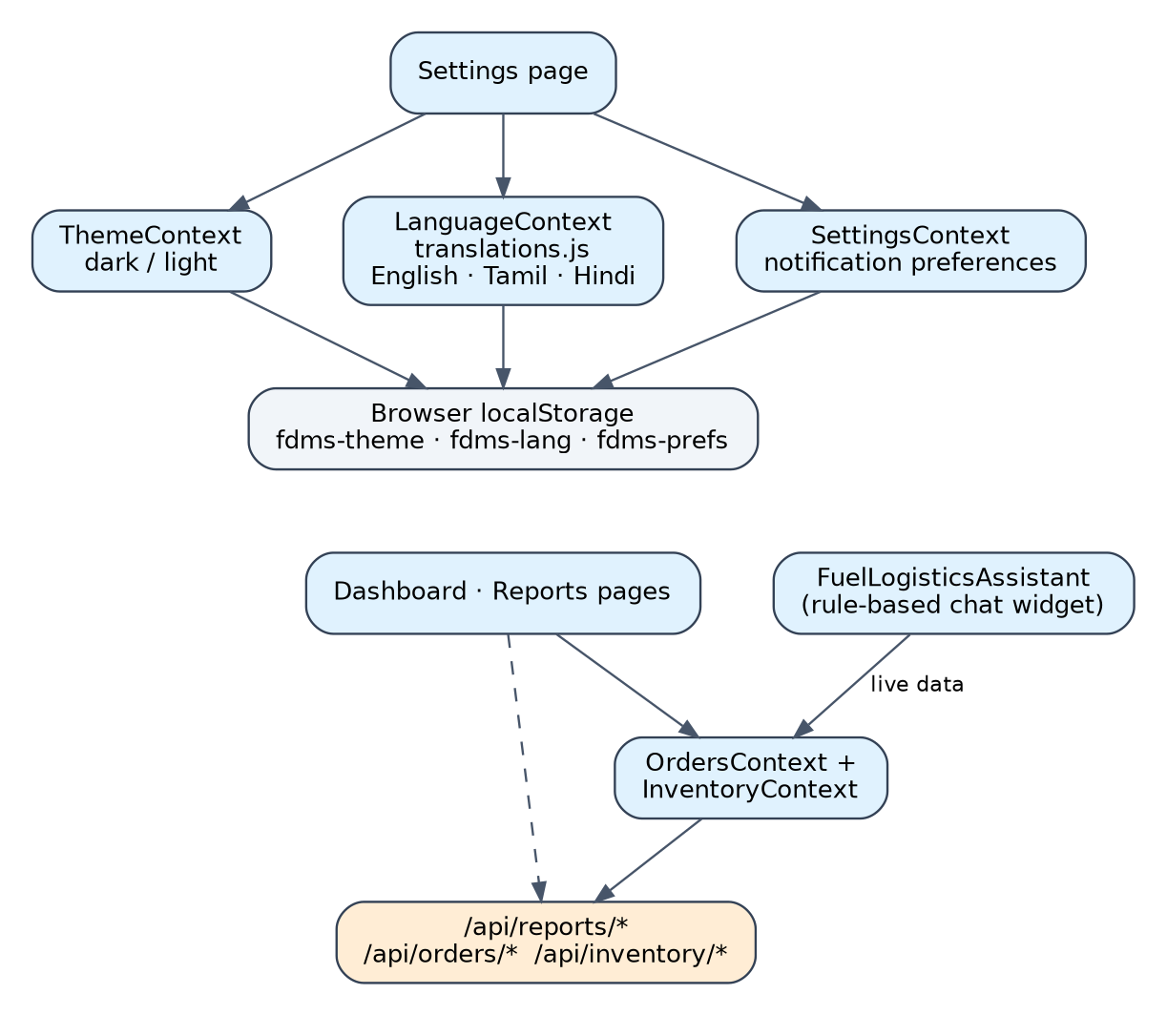
Fig 8.8.A Low-level architecture – DASHBOARD, SETTINGS, LOCALISATION & ASSISTANT
Request flow
- Settings change → context state → localStorage → theme, language and notification behaviour update.
- Dashboard → OrdersContext and InventoryContext → derived cards and charts.
- Assistant message → keyword match → answer built from the same context data.

API Design
Method | Endpoint | Purpose / contract
GET | /api/reports/* | Supply analytics to the reports and dashboards
GET | /api/orders/* | Supply order metrics
GET | /api/inventory/* | Supply stock metrics
GET | /api/gps/*, /api/fleet/* | Supply fleet visibility

DB Design
Collection / Model | Keys & indexes | Key fields
Order | _id | status, totals, city, quantity
Inventory (tanks) | _id | currentStock, minimumThreshold
Browser localStorage | keys such as fdms-theme, fdms-lang, fdms-orders, fdms-depot-tanks | preferences and cached data; not stored in MongoDB

8.8.1Screenshots
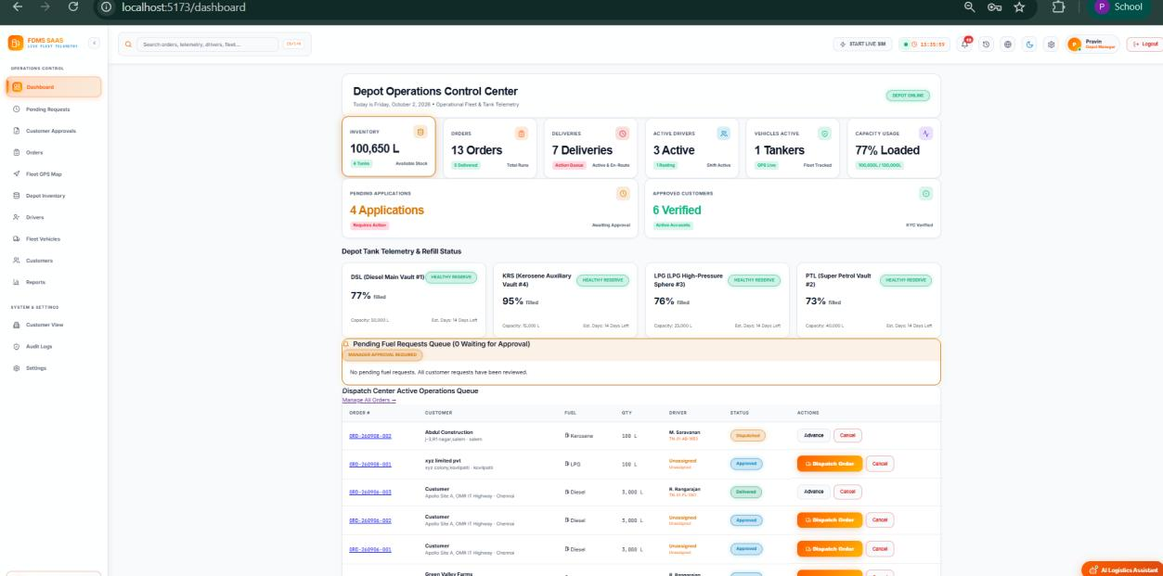
Fig 8.8.1 Depot Operations Control Center (Depot Manager dashboard)
Cards show reserved fuel, orders, deliveries, active drivers, tankers and capacity loaded, followed by pending and approved application counts. Tank telemetry cards show the fill level of each fuel. A pending fuel requests queue and the dispatch center operations queue list the orders to act on.
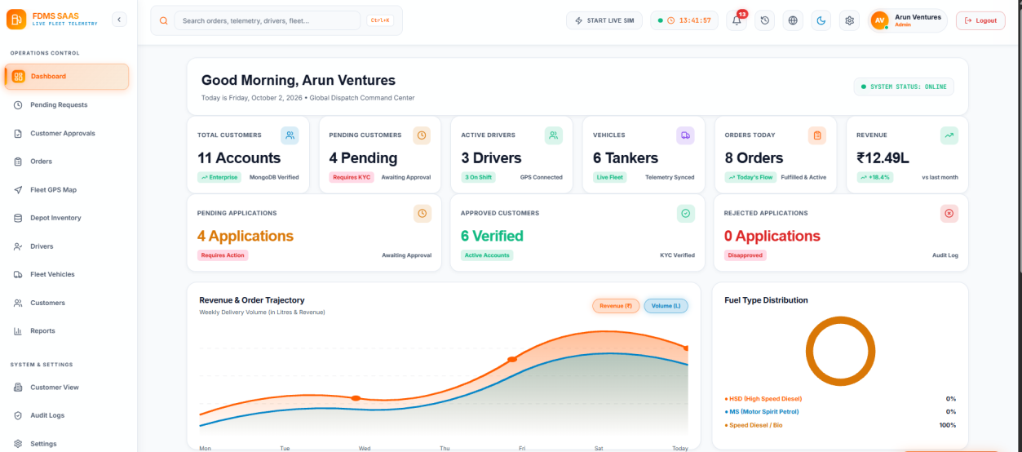
Fig 8.8.2 Admin dashboard
Cards show total customers, pending customers, active drivers, vehicles, orders today and revenue. Application counters, a revenue and volume trend chart and the fuel-type distribution complete the view.
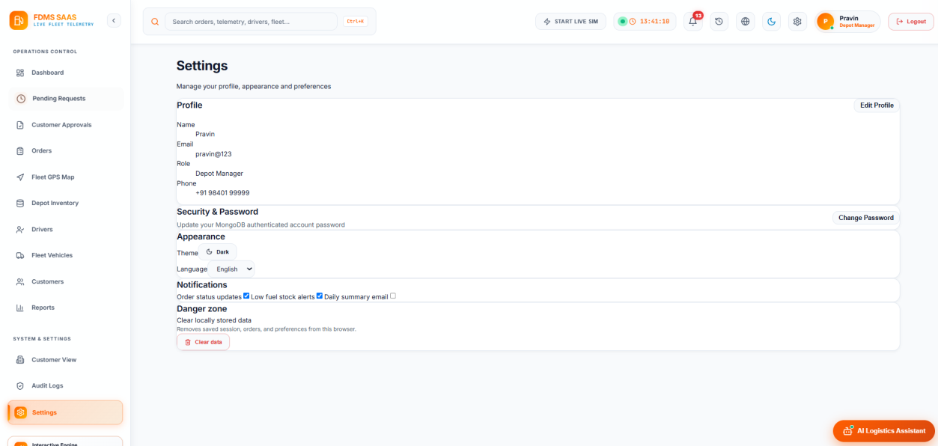
Fig 8.8.3 Settings page
The page shows the profile, password change, appearance (theme and language), notification preferences and a danger zone for clearing locally stored data.

8.9 DEPLOYMENT, CI/CD & TESTING

Purpose & Scope
This module covers how the application is built, deployed and checked. A Jenkins pipeline builds the frontend, a Vercel configuration describes the two deployed services, a seeder fills the database with demonstration data, and a set of Node.js scripts exercises the main flows.

Functional Requirements
- Jenkins pipeline: four stages run on a Windows agent: checkout of the source, installation of dependencies, production build with Vite, and deployment of the build output to a Jenkins-hosted folder.
- Vercel configuration: vercel.json declares the Vite frontend and the Express backend as two services and routes /api requests to the backend.
- Database connection on demand: the API router reconnects to MongoDB if the connection is not ready, which suits serverless cold starts.
- Seeding: seeder.js inserts demonstration users, prices, tanks, drivers, vehicles, orders, registrations and notifications (data:import) and removes them (data:destroy).
- Health check: GET /api/health returns the service status.
- Test scripts: nine Node.js scripts cover the end-to-end order flow, the approval workflow, role-based access, Google and OTP sign-in, the driver-location flow, the support role, and general API checks.

Non-Functional Requirements
- Repeatable builds: the same pipeline builds the application on every run.
- Configuration outside code: connection strings, token secrets and the Google client identifier are supplied as environment variables.
- Honest testing scope: the scripts are run by hand against a running server; the backend test script is a placeholder and there is no automated test framework yet.
- Stateless API: the Express service keeps no session state, so it can run on serverless or container hosting.

Tech Stack
Concern | Choice | Why it fits this module
CI/CD | Jenkins declarative pipeline | Visible stages and a repeatable build
Frontend build | Vite production build | Fast, optimized static output
Hosting configuration | Vercel | Frontend and backend described in one file
Demonstration data | seeder.js | Reproducible data for reviews and demos
Testing | Node.js scripts using HTTP calls | Quick checks of the main flows

Back-of-the-Envelope Estimation
This module is about process rather than load, so the table lists counts taken from the project.
Quantity | Estimate | Basis
Pipeline stages | 4 | Checkout, install, build, deploy
Test scripts | 9 | Files named test_*.js in the backend
Seed helpers | 3 | seeder.js, seed_phones.js, seed_support_user.js
Roles seeded | 6 | One or more demonstration users per role

Low-Level Architecture
Fig 8.9.A Low-level architecture – DEPLOYMENT, CI/CD & TESTING
Request flow
- Developer pushes code → Jenkins checks out the repository → installs dependencies → builds the frontend → publishes the build output.
- Vercel builds the frontend service and runs the Express service, with /api routed to the backend.
- A tester runs seeder.js and then the test_*.js scripts against the running API.

API Design
Method | Endpoint | Purpose / contract
GET | /api/health | Check service health
GET | /api | List API route groups

DB Design
Collection / Model | Keys & indexes | Key fields
All collections | as defined in Chapter 5 | No new collection; the seeder fills the existing ones with demonstration records

Screenshots
This module has no user-interface screens. Its output is the build pipeline, the deployment configuration and the test scripts described above.
CHAPTER 9

CONCLUSION
The Smart Fuel Dispatch & Fleet Telemetry System brings customer onboarding, ordering, approval, dispatch, live tracking, inventory, pricing, notifications, auditing and reporting into one full-stack web application. Its layered design, with a React client, an Express API and MongoDB storage, keeps each responsibility in its own module. The completed project meets the academic objective of demonstrating a practical modern web technology solution for fuel dispatch and fleet visibility.

Key outcomes
- A role-aware interface for six roles, with Google and OTP sign-in and a corporate registration and approval workflow.
- A full order lifecycle with automatic pricing, stock reservation, delivery proof and invoices.
- Smart dispatch that recommends the nearest depot, tanker and arrival time using the Haversine formula.
- Live GPS tracking through REST and Socket.IO, with history stored separately from the current vehicle state.
- Inventory monitoring with low-stock alerts, notifications and an audit trail.
- A multilingual interface, dashboards, reports, a rule-based assistant, a Jenkins pipeline and test scripts.

Current limitations
- Route-level authorization is partial. protect and authorize are applied to profile, password, user listing, customer status and deletion, and activity-log routes. Order, inventory, pricing, driver, vehicle, registration, report, notification and GPS routes should also require a token and a role.
- Administrator and Depot Manager responsibilities overlap. The next step is to separate platform governance (users, pricing, customer approval, audit) from daily depot operations (orders, dispatch, inventory, fleet).
- Hardening is incomplete. Cross-origin access is open, there is no rate limiting or security-header middleware, and the self-registration endpoint should not accept a role from the client.
- OTP codes are not sent by SMS, and are generated with a general-purpose random function. A gateway and a cryptographic generator are needed for production.
- Distances are straight-line values, and reports load whole collections into memory, while location history has no retention policy.
- Uploaded documents are stored on the server's disk, which is not suitable for serverless hosting.
- Tests are manual scripts rather than an automated suite.

Future enhancements
The modular architecture allows these improvements without a redesign: role-based access on every route, road-network routing and traffic-aware ETAs, SMS and e-mail delivery, cloud storage for documents, database aggregation and retention rules for telemetry, a depot field on tanks, drivers and vehicles, a language-model assistant, payment integration and automated tests in the Jenkins pipeline.

