- Home – advanced flood Risk Management Solution Replace with - Flood Risk Assessment Consultants
Add this tag line - HYDRisk is a leading global consultant in flood risk assessment and hydraulic solutions. From solar PV plants to industrial, commercial, and residential projects, we help you stay resilient, compliant, and future-ready.
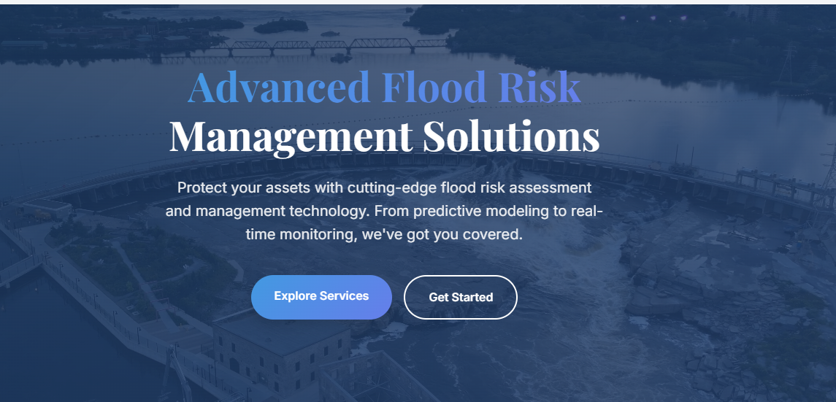

- Home Page- About Hydrisk
Remove following information and Add the following information

Add this points in pervious manners.
✅ Global Expertise – Leading consultancy in flood risk assessment and hydraulic solutions.
✅ Comprehensive Services – From solar PV plants to industrial, commercial, and residential projects worldwide.
✅ Science-Driven Approach – Built on strong foundations of hydrology, engineering, and technology.
✅ Actionable Insights – Delivering accurate, reliable, and practical solutions for flood challenges.
✅ Resilience & Sustainability – Helping clients adapt to climate change and safeguard their assets.

Add this image Also (folder) – HEC-RAS > 4_HEC_RAS_Flood_About_US

- Home – page - Add the all the service on the home pages – Few services are missing.
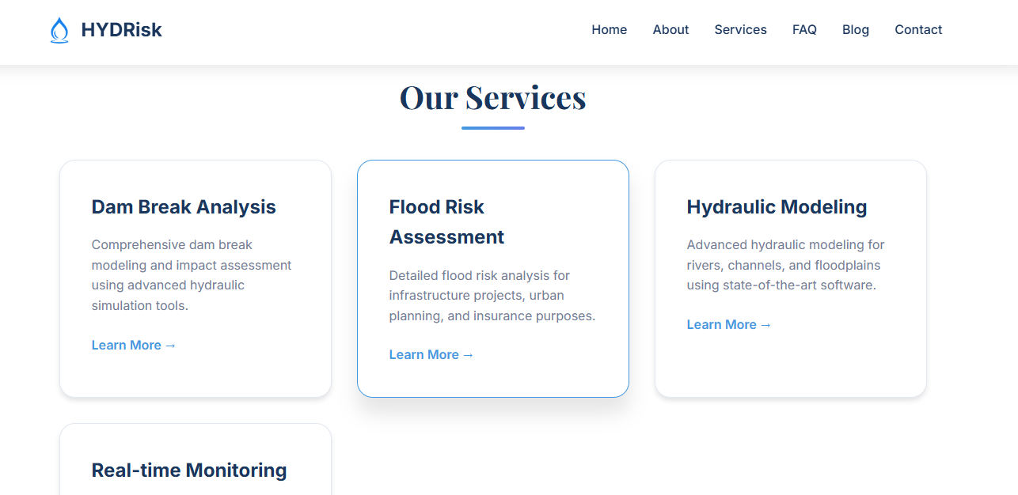
Add this services with following details above in same manners.
1. Flood Risk Assessments
Global expertise in evaluating flood risks for solar PV plants, industries, commercial, and residential sites.
2. Hydraulic Modelling
Using advanced computer simulations, we accurately predict how water will flow during a flood, helping you plan effectively.
3. Dam Break & River Flood Modelling
Predict and prepare for the worst-case scenarios with accurate dam breach and river flood simulations.

4. Climate Risk Flood Analysis
We assess how future climate change scenarios will impact your flood risk, helping you build resilience for the long term.

5. Drainage Strategies –
We provide tailored mitigation solutions and safe water passage systems for solar PV plants, industrial, commercial, and residential developments.
6. Levelling and Grading
We shape the land to ensure proper water flow and a stable foundation for your development, reducing future flood vulnerabilities.

- Below services add the details of - What we do? (pdf)
- What We Do
- Our Expertise
- What Projects Can We Help With?
- Why Undertake a Flood Risk Assessment at Your Solar PV / Property / Industry?
- Who We Work With
- Why Choose Us?

- Services –

List of services should see there.



- Services –
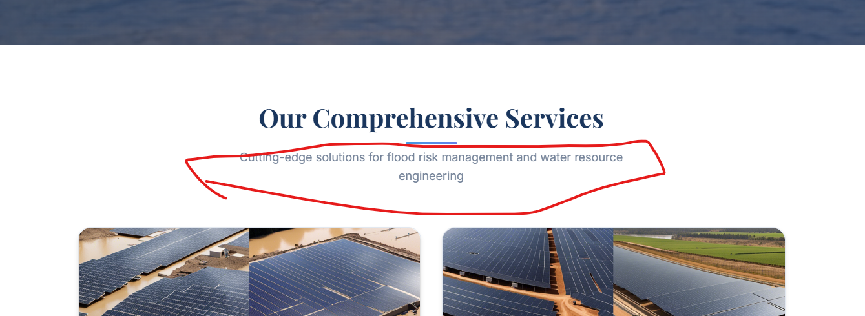

Add this - HYDRisk specializes in comprehensive flood risk assessment and hydraulic solutions for solar PV plants, industrial, commercial, and residential developments worldwide. Our services ensure your projects are resilient, compliant, and sustainable in the face of increasing flood risks.

- Service >Add Service> Flood Risk assessment Solar PV Pant

1.1. Flood Risk Assessments for Solar PV Plants Global - Flooding can severely impact the performance and safety of solar PV installations. Our global service provides location-specific flood risk analysis to guide placement, design, and mitigation strategies for solar farms.
What it is: Solar PV plants often cover large areas, making them susceptible to widespread flood damage. Our assessments for solar plants specifically analyze the unique vulnerabilities of these installations, such as panel submergence, foundation erosion, and damage to electrical infrastructure. We use advanced mapping and hydrological data to pinpoint areas at risk and recommend protective measures.
Why it matters:
- Protecting Investment: Solar PV plants are significant investments. An FRA helps safeguard against costly flood damage to panels, inverters, and supporting structures.
- Operational Continuity: Minimizes downtime and ensures the continuous generation of power, which is critical for revenue and energy supply.
- Compliance: Ensures the plant meets regulatory requirements for flood risk management.
We Offer:
- Site-specific flood zone analysis
- Rainfall-runoff modeling
- Historical flood data integration
- Worst case scenario Analysis (RP -200, RP- 100, .. RP-2)
- Risk mapping & mitigation recommendations
- Post flood modelling with adapted Mitigation
Image Suggestion: An aerial view of a solar farm with an overlay showing potential flood zones or water flow paths.

- Services> FRA
Service process Icon design should be same. It should be like you have shown on the DAM break analysis.
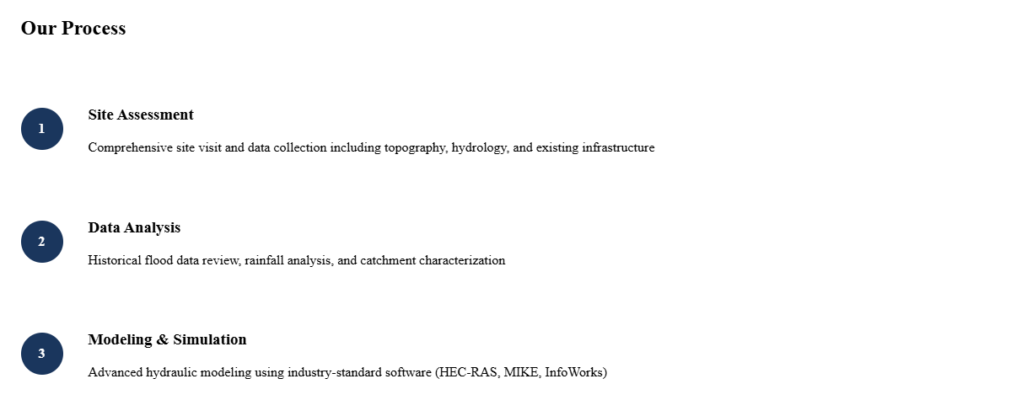

- Services > Hydraulic Modeling Use the same color and font marked in red color box
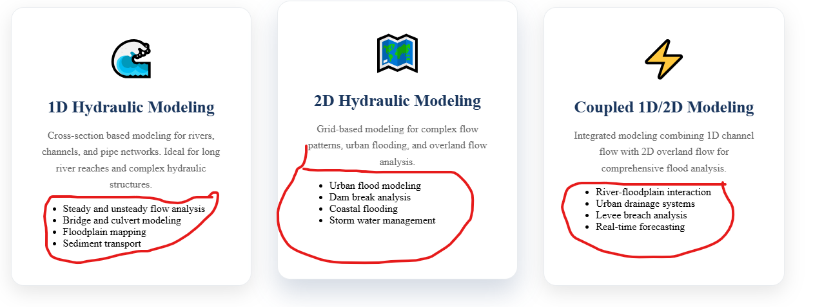
- About Us – Add following contains after Goal
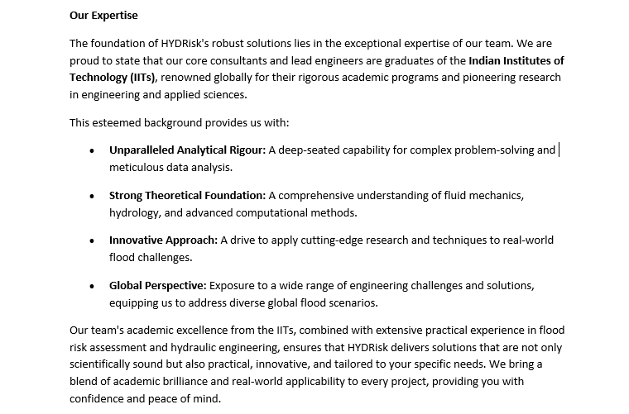

- Photos – Add the photos as per service/
Climate change – satellite image in background in place required
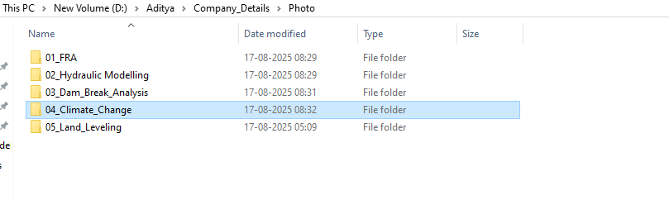

Address –
HYDRisk Solutions
Level 5, Tower B, Cybercity,
Magarpatta City, Hadapsar,
Pune – 411013, Maharashtra, India
Contact - +91-9156882405
Email: info@hydrisk.com
Support@hydrisk.com
Temp- hydrisk@hotmail.com

