Cover In Assignment

|  |  |  |
| --- | --- | --- |
| **Sr.No.** | **Topic Cover** | **Name** |
| 1 | API Project | ShopBridgeAPI |
| 2 | Web Project | ShopBridgeWeb2 |
| 3 | DataBase | ShopBridge |
| 4 | Unit Test 4 Pass 1 Failed Test Case (MS Unit Testing) | ShopBridgeBussinessTests |
| 5 | Text Error Log (Both API & Web) |  |

1. API Project
   1. Controller

* Masters:
  + GetInventoryDetails
* Transactions:
  + PostInventoryDetails

1. Web Project
   1. Page Name: Inventor

**Master data Load Inventory Details**

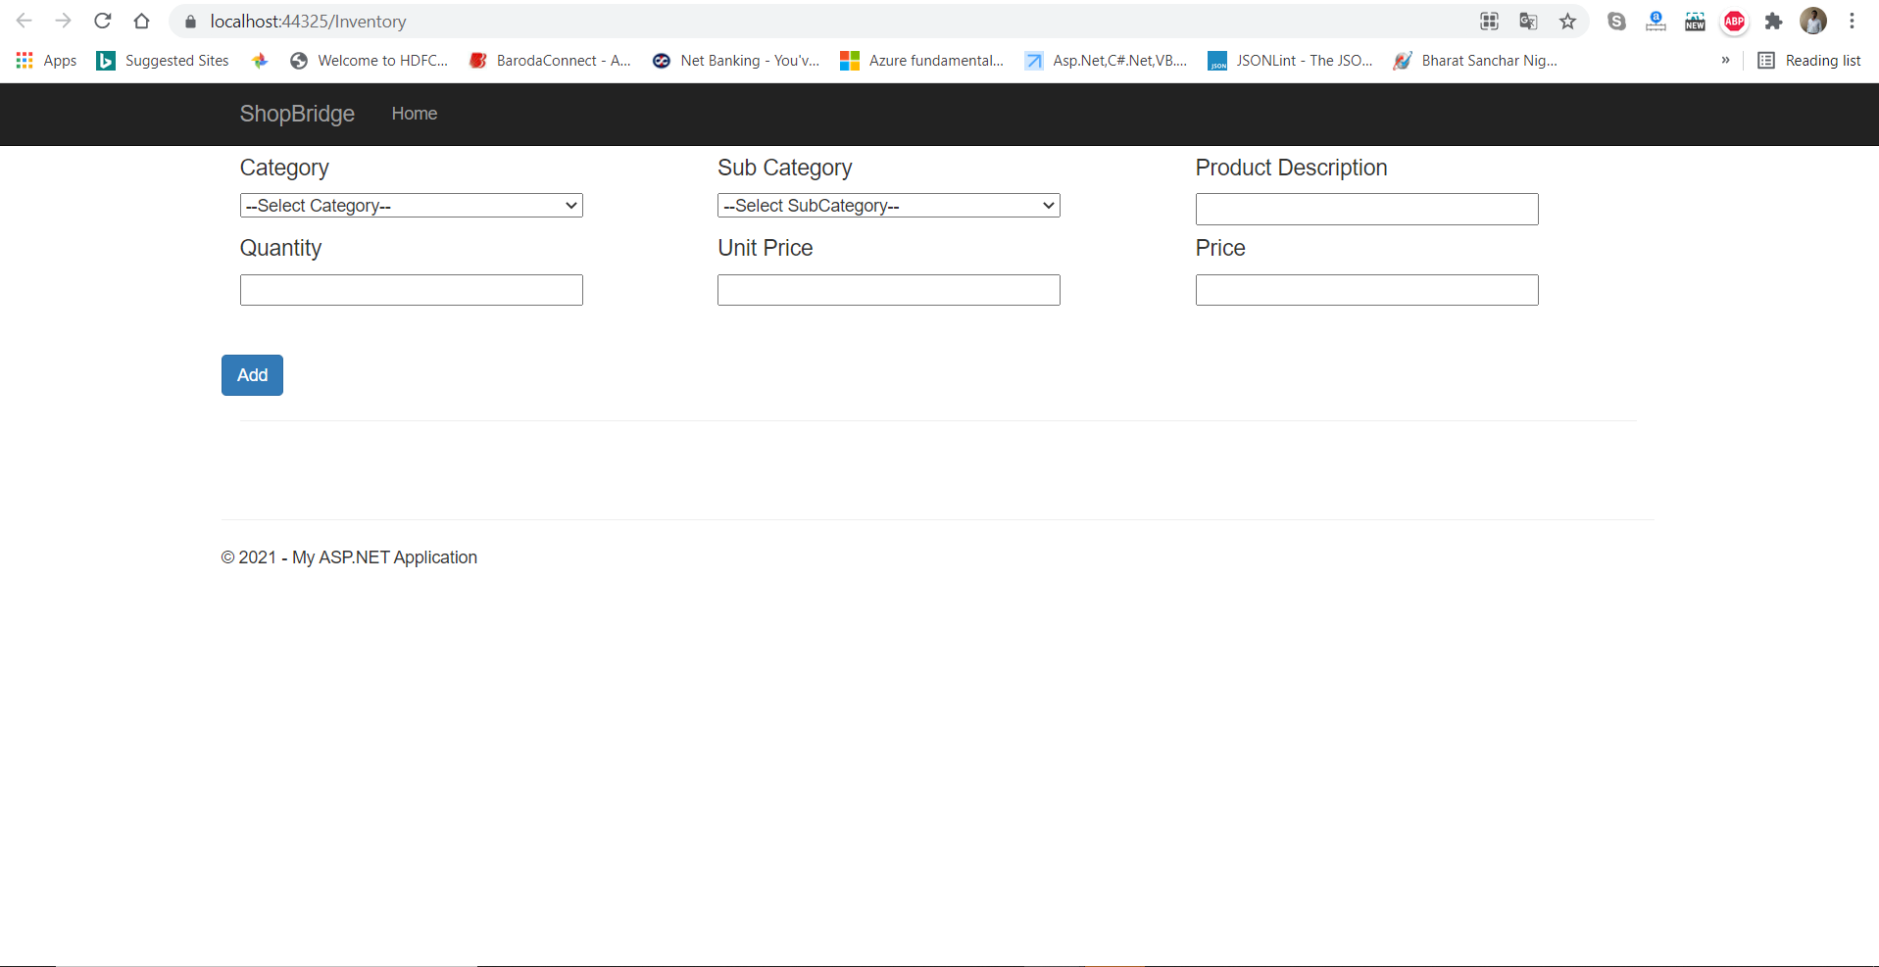

**Add Inventory Details**

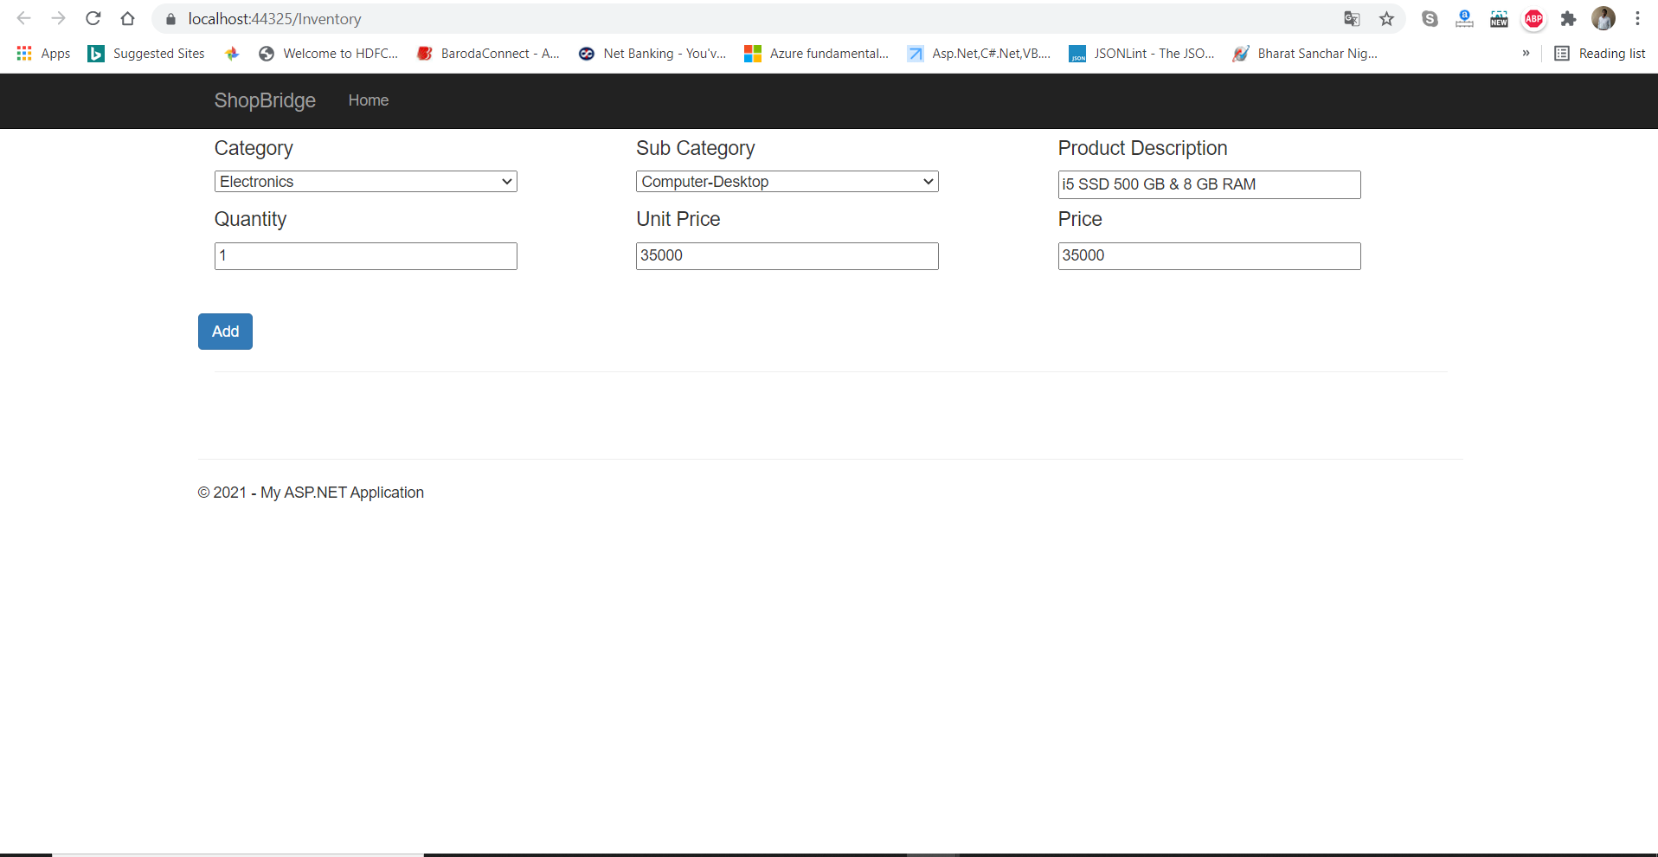

**Submit Inventory Details Message**

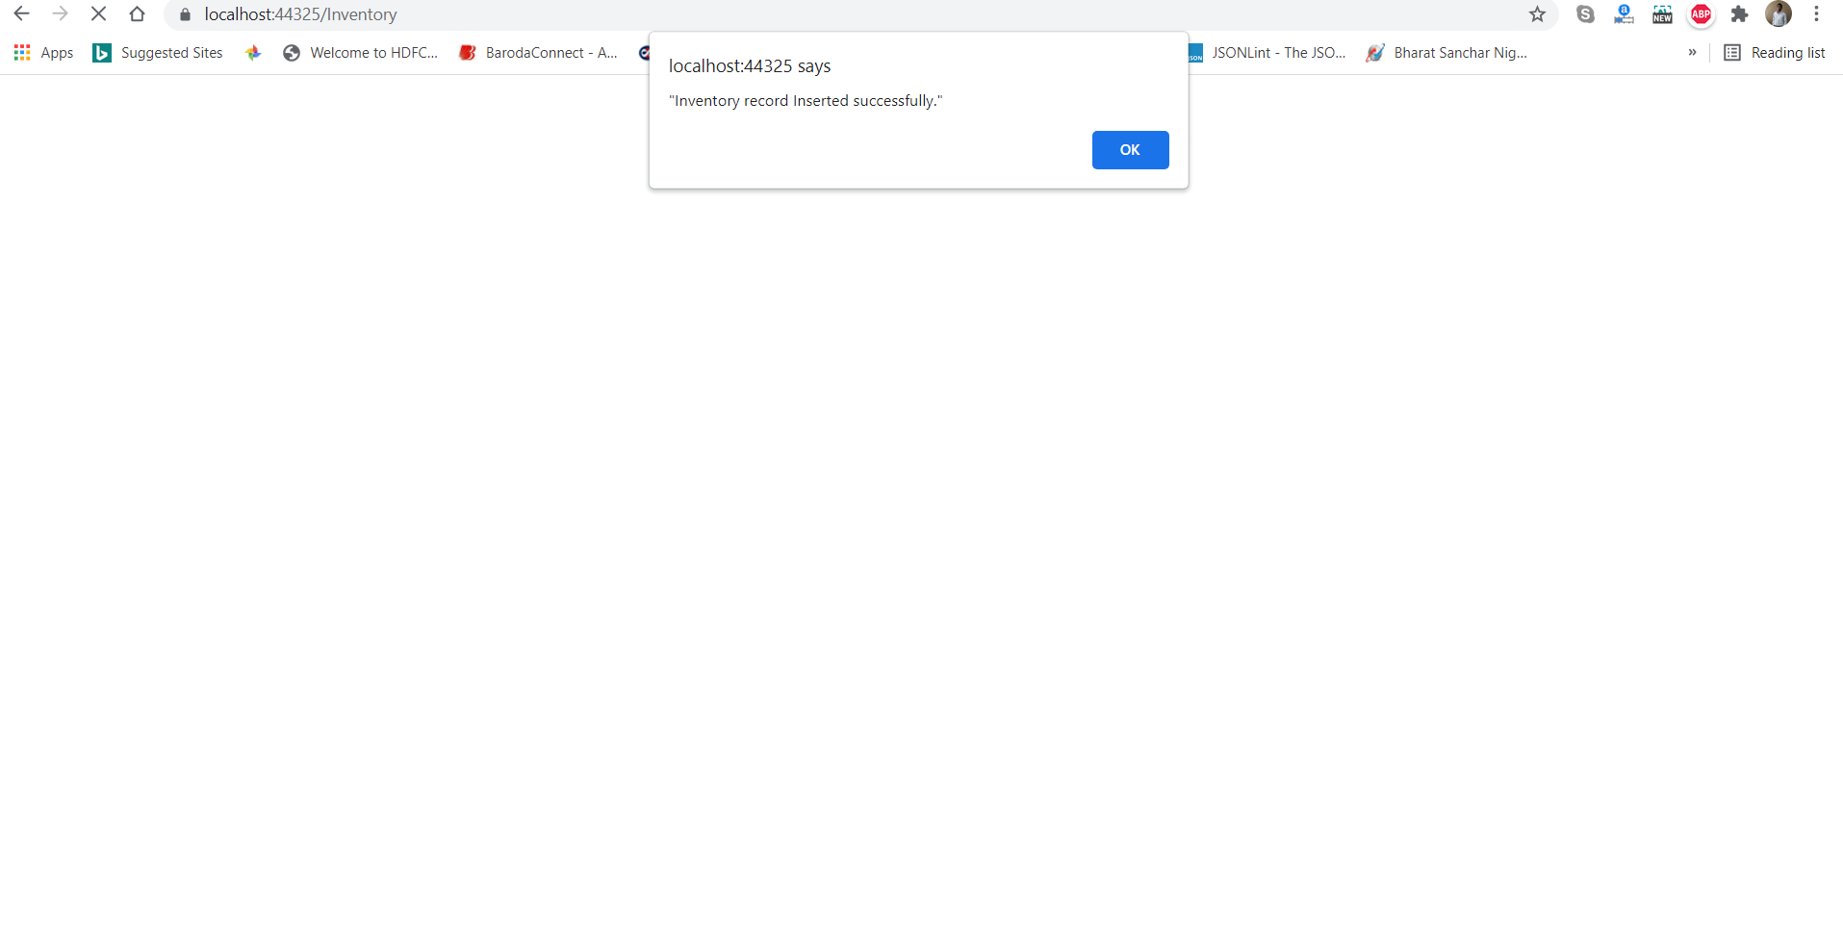

**Show Inventory Details : Grid Data**

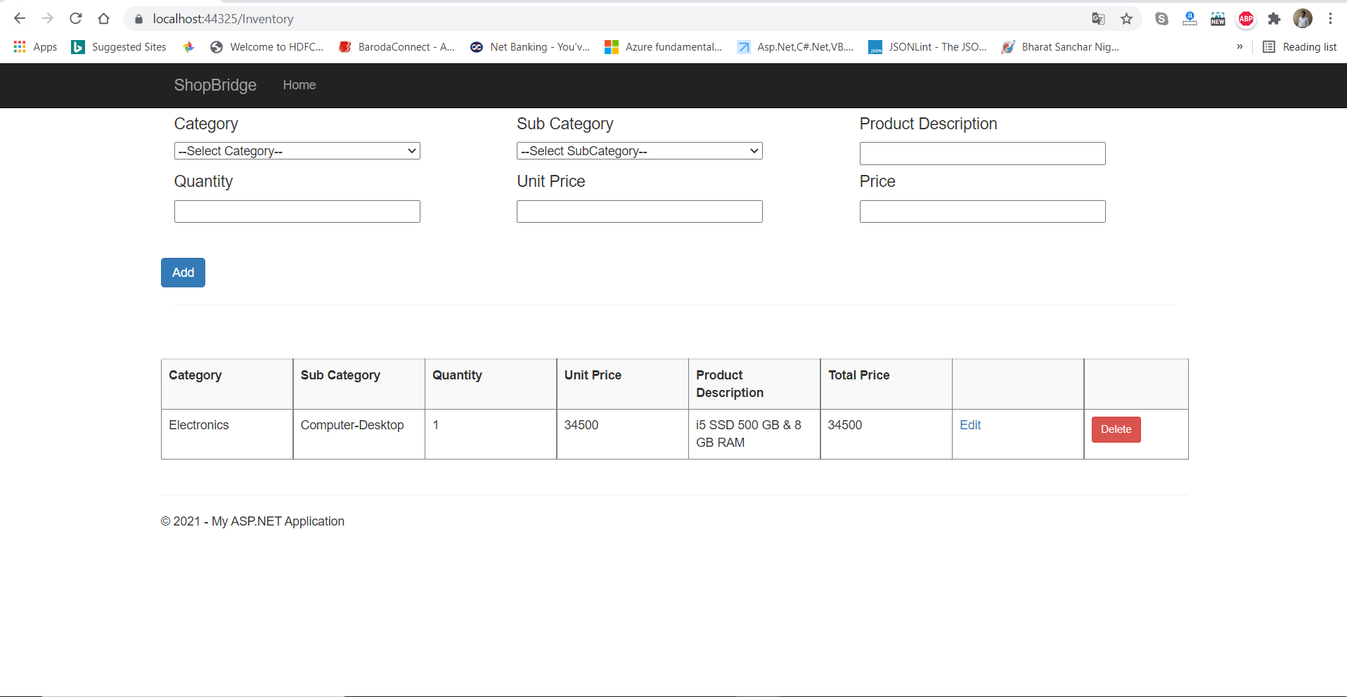

**Edit Inventory Details**

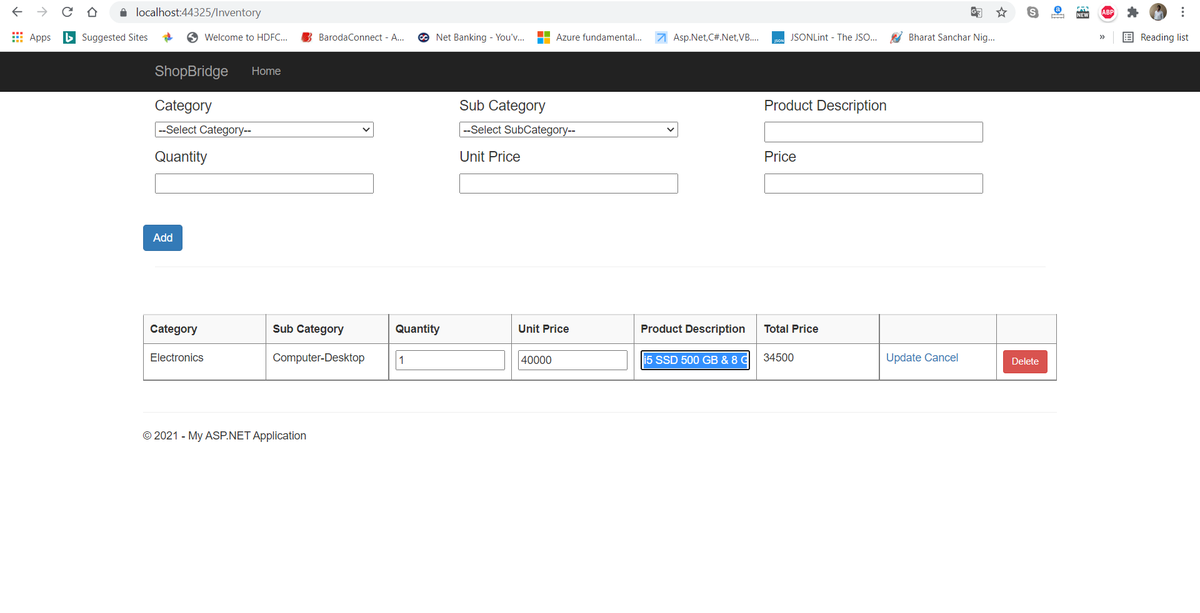

**After Edit Inventory Details Message**

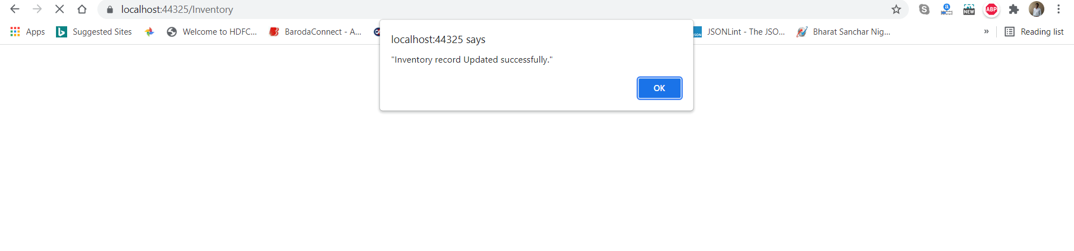

**After Delete Inventory Details Message**

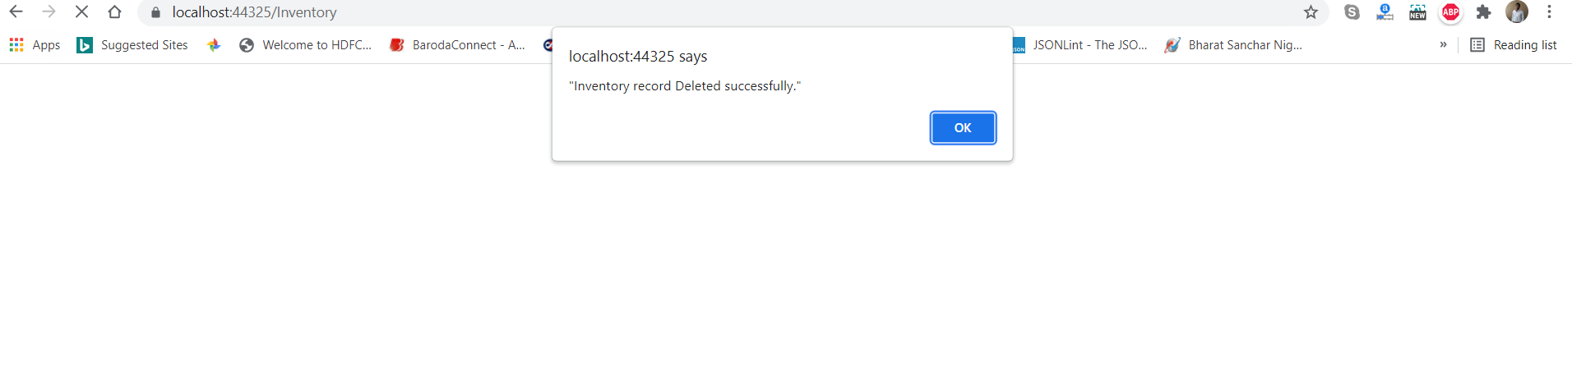

1. Sql Query Script with data
   1. ShopBridge.sql
2. Test Cases
   1. ShopBridgeBussinessTests(4 Unit Case Pass & 1 Failed)

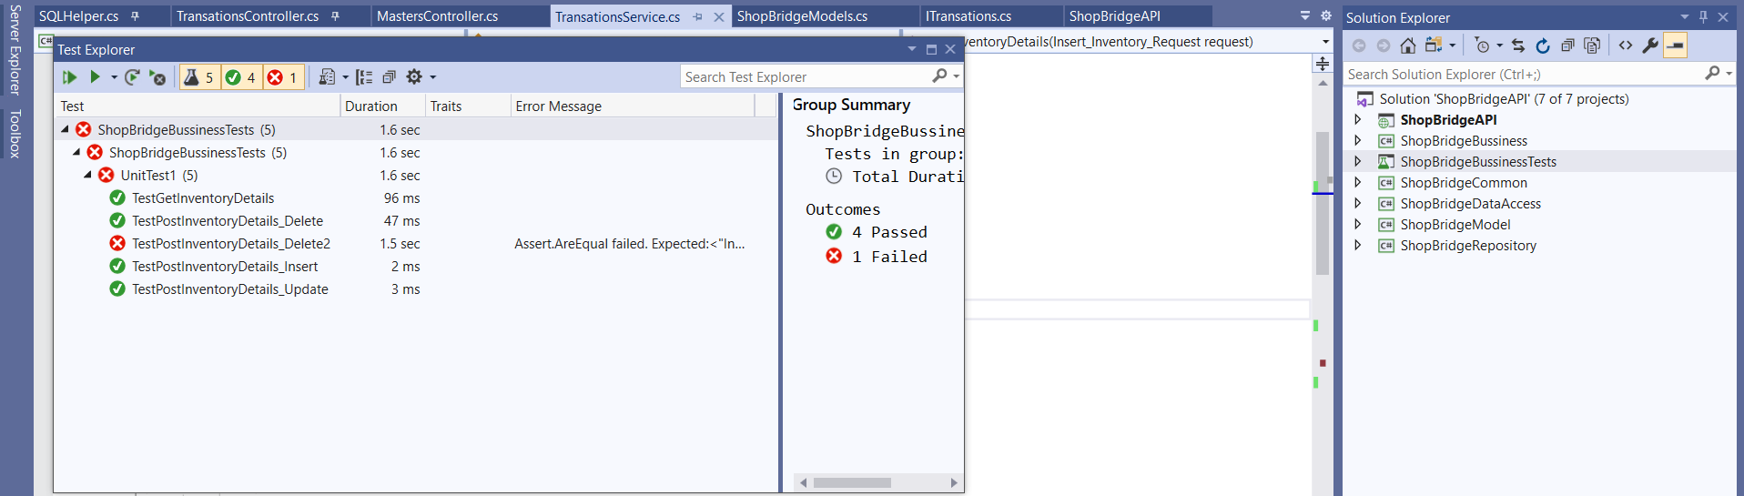

1. Error Log
   1. Text Error Log

