The Edupreneur Village Fund

Submit your Business Plan Summary at info@edupreneurvillage.com

The Edupreneur Village Challenge 2018

A business plan competition for aspiring or early stage Ed-Tech Entrepreneurs

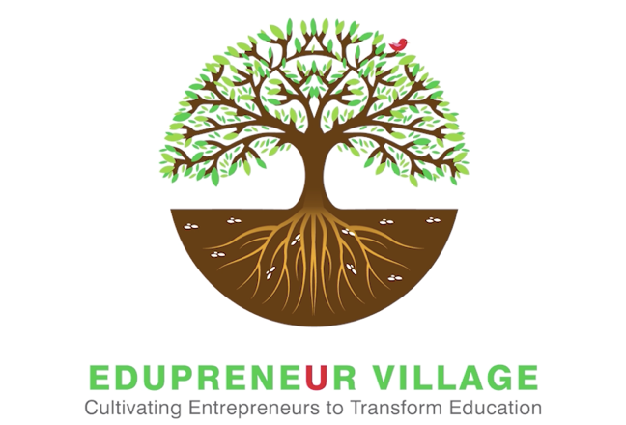

BUSINESS PLAN SUMMARY

TEMPLATE

|  |
| --- |
| 1. Problem statement – *Core user need which the venture wishes to satisfy* |

* 1. **Problem statement –** Narration

For the target user group (working mother of kids in the classes from 1st to 6th)

* + - Works from 8:00 AM- 8:00 AM including travel through traffic.
    - Have limited time available to spend with kids.
    - After coming back from office, need to take care of dinner for the family and remaining household work.
    - In the same time, need to get the homework, assignments of school done by kids
    - This leads to pretty transactional interactions with kids and does not provide opportunities to spend time on developing other values such as being responsible, delayed gratification etc.
    - Sometimes feels guilty, not good enough as a parent.
    - Feels concerned about how the kids will grow up.
    - At times attends the parenting workshop to gain the knowledge on good parenting practices.
    - Sometimes, searches for parenting tips online
    - Often this is the topic of discussion with the other colleagues in office and parents of kids friends.
    - Although gets lot of parenting tips from different source, can not practice it as is driven by life. At times the content available is so huge, that it becomes difficult to comprehend and bring into practice.

|  |
| --- |
| 1. **Solution –** *Solution idea to address the problem statement* |

* 1. **Solution** – *Core idea to solve the problem*
* A mobile app with following features to address parenting issues
  + Point System to develop habits
    - Point Collector : Tracker for the habits and the points to earn for good habit.
    - Points Redeemer: Keeps an account of points used
  + WishList for Delayed Gratification/ Too many demands:
    - WishList: Kid adds all his demands in the WishList. A demand which remains at the top of the wishlist for > 1 month is what is bought.
  1. **Product description –** *Key product modules/offerings which as a whole will offer a solution to the problem*
* The product shall be available as mobile and web application having following modules:
  + Point System:

Point system shall provide a way to specify the tasks which kid should take responsibility of and complete on his own. This is a task tracker which will help perform that task over a period so that it becomes a habit. The kid is awarded points for completing the task every day. Each task could be of different points.

The point system shall track all the points the kid earns on the daily basis . Kid can redeem his points against any of the bonuses such as purchase of toy, TV time, mobile time, mother or father time or family trip together.

From time to time, parents could publish some rewards for certain number of points e.g. 30 points of every 1 hour of TV time, 100 points for a 1-1 time with mom on weekend, 1 point = 1Rs to purchase a toy etc.

The point system shall have following sub modules:

* + - General:

This is the default sub module in which, parents can configure which tasks are to be added to the point system and for how many points.

* + - Exam Preparator:

This sub module provides a calendar to schedule the preparation for the terminal or unit exam. Completion of the exam revision/preparation is considered as a task in the General System and may have more points as this is occasional.

* + - Food

This submodule provides a specific need to develop good food habits. This will come with pre-defined food items and its protein, fats, carb content. The kid can log the food he eats every day and earn some points for say certain amount of vitamins, proteins etc.

* + - Classes

This submodule is available in partnership with various classes the kids go to such as sports, dance, phonics, abacus etc..

The providers of such classes can subscribe to this system and can make this module available for the parents on enrollment to their classes. The kids could earn points for good behavior and achievement in classes and those shall be added to the overall point system.

* + - HomeWork

This module is available in 2 variants – 1 for parents and 1 for schools

* + - * HomeWork for parents

This module can scan the homework done by the kid in the notebook and apply AI to also evaluate the correctness. One the homework is complete, it will mark as complete in the point system and award the corresponding points to the kid.

* + - * HomeWork for schools

This module will make typical questions for home work available to school teacher for the given education board (e.g. SSC). With this teacher has to just ask the module to set the homework for that class on a particular chapter and the module will select the questions for homework as per the syllabus.

This set homework shall automatically be assigned as a task in the point system for the kid to earn the points.

It saves the school teacher is the time spent in giving the homework in the class orally or by writing on the white board.

The homework module can be available to schools off the shelf for purchase on license basis.

Alternately the existing school management system provider can integrate this module by paying for the API usage.

This module needs to be updated with the knowledge base of the latest syllabus. The schools can contribute in upgrading this knowledge base and can earn discounts on the licensing costs.

* + Wish List

This module helps in building the virtue of delayed gratification in kids.

Whenever kids make any demand, parents would ask them to add it to their wish list instead of purchasing it out right there.

On a defined period, e.g. every month, the wish which is at the top of the wish list shall be catered to.

From time to time kid can change the place of his/her wish in the wishlist.

Kid will get special bonus point for distinguishing an item in the wishlist as need or wish.

Points earned in the point system can be redeemed against the top wish in the wishlist.

A wish should complete at least certain time in the wishlist before it is fulfilled.

* + My Coach

With this module, the parent will have access to the parenting counselor with whom she can chat or have 1-1 discussion by taking certain number of appointments every month. The coach shall help the parent make best use of the tools available on the mobile to address the parenting concern.

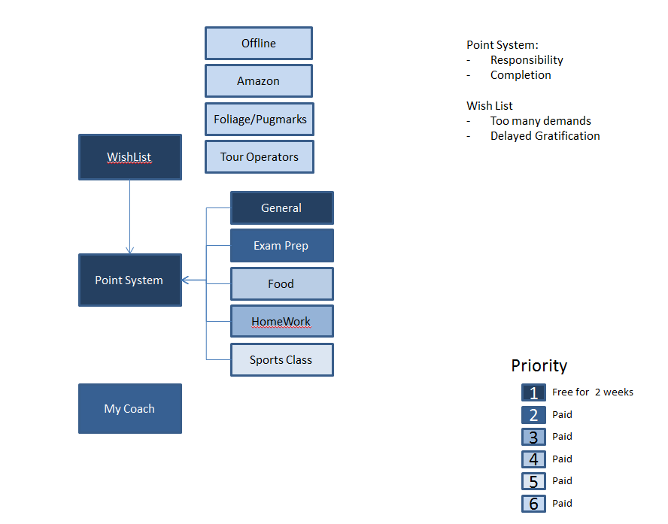

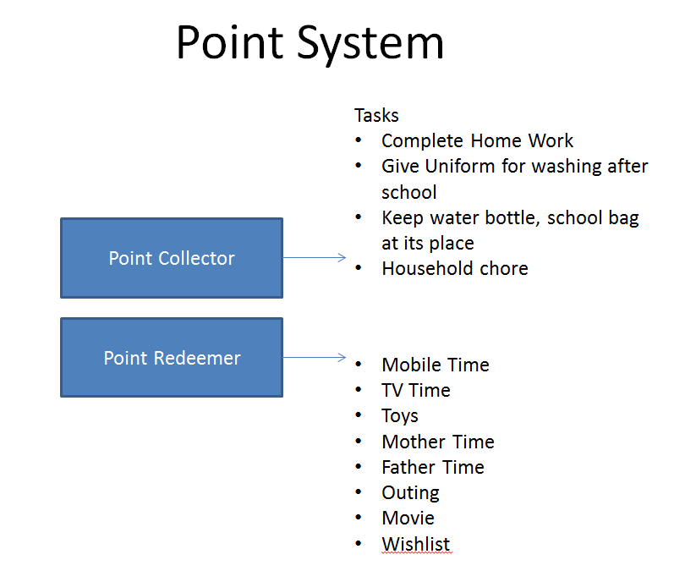

* 1. **Validation** – *Any Proof that the idea will work – Successful example, Industry parallel, Any research, etc.*
* I have been using the point system at my home in the form of printed hard copies of the powerpoint slides pasted on fridge.
* This has worked well so far and when other kids and parents visit our home, they have shown interest in using the similar system.

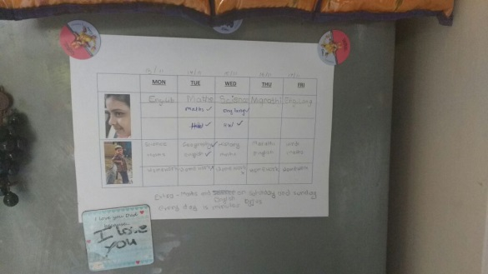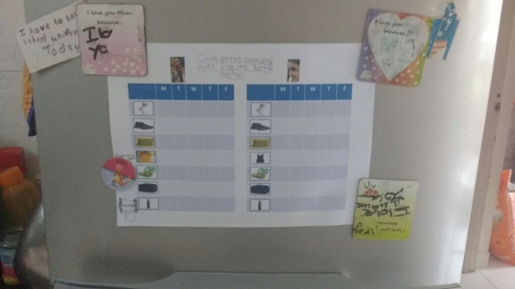

|  |
| --- |
| 1. **Market sizing –** *Likely annual market size for the business* |

* 1. **Target Customer Group –** *Typical profile (persona) of the Target Group (TG) of users*

1. **What are they trying to achieve:**

While balancing work life, raise the kids to develop value based habits.

1. **Name:** Swapna
2. **Age:** 35 Yrs
3. **Gender:** Female
4. **Address:** Bangalore
5. **Occupation:** Team Leader. Software Developer
6. **Married (Y/N): Y**
7. **Children (Y/N): Y 6 years**
8. **5 Places they spend their time online/offline to resolve this problem:**
   * 1 Friends, Family and Colleagues (Offline)
   * 2 Parenting workshops (offline)
   * 3 Parenting sites (online)
   * 4 Parenting Cunselors (offline)
   * 5 Parenting forums (onlune)
   1. **Addressable market size –** *Of all the segments likely to buy, within the larger market.*

* **Overall market size numbers** (Users, revenue potential, etc.)**:** 
  + 8100 people/month search for parenting tips worldwide on google
  + 1.5 lac
* **Annual potential TG users:** 
  + 7500.
* **Potential ARPU (Annual Revenue Per User):** 
  + Rs. 5000.00
* **Addressable Market size (**Annual potential TG users X Potential ARPU):
  + **Rs. 5000 X 7500= 3,75,00,000.00**
  1. **Key assumptions**: *To arrive at Addressable Market Size*
* 25 lac software engineers are employeed in indian software industry
* On an average, 25% of these employees are female employees – 6.25 lac
* 25% of these are in the target age with kids – 1.5 lac
* Every year about 5% of remaining female employees enter the target group - 7500

|  |
| --- |
| 1. **Competition –** *Likely competitors & sources of long term competitive advantage* |

* 1. **Competitors**–*Serving the customer need with a similar product*
* Parenting Websites and blogs
* Parenting Counselors
  1. **Differentiation –** *Key sources of differentiation from competitors*
* Tools (in the form of app and games) which practically engages both parents and kids.
* With the app in the mobile, buddy is available all the time
* One platform which aggregates all the content required to raise the kids in classes 1 to 6
  1. **Long term competitive advantage –** *Key reasons why venture will be able to outfox competitors for 5-10 years?*
* Addition of new modules to address different parenting issues
* Addition of more counselors and service providers over the years.
* Competitors themselves can use this tool increase their bussiness

|  |
| --- |
| 1. **Business Model –** *Key tenets about how is Business is run* |

* 1. **Revenue model / Pricing Structure –** *Key revenue sources and pricing levels*
* 1 Months Subscription for Point System and Wish List – Free
* 3 Months Subscription Fee – 2000
* 6 Months Subscription Fee – 3800
* 12 Months Subscription Fee - 7200
* Commissions from Counselling sessions – 10% of counseling fee
* Subscriptions by Counselors, content providers and other service providers (classes, schools etc) – Rs. 1000 per enrollment.
  1. **Production method** – *How will different product modules/offerings be created? For e.g.: Content, Website, etc.*
* Mobile and Web Application Development
* Development of software platform to integrate content and service providers.
  1. **Sales / Distribution method –** *Channels to be used and method to sell through each channel*
* Social Media – through digital marketing on google, facebook, youtube, quora
* Parenting Counselors – tools prescribed by the counselors
* Parenting workshops – basis subscription provided for attending the parenting workshops by the parenting counselors subscribed to this service
* Mouth to Mouth – personal experience
  1. **Servicing method –** *Channels to service the users*
  + In app chat/chatbots
  + Service Email
  1. **Renewal method** – *How are customer contracts renewed?*
* Customer can subscribe for a year in a discounted price or can subscribe for minimum 3 months.
* One gets to use Point System and WishList free for a month.
* One can renew the subscription on expiry of current subscription.
  1. **Unit economics –** *Estimated numbers that show there is money to be made at unit level, ensuring scalability*

|  |  |  |  |  |  |
| --- | --- | --- | --- | --- | --- |
| LTV (Life Time Value) | COGS | CAC | COS | COR | Net margin |
| Revenue which an average customer is likely to give you in his lifetime | **(Cost of Goods Sold)** | **(Sales & Marketing Cost to Acquire a Customer)** | **(Cost of Servicing)** | **(Cost of Renewal)** | **(LTV – COGS – CAC – COS – COR)** |
| Rs. 43200 | Numbers | Numbers | Numbers | Numbers | Numbers |

|  |
| --- |
| 1. **Execution – Implementation so far (Only for ventures already started)** |

|  |  |  |
| --- | --- | --- |
|  | Since inception (Please mention date of incorporation) | Latest monthly |
| Revenue - Revenue incurred (Avoid cash received or future revenue pipeline). As per all revenue heads | Numbers | Numbers |
| Selling method: How were the customers acquired so far and through which channels? | Narration | Narration |
| Expenses: Expenses incurred. As per key expense buckets | Numbers | Numbers |
| Operational metrics: Key operational metrics and numbers achieved, like Visitors, Paid users, Engagement time, Content, etc. | Numbers | Numbers |

|  |
| --- |
| 1. **Business Plan –** *For next 8 Quarters, taking care of milestones till next funding round* |

**Profit & Loss –** *How will business pan out over 8 quarters*

|  |  |  |  |  |  |  |  |  |
| --- | --- | --- | --- | --- | --- | --- | --- | --- |
| In INR Lacs | Q1 | Q2 | Q3 | Q4 | Q5 | Q6 | Q7 | Q8 |
| Revenue (A) |  |  |  |  |  |  |  |  |
| COGS (B) |  |  |  |  |  |  |  |  |
| Gross Margin |  |  |  |  |  |  |  |  |
| Operating Expenses (C) |  |  |  |  |  |  |  |  |
| Management |  |  |  |  |  |  |  |  |
| Sales & Marketing |  |  |  |  |  |  |  |  |
| Product development |  |  |  |  |  |  |  |  |
| Overheads |  |  |  |  |  |  |  |  |
| Miscellaneous |  |  |  |  |  |  |  |  |
| EBITDA (D = A-B-C) |  |  |  |  |  |  |  |  |
| Capex (E) |  |  |  |  |  |  |  |  |
| Cash needed (F = D+E) |  |  |  |  |  |  |  |  |
| Investments (G) |  |  |  |  |  |  |  |  |
| Cash remaining (H = G-F) |  |  |  |  |  |  |  |  |