**Online Food Ordering System**

**Abstract**

ONLINE FOOD ORDER SYSTEM is a website designed primarily for use in the food delivery industry. The system also allows to quickly and easily manage an online menu which customers can browse and use to place orders with just few clicks. Restaurant employees then use these orders through an easy to navigate graphical interface for efficient processing.

**Introduction:**

Online ordering system that I am proposing here, greatly simplifies the ordering process for both the customer and the restaurant. System presents an interactive and up-to-date menu with all available options in an easy to use manner. Admin can manage all the restaurants from the dash board and change status of the orders. Customers can choose food Items of their choice and order them. Customer can view order history, and can check status of the order. If order is Accepted/Rejected/Out for Delivery etc. Once the order is placed it is entered in the database and retrieved in pretty much real time.

**Functional Requirements:**

The functional requirements of the project are:

**For the Admin**

• Can Login.

• Can add Restaurant.

• Can delete restaurant.

• Can modify Restaurant.

• Can add food items to existing Restaurant.

• Can view all Restaurants

• Can view, food items.

• Can update food items.

• Can delete food items.

• Can accept or reject orders

**For the Customer:**

• Can Register and login.

• Can view user profile.

• Can browse through all Restaurants.

• Can browse through all food items.

• Can choose quantity of food items.

• Can load balance in wallet.

• Can view order history.

• Can cancel order and get refund for the same.

• Can place order

**Technologies used**

1. Angular -8
2. HTML-5, CSS-3, Bootstrap
3. Java -1.8
4. Spring Boot
5. Maven
6. Spring Data JPA
7. Hibernate
8. My SQL

**Link to Source code**

GitHub (Backend): <https://github.com/PravinKatiyar/ofos-backend>

GitHub (Frontend): <https://github.com/PravinKatiyar/ofos-frontend>

**Snapshots of the project**

Homepage and Signup page

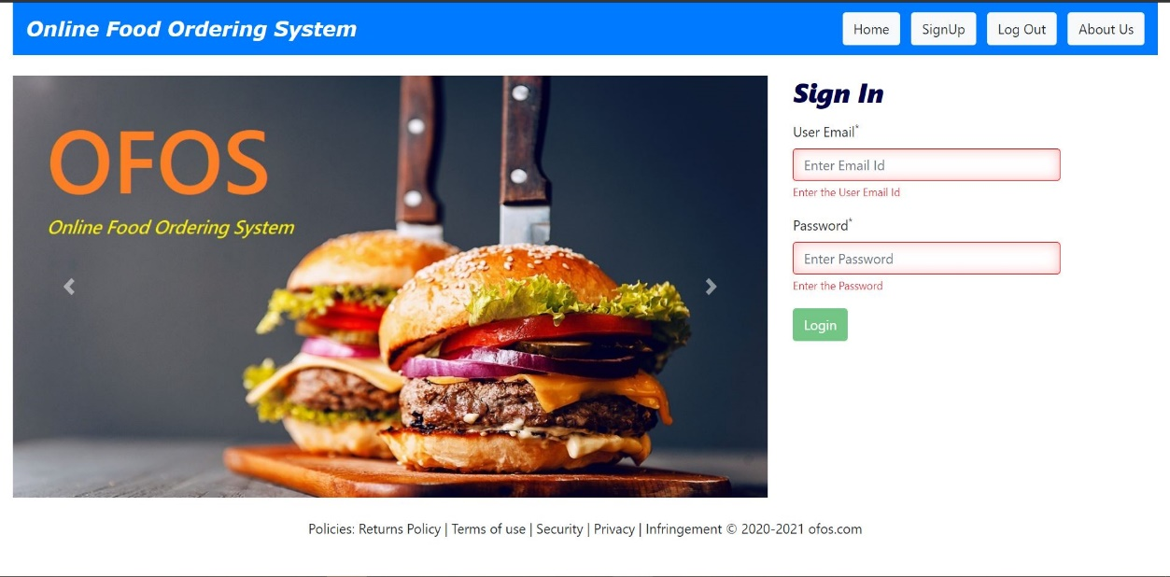

Signup page (with client side validation)

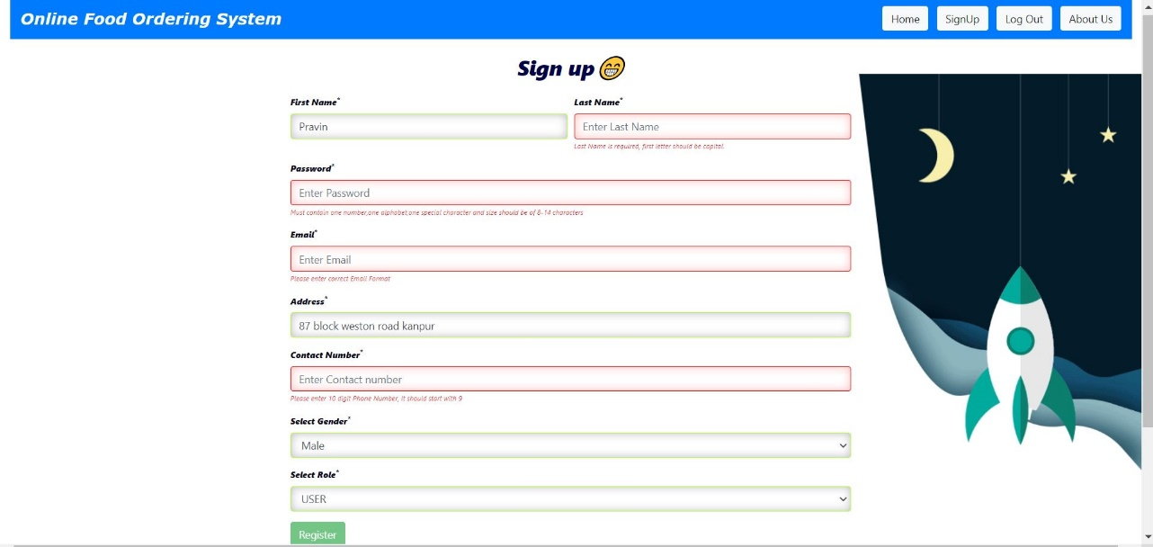

Admin Dashboard

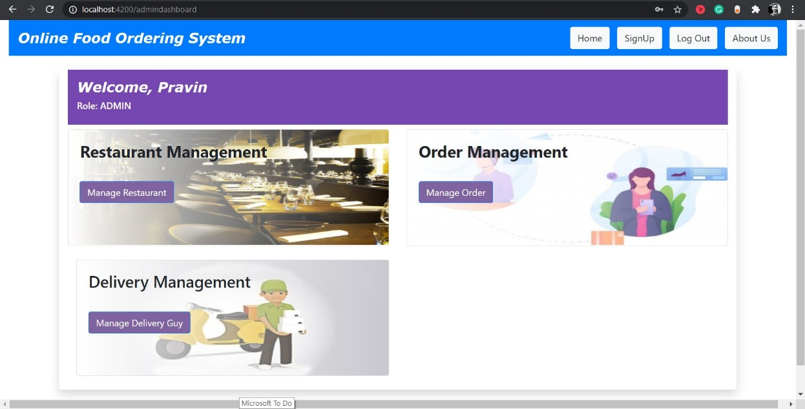

Restaurant Management

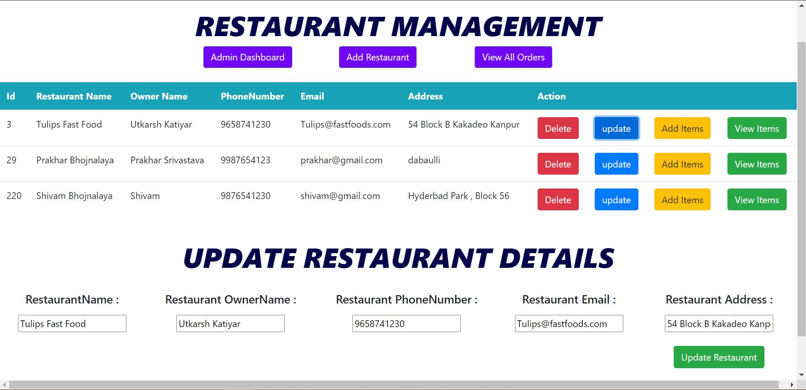

Add food items to Restaurant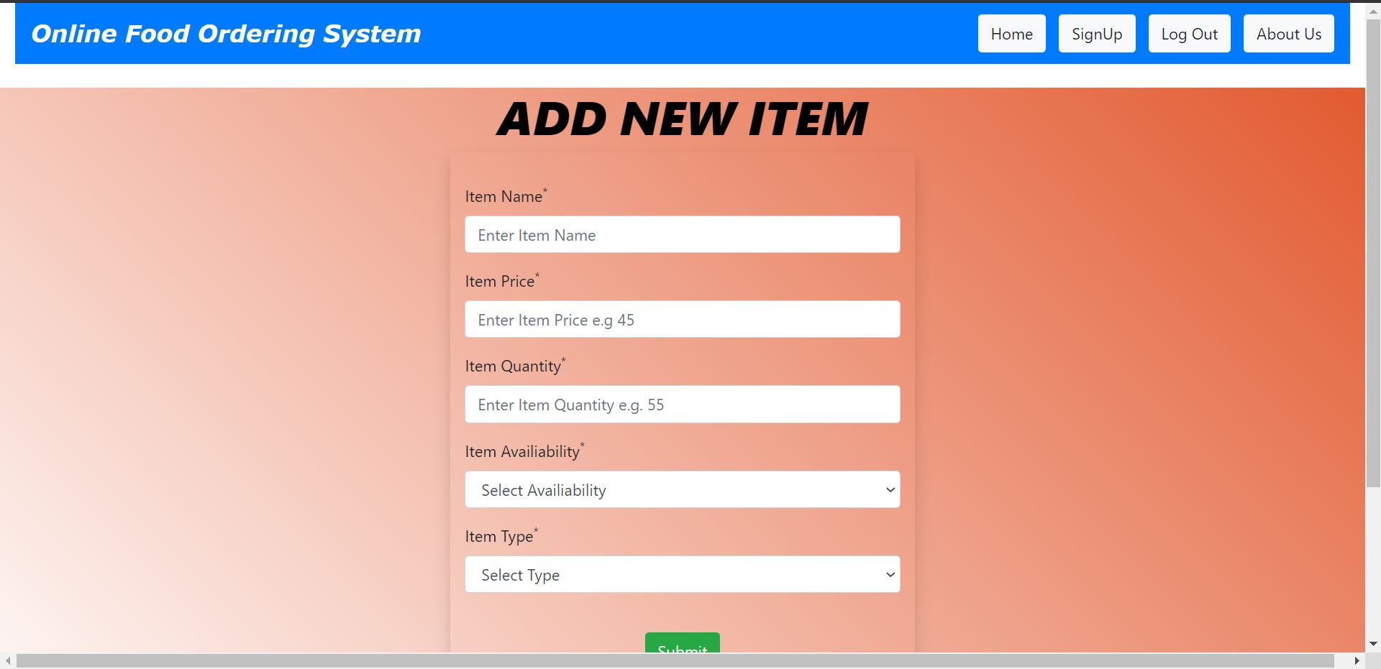

Update food Items (Updating price, quantity, Availabilty of food items)

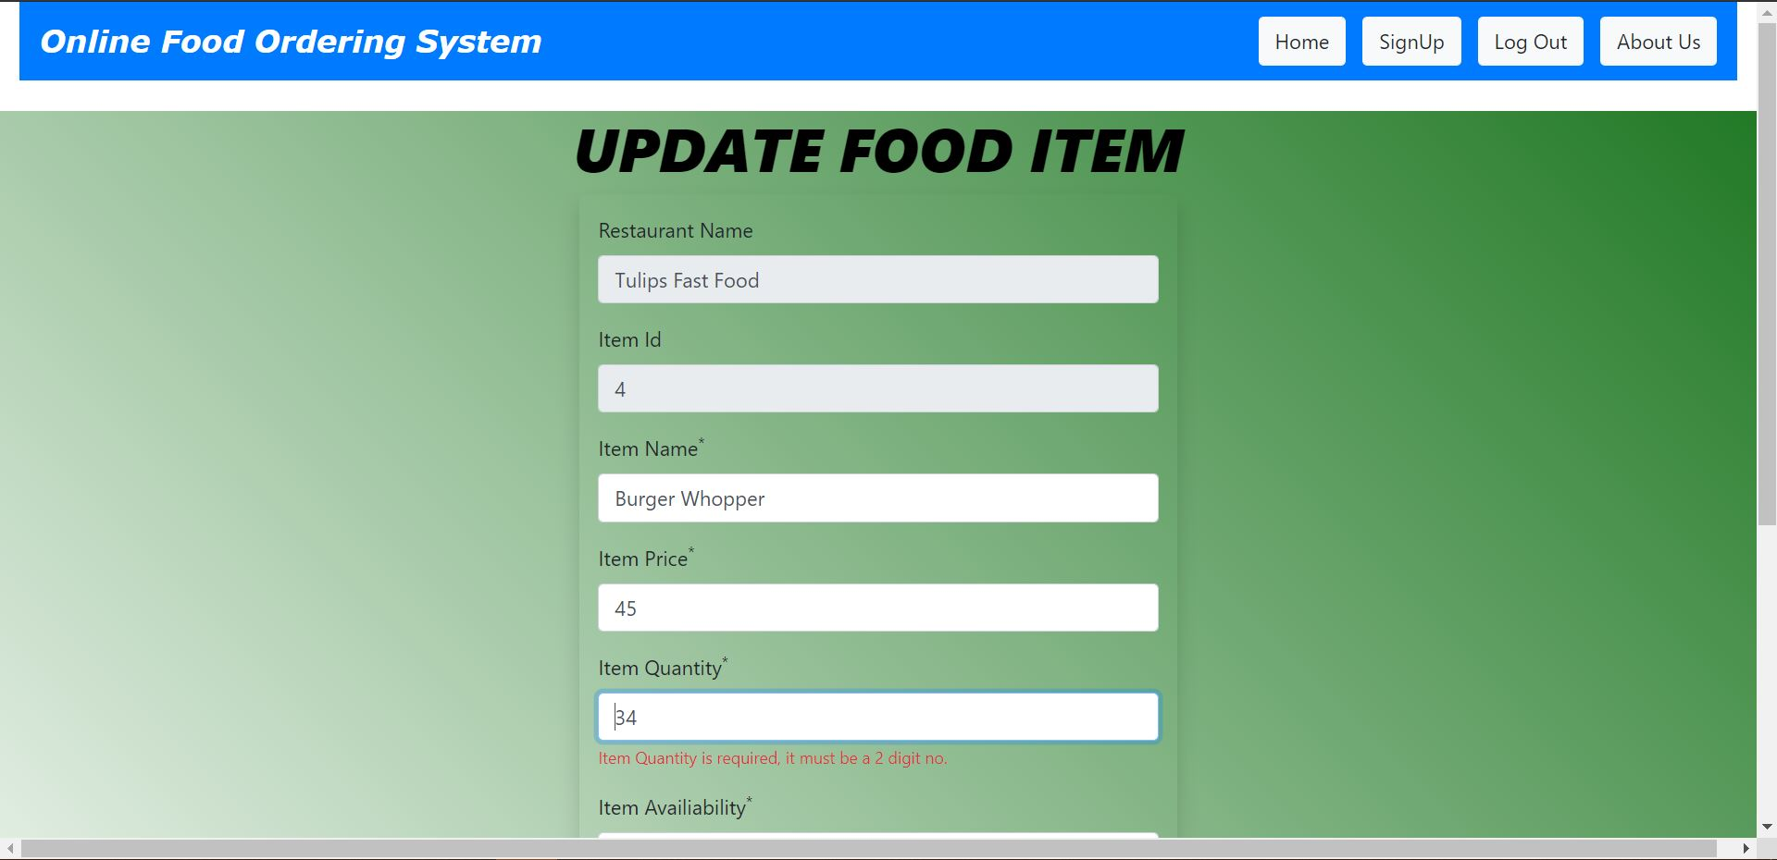

View All orders

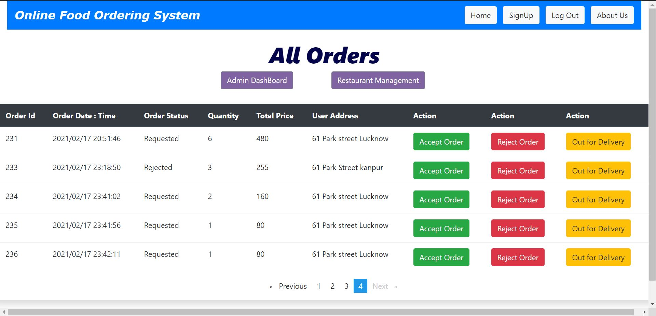

Mark orders as delivered

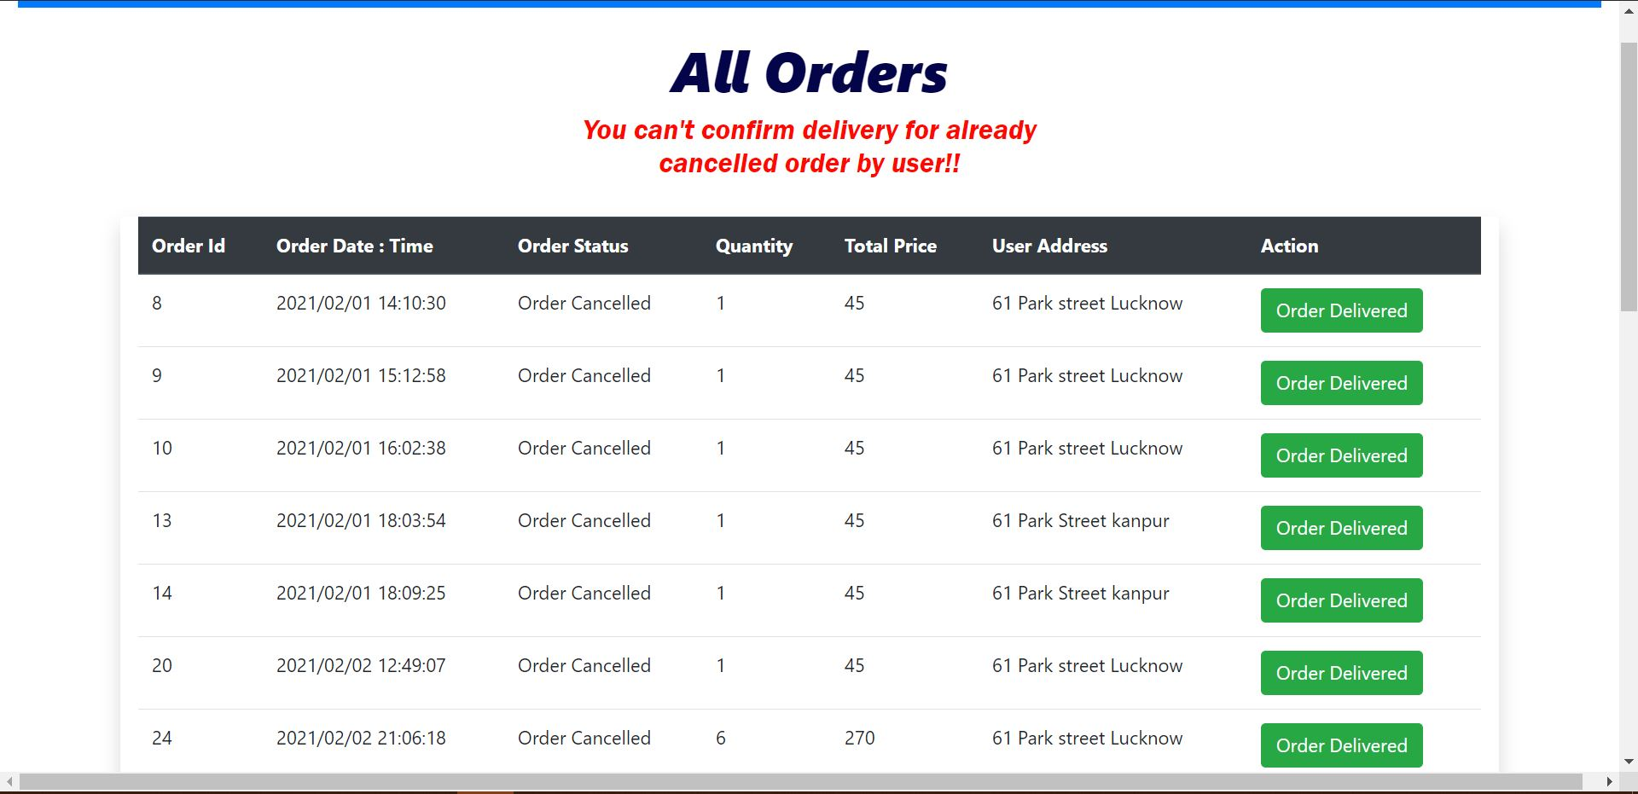

User Dashboard

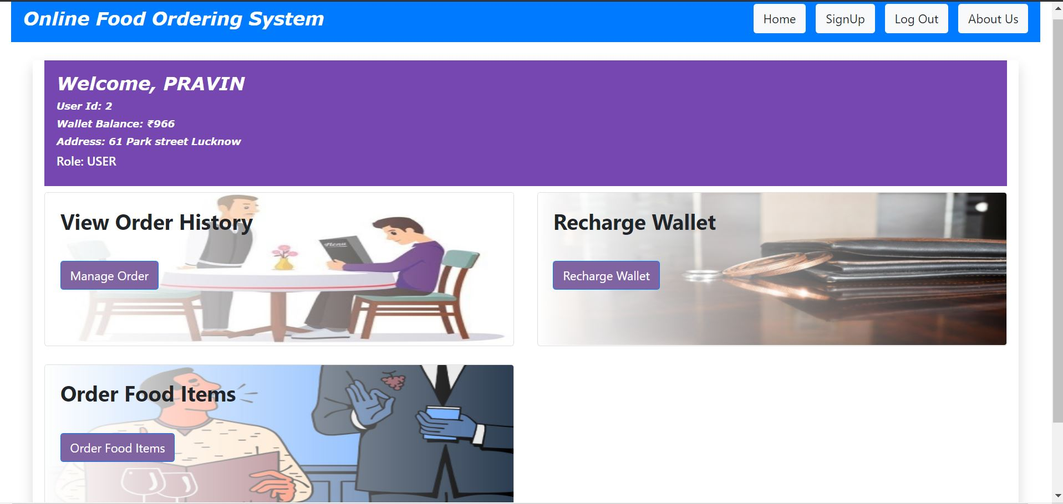

Wallet Recharge by User

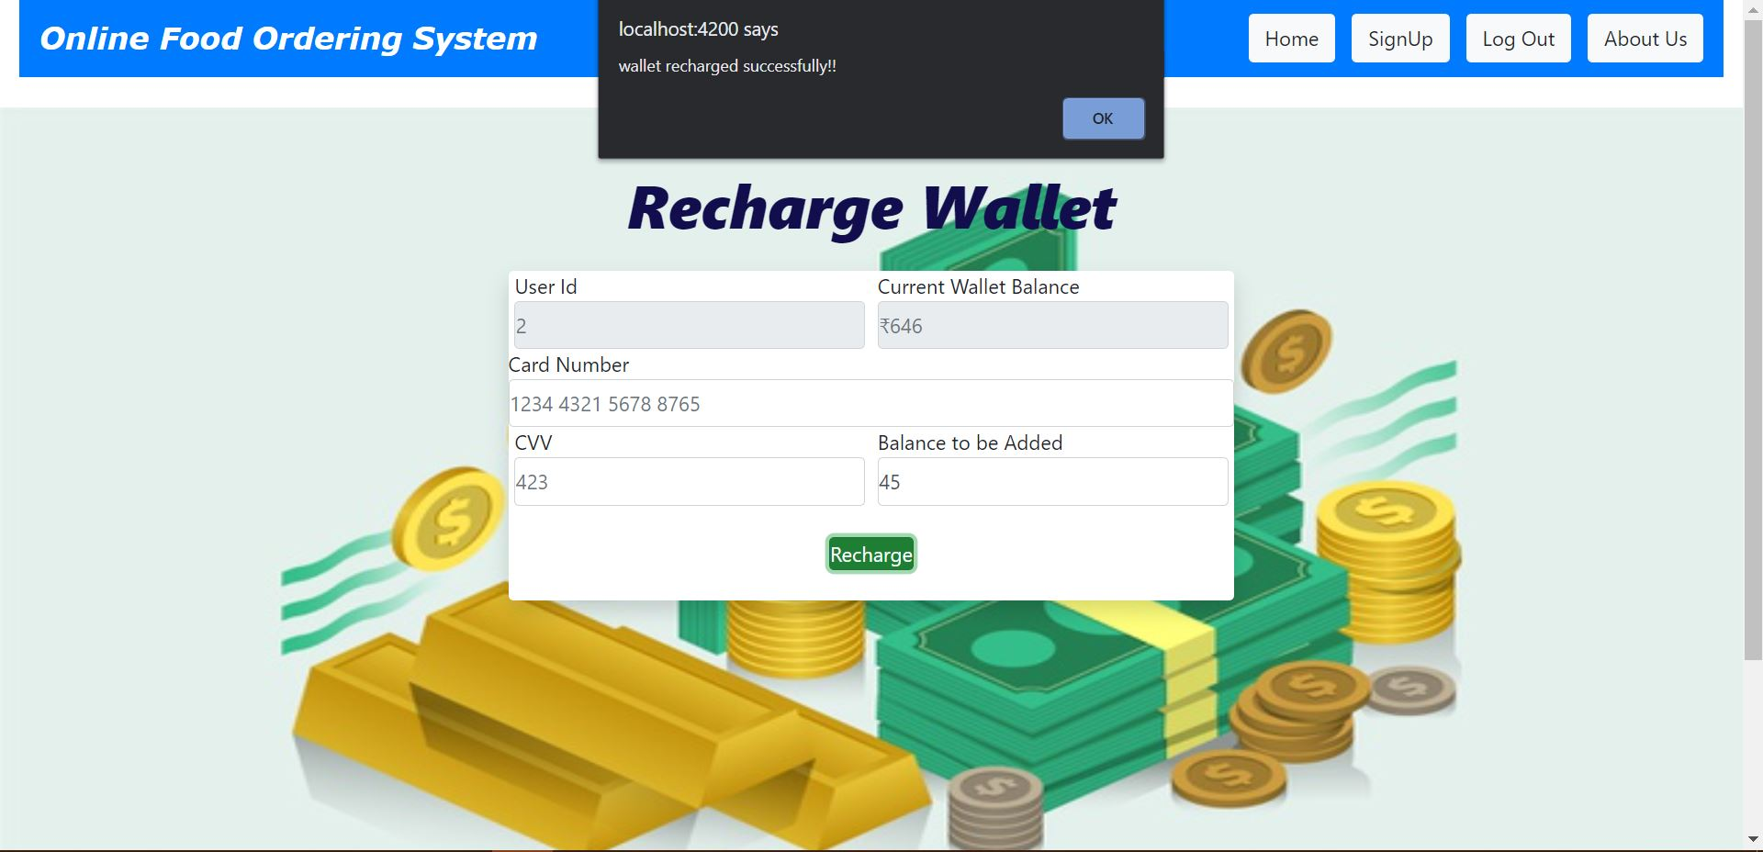

Select Restaurant while ordering food items

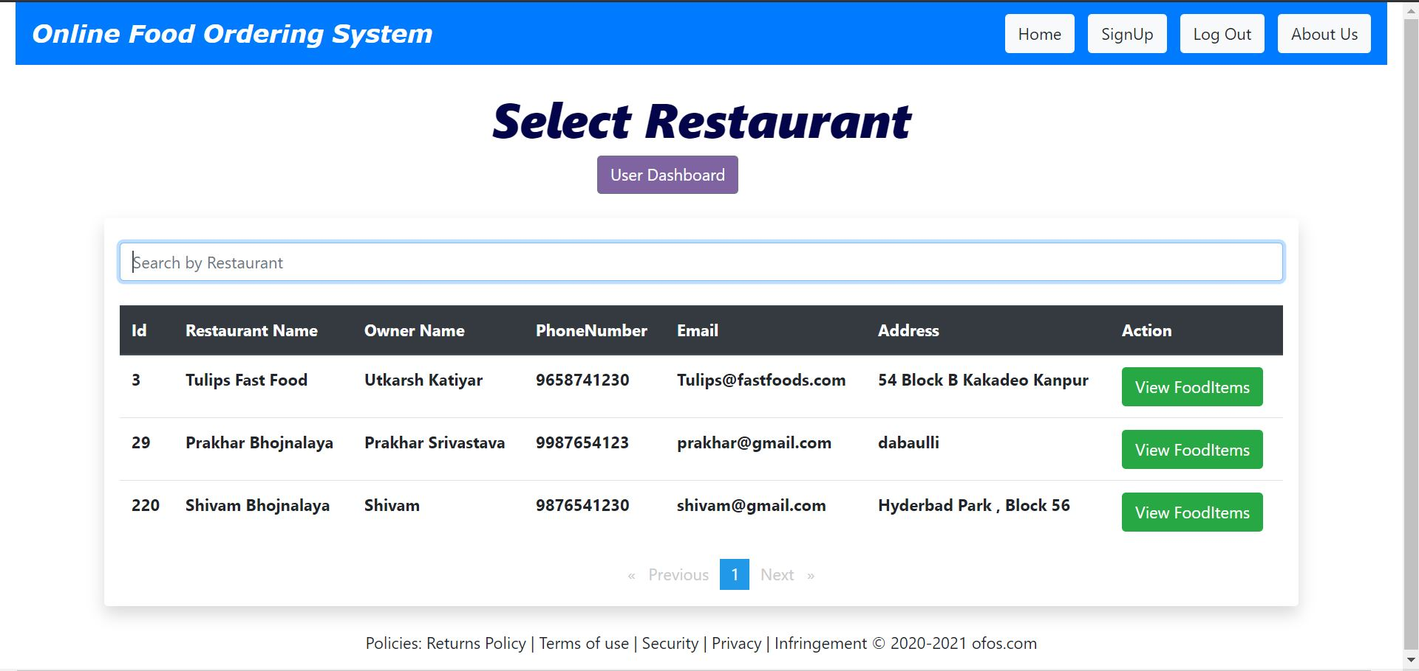

Selecting food items which are in above selected restaurant (Only those items will be available to users whose availability= ’Yes’ and item quantity is >0)

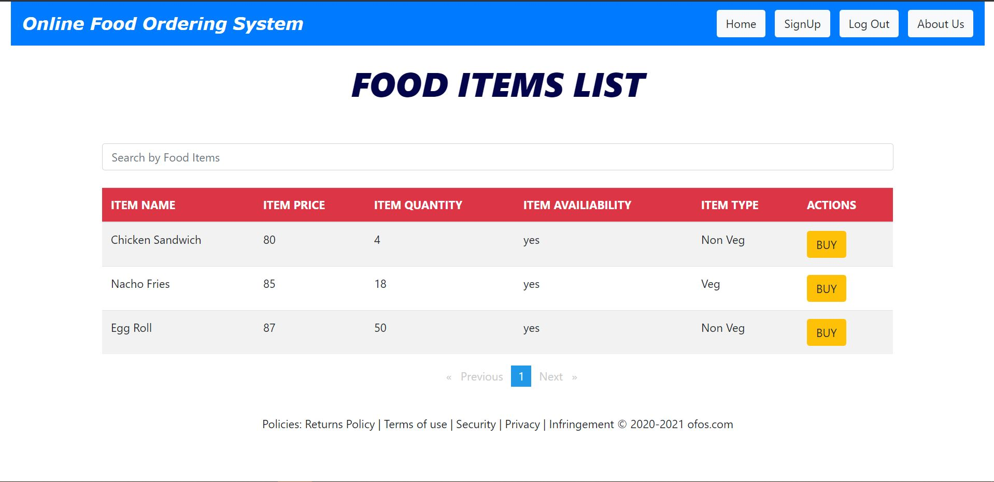

Selecting desired quantity to buy (If ordered quantity> quantity in stock, then it will prompt a message)

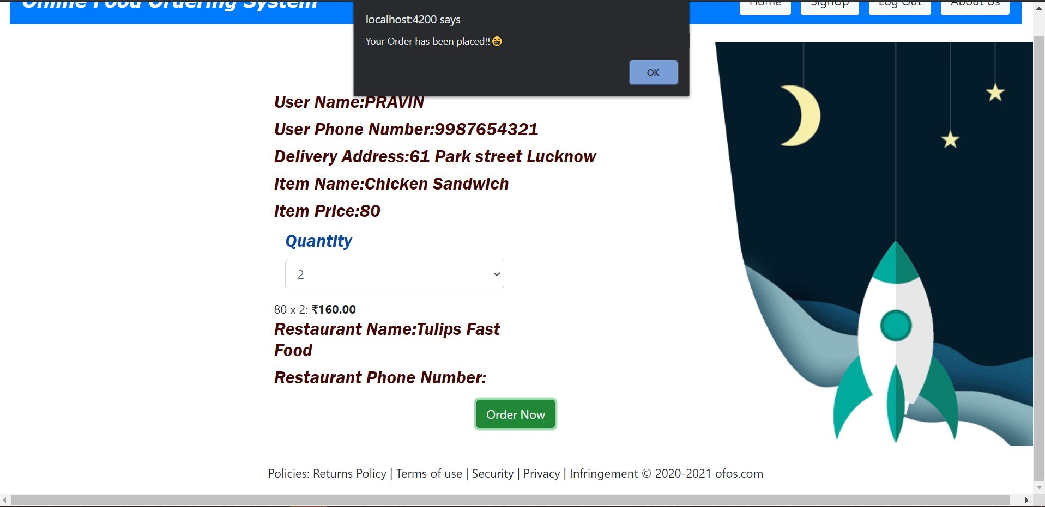

While ordering food items if wallet Balance< order amount, then it will prompt a message

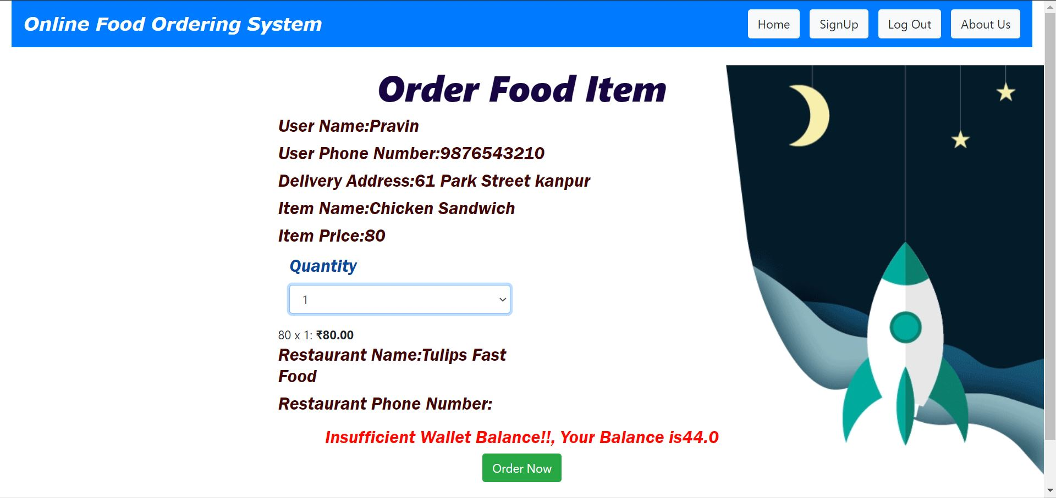

User can cancel or track the placed orders

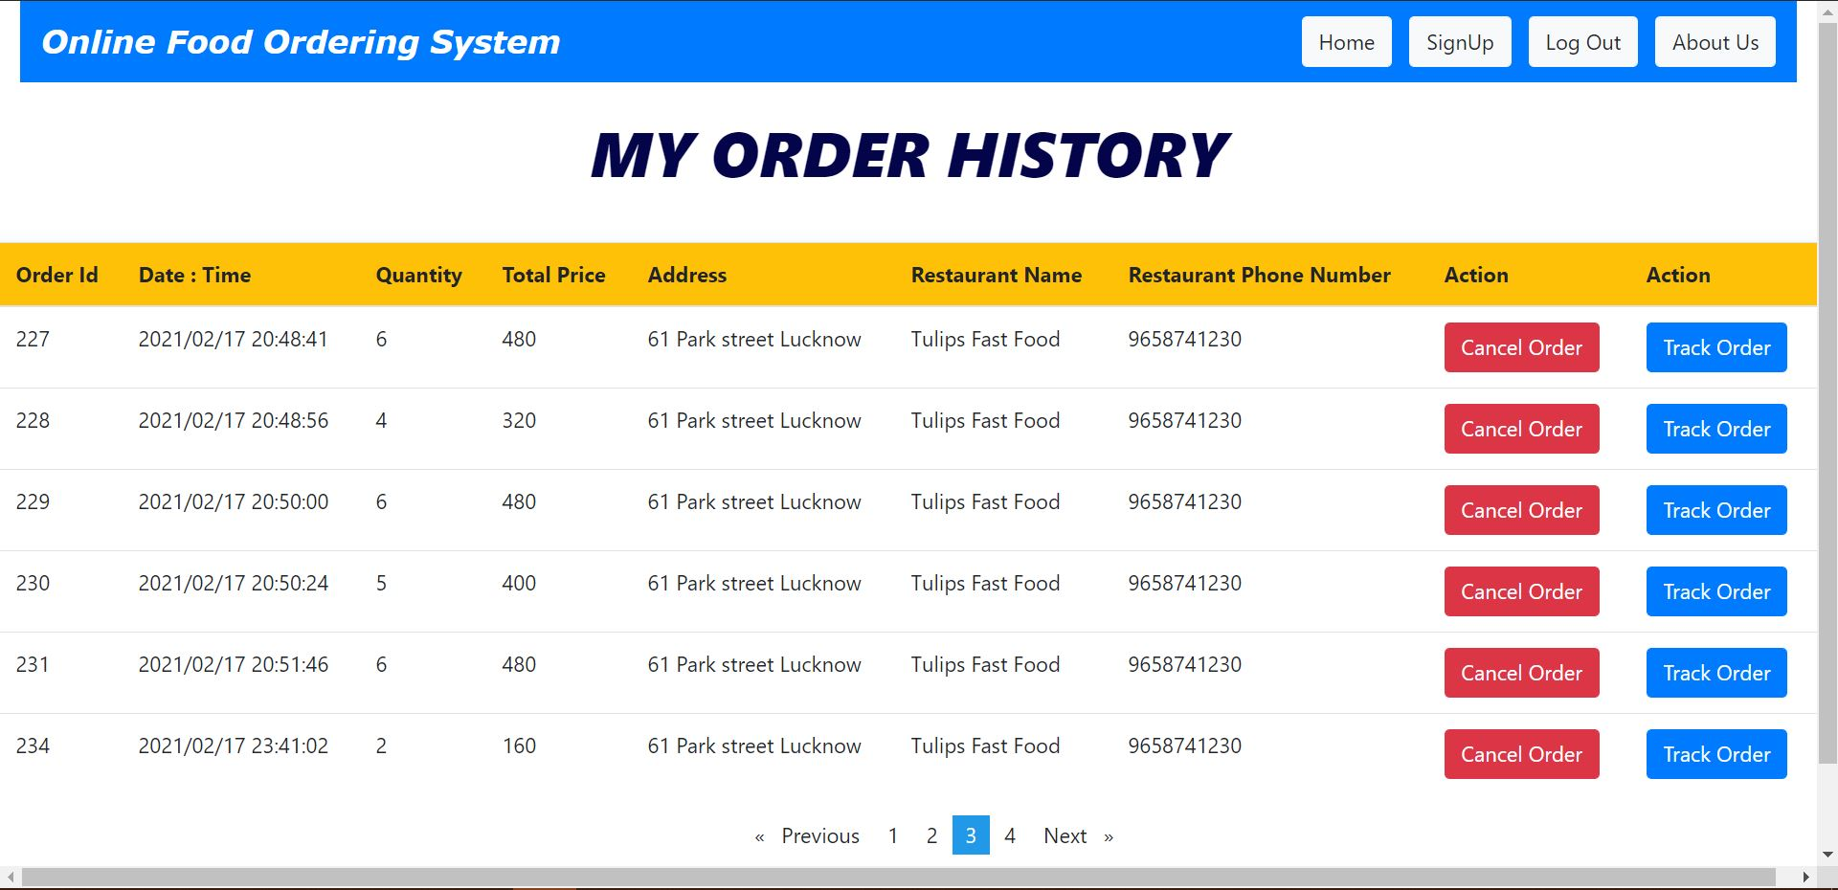

Here user can track the status with help of progess bar

