21.First Take Backup of your assignments & projects.This is required because due to incorrect GIT operation you may lose your files.

22.Create an empty directory ‘Assignments’& cd to ‘Assignments’.

23.Create a file README.txt inside ‘Assignments’ & write few lines about the contents of ‘Assignments’ folder.

24.Commit README.txt file.

25.Now create a new branch ‘html-assignments’.

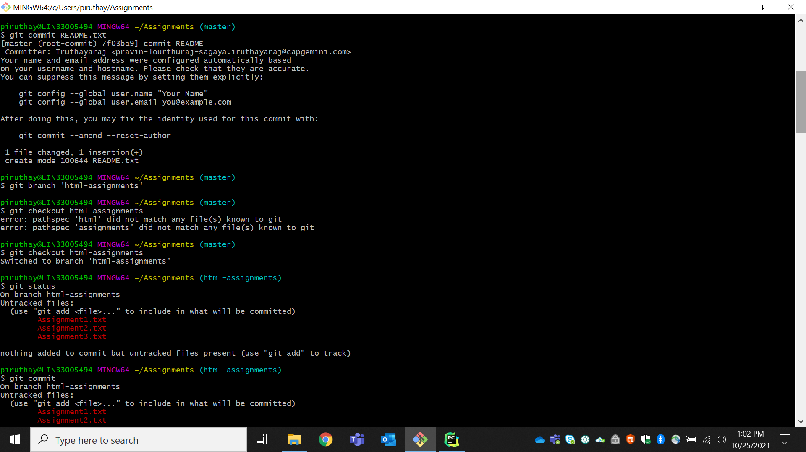

26.Switch to ‘html-assignments’ branch.

27. Copy all HTML assignments inside ‘Assignments’ folder.

28. Commit HTML assignments into ‘html-assignments’ branch.

29. Make minor changes into few files belonging to ‘html-assignments’ branch.

30.Commit those changed files.

31.Switch to master branch.

32.Make minor changes into README.txt file & commit those changes into master. 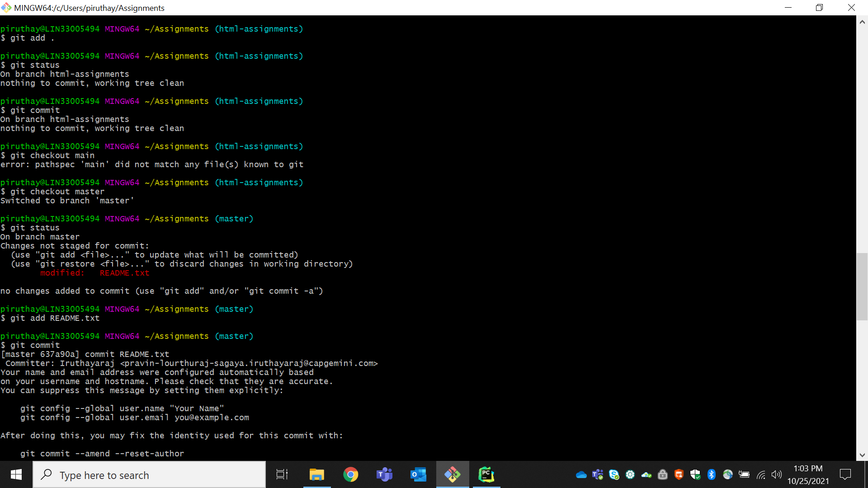

33.Again switch to ‘html-assignments’ branch.

34.make minor changes into few files belonging to ‘html-assignments’ branch.

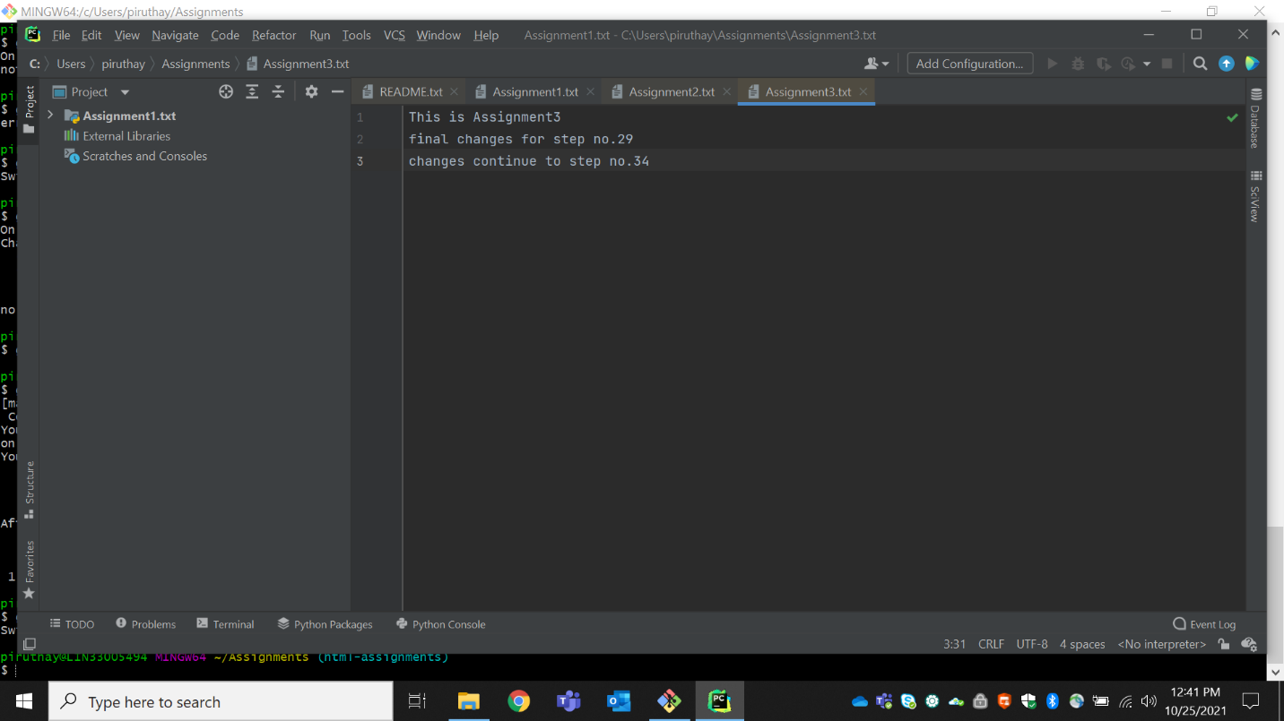

35.Commit those changes.

36.Switch to master.

37.Merge ‘html-assignments’ branch into master.Confirm all html assignments are shown in master.

38.Finally delete the ‘html-assignments’ branch.

