Automated Interview Evaluation System

Reading, Pronunciation & Speaking Skill Assessment using Classical ML/DSP Methods
Project Report / Technical Blueprint
Date: 17 July 2026
Constraint: This is a NO-AI project. It uses only traditional, statistical Machine Learning and Digital Signal Processing techniques (GMM-HMM, SVM, Random Forest, TF-IDF, DTW, rule-based alignment, dictionary lookup). No AI models of any kind are used - no deep learning, no neural networks, no pretrained embeddings, no LLMs, and no generative models anywhere in the pipeline. Section 1.3 lists the exact boundary between what is used and what is excluded.

1. Project Overview
The goal is to build an automated interview-evaluation platform that assesses a candidate's English reading, pronunciation, and spoken-answer quality without relying on AI/LLM models. The system runs the assessment in three sequential rounds, each producing an objective score derived from acoustic and text-based features processed through classical ML algorithms.

1.1 Objectives
- Evaluate reading accuracy and fluency when a candidate reads a displayed script sentence aloud.
- Evaluate pronunciation correctness of a displayed "difficult word" at the phoneme level.
- Evaluate whether a candidate's spoken answer to a pre-loaded interview question matches the reference answer in meaning/content.
- Produce a consolidated, explainable score report per candidate using transparent statistical/ML methods (not black-box neural models).

1.2 Scope & Constraints
- No use of deep neural network ASR (e.g., Whisper, wav2vec2) or LLMs (e.g., GPT, BERT, T5) anywhere in the pipeline.
- Speech recognition is done through classical GMM-HMM based acoustic modeling (CMU Sphinx / Kaldi).
- Pronunciation scoring uses signal-processing features (MFCC, pitch, formants) with statistical scoring (GOP) and classical classifiers (SVM/Random Forest).
- Answer-matching uses classical NLP/IR techniques (TF-IDF, cosine similarity, WordNet, fuzzy string matching) rather than embeddings from pretrained language models.
- The system must remain explainable: every score should be traceable to a measurable feature or rule.

1.3 Traditional ML vs. AI - Explicit Boundary
To remove any ambiguity, this project uses ONLY statistical/traditional Machine Learning techniques. No AI, deep learning, or generative models are used anywhere in the system - not for speech recognition, not for scoring, not for text matching. The table below draws the line explicitly.
USED - Traditional / Statistical ML (this project) | NOT USED - AI / Deep Learning / Generative Models
GMM-HMM acoustic models (CMU Sphinx, Kaldi) for speech-to-text | Neural / deep-learning ASR (Whisper, wav2vec2, DeepSpeech, Conformer)
Montreal Forced Aligner - GMM-HMM based forced alignment | End-to-end neural alignment or attention-based aligners
MFCC, pitch, formants, energy (signal-processing features) | Learned neural audio embeddings / self-supervised audio models
Goodness-of-Pronunciation (GOP) - HMM likelihood ratio, a statistical formula | Neural pronunciation-scoring models
SVM, Random Forest, Logistic/Linear Regression (scikit-learn classical classifiers) | Deep neural networks, CNNs, RNNs/LSTMs, Transformers
TF-IDF vectorization + cosine similarity (scikit-learn) | Word/sentence embeddings from pretrained models (word2vec, GloVe, BERT, sentence-transformers)
WordNet dictionary lookup (rule-based synonym sets) | Language models / LLMs (GPT, BERT, T5, LLaMA, etc.)
Levenshtein distance, DTW - deterministic sequence-alignment algorithms | Any generative AI (text or speech generation models)
RapidFuzz fuzzy string matching - rule-based edit-distance ratios | Any API call to a third-party AI/LLM service
Every algorithm named anywhere else in this report (ASR, alignment, scoring, text matching) is drawn only from the left-hand "Used" column above.

2. System Architecture
The architecture follows a modular pipeline: audio is captured in the browser, pre-processed, converted into acoustic/text features, evaluated independently by three round-specific engines, and finally combined by a scoring/aggregation layer that writes results to a report.
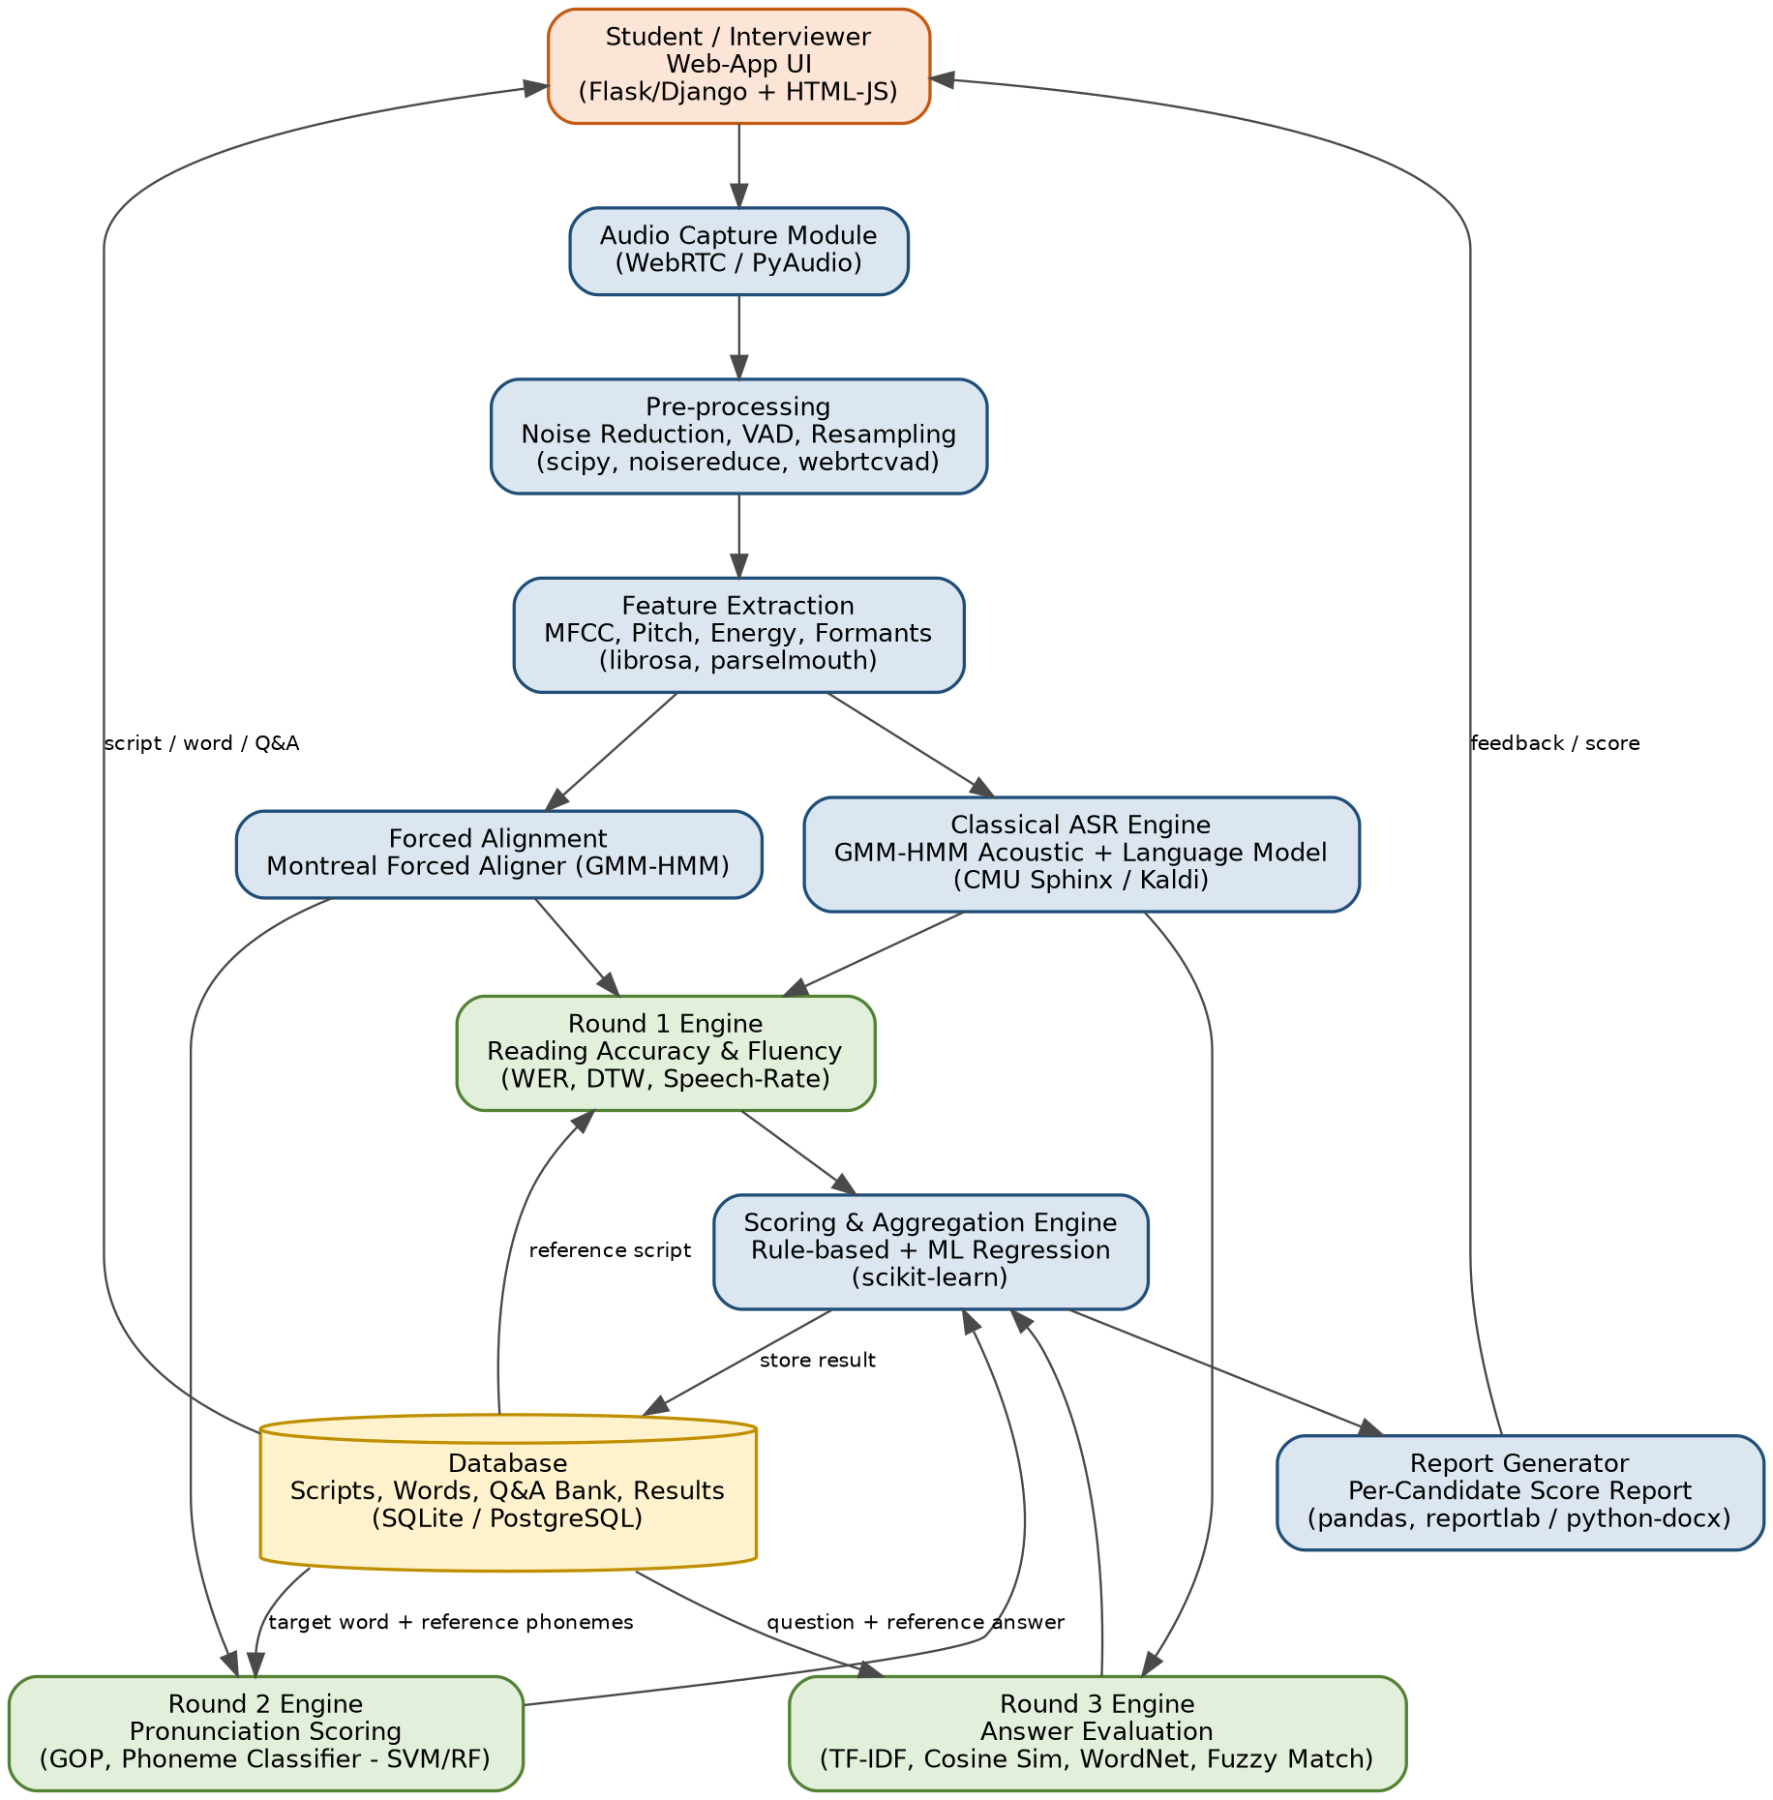
Figure 1: High-level system architecture

2.1 Layer Description
- Presentation Layer: Web UI (Flask/Django templates or a lightweight React app) that displays the script, word, or question, and captures audio via the browser's MediaRecorder API or a desktop PyAudio client.
- Pre-processing Layer: Cleans raw audio: resampling to 16 kHz, noise reduction, and Voice Activity Detection (VAD) to trim silence before feature extraction.
- Feature Extraction Layer: Extracts MFCC, pitch (F0), energy, formants, and speech-rate features using librosa and Praat (via parselmouth).
- Recognition & Alignment Layer: A classical GMM-HMM ASR engine (CMU Sphinx/Kaldi) transcribes speech; Montreal Forced Aligner aligns audio to the expected phoneme/word sequence for time-stamped comparison.
- Evaluation Engines: Three independent, round-specific scoring modules (detailed in Section 3) consume the aligned features/transcripts and output a numeric sub-score with supporting evidence (e.g., which words were misread, which phonemes were mispronounced).
- Scoring & Aggregation Layer: Combines the three round scores using the weighting scheme in Section 5 to produce a final candidate score.
- Data Layer: A relational database (SQLite for prototyping, PostgreSQL for production) stores the script bank, difficult-word list with reference phonemes, the Q&A bank with reference answers, and all candidate results.
- Reporting Layer: Generates a per-candidate report (PDF/Word) summarizing round-wise scores, error details, and the final grade.

3. Detailed Workflow (Round-by-Round)
The diagram below shows the end-to-end candidate journey across all three rounds, from session start to the final aggregated report.
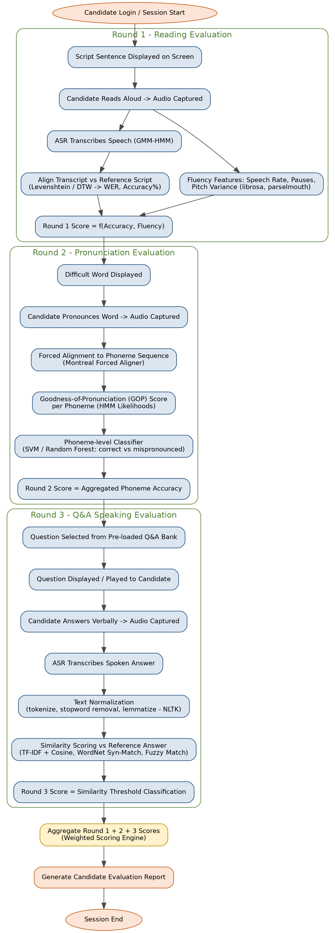
Figure 2: End-to-end evaluation workflow across Round 1, 2 and 3

3.1 Round 1 - Reading Evaluation
A sentence from the pre-loaded script bank is displayed on screen. The candidate reads it aloud; the recording is transcribed by the classical ASR engine and compared against the reference script.

Technical Approach
- Transcribe the reading using CMU Sphinx / Kaldi (GMM-HMM acoustic model + n-gram language model built from the script bank).
- Compute Word Error Rate (WER) via Levenshtein distance between the ASR transcript and the reference script to get an accuracy percentage.
- Extract fluency features: speech rate (words/minute), pause count and duration (from VAD segments), and pitch-variance (stability of intonation) using librosa/parselmouth.
- Combine accuracy and fluency into a Round 1 score using a rule-based weighted formula (see Section 5), calibrated with a linear regression model trained on human-graded samples.

Output
- Accuracy % (words correctly read), list of misread/skipped words, fluency score, and overall Round 1 score.

3.2 Round 2 - Pronunciation Evaluation
A difficult word (with a known reference phoneme/IPA transcription) is displayed. The candidate pronounces it; the system scores pronunciation at the phoneme level.

Technical Approach
- Use Montreal Forced Aligner (GMM-HMM based) to align the recorded audio to the expected phoneme sequence of the target word.
- Compute a Goodness-of-Pronunciation (GOP) score per phoneme: the log-likelihood ratio between the expected phoneme's HMM state and the best-matching state in the recording.
- Extract supporting acoustic features per phoneme (duration, energy, formant positions - F1/F2) to characterize vowel/consonant articulation.
- Feed GOP + acoustic features into a trained classical classifier (SVM or Random Forest) that outputs correct / mispronounced per phoneme, using a small labeled dataset of correct and common mispronunciations for calibration.

Output
- Phoneme-level correctness map, overall pronunciation accuracy %, and the specific phoneme(s) that were mispronounced (useful as feedback).

3.3 Round 3 - Q&A Speaking Evaluation
A question is selected from the pre-loaded Q&A bank (each question has one or more reference/acceptable answers). The candidate answers verbally; the system checks whether the answer matches the reference content.

Technical Approach
- Transcribe the spoken answer using the same classical ASR engine as Round 1.
- Normalize both the transcribed answer and the reference answer(s): lowercase, remove stopwords, tokenize and lemmatize using NLTK.
- Vectorize both texts with TF-IDF (scikit-learn) and compute cosine similarity as the primary match score.
- Supplement with WordNet-based synonym expansion (to catch paraphrases using different but related words) and RapidFuzz fuzzy string matching (to tolerate minor ASR transcription errors).
- Classify the answer as correct / partially correct / incorrect using a threshold on the combined similarity score, calibrated via logistic regression on sample graded answers.

Output
- Similarity score, matched/missing key concepts from the reference answer, and a correctness label with the Round 3 score.

4. Data Requirements
- Script Bank: A set of reading passages/sentences of varying difficulty, stored with plain text (used to build the ASR language model and as the WER reference).
- Difficult-Word List: Target words with their reference phoneme/IPA transcription (needed for forced alignment and GOP scoring).
- Q&A Bank: Interview questions with one or more acceptable reference answers (and optionally key concepts/keywords per answer for partial-credit matching).
- Labeled Training Samples: A modest set of recordings labeled as correct/incorrect pronunciation (for the Round 2 SVM/Random-Forest classifier) and sample graded answers (for calibrating the Round 3 similarity threshold).

5. Scoring & Weighting Methodology
Each round produces an independent, explainable sub-score. The final candidate score is a weighted combination, with weights adjustable based on what the evaluation prioritizes (e.g., a reading-focused test could increase Round 1's weight).
Round | Suggested Weight | Score Components
Round 1 - Reading | 35% | Word/Sentence Accuracy (WER-based) 60% + Fluency (speech-rate, pause ratio, pitch stability) 40%
Round 2 - Pronunciation | 30% | Phoneme-level GOP score 70% + Classifier confidence (SVM/RF correct-vs-mispronounced) 30%
Round 3 - Speaking / Q&A | 35% | Semantic/keyword similarity to reference answer (TF-IDF + WordNet) 70% + Response fluency (speech rate, filler/pause ratio) 30%

All thresholds and weights should be calibrated using a held-out set of human-graded recordings before deployment, and re-validated periodically.

6. Libraries, Tools & Technology Stack
The stack below uses exclusively classical ML/DSP libraries and statistical models - no pretrained deep-learning or generative-AI components.
Category | Library / Tool | Purpose in the Project
Audio I/O & Capture | PyAudio / WebRTC (browser mic) | Record candidate's speech from the web UI
Audio Pre-processing | scipy, soundfile, noisereduce, webrtcvad | Resampling, noise reduction, silence/voice-activity detection
Feature Extraction | librosa, python_speech_features | MFCC, pitch (F0), energy, spectral features, speech-rate
Prosody / Formant Analysis | praat-parselmouth (Praat engine) | Pitch contour, formants, jitter/shimmer for pronunciation & fluency cues
Classical ASR (Speech-to-Text) | CMU Sphinx (pocketsphinx) or Kaldi (GMM-HMM) | Transcribe read sentences / spoken answers without neural/AI models
Forced Alignment | Montreal Forced Aligner (MFA, GMM-HMM based) | Align audio to expected phoneme/word sequence for pronunciation scoring
Sequence / Text Alignment | python-Levenshtein, difflib, fastdtw | Compare read text vs script (WER, edit distance), DTW on acoustic features
Text Processing (NLP - classical) | NLTK | Tokenization, stopword removal, stemming/lemmatization, POS tagging, WordNet
Text Similarity | scikit-learn (TfidfVectorizer, cosine_similarity), RapidFuzz | Match candidate's spoken answer against the reference answer bank
ML Classification / Regression | scikit-learn (SVM, Random Forest, Logistic Regression, Linear/SVR) | Pronunciation correctness classifier, fluency/score regression, answer-match classifier
Data Handling | pandas, numpy | Manage question bank, scripts, word lists, scoring datasets
Database | SQLite / PostgreSQL | Persist scripts, difficult-word lists, Q&A bank, candidate scores
Backend / API | Flask or Django (REST API) | Serve UI, manage session flow across the three rounds
Frontend | HTML5/JS (MediaRecorder API), React (optional) | Display script/word/question, capture audio, show results
Reporting | pandas, matplotlib, python-docx / reportlab | Generate the per-candidate evaluation report (PDF/Word)
Model Persistence | joblib / pickle | Save and load trained scikit-learn models (SVM, RF, etc.)

7. Implementation Roadmap
A suggested ~12-week roadmap to take this from requirements to a deployed pilot.
Phase | Duration | Key Activities | Deliverable
1 | Week 1 | Requirement finalization; collect reading scripts, difficult-word list (with reference phoneme/IPA), and Q&A bank with reference answers; define scoring rubric and weightage | Finalized dataset (scripts, words, Q&A) + scoring rubric document
2 | Week 2 | Set up audio capture (browser MediaRecorder / PyAudio); build pre-processing pipeline (resampling, noise reduction, VAD) | Working audio-recording module producing clean WAV files
3 | Weeks 3-4 | Install & configure classical ASR (CMU Sphinx / Kaldi GMM-HMM) and Montreal Forced Aligner; test transcription and phoneme alignment accuracy on sample recordings | ASR + forced-alignment pipeline producing transcript and phoneme timings
4 | Week 5 | Build Round 1 engine: WER/Levenshtein-based accuracy scoring + fluency features (speech rate, pause ratio, pitch variance) combined into a fluency score | Round 1 scoring module with test results on sample recordings
5 | Week 6 | Build Round 2 engine: Goodness-of-Pronunciation (GOP) scoring from HMM likelihoods; train SVM/Random-Forest classifier on labeled correct/incorrect pronunciation samples | Round 2 pronunciation-scoring module + trained classifier
6 | Week 7 | Build Round 3 engine: text normalization (NLTK), TF-IDF + cosine similarity, WordNet synonym expansion, fuzzy matching; calibrate similarity threshold for correct/incorrect answers | Round 3 answer-evaluation module
7 | Week 8 | Build the weighted scoring/aggregation engine combining Round 1-3 scores; design DB schema and integrate with backend (Flask/Django) | End-to-end backend with score aggregation and DB persistence
8 | Week 9 | Build frontend flow (script/word/question display, recording controls, round transitions) and connect to backend APIs | Functional web application covering all 3 rounds
9 | Week 10 | Pilot testing with sample students; collect feedback; calibrate thresholds and model weights; generate evaluation report output | Validated system + sample candidate reports
10 | Week 11-12 | Bug fixing, performance tuning, documentation, and deployment (on-prem or cloud VM) | Deployed, documented system ready for use

8. Evaluation Metrics & Validation
- Round 1: Word Error Rate (WER), reading-accuracy %, correlation of fluency score with human raters.
- Round 2: Phoneme-level classifier accuracy/F1-score against human-labeled pronunciation data; correlation of GOP score with expert pronunciation ratings.
- Round 3: Precision/Recall of the correct-vs-incorrect answer classification against human-graded answers; false-positive rate on off-topic answers.
- System-level: Inter-rater agreement between the automated score and human interviewer scores (e.g., Pearson/Spearman correlation) on a validation set.

9. Limitations & Future Enhancements
- Classical GMM-HMM ASR is less robust to accents/noise than modern neural ASR - mitigate with a well-tuned language model restricted to the known script/word/answer vocabulary.
- TF-IDF/WordNet-based answer matching may miss paraphrases with very different wording - mitigate by allowing multiple reference-answer variants and key-concept keyword lists per question.
- Future enhancement (outside current AI-free constraint): once permitted, an optional neural ASR or embedding-based similarity module could be added as a plug-in without changing the overall architecture.
- Continuous recalibration of classifier thresholds as more labeled candidate data becomes available.

10. Conclusion
This blueprint defines a fully explainable, classical ML/DSP-based pipeline for automated reading, pronunciation, and spoken-answer evaluation, avoiding any generative AI or deep-learning foundation models. The modular architecture allows each round's engine to be developed and validated independently, and the roadmap provides a practical week-by-week path from data collection to a deployed pilot.

