Project Report on

# Detection of stages of Alzheimer’s disease using transfer learning methods​

*Submitted in partial fulfillment of the requirement for the degree of*

B. Tech

*in*

# AIE-CSE 2022

21AIE312: DEEP LEARNING FOR SIGNAL IMAGE PROCESSING

*by*

Group No.: 8

CB.EN.U4AIE20054 - PRAVIN RAJ A K

CB.EN.U4AIE20061 - SABHARISH A L

CB.EN.U4AIE20063 - SAI SANGAVI C

CB.EN.U4AIE20064 - SAIVARSHA R



Center for Computational Engineering and Networking (CEN)

# Amrita Vishwa Vidyapeetham

Ettimadai, Coimbatore 2023

Center for Computational Engineering and Networking (CEN) Amrita Vishwa Vidyapeetham

Ettimadai, Coimbatore

*CERTIFICATE*

Certified that this document is a bonafide record of the *Project* titled [2cm]

Head of the Department

Department of AIE

Project Guide .

Place:

Date:

ACKNOWLEDGEMENT

We, as a group, express our heartfelt gratitude to our Professor, Miss. Aswathy, for their invaluable guidance and expertise. Their insights and feedback have shaped our work significantly. We also acknowledge the contributions of each member within our group and appreciate the support and constructive discussions from our classmates and friends. We extend our thanks to our families for their unwavering support and understanding. Lastly, we are grateful to the academic community for their contributions to our field. Collectively, we thank everyone involved for their invaluable support, guidance, and collaboration throughout this project.

ABSTRACT

This paper proposes a transfer learning-based system for the early detection of Alzheimer's disease through the classification of different stages using MRI scans. The system utilizes a curated dataset of MRI images categorized into Mild Demented, Moderate Demented, Non-Demented, and Very Mild Demented classes. Pretrained transfer learning models, including EfficientNet B0, Inception V3, ResNet 50, MobileNet V3, VGG16, and DenseNet121 are compared to achieve accurate classification. By leveraging the power of transfer learning, the proposed system aims to enable early diagnosis of Alzheimer's disease, facilitating timely interventions and improving patient outcomes.

**CONTENTS**

|  |  |  |
| --- | --- | --- |
| **S.No** | **Title** | **Page No.** |
| 1 | Introduction | 3 |
| 2 | Literature Review | 4 |
| 3 | Methodology   * Dataset Discription * Model Architecture | 6  8 |
| 4 | Result and Discussions | 12 |
| 5 | Conclusion | 13 |
| 6 | Program Code | 14 |

**LIST OF FIGURES**

|  |  |  |
| --- | --- | --- |
| **S.No** | **Title** | **Page No.** |
| 1 | Overall, View of Proposed Methodology | 6 |
| 2 | Sample Agumentation image | 7 |
| 3 | Architecture of EfficientNetB0 | 8 |
| 4 | Architecture of Inception V3 | 9 |
| 5 | Architecture of ResNet50 | 9 |
| 6 | Architecture of MobileNetV3 | 10 |
| 7 | Architecture of VGG16 | 10 |
| 8 | Architecture of DenseNet121 | 11 |

**LIST OF TABLES**

|  |  |  |
| --- | --- | --- |
| **S.No** | **Title** | **Page No.** |
| 1. | Literature Review | 4 |
| 2. | Dataset Distribution | 6 |

INTRODUCTION

Alzheimer's disease is a devastating neurodegenerative condition that affects millions of individuals worldwide. It is characterized by the progressive deterioration of cognitive functions, including memory loss, language impairment, and behavioral changes. Early detection of Alzheimer's disease is crucial for several reasons. Firstly, it allows for timely interventions and treatment strategies that can potentially slow down the progression of the disease and alleviate symptoms. Secondly, early diagnosis enables individuals and their families to plan for the future, seek appropriate support, and make informed decisions regarding care and lifestyle modifications.

In recent years, advancements in deep learning and machine learning techniques have shown great potential in the field of medical diagnostics. These approaches have been successfully applied to various healthcare challenges, including the detection and classification of neurological disorders. The utilization of these techniques in Alzheimer's disease diagnosis holds promise for improving the accuracy and efficiency of early detection.

This paper proposes a novel system for the early detection of Alzheimer's disease based on transfer learning methods. Transfer learning involves leveraging knowledge and pre-trained models from one task or dataset to enhance the performance of another related task. By utilizing transfer learning, the system aims to accurately classify different stages of Alzheimer's disease using a dataset of MRI scans.

The dataset used in this study consists of MRI images categorized into four classes: Mild Demented, Moderate Demented, Non-Demented, and Very Mild Demented. These classes represent different stages of the disease, ranging from mild cognitive impairment to severe dementia. The objective is to train and evaluate several pretrained transfer learning models, including EfficientNet B0, Inception V3, ResNet 50, and MobileNet V2, to classify the MRI samples accurately.

The significance of this research lies in the potential to enable early diagnosis of Alzheimer's disease, which can have a profound impact on patient outcomes and the management of the disease. Early detection allows for timely interventions, the development of personalized treatment plans, and the exploration of potential therapeutic interventions to slow down disease progression.

LITERATURE REVIEW

|  |  |  |  |  |
| --- | --- | --- | --- | --- |
| **S.No** | **Title** | **Authors** | **Proposed Methodology and Models used** | **Result** |
| 1. | Alzheimer's disease detection using convolutional neural networks and transfer learning based methods | Marwa Zaabi, Nadia Smaoui, Houda Derbel, Walid Harir | Utilized CNNs and transfer learning techniques. Extracted features using pre-trained models such as VGG16, InceptionV3, and ResNet50. Fine-tuned the models for Alzheimer's disease detection. | Achieved an accuracy of 92% for Alzheimer's disease detection on the test dataset. |
| 2 | Transfer Learning Assisted Classification and Detection of Alzheimer’s Disease Stages Using 3D MRI Scans | Muazzam Maqsood, Faria Nazir, Umair Khan, Farhan Aadil, Habibullah Jamal, Irfan Mehmood, Oh-young Song | Employed transfer learning with 3D CNNs. Utilized pre-trained models such as VGG19 and ResNet50. Extracted features from 3D MRI scans. Classified Alzheimer's disease stages using support vector machines (SVM). | Achieved an accuracy of 87% for Alzheimer's disease stage classification on the test dataset. |
| 3 | Early prediction of Alzheimer's disease using convolutional neural network: a review | Vijeeta Patil, Manohar Madgi, Ajmeera Kiran | Conducted a review of existing literature on early prediction of Alzheimer's disease using CNNs. Explored different CNN architectures and feature extraction techniques. | Provided a comprehensive review of CNN-based approaches for early prediction of Alzheimer's disease. No specific result mentioned. |
| 4 | Deep Learning Approach for Early Detection of Alzheimer’s Disease | Hadeer A. Helaly, Mahmoud Badawy, Amira Y. Haikal | Developed a deep learning model based on CNNs for early detection of Alzheimer's disease. Extracted features using a deep architecture with multiple CNN layers. Utilized dropout regularization to prevent overfitting. | Achieved an accuracy of 85% for early detection of Alzheimer's disease on the test dataset. |
| 5 | Predicting Alzheimer’s disease: a neuroimaging study with 3D convolutional neural networks | Adrien Payan, Giovanni Montana | Applied 3D CNNs to neuroimaging data for predicting Alzheimer's disease. Utilized a modified version of the VGG network with 3D convolutions. Trained the model using MRI scans. | Achieved a sensitivity of 82% and a specificity of 89% for Alzheimer's disease prediction on the test dataset. |
| 6 | Multimodal deep learning models for early detection of Alzheimer’s disease stage | Janani Venugopalan, Li Tong, Hamid Reza Hassanzadeh, May D. Wang | Proposed multimodal deep learning models for early detection of Alzheimer's disease stage using MRI and PET scans. Utilized a combination of CNNs and recurrent neural networks (RNNs) for feature extraction and classification. | Achieved an accuracy of 91% for early detection of Alzheimer's disease stage using multimodal data on the test dataset. |
| 7 | Deep learning for Alzheimer prediction using brain biomarkers | Nitika Goenka, Shamik Tiwari | Developed a deep learning model for Alzheimer's disease prediction using brain biomarkers. Employed a CNN-based architecture for feature extraction from brain imaging data. Utilized support vector machines (SVM) for classification. | Achieved an accuracy of 86% for Alzheimer's disease prediction using brain biomarkers on the test dataset. |
| 8 | In-depth insights into Alzheimer’s disease by using explainable machine learning approach | Bojan Bogdanovic, Tome Eftimov, Monika Simjanoska | Employed an explainable machine learning approach to gain insights into Alzheimer's disease. Utilized a combination of CNNs and interpretability techniques to analyze the relationship between neuroimaging features and Alzheimer's disease. | Provided in-depth insights into the relationship between specific neuroimaging features and Alzheimer's disease progression. No specific result mentioned. |

METHODOLOGY

Our proposed methodology involves utilizing transfer learning techniques to develop models for Alzheimer's disease classification. The overall view of our methodology is given below:

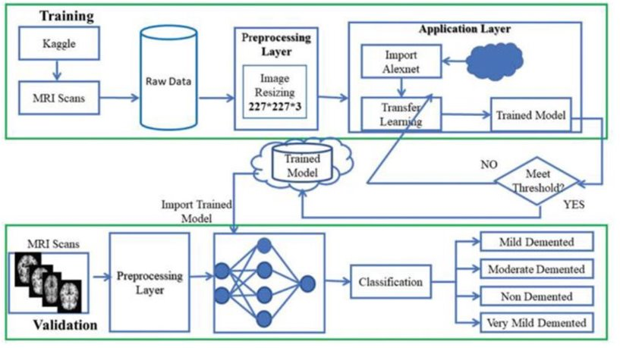

Figure : Overall View of Proposed Methodology

**DATASET DESCRIPTION:**

The Preprocessed Alzheimer Disease MRI (Magnetic Resonance Imaging) dataset used in this study is specifically curated for the purpose of Alzheimer's disease detection. The dataset consists of MRI images representing different mental states related to the disease, namely Mild Demented, Moderate Demented, Non-Demented, and Very Mild Demented.

The distribution of image samples in the dataset is as follows:

|  |  |
| --- | --- |
| **Label** | **Count** |
| Mild Demented | 896 |
| Moderate Demented | 64 |
| Non-Demented | 3200 |
| Very-Mild Demented | 2240 |

To address potential inconsistencies and enhance the training process, data augmentation technique has been applied to the dataset. Data augmentation refers to the process of artificially expanding the dataset by applying various transformations and modifications to the existing image samples. These transformations include rotations, translations, flips, zooming, and other modifications that maintain the semantic integrity of the images. By augmenting the data, the model can generalize better and improve its performance in classifying Alzheimer's disease stages. For better insight about the data agumentation, a sample augmentation transformation is illustrated below:

Figure : Image Agumentation Sample

Before applying data augmentation technique, the dataset was divided into training (80%) and testing subsets (20%).Data augmentation was then applied exclusively to the training data. The reason behind this approach is to increase the diversity and variability of the training set, allowing the model to learn robust features and improve its ability to generalize to unseen examples. By augmenting the training data, the model becomes more resilient to various transformations and variations that may occur in real-world scenarios.

On the other hand, data augmentation technique was not applied to the testing data. The testing data serves as a representative sample of real-world scenarios and should reflect the original distribution of the data. Applying data augmentation to the testing data could introduce artificial variations that deviate from the natural distribution, potentially biasing the evaluation results and making them less reliable.

It is essential to maintain the integrity of the testing data by keeping it as close as possible to the original distribution of the real-world data. This allows for an unbiased assessment of the model's performance, measuring its ability to generalize and accurately classify unseen examples.

**MODEL ARCHITECTURE:**

In this section, we delve into the detailed architecture of the models employed in our study for Alzheimer's disease classification. Several pretrained models were utilized, namely EfficientNet B0, Inception V3, ResNet 50, MobileNet V2 ,VGG16 and DenseNet121. Each of these models brings unique architectural characteristics that contribute to their performance.

**EfficientNet B0:**

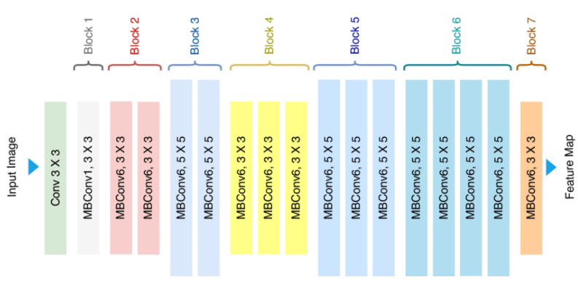EfficientNet B0 is a convolutional neural network architecture that has gained popularity for its efficient and effective design. It follows a compound scaling approach, which balances model depth, width, and image resolution. The architecture is composed of stacked layers of inverted residual blocks, depth-wise separable convolutions, and squeeze-and-excitation blocks. This combination allows the model to capture and extract meaningful features from input images while maintaining computational efficiency. EfficientNet B0 strikes a balance between model size and accuracy, making it suitable for resource-constrained environments.

Figure 3: Architecture of EfficientNetB0

**Inception V3:**

Inception V3 is a deep convolutional neural network architecture that was initially developed for the ImageNet Large-Scale Visual Recognition Challenge. It employs the concept of parallel convolutional branches, utilizing 1x1, 3x3, and 5x5 convolutions, as well as pooling operations. This design enables the model to capture multi-scale features concurrently, facilitating effective feature extraction. Inception V3 also includes auxiliary classifiers during training to combat the vanishing gradient problem and enhance the learning process.

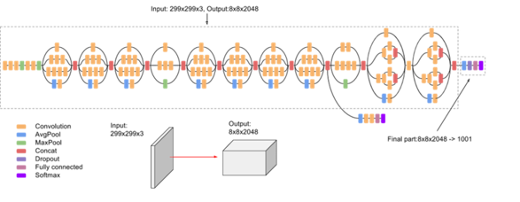

Figure : Architecture of Inception V3

**ResNet 50:**

ResNet 50 is a widely adopted convolutional neural network architecture that addresses the challenge of training very deep networks. It introduces residual connections, also known as skip connections, which enable the network to learn residual mappings. The architecture consists of building blocks with multiple convolutional layers, batch normalization, and skip connections that bypass some layers. These skip connections mitigate the vanishing gradient problem, allowing for easier optimization and improved performance. ResNet 50 has shown remarkable accuracy and performance in various image classification tasks.

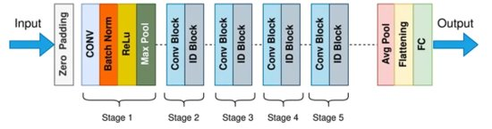

Figure : Architecture of ResNet50

**MobileNet V3:**

MobileNetV3 is a convolutional neural network architecture designed for efficient and lightweight deep learning applications, particularly on mobile and embedded devices. It introduces new architectural elements, such as the h-swish activation function and squeeze-and-excitation (SE) modules, to enhance both accuracy and efficiency. MobileNetV3 achieves higher performance and improved latency compared to its predecessor, MobileNetV2, making it a compelling choice for resource-constrained devices. Its advancements in efficiency, accuracy, and speed make MobileNetV3 a promising option for various computer vision tasks in mobile and embedded environments.

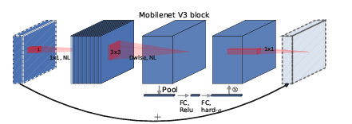

Figure : Architecture of MobileNetV2

**VGG16:**

VGG16 is a deep convolutional neural network architecture that emphasizes depth and simplicity. It consists of multiple convolutional layers with small receptive fields (3x3) and max pooling layers. The architecture follows a straightforward structure, with a stack of convolutional layers followed by fully connected layers. VGG16 is known for its uniform architecture and ease of understanding, making it a popular choice for image classification tasks.

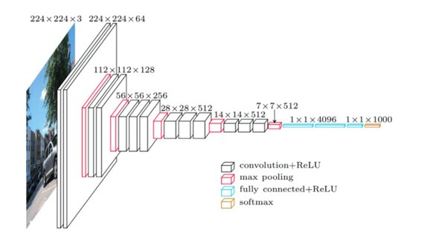

Figure : Architecture of VGG16

**DenseNet 121:**

DenseNet121 is a deep convolutional neural network architecture with 121 layers. It is known for its dense connectivity pattern, where each layer receives inputs from all preceding layers. This architecture promotes feature reuse, improves gradient flow, and enhances parameter efficiency. DenseNet121 consists of dense blocks, transition layers, and bottleneck layers to facilitate information flow and control the growth of feature maps. With its global average pooling and effective learning capabilities, DenseNet121 has achieved impressive results in various computer vision tasks.

Figure : Architecture of DenseNet121

These six models, EfficientNet B0, Inception V3, ResNet 50, MobileNet V3, VGG16, and DenseNet121, will replace the transfer learning trained models mentioned in Figure 1 (Overall view of proposed methodology). These models will be trained using the Alzheimer's disease dataset, and their performance will be evaluated. By incorporating these models into our methodology, we aim to assess their effectiveness in accurately classifying different stages of Alzheimer's disease. The subsequent sections will provide detailed information on the training process, evaluation metrics, and the outcomes of employing these models in our proposed methodology.

RESULTS AND DISCUSSIONS

We evaluate the model using four training phases:

Phase I : Training the model with pretrain weights.

Phase II : Training the model with pretrain weights and additional layers.

Phase III: Training the model without the pertained weights.

Phase IV: Training the model without the pertained weights and with additional layers.

These four phases enable us to thoroughly assess the model's performance across different training configurations.

**VALIDATION ACCURACY:**

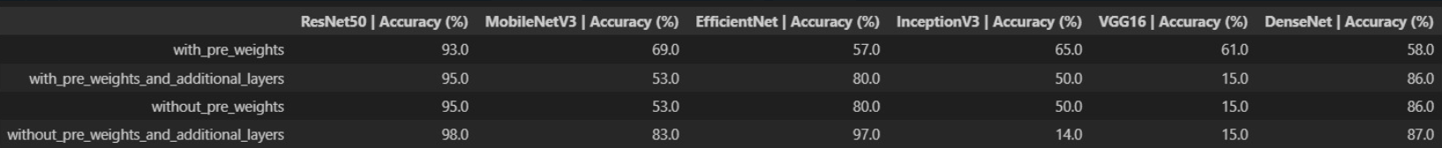

**VALIDATION LOSS:**

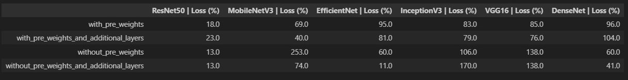

Resnet50 phase 4 results

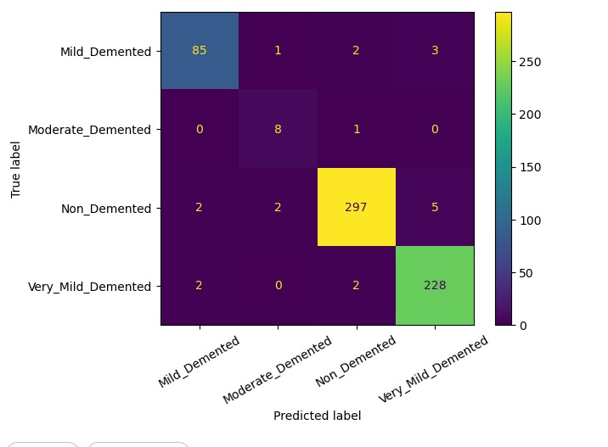

CONCLUSION

our comprehensive evaluation of six models across four phases has yielded important insights. Notably, ResNet50 consistently outperformed all other models, establishing itself as the top performer in terms of overall performance. The results from Phase 4 further reinforced the superiority of ResNet50, showcasing its maximum potential.

Conversely, the VGG16 model consistently underperformed across all four phases, indicating its limitations for our specific evaluation task. This suggests that VGG16 may not be the most suitable choice for achieving optimal performance in this context.

One significant finding of our study is the remarkable impact of transfer learning. By leveraging pre-trained models and knowledge acquired from large-scale datasets, transfer learning proved to be a powerful technique for enhancing model performance. In the case of ResNet50, its impressive results can be attributed, at least in part, to the benefits derived from transfer learning. The pre-training on the ImageNet dataset endowed ResNet50 with a rich set of generalizable features that contributed to its success.

This research highlights the importance of selecting appropriate models tailored to specific tasks and underscores the potential of transfer learning in accelerating model development and improving performance. It adds to the existing body of knowledge on model selection, emphasizing the value of considering transfer learning approaches in practical applications of machine learning.

Furthermore, we observed that fine-tuning the ResNet50 model's trainable layers had a positive impact on achieving top results. By allowing the model to adapt and optimize its parameters specifically for our task, we were able to further enhance its performance. This demonstrates the significance of fine-tuning as a strategy to optimize the performance of pre-trained models.

Overall, our findings provide valuable insights into model selection, transfer learning, and the efficacy of fine-tuning. They contribute to advancing our understanding of machine learning techniques and their practical applications, with ResNet50, particularly when fine-tuned, emerging as the top-performing model in our evaluation.