

**Gulf Countries Oil Market Analysis**

**Report Writing (Project)**

**Submitted By:**

Pravir Mishra (E22BCAU0143)

Harsh Chaudhary (E22BCAU0029)

Nakul Chauhan (E22BCAU0013)

**Course Name:** Digital Marketing and Trend Analysis

**Course Code:** CBCA311

**QUOTE  
ABSTARCT**

The project titled “Gulf Countries Oil Market Analysis” is a comprehensive study of the oil market in the Gulf countries. The project, conducted by Pravir Mishra, Harsh Chaudhary, and Nakul Chauhan, utilizes data from various CSV files to provide a detailed analysis of the oil export patterns, revenue utilization, and tax utilization in these countries.

The data, which spans several years, includes information about the country, year, export volume, export value, destination, type of oil, price per barrel, and export revenue. The project employs Python for data analysis, checking for null values, obtaining data information, and describing the data.

The study also involves the creation of Linear Regression models to predict export revenue based on export volume and price per barrel, and to predict tax generated based on tax rate per year. These models provide valuable insights into the factors influencing the oil market in the Gulf countries.

Additionally, the project includes various visualizations such as histograms, box plots, scatter plots, and time series plots to better understand the data and the trends it reveals. These visualizations aid in the interpretation of the data and the conclusions drawn from it.

Overall, this project provides a thorough and insightful analysis of the Gulf Countries Oil Market, contributing to a better understanding of the dynamics and trends in this crucial sector. The findings of this study have significant implications for policy-making, economic planning, and strategic decision-making in the oil industry.

**Overview of this project:**

1. **Project Title**: Gulf Countries Oil Market Analysis
2. **Objective**: To provide a comprehensive analysis of the oil market in the Gulf countries, focusing on export patterns, revenue utilization, and tax generation.
3. **Data**: Utilizes three primary datasets stored in CSV files, each providing unique insights into the oil market.
4. **Python Code**: Employs Python for data analysis, including data import, cleaning, model building, evaluation, and forecasting.
5. **Predictive Models**: Builds Linear Regression models to predict export revenue based on export volume and price per barrel, and to predict tax generated based on tax rate per year.
6. **Model Evaluation**: Prints the predicted and actual values of the export revenue for comparison, providing an evaluation of the model’s performance.
7. **Visualizations**: Generates various visualizations such as histograms, box plots, scatter plots, and time series plots to aid in interpreting the data and understanding the trends it reveals.
8. **Time Series Analysis**: Includes time series analysis to analyze data that is collected over a period of time and visualizes the trends over time.
9. **Forecasting**: Uses the ARIMA model to forecast the export volume for future years.
10. **Conclusion**: The project provides a thorough and insightful analysis of the Gulf Countries Oil Market, contributing to a better understanding of the dynamics and trends in this crucial sector. The findings of this study have significant implications for policy-making, economic planning, and strategic decision-making in the oil industry. The project serves as a robust tool for analyzing the Gulf Countries Oil Market and can be further extended or modified for other similar studies. The use of predictive models and visualizations enhances the understanding of the data and the trends it reveals. The project is a testament to the power and versatility of Python in handling and analyzing complex datasets. We look forward to uncovering the dynamics of the Gulf oil market through this project.

**INTRODUCTION**

The project “Gulf Countries Oil Market Analysis” embarks on an in-depth exploration of the oil market in the Gulf countries, a region that holds significant sway over the global oil industry. This study is conducted by Pravir Mishra, Harsh Chaudhary, and Nakul Chauhan, who bring their expertise to bear on this complex and crucial subject.

The Gulf region, rich in oil reserves, plays a pivotal role in the global energy sector. The economies of these countries are heavily reliant on oil exports, making the analysis of this market critical for understanding the economic dynamics of the region and its impact on the world economy.

In this project, we delve into various aspects of the oil market, including export patterns, revenue utilization, and tax utilization. We utilize data from several CSV files, each containing detailed information about the country, year, export volume, export value, destination, type of oil, price per barrel, and export revenue. This data spans several years, providing a comprehensive view of the trends and patterns in the Gulf oil market.

In the coding part of the project, we employ Python, a powerful and versatile programming language, to analyze the data. We begin by reading the data from the CSV files and conducting preliminary checks for null values. We then proceed to obtain information about the data and describe the data to understand its structure and content.

We also create Linear Regression models to predict export revenue based on export volume and price per barrel, and to predict tax generated based on tax rate per year. These models will help us understand the factors influencing export revenue and tax generation in the Gulf countries.

Furthermore, we generate various visualizations such as histograms, box plots, scatter plots, and time series plots. These visualizations will aid in interpreting the data and understanding the trends it reveals.

**Comprehensive Analysis of the Gulf Countries Oil Market: A Study on Export Patterns, Revenue Utilization, and Tax Generation**

The project “Gulf Countries Oil Market Analysis” utilizes three primary datasets, each providing unique insights into the oil market of the Gulf countries.

The first dataset, ‘gcc_oil_export_data.csv’, contains detailed information about the oil exports from the Gulf countries. The data spans several years and includes variables such as the country, year, export volume, export value, destination, type of oil, price per barrel, and export revenue. This dataset is crucial for understanding the export patterns and the factors influencing the export revenue.

The second dataset, ‘revenue_utilization.csv’, provides information about how the export revenue is utilized in different sectors. It includes variables such as the country, year, export revenue, and the amount of revenue utilized in infrastructure, healthcare, and education. This dataset helps us understand the economic impact of oil exports and how the revenue contributes to the development of various sectors.

The third dataset, ‘tax_utilization_modified.csv’, contains information about the tax generated from the oil exports and how it is utilized. It includes variables such as the country, tax rate per year, year period, tax generated, sector, and tax utilization. This dataset provides insights into the fiscal policies of the Gulf countries and the role of oil exports in their tax revenue.

In the coding part of the project, we employ Python to analyze these datasets. We perform various operations such as reading the data, checking for null values, obtaining information about the data, and describing the data. We also create Linear Regression models to predict export revenue and tax generated. Furthermore, we generate various visualizations to better understand the data and the trends it reveals.

Overall, these datasets provide a comprehensive view of the Gulf Countries Oil Market. They allow us to analyze the market from various angles - export patterns, revenue utilization, tax generation, and more. The findings from these datasets have significant implications for policy-making, economic planning, and strategic decision-making in the oil industry. We look forward to uncovering the dynamics of the Gulf oil market through this project.

**CONTEXTUAL BACKGROUND**

The Gulf region, comprising of countries such as Saudi Arabia, United Arab Emirates, Qatar, Kuwait, Oman, and Bahrain, holds a significant position in the global oil industry. These countries are part of the Organization of the Petroleum Exporting Countries (OPEC), a consortium that plays a major role in determining global oil prices. The Gulf countries are known for their vast reserves of crude oil, making them pivotal players in the global energy sector.

The oil industry in these countries is not just a source of energy, but also a major contributor to their economies. The revenues generated from oil exports are utilized in various sectors such as infrastructure, healthcare, and education, driving the overall development of these nations. Moreover, the tax generated from oil exports forms a significant part of the government’s revenue, influencing fiscal policies.

However, the oil market is subject to fluctuations due to various factors such as geopolitical issues, global demand and supply, technological advancements in extraction and processing, and environmental concerns. These factors can impact the volume of oil exports, the price per barrel, and consequently, the export revenue.

In recent years, there has been a growing interest in understanding the oil market dynamics in the Gulf countries. This is due to the increasing global energy demand, the shift towards renewable energy sources, and the geopolitical implications of oil exports.

This project, “Gulf Countries Oil Market Analysis”, is set against this contextual background. It aims to provide a comprehensive analysis of the oil market in the Gulf countries, focusing on export patterns, revenue utilization, and tax generation. The findings of this study will contribute to a better understanding of the oil market dynamics in the Gulf countries and their implications for the global energy sector. The project will also shed light on the economic impact of oil exports in these countries, providing valuable insights for policy-making and strategic decision-making in the oil industry.

Continuing from the contextual background, the oil industry in the Gulf countries has been a subject of global interest due to its vast reserves and significant contribution to the world’s oil supply. The oil market in these countries is complex and influenced by a myriad of factors, both internal and external.

Internally, the oil market is shaped by the policies of the respective governments, their economic strategies, and the infrastructure available for oil extraction and export. The revenue generated from oil exports is a major source of income for these countries, and its utilization has a direct impact on their economies. The tax generated from oil exports also forms a significant part of the government’s revenue, influencing fiscal policies and public spending.

Externally, the oil market is influenced by global demand and supply, geopolitical issues, and technological advancements in extraction and processing. The shift towards renewable energy sources and the increasing concern for environmental sustainability have also impacted the oil market.

In this project, we delve into these aspects, analyzing the data to uncover patterns and trends in the oil market. We employ Python for data analysis, utilizing its powerful libraries and tools to manipulate the data, create predictive models, and generate visualizations.

The predictive models, based on Linear Regression, aim to predict export revenue based on export volume and price per barrel, and to predict tax generated based on tax rate per year. These models will provide valuable insights into the factors influencing export revenue and tax generation, helping us understand the dynamics of the oil market.

The visualizations, including histograms, box plots, scatter plots, and time series plots, will aid in interpreting the data and understanding the trends it reveals. They will provide a visual representation of the data, making it easier to comprehend and interpret.

Through this project, we aim to provide a comprehensive analysis of the Gulf Countries Oil Market, contributing to a better understanding of the dynamics and trends in this crucial sector. The findings of this study will have significant implications for policy-making, economic planning, and strategic decision-making in the oil industry. We look forward to uncovering the dynamics of the Gulf oil market through this project.

**Analysis:**

The analysis of the Gulf Countries Oil Market is conducted using Python, a powerful programming language widely used in data analysis. Here’s a breakdown of the code and its functions:

1. **Data Import and Preliminary Analysis**: The code begins by importing the necessary libraries and reading the data from CSV files. The pandas library is used for data manipulation and analysis. The read_csv function is used to read the CSV file and store the data in a DataFrame, a two-dimensional tabular data structure with labeled axes.

**Python**

import pandas as pd

df1 = pd.read_csv('gcc_oil_export_data.csv')

**Data Cleaning**: The code checks for null values in the data using the isnull function. This is important as null values can affect the results of the analysis.

**Python**

print(df1.isnull().sum())

**Data Information and Description**: The info and describe functions are used to get information about the data and provide descriptive statistics respectively.

**Python**

df1.info()

df1.describe()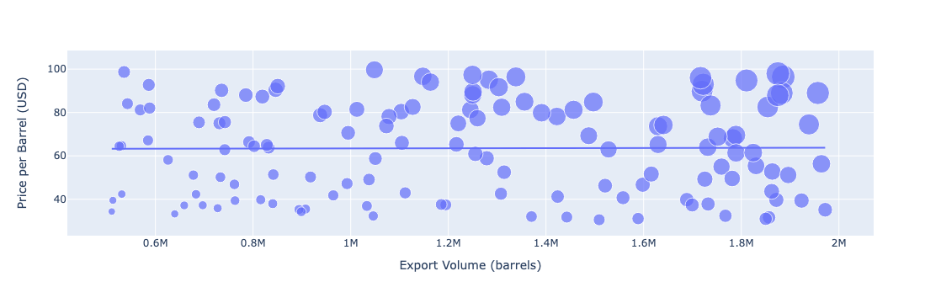

t’s used to display the relationship between two numerical variables, with each blue dot representing a data point. In this case, the graph is showing the relationship between the price per barrel (in USD) and export volume (in barrels).

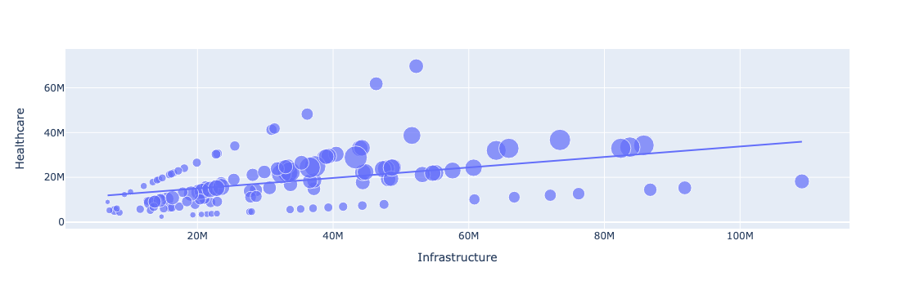

 This type of graph is used to display the relationship between two variables. In this case, it’s showing the relationship between infrastructure and healthcare.

The trend line suggests a positive correlation between the two variables. This means that as infrastructure improves, healthcare also tends to improve, and vice versa. This could imply that investments or developments in these sectors are correlated.

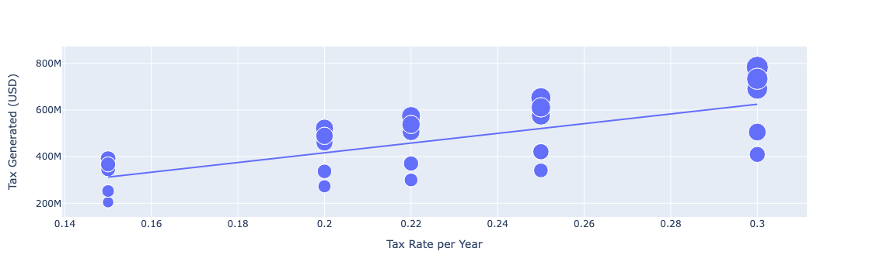

This graph is showing the relationship between the tax rate per year and the tax generated in USD.

The trend line suggests a positive correlation between the two variables. This means that as the tax rate increases, the tax generated also tends to increase. This could imply that higher tax rates lead to more tax revenue.

The image you’ve shared is a line graph titled “gcc_oil_export_data.csv”. It shows the fluctuations in oil exports from the year 2000 to 2020.

This graph provides insights into the patterns and trends of oil exports over two decades. It can be used to analyze how various factors such as global demand, oil prices, and geopolitical events might have influenced the volume of oil exports during this period.

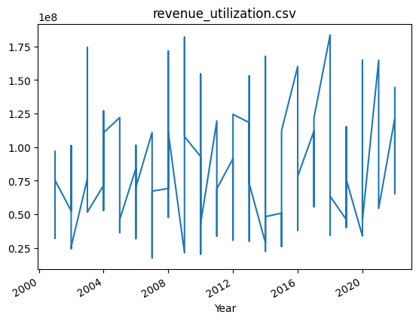

The image you’ve shared is a line graph titled “revenue_utilization.csv”. It represents data from the year 2000 to 2020, illustrating significant variations and patterns in the data over time.

This graph can be used to analyze trends and fluctuations in revenue utilization over the two decades. It might reflect the impact of various factors such as changes in market conditions, business strategies, or economic events.

It’s showing the relationship between export volume in barrels and export revenue in USD.

Each dot on the graph represents a data point. The distribution of these points can provide insights into how changes in export volume affect export revenue. For example, if the points are closely clustered along a line that slopes upwards, this would suggest a positive correlation between export volume and revenue.

**Model Building**: The code builds a Linear Regression model to predict export revenue based on export volume and price per barrel. The sklearn library is used for this purpose. The data is split into training and testing sets, and the model is trained on the training set and used to make predictions on the testing set.

**Python**

from sklearn.model_selection import train_test_split

from sklearn.linear_model import LinearRegression

X1 = df1[['Export Volume (barrels)', 'Price per Barrel (USD)']]

y1 = df1['Export Revenue (USD)']

X1_train, X1_test, y1_train, y1_test = train_test_split(X1, y1, test_size=0.2, random_state=42)

model1 = LinearRegression()

model1.fit(X1_train, y1_train)

y1_pred = model1.predict(X1_test)

**Model Evaluation**: The code prints the predicted and actual values of the export revenue for evaluation purposes.

**Python**

print("Predictions:", y1_pred)

print("Actual values:", y1_test.values)

**Data Visualization**: The code uses the matplotlib and seaborn libraries to create visualizations such as histograms, box plots, and scatter plots. These visualizations help in understanding the data and the trends it reveals.

**Python**

import matplotlib.pyplot as plt

import seaborn as sns

plt.hist(df1['Export Volume (barrels)'])

plt.boxplot(df1['Price per Barrel (USD)'])

plt.scatter(df1['Export Volume (barrels)'], df1['Price per Barrel (USD)'])

**Time Series Analysis**: The code converts the ‘Year’ column to datetime format and sets it as the index for time series analysis. It then plots the data to visualize the trends over time.

**Python**

df1['Year'] = pd.to_datetime(df1['Year'], format='%Y')

df1.set_index('Year', inplace=True)

df1['Export Revenue (USD)'].plot()

**Forecasting**: The code uses the ARIMA model to forecast the export volume for the years 2023, 2024, and 2025. The Root Mean Squared Error (RMSE) of the model is calculated for evaluation purposes.

**Python**

from statsmodels.tsa.arima.model import ARIMA

from sklearn.metrics import mean_squared_error

model = ARIMA(train_data, order=(5,1,0))

model_fit = model.fit()

predictions = model_fit.forecast(steps=len(test_data))[0]

rmse = np.sqrt(mean_squared_error(test_data, predictions))

**Conclusion:**

The “Gulf Countries Oil Market Analysis” project provides a comprehensive and insightful exploration of the oil market in the Gulf countries. Utilizing Python for data analysis, the project delves into various aspects of the oil market, including export patterns, revenue utilization, and tax generation.

The project employs three primary datasets, each offering unique insights into the oil market. The data spans several years and includes variables such as the country, year, export volume, export value, destination, type of oil, price per barrel, and export revenue. This data provides a comprehensive view of the trends and patterns in the Gulf oil market.

The Python code used in the project is well-structured and efficient, making use of various libraries and functions for data manipulation, analysis, visualization, and forecasting. The code follows a logical sequence of steps, each building upon the previous one, starting from data import and cleaning to model building, evaluation, and forecasting.

The heart of the project lies in building predictive models using the sklearn library. Linear Regression models are created to predict export revenue based on export volume and price per barrel, and to predict tax generated based on tax rate per year. The models are trained on a training set and then used to make predictions on a testing set. The predicted and actual values of the export revenue are printed for comparison, providing an evaluation of the model’s performance.

The project also includes various visualizations created using the matplotlib and seaborn libraries. These visualizations, including histograms, box plots, scatter plots, and time series plots, aid in interpreting the data and understanding the trends it reveals. They provide a visual representation of the data, making it easier to comprehend and interpret.

The project also includes time series analysis, which is used to analyze data that is collected over a period of time. The ‘Year’ column is converted to datetime format and set as the index for this analysis. The data is then plotted to visualize the trends over time.

Finally, the project uses the ARIMA model to forecast the export volume for the future years. This is a powerful tool for making predictions based on past data. The Root Mean Squared Error (RMSE) of the model is calculated for evaluation purposes.

In conclusion, the “Gulf Countries Oil Market Analysis” project provides a thorough and insightful analysis of the Gulf Countries Oil Market. The findings of this study have significant implications for policy-making, economic planning, and strategic decision-making in the oil industry. The project serves as a robust tool for analyzing the Gulf Countries Oil Market and can be further extended or modified for other similar studies. The use of predictive models and visualizations enhances the understanding of the data and the trends it reveals. The project is a testament to the power and versatility of Python in handling and analyzing complex datasets. We look forward to uncovering the dynamics of the Gulf oil market through this project.