## Functional Flow Diagram:

## 

**Structural Diagram:**

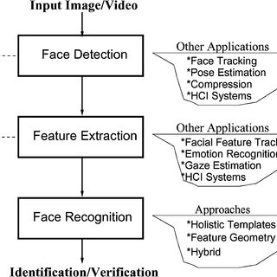

**Behavioural Diagram:**

**INPUT**

A Face image is passed into the system for classification

**PRE-PROCESS**

Noise and other unwantedelements are removed from the image.

**CLASSIFIER**

Decides to which subject in the database the input image belongs to.

**OUTPUT**

Indicates whether the subject in the input image is present in the database or not

**UML Diagram**

