**Client POC by using Angular/Web API**

**Project Overview:**

This project demonstrate the solution for a system where User can change his/her group followed by registered by the Admin.

**Database Design:**

**List of table:**

* **User**
* **Group**
* **Login**
* **Role**
* **RoleGroupMapping**
* **UserRoleGroupMapping**

**Web API Service:**

Below steps need to be followed for creating new Employee

1. Create Models as per requirement.
2. Create API route which can create/update/read/delete the employee object – “we should use Entity Framework”
3. Enable CORS so that angular application can talk to the API.
4. Enable windows authentication.

Test API functionality using fiddler/postman for respective CRUD operation.

**Angular/UI Design:**

* **Login as a Admin user:**

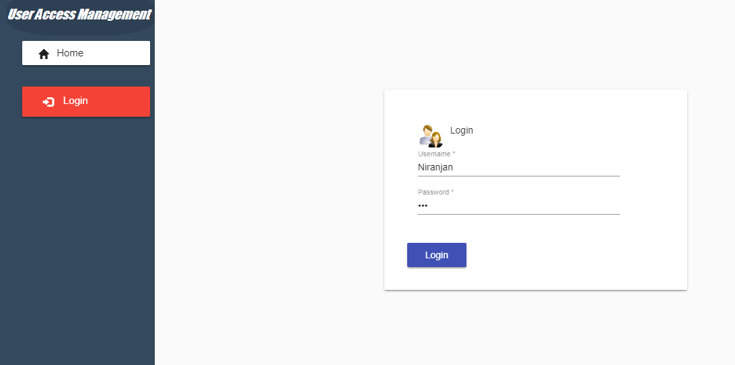

* Welcome Screen

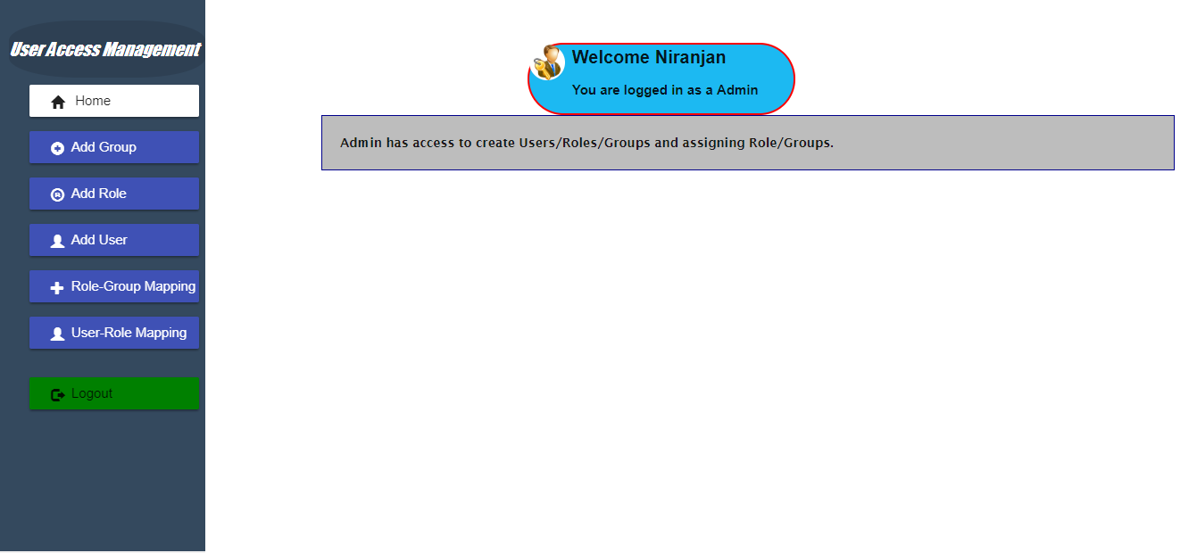

* Create Group Screen

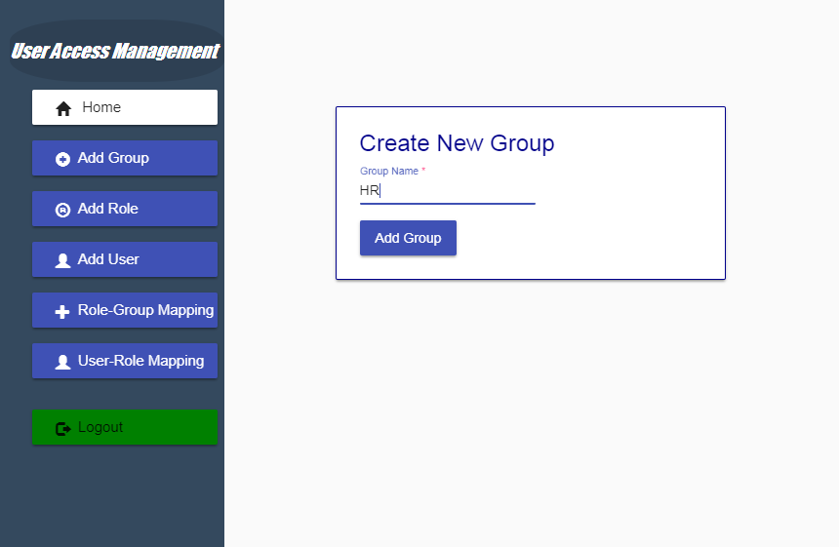

* Create Role Screen

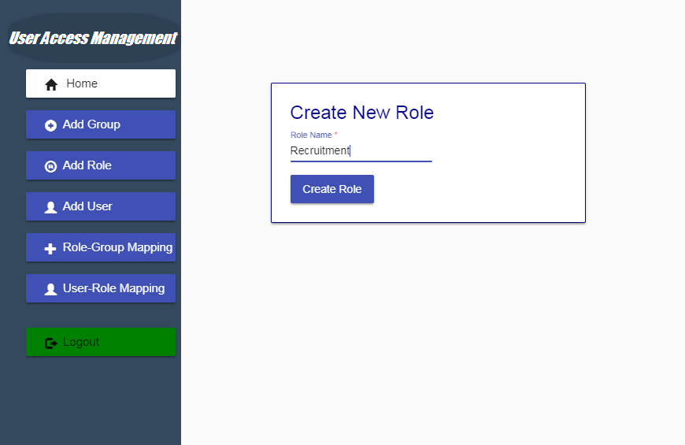

* User Registration Screen

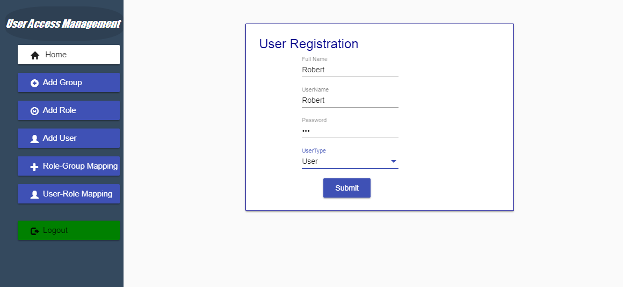

* Assign Role Screen

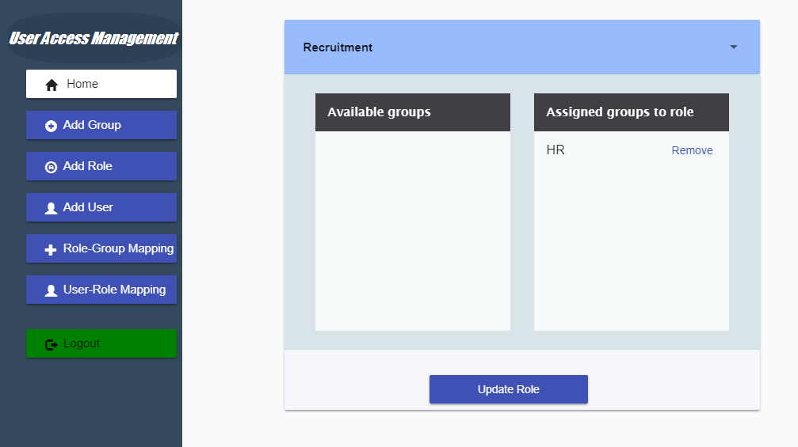

* Assign Role to user screen

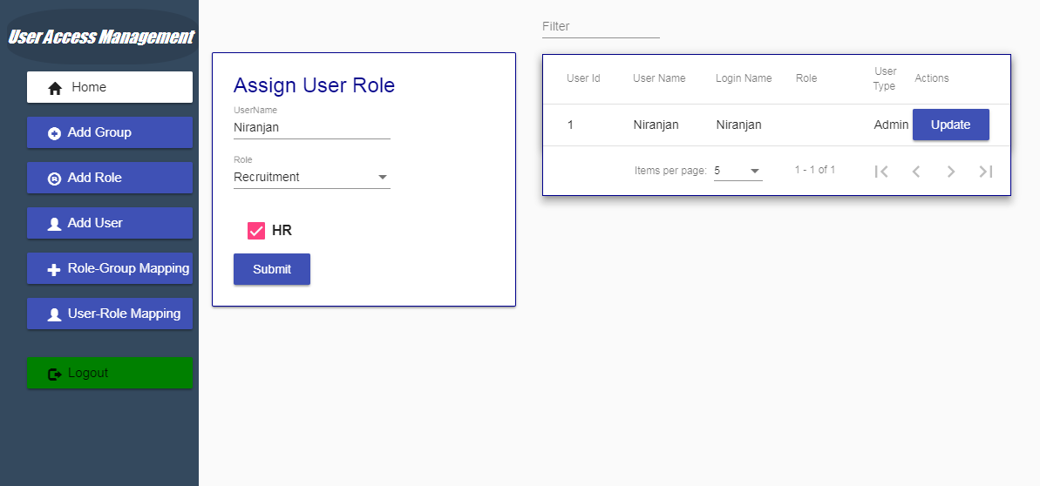

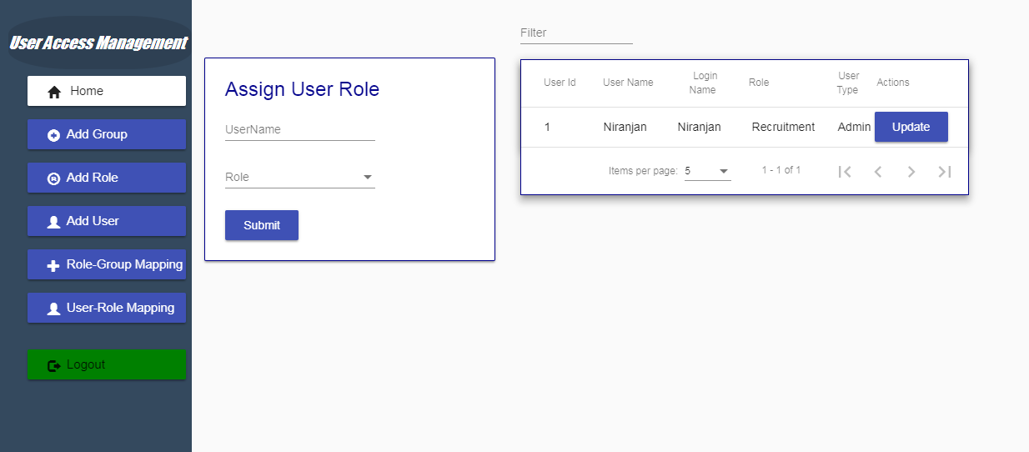

* Login With the created User screen

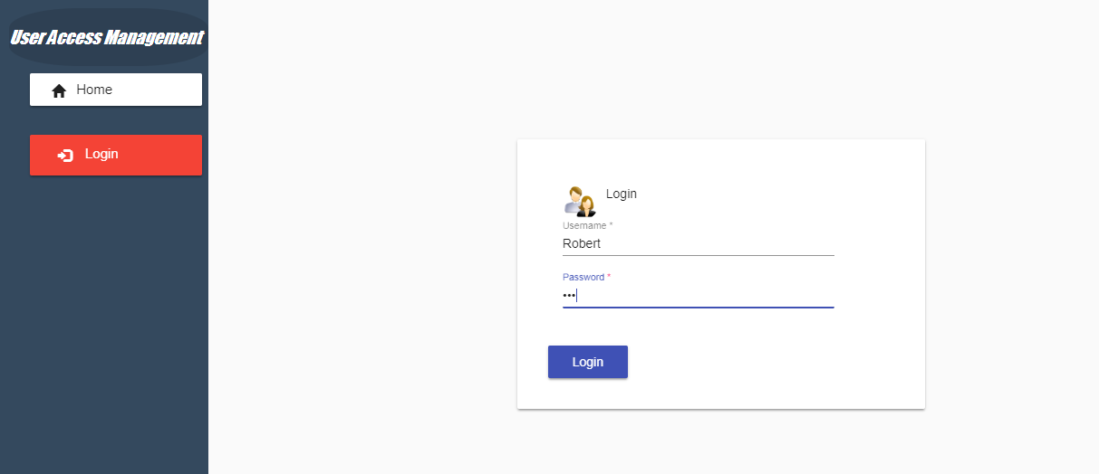

* User Login Welcome screen

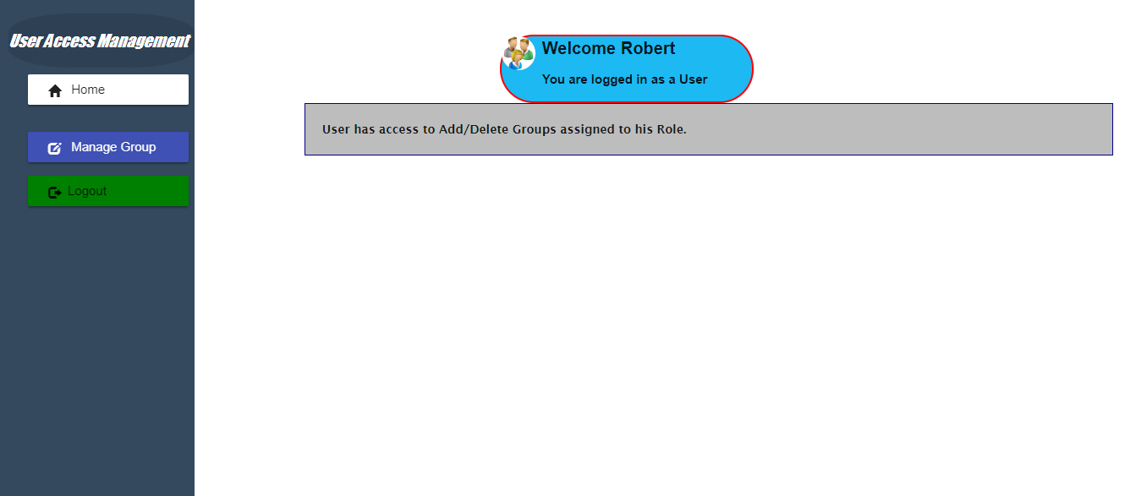

* Manage group Screen

